# $ + K @ Why Guitar Alchemist ?
The idea behind Guitar Alchemist was to create a tool that could really help guitarists finding the right paths in the jungle of notes. Guitar Alchemist achieves this goal putting in relation scales, notes on the staff, positions on the fingerboard and derived chords.
More than a simple chord dictionary, Guitar Alchemist is the perfect reference for finding the exact sound you’re looking for.

# $ + K @ System Requirements

Minimum
Microsoft Windows 98/NT/2000/XP
Intel Pentium Processor or compatible
16 MB of RAM
1024x768 screen resolution or higher
Sound card

Recommended
Microsoft Windows 2000 / XP
Intel Pentium III Processor or compatible (or faster)
32 MB of RAM
20 MB of Hard Disk space
32 Bit Color Settings

# $ + K @ How to buy Guitar Alchemist

You can buy Guitar Alchemist for only $24.95.
You will get free minor upgrades and email support.
To buy Guitar Alchemist, click on Register in the Help menu, the following registration dialog will pop up.

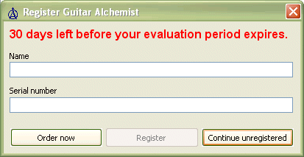

On the dialog, click on the Order Now button that will open your browser at our web store powered by eSellerate, and follow the instructions. Once you have made your purchase, you should receive your Serial Number by email. Fill the form with your name and your Serial Number, the Register button.
If you have any questions regarding your purchase, please contact sales@guitaralchemist.com

# $ + K @ The main window
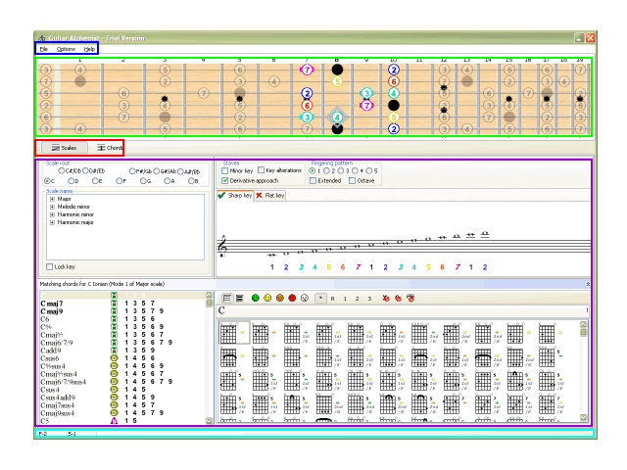
The main window consists in five different areas which respectively are :
The menu bar
The fingerboard
The view selector
The view panel*The_scales_view
The status bar

# $ + K @ The options dialog
To open the options dialog, just click Options on the main menu.
The option dialog contains the follwing sections organized by pages :
The fingerboard options page
The theme options page
The MIDI options page

Note that the options that you modify are kept across Guitar Alchemist sessions.

# $ + K @ The fingerboard options page

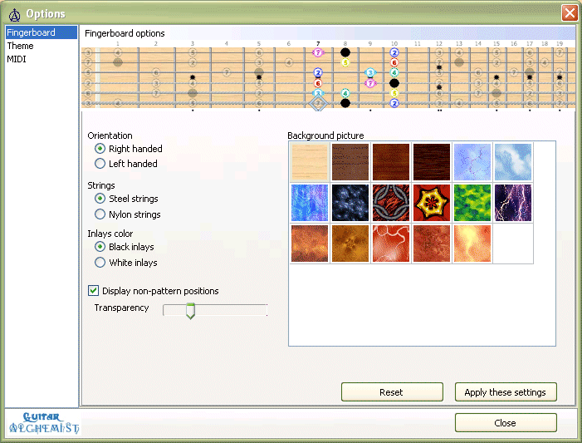

You can here adjust the aspect of the fingerboard like :

The orientation (Left or right handed)
The kind of strings (Steel or nylon) – (This option is not available in the free version of Guitar Alchemist)
The color of the inlays (Black or white)
You can choose whether you want to view the scale positions along with the pattern ones, and set their transparency.
You can customize the background texture of you fingerboard. You can add you own texture files in Guitar Alchemist’s folder and they will be listed the next time you will run Guitar Alchemist (Not available in the free version)
# $ + K @ The theme options page

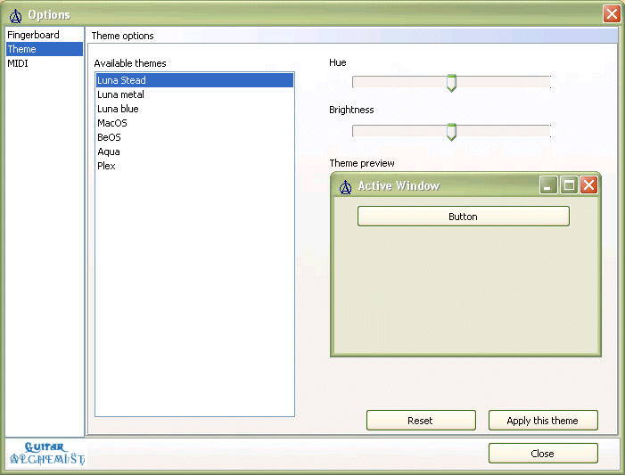

Using this page, you can choose which theme you want to use with Guitar Alchemist, and adjust the hue and brightness fo your theme. You can add your own themes copying the files to application folder.

# $ + K @ The MIDI options page

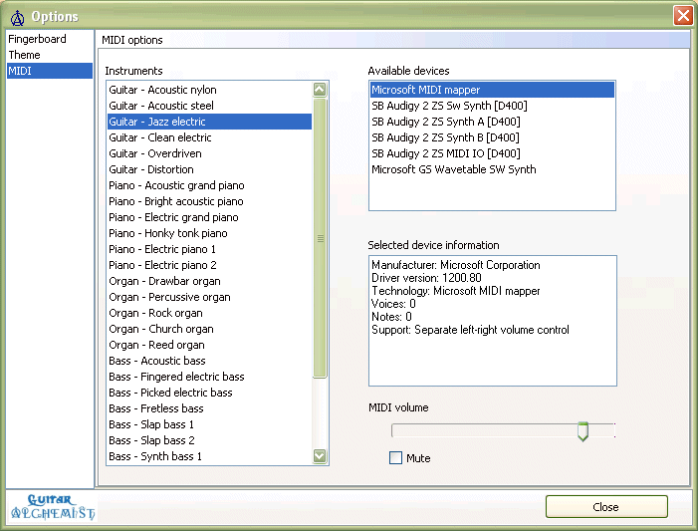

On this page, you can choose the MIDI device and instrument you want to use for playing notes and chords.

You can also adjust the MIDI volume, or completely mute the MIDI output.

# $ + K @ View selector

You can switch between the different views using the view selector

# $ + K @ The menu

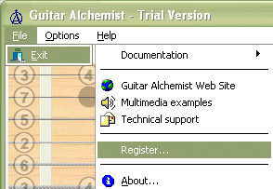

To exit the application, click on File | Exit
To open the options dialog, click on Options

# $ + K @ The fingerboard

The fingerboard can be userd to visualize scales and chords.
At any time, you can play a fingerboard position by clicking on the mouse.
You can customize the aspect of the fingerboard in the fingerboard options page.

Example of scale displayed on the fingerboard
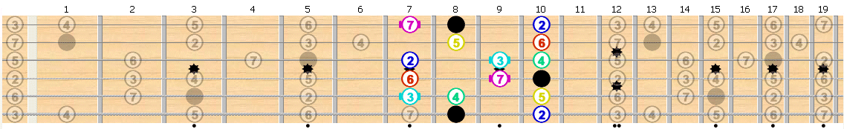
When a scale is displayed on the fingerboard, the pattern positions (positions reached by the fingers without moving the hand) are shown in color, while the other positions are optionally displayed in gray. You can hide these non-pattern positions and change the transparency level in the options.
Each color corresponds to one of the 12 possible intervals, and the root of the scale is colored in black. The numbers inside the circle identifies the intervals. Positions with lines beside are called the character tones.

Example of chord displayed on the fingerboard
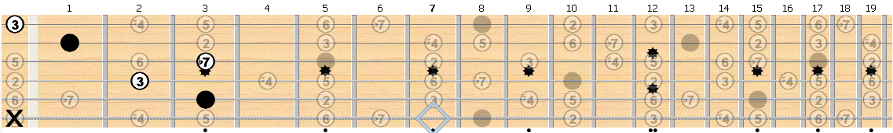

When a chord is displayed on the fingerboard, the chord positions are displayed in black, while the other scale positions are optionally displayed in gray. The number inside the circle identifies the intervals.
You can hide these non-pattern positions and change the transparency level in the options.
The X represent muted positions.

# $ + K @ The status bar

The first two panels show some information relative to the note focused in the fingerboard or the staff. The first panel indicates the name and octave of the note (separated by a dash), while the second panel the position on the fingerboard (string and fret, separated by a dash)
The third panel displays the help related to the elements pointed by your mouse cursor.

# $ + K @ The scale selector panel
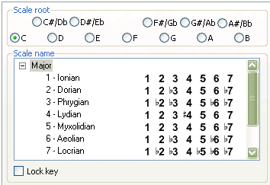

The scale root group box is used to select the root of the scale you want to display. You can double click on an item to play the note.

The scale name group box features a scale tree selector with contains a parent scale node that contains all the modes as children nodes. The number indicates the rank of the mode toward the scale (For example, the Dorian mode is the second mode of the Major scale). The numbers beside the mode name represent each degrees of the scale.

The lock key check box is used to help guitarists finding chord vamps to play over a given mode (This feature is not included in the free version of Guitar Alchemist).

Example:
Imagine you want want to find a small series of chords that you can play over B Dorian mode.
- Select B as scale root and Dorian as scale name, then click on the Lock key check box.
- Select a chord template that sounds good to you, Bm7 for example and choose a fingering in the chord dictionary.
- Now pick another scale (usually, a second, fourth or fifth further sounds good, respectively phrygian, mixolydian and aeolian if you start from the Dorian mode), mixolydian for example.
- Select a template that sounds good to you for this mode, Edom9 for example and choose a fingering in the chord dictionary.

It’s that simple. You’ve found a good vamp (or simple series of chords) to play with the B Dorian mode !

You can listen to this example by clicking on this link http://www.guitaralchemist.com/examples

# $ + K @ The scale pattern panel
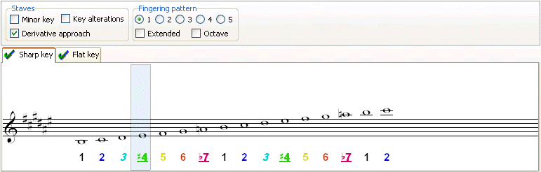

In the bottom part of the scale pattern panel, you see on a staff the notes of the selected scale for the current pattern. You can move your mouse over the notes, and you’ll see that the cursor will move accordingly on the fingerboard to show you the position of the note.
The number below each notes represent the interval quality of the note. Underlined degrees indicate a primary character tone while italic ones indicate a secondary character tone (see character tones).
The scale can be displayed using both a sharp key and a flat key in certain cases, and sometimes in one of theses only. You can click on the tabs to switch between the sharp key and flat key staves. When a key is not available, the tab is marked with a red cross, and a green check mark otherwise.

The staves group box

The stave group box is used to change the way you see the scale pattern on the staves.
The minor key check box can be used to change the key into a minor key.
The key alterations is useful to show the alterations due to key directly on the staff.
When the derivative approach check box is on (by default), Guitar Alchemist computes the key that suits the best for writing the mode, computing the parent scale from which the mode is derived. You can turn it off if you want to use the same key as the root of the mode. Note that when this option is on, the third status panel will indicate the parent scale for this mode this is also the name of the key which is used on the staff.

The fingering pattern group box

You can change the fingering pattern number to climb up and down the fingerboard. Note that you can also change it directly from the fingerboard by just clicking on one of the scale positions outside the pattern (Visible only when the Display non pattern option is turned on)
Checking the extended check box, you can switch between the condensed and expanded hand shape. Neither approach is better than the other, they are simply different. It’s up to you to experiment to see which approach you prefer.
The octave check box is used to display the pattern after the 12th fret. In some situations, clicking on it won’t have any effect because there’s no octave position for the position you are.

# $ + K @ The matching chords panel
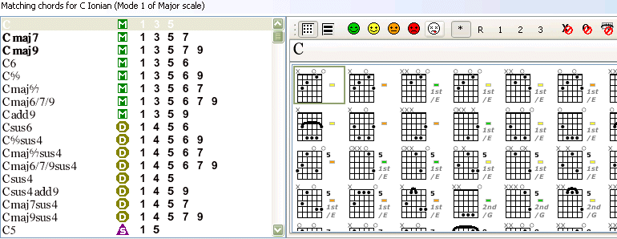

This panel can be hidden by click on the little button on the extreme right of the panel header.

The panel headers displays the selected scale.
Below the header, there’s a list of all the chord patterns that match this scale. The patterns in bold are those constructed by stacking the intervals of a 3rd above the root note, which is the most common way of constructing the chords from a scale. On the right of the chord template name, a symbol indicates the function of the chords which be major, minor, dominant or special. On the right of the symbol is displayed the formula of the template (i.e. All the interval qualities that the chord template contains). Just click on a chord template to play it. A few moments after the template is selected, all the chord voicing for this template will be computed and listed on the chord dictionary. You can also double click on the selected template to force the chord dictionary to refresh the list right away.

# $ + K @ The chord selector panel
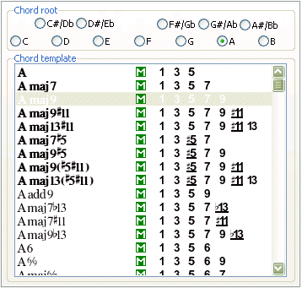

You can select the chord root and the chord template to be using for computing the list of voicings in the chord dictionary. This process is explained in the chord selector panel section of this help

# $ + K @ The chord dictionary panel

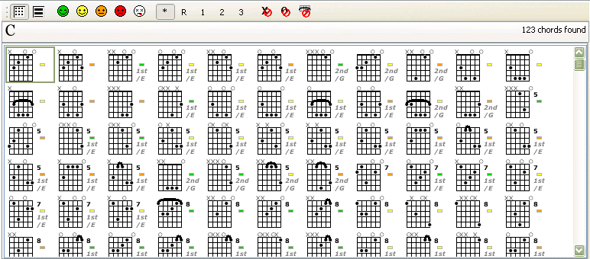

The chord dictionary panel contains :
A tool bar to control which chords are listed in the dictionary.
An information panel which indicates the current chords (and optionally the name of the first note if the selected voicing is an inversion). The number of chords in the list is also indicated.
The actual list of chords which can be presented in a simple or detailed list (see detailed view)

The chord dictionary tool bar:

These buttons allows you to switch between the simple and detailed view (The detailed view is detailed further).

These buttons allow you to set the maximum difficulty for the voicings listed in the chord dictionary (Easy, medium, hard, very hard, mortal).

These buttons controls which kind of inversions you want to be included in the list of chords :
* means any inversion
R means the root voicing only
1 means the first inversion only
2 means the second inversion only
3 means the third inversion only (This one is useful for 7th chords and their extensions only)

The first button allows you to exclude chords containing muted strings from the list.
The second button is used to exclude chords which contain open strings positions from the list.
The third button excludes barré chords from the list.

The detailed view:

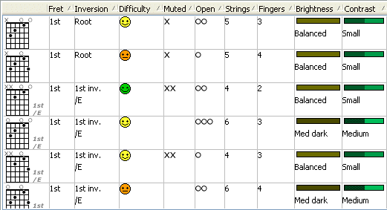

The detailed view is used when you want to find a specific chord voicing. The main advantage of using this detailed view resides in the fact that you can sort the chords by their characteristics. You can change the sorting order just by moving the columns to the left. For example, if you want your list to be sorted by contrast, then by difficulty, move the contrast column on the leftmost, then move the difficulty column just after the contrast column. You can also reverse the order just by clicking on the column header. Note that the selected voicing in simple and detailed view always remain synchronized.
This feature is not available in the free version of Guitar Alchemist.

# $ + K @ The matching scale panel

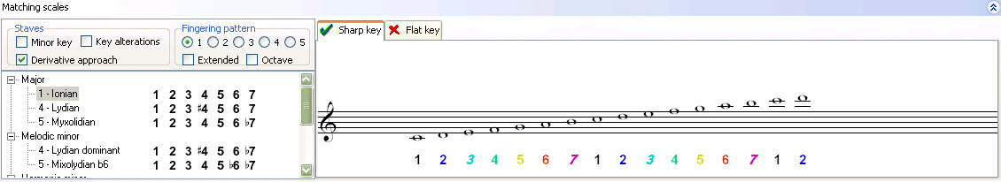

You can select between the scales that match the selected chord. This has already been described in the scales view.

# $ + K @ The scales view

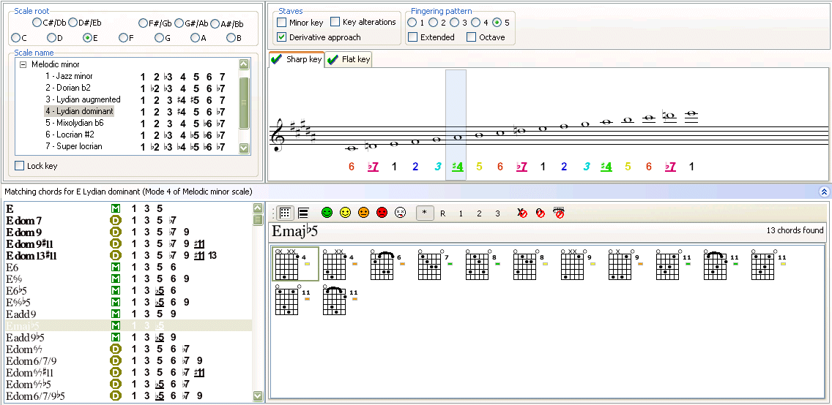

The different elements of the scales view are :
The scale selector panel
The scale pattern panel
The matching chords panel

# $ + K @ The chords view

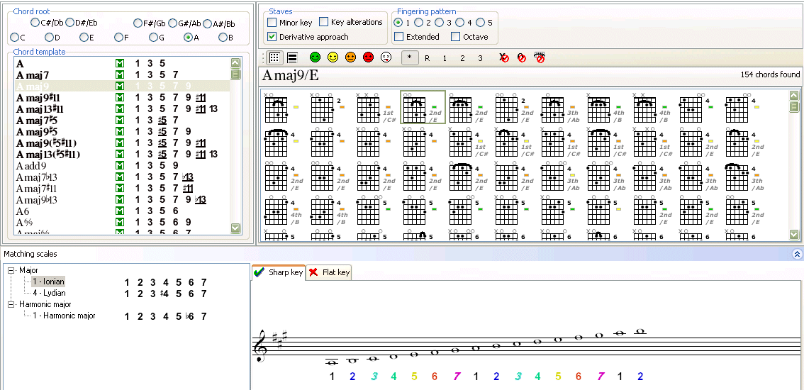

The different element of the chords view are :

The chord selector panel
The chord dictionary panel
The matching scale panel

# $ + K @ The intervals
An interval is the musical distance between two notes. You need to have a basic understanding of intervals before you can discuss about scales or chords. There’s two type of intervals : harmonic and melodic. An interval is harmonic when two notes are played at the sale time, such as in chord or a vocal harmony. Melodic intervals are like melodies : a succession of single notes.

The half-step is the smallest interval commonly user in Western Music theory (music of the western hemisphere, not Country Western !). On a guitar, a half step is the distance from one fret to next on the same string, and a whole step is equal to two half-steps – the distance of two frets.

Interval have two attributes : size and quality. In other words, you need to know how big is an interval (size) and how to describe the nature of it’s sound (quality). The size of an interval tells us how many lines and spaces separate a not from another. You have to remember to count the lowest note as 1. The quality of an interval describes its sound. The terms which are used to describe these sounds are : perfect, major, minor, diminished and augmented. The are the same terms which will later be used to describe certain chord sounds.

To help determine the quality of an interval, it’s necessary to look at the interval numbers and qualities which exist in the major scale. This scale is used as a reference in music theory. The arrangement of two whole steps, one half step, the whole steps, and one half step (w-w-h-w-w-w-h) is the formula or definition of the major scale. The notes must be spaced according to this formula in order for the scale to have the sound that we call major. Any other arrangement of whole and half-steps will result in some other scale or mode

The major scale
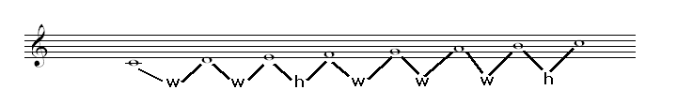

The perfect and major intervals

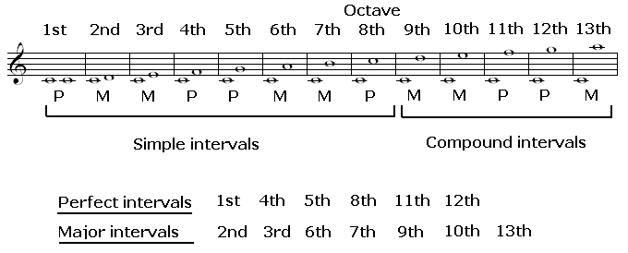

The major scale contains only two of the five different qualities of intervals. The leaves minor, diminished and augmented intervals. The intervals are produced by altering the perfect and major intervals.
Altering the major and perfect intervals is done by bringing two notes closer together (contraction) or by placing them further apart (expansion). It’s important to remember that altering an interval does not mean that the number of the interval is going to change, only the quality will change.

There are a few different symbols used to bring notes closer together or place them further apart. These symbol are called accidentals.

The accidentals

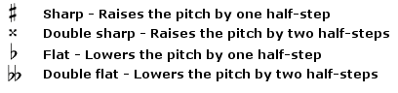

Whenever a perfect interval is expanded by one half-step, it becomes augmented.
Whenever a perfect interval is contracted by one half-step, it becomes diminished.
Whenever a major interval is expanded by one half-step, it becomes augmented (Just like the perfect interval).
Whenever a major interval is contracted by one half-step, it becomes minor.
Whenever a minor interval is contracted by one half-step, it becomes diminished

# $ + K @ The keys

The sequence of sharps and flats stays consistent in every key. If one sharp appears in the signature at the beginning of a piece of music, if will always be F#. If two sharp appear, they will be F# and C#. Same thing for flats.

Here’s a chart showing all the key signatures and the number of sharps and flats in each key
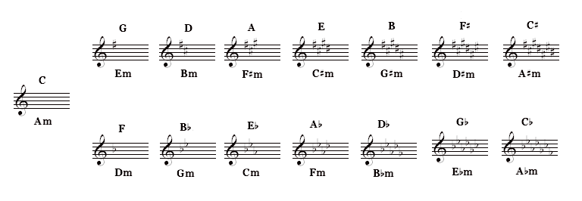

# $ + K @ The major scale modes

Let’s first explain what a mode is. A mode is an inverted scale, where one of the notes from the scale functions as the starting point (tonic or root) and is the focal point of the scale.
In the C major scale, this note is C. When C is the root or tonic tone, we call it a C major scale.
Each mode of the major scale has a greek name.

Here are the modes of the C major scale :
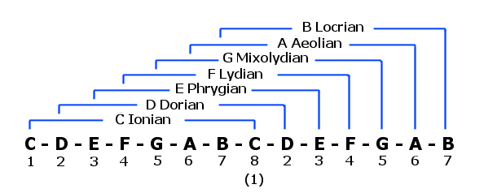

The formulas for all the modes of the major scale are :

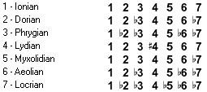

The reason for learning the modes is that there will come a time when you’ll need a particular sound that goes with a given chord. Many different chord exists and it’s likely that one of these modes will sound good when played over them.

# $ + K @ The melodic minor modes

Here are the modes of the C melodic minor scale :
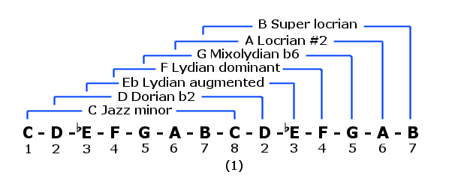
The formulas for all the modes of the melodic minor scale are :

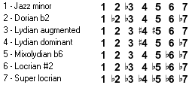

(Note that the melodic minor scale and its modes are not available in the free version of Guitar Alchemist)

# $ + K @ The harmonic minor modes

Here are the modes of the C harmonic minor scale :
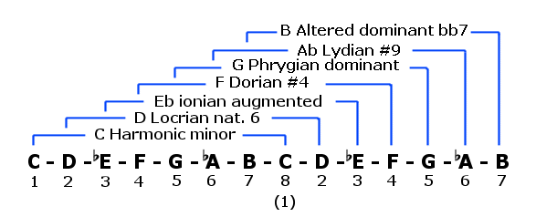

The formulas for all the modes of the melodic minor scale are :

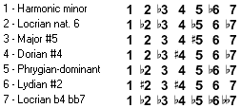

(Note that the harmonic minor scale and its modes are not available in the free version of Guitar Alchemist)

# $ + K @ The harmonic major modes

Here are the modes of the C harmonic minor scale :
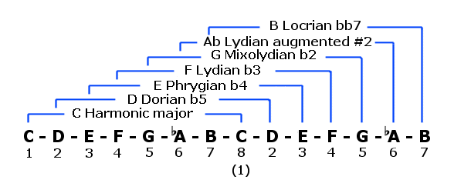

The formulas for all the modes of the melodic major scale are :

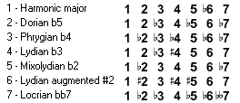

(Note that the harmonic major scale and its modes are not available in the free version of Guitar Alchemist)

# $ + K @ The character tones

The character tones are the tones which give a scale or mode its unique sound. The primary tones are very important and should be absolutely played while secondary character tones are less important.

# Why_Guitar_Alchemist_
$ Why Guitar Alchemist ?
+ MAIN:000010
K Why Guitar Alchemist ?
@ Status|0|||0||||||
# System_Requirements
$ System Requirements
+ MAIN:000020
K System Requirements
@ Status|0|||0||||||
# How_to_buy_Guitar_Alchemist
$ How to buy Guitar Alchemist
+ MAIN:000030
K Register;Serial Number;Order Now button;How to buy Guitar Alchemist
@ Status|0|||524288||||||
# The_main_window
$ The main window
+ MAIN:000040
K The main window
@ Status|0|||0||||||
# The_options_dialog
$ The options dialog
+ MAIN:000170
K The options dialog
@ Status|0|||0||||||
# The_fingerboard_options_page
$ The fingerboard options page
+ MAIN:000180
K The fingerboard options page
@ Status|0|||0||||||
# The_theme_options_page
$ The theme options page
+ MAIN:000190
K The theme options page
@ Status|0|||0||||||
# The_MIDI_options_page
$ The MIDI options page
+ MAIN:000200
K The MIDI options page
@ Status|0|||0||||||
# View_selector
$ View selector
+ MAIN:000080
K View selector
@ Status|0|||0||||||
# The_menu
$ The menu
+ MAIN:000060
K The menu
@ Status|0|||0||||||
# The_fingerboard
$ The fingerboard
+ MAIN:000050
K The fingerboard
@ Status|0|||0||||||
# The_status_bar
$ The status bar
+ MAIN:000070
K The status bar
@ Status|0|||0||||||
# The_scale_selector_panel
$ The scale selector panel
+ MAIN:000100
K The scale selector panel
@ Status|0|||0||||||
# The_scale_pattern_panel
$ The scale pattern panel
+ MAIN:000110
K The scale pattern panel
@ Status|0|||0||||||
# The_matching_chords_panel
$ The matching chords panel
+ MAIN:000120
K The matching chords panel
@ Status|0|||0||||||
# The_chord_selector_panel
$ The chord selector panel
+ MAIN:000140
K The chord selector panel
@ Status|0|||0||||||
# The_chord_dictionnary_panel
$ The chord dictionnary panel
+ MAIN:000150
K The chord dictionnary panel
@ Status|0|||0||||||
# The_matching_scale_panel
$ The matching scale panel
+ MAIN:000160
K The matching scale panel
@ Status|0|||0||||||
# The_scales_view
$ The scales view
+ MAIN:000090
K The scales view
@ Status|0|||0||||||
# The_chords_view
$ The chords view
+ MAIN:000130
K The chords view
@ Status|0|||0||||||
# The_intervals
$ The intervals
+ MAIN:000210
K The intervals
@ Status|0|||0||||||
# The_keys
$ The keys
+ MAIN:000220
K The keys
@ Status|0|||0||||||
# The_major_scale_modes
$ The major scale modes
+ MAIN:000230
K The major scale modes
@ Status|0|||0||||||
# The_melodic_minor_modes
$ The melodic minor modes
+ MAIN:000240
K The melodic minor modes
@ Status|0|||0||||||
# The_harmonic_minor_modes
$ The harmonic minor modes
+ MAIN:000250
K The harmonic minor modes
@ Status|0|||0||||||
# The_harmonic_major_modes
$ The harmonic major modes
+ MAIN:000260
K The harmonic major modes
@ Status|0|||0||||||
# The_character_tones
$ The character tones
+ MAIN:000270
K The character tones
@ Status|0|||0||||||

