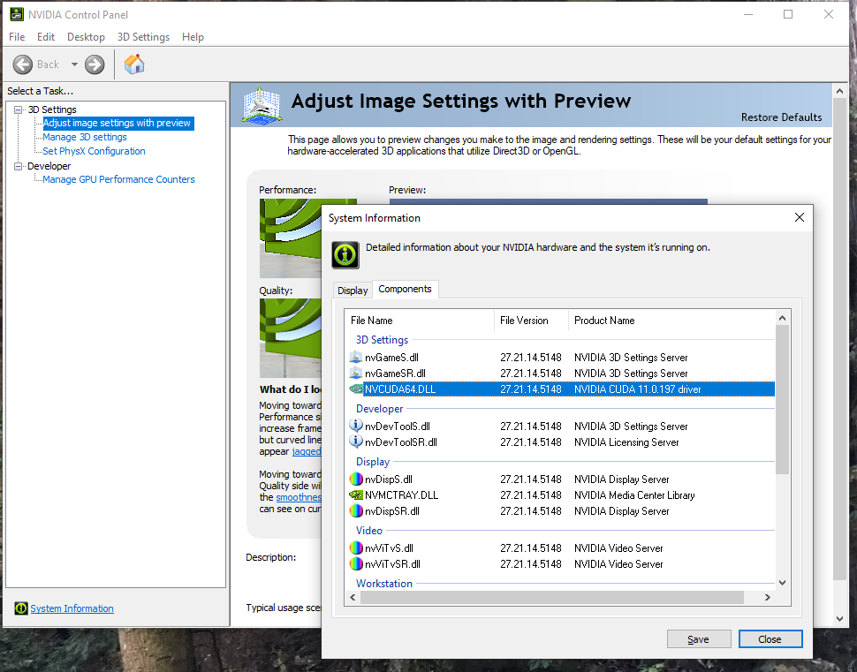
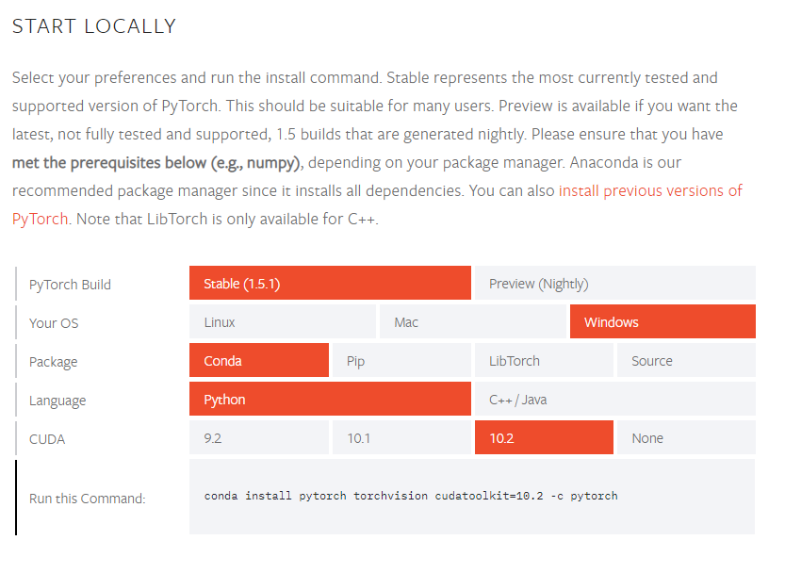
Setup your computer for Model Training (Windows 10)
- Check your NVIDIA GPU for Cuda compatibility, and install any required drivers
  - Right click on desktop and select NVIDIA Control Panel
    - If you don’t have the NVIDIA Control Panel, go to the website and download the NVIDIA driver for your graphics card. https://www.nvidia.com/Download/index.aspx
  - Select “Help” from toolbar, then “System Information” and click the “Components” tab.
  - Note the CUDA driver version (below image is version 11.0) for pytorch install later on.

  - Reference: https://medium.com/analytics-vidhya/cuda-toolkit-on-windows-10-20244437e036 for more info
Note: Cuda Toolkit download not needed, Pytorch handles what’s needed for Cuda

- Install Anaconda
  - https://www.anaconda.com/products/individual
  - Download and install the Windows 64- bit graphical installer for python 3.7

- Install Pytorch and Pytorch_lightning in Anaconda environment
  - Go to https://pytorch.org/get-started/locally/ and select the options show in picture below, except choose the CUDA version that matches yours. If your version is higher than 10.2, choose 10.2.
  - Open an Anaconda Prompt (type in search bar, should come up, otherwise go to Anaconda install folder and run from there)
  - Run the command shown in the “Run this command:” section in the Anaconda Prompt to install pytorch.
  - To install pytorch-lightning (high level pytorch interface) run this from the Anaconda Prompt:

“conda install pytorch-lightning -c conda-forge”

- Download PedalNetRT code repository from Github
  - Go to https://github.com/keyth72/PedalNetRT and the click green “Code” button, “Download Zip” and unzip somewhere easy to access on your computer. The model training and prediction commands will be run from here.
Note: Optionally, you could copy the repo url and use “git clone” to have the git repository, if you have git installed on your computer.
- Download SmartGuitarPedal plugin from Github releases:
  - Go to https://github.com/keyth72/SmartGuitarPedal/releases
  - Click “SmartPedal.vst3” to download. Copy to your DAW's working VST plugin folder as with any other plugin.
Note: There is also a standalone app, but it is significantly slower than using the VST3 plugin, so it's not recommended for actual guitar playing.

