**Step1**  
**Create a CSV file** with these fields:

* session_name: The name that should be used for the session. If this field does not exist, the hostname field is used as the session_name.
* folder: Relative path for session as displayed in the Connect dialog.
* hostname: The hostname or IP for the remote server.
* protocol: The protocol
* port: The port on which remote server is listening
* username: The username for the account on the remote server
* emulation: The emulation
* description: The comment/description. Multiple lines are separated with ‘\r’

**Remember:** It is not a requirement that all the options be used.

Suppose you want import sessions with these fields: session_name, hostname, protocol, folder.

The following is an example of what your data file might look like:

session_name,hostname,protocol,folder

ciscozine_rt,192.168.100.1,SSH2,work/router

ciscozine_sw1,192.168.100.254,Telnet,work/switch

ciscozine_sw2,192.168.100.253,Telnet,work/switch

**Note:**

* The emulations available are: XTerm, VT100, VT102, VT220, ANSI, Linux, SCOANSI, VShell, WYSE50 and WYSE60.
* The protocols available are: SSH2, SSH1, Telnet and RLogin.

**Step2**  
**Download**the **Import_sessions.py** and **run** it using the “Script -> run …” tab as you see below.

[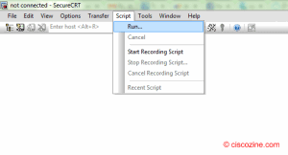](https://www.ciscozine.com/wp-content/uploads/SecureCRT-How-to-import-sessions-via-CSV-file.png)

A new window appears:**select your CSV** file and click on the “Open” button.

[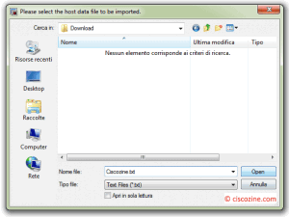](https://www.ciscozine.com/wp-content/uploads/SecureCRT-How-to-import-sessions-via-CSV-file-2.png)

After the work has been completed, **the script will print the import result**.

[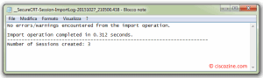](https://www.ciscozine.com/wp-content/uploads/SecureCRT-How-to-import-sessions-via-CSV-file-3.png)

Now you can open the SecureCRT application and view the Connect dialog to **see the sessions that have been created**.

[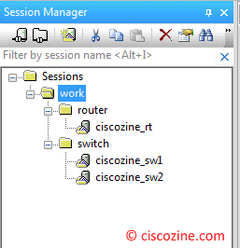](https://www.ciscozine.com/wp-content/uploads/SecureCRT-How-to-import-sessions-via-CSV-file-4.png)