Group B

Team Members
- Michael Gordon
- Michael Benko
- Jacob Richman

Report 1: Equipment Sales Analysis

Business Question
Do enough customers purchase equipment to justify continuing equipment sales?

Description
This report summarizes equipment sales activity by equipment item, including the total number of transactions and the total quantity sold. The report helps management evaluate whether equipment sales remain a valuable part of the business.
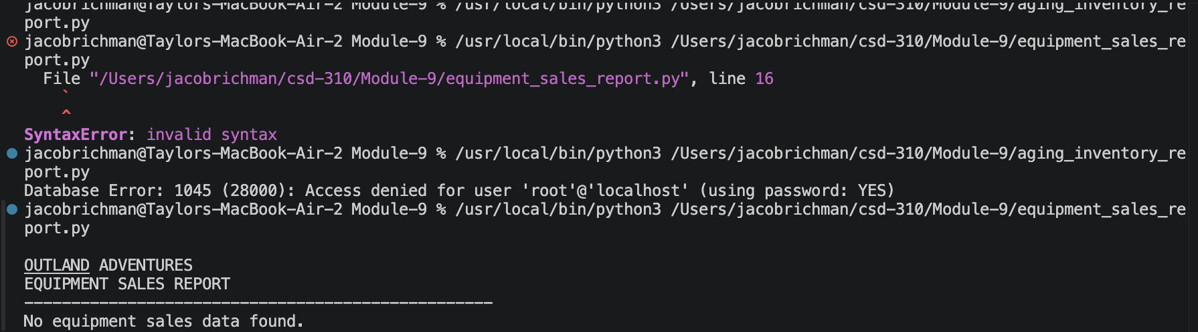

Report 2: Booking Trends Report

Business Question
Is any location experiencing a downward trend in bookings?

Description
This report summarizes booking activity by location and year. It helps identify locations where customer demand may be increasing or decreasing over time.
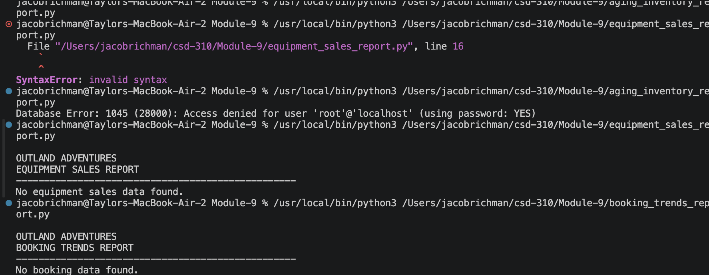

Report 3: Aging Inventory Report

Business Question
Are there equipment items more than five years old?

Description
This report identifies equipment inventory older than five years and helps management make decisions regarding replacement or maintenance.
