Jacob Richman
CSD 340 Web Development with HTML
Module 1.3 Assignment
Due 10/26/2026

Screenshot with Mistakes
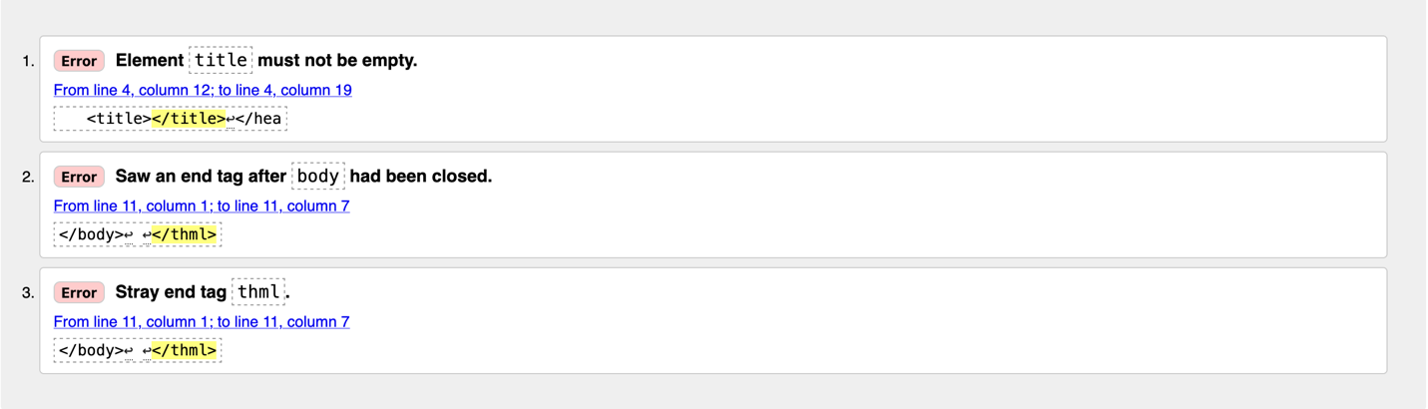
Screenshot with Correction
