CSD340-302E Web Development with HTML
Jacob Richman
Dr. Mortoza Abdullah
Due 10/26/26

GitHub
https://github.com/Guitarjake15/csd-340
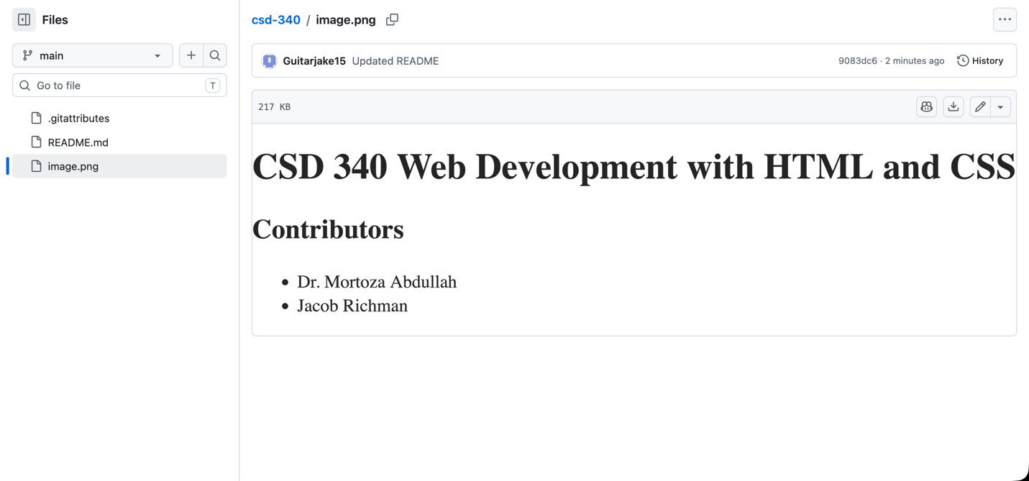
Terminal Screenshot
