Jacob Richman
Csd-402 Module 1.2 Assignment
Toni Farley
Due 10/26/2026

GitHub Repository Link:
https://github.com/YOUR_USERNAME/csd-402

GitHub Repository:
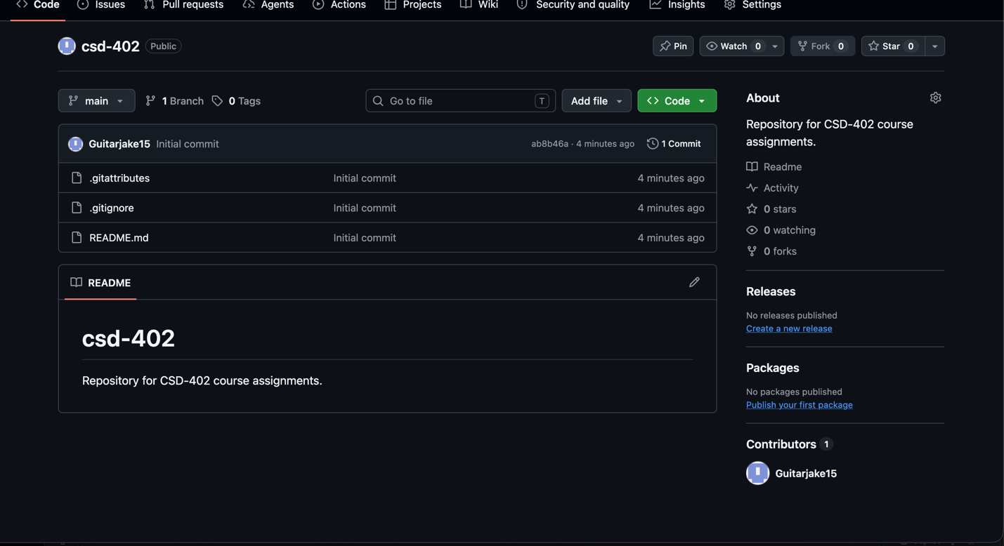

Local Directory Structure:
