CSD 402 Module 1 Assignment
Energy Needed to Heat Water
Jacob Richman
Date: October 24, 2026

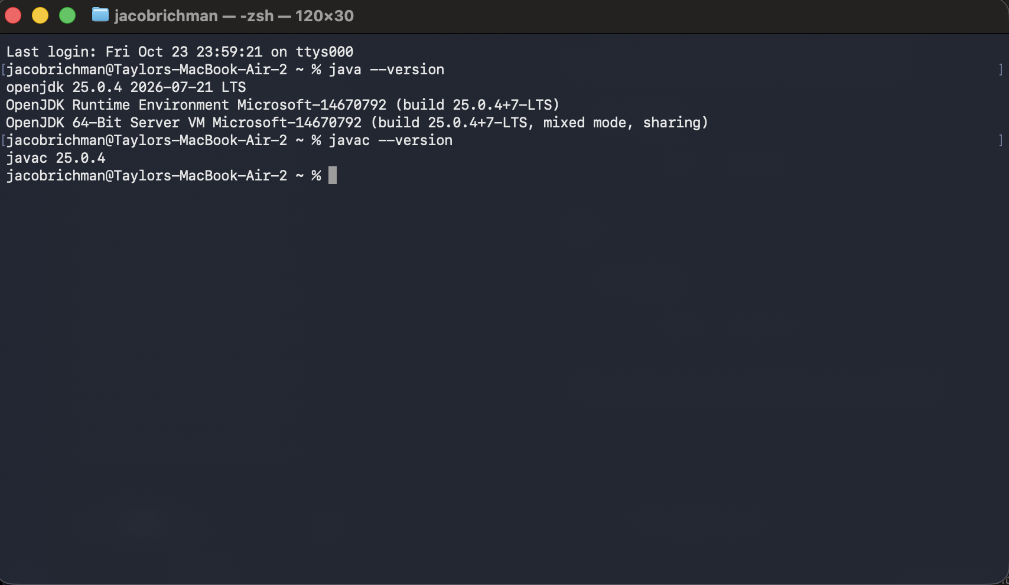
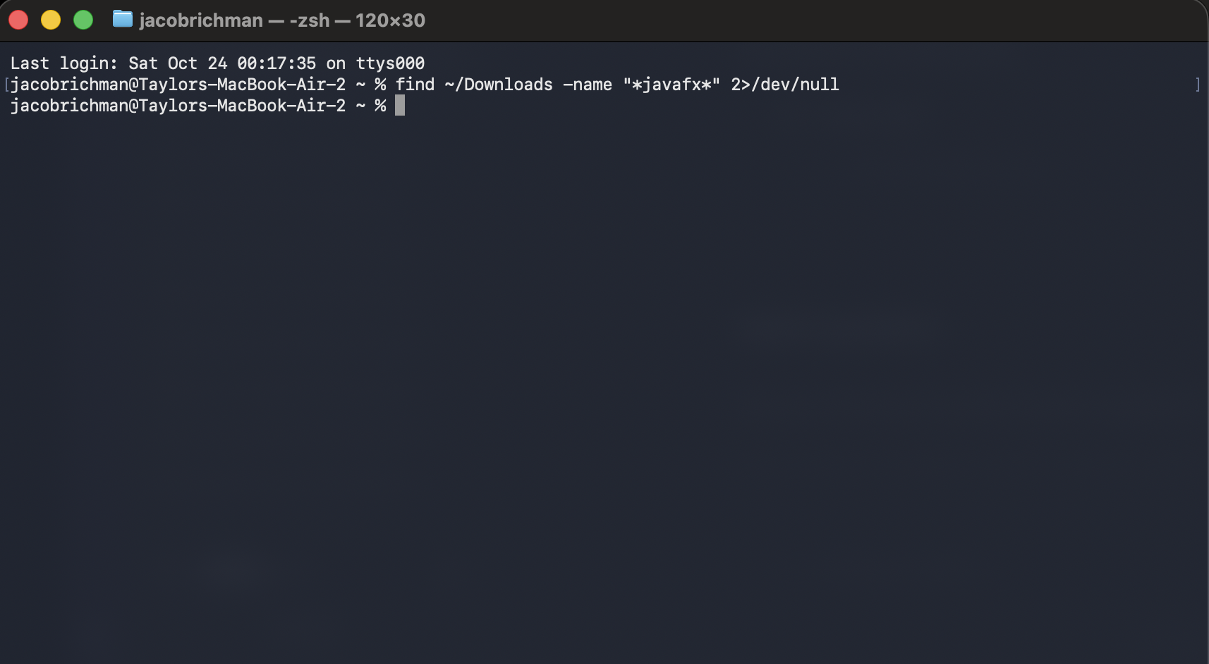
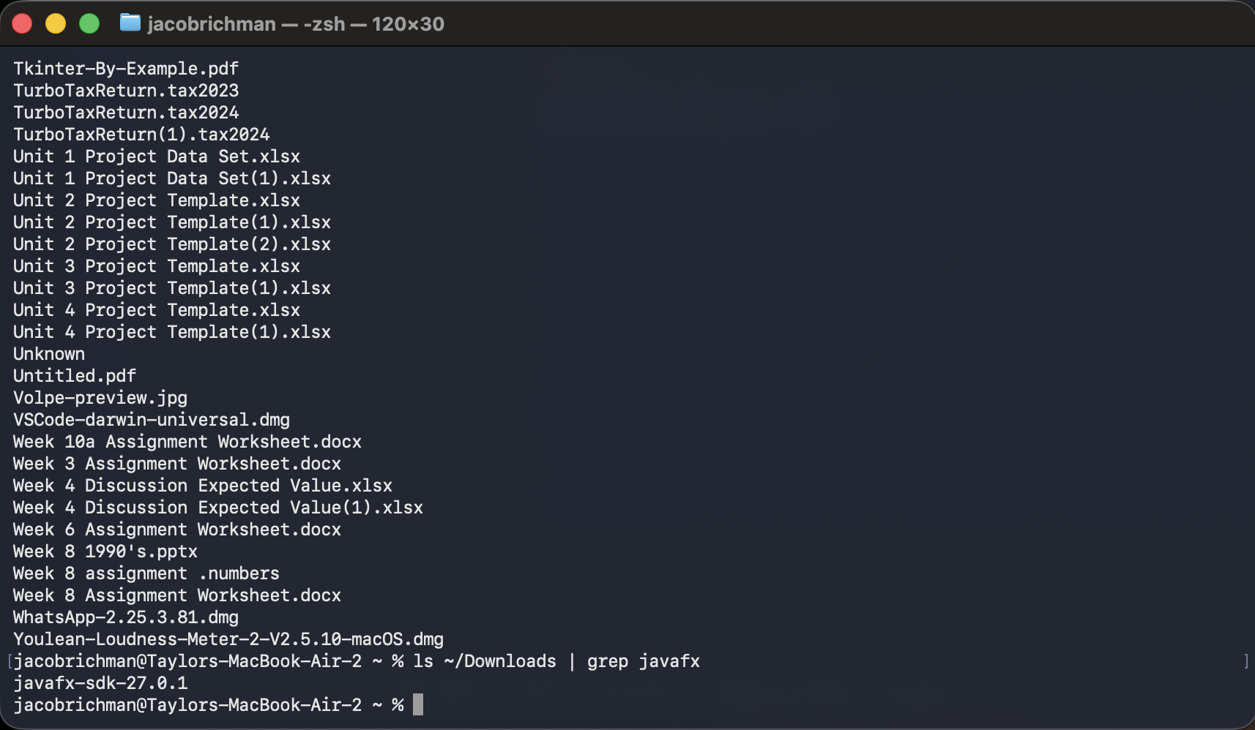

Q = 2 × (50 - 10) × 4184
Q = 334,720 Joules

