

Lead Generation Partner Specifications
Refinance

Revision 2.0, December 20, 2007

Table of Contents
Overview 3
Flow Chart 4
Fields and Validation Requirements 5

Overview
This document is meant to guide select affiliate partners with regards to successfully delivering mortgage refinance leads to LowerMyBills.com via HTTPS post method.

Home Refinance Field List & Data Map with GUI Validations
Partners must post data formatted to the following specifications. The data must match the Data Values column. A LowerMyBills.com Technology specialist will be able to discuss these methods with the Lead Generation Partners.

Required Materials
After a LowerMyBills Affiliate Marketing Manager has reached an agreement with a prospective affiliate partner, and the terms set forth in the official Insertion Order have been signed and faxed, LowerMyBills will provide the affiliate partner with the following required materials
- This posting specification document
- An assigned marketing source ID
- Any logos, creative, or ad copy that is to be used
- Terms of use, legal and privacy language

QA Testing and Workflow
- LowerMyBills and affiliate partner sign and fax insertion order
- Partner completes development on HTML form per specifications provided and requests authorization to begin submitting test leads
  - Partner must provide the IP address from which tests will be submitted, so that LMB can create a firewall exception
- Upon approval and creation of firewall exception, partner submits tests and provides lead data and response string to LowerMyBills for delivery verification
- Once LowerMyBills’ QA Team is satisfied that all fields are passing validation and being successfully stored in LMB database, partner will be approved to begin posting real-time leads to the LMB production environment
- Partner will change post URL from staging to production server
- Upon “going live” partner will notify LMB for final QA verification

HTTPS Post Delivery
- The URL for posting test leads is: https://staging.lowermybills.com/servlet/LMBServlet
- The URL for delivery of real-time leads is: https://www.lowermybills.com/servlet/LMBServlet
- LMB will provide a Source ID. As indicated in the table above, this parameter and the_action=LGLending should be included with each Post submission.
- The Lead Gen Partner will HTTPS Post each lead to the appropriate URL and receive a response. Each HTTPS Post will contain only one lead.
- LMB will reply with a XML formatted Success or Fail message correlating to the lead submission. A Failure message will contain the specific error message encountered (typically a validation error) which the Lead Gen Partner may report back to the user if the lead was delivered in real time.
HTTPS Post-Response Method II – Real Time
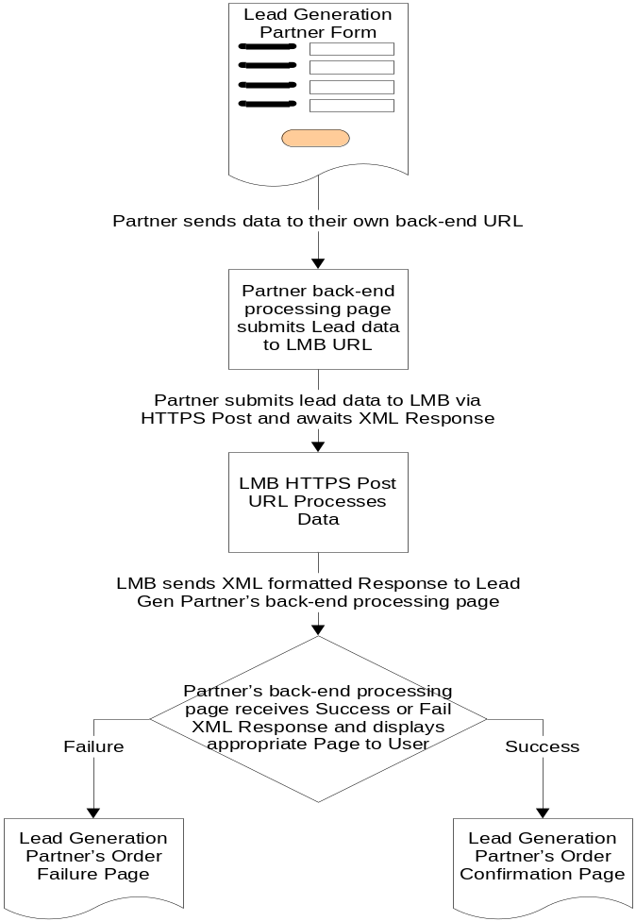

GUI Labels | HTTPS Post Parameter Names | On-Screen Options | Data Values  (HTTPS Post) | Required | Additional (GUI) Validations
 | the_action |  | LGLending | Y for HTTPS Post only
 | sourceId | Maximum 50 alphanumeric | Maximum 50 alphanumeric | Y
Property State | propertyStateCode | 49 US States (exclude “Montana”) plus “District of Columbia” | 2 letter state code | Y
 |  | - Alabama  - Alaska  - Arizona  - Arkansas  - California  - Colorado  - Connecticut  - Delaware  - District of Columbia  - Florida  - Georgia  - Hawaii  - Idaho  - Illinois  - Indiana  - Iowa  - Kansas  - Kentucky  - Louisiana  - Maine  - Maryland  - Massachusetts  - Michigan  - Minnesota  - Mississippi  - Missouri  - Nebraska  - Nevada  - New Hampshire  - New Jersey  - New Mexico  - New York  - North Carolina  - North Dakota  - Ohio  - Oklahoma  - Oregon  - Pennsylvania  - Rhode Island  - South Carolina  - South Dakota  - Tennessee  - Texas  - Utah  - Vermont  - Virginia  - Washington  - West Virginia  - Wisconsin  - Wyoming | - AL  - AK  - AZ  - AR  - CA  - CO  - CT  - DE  - DC  - FL  - GA  - HI  - ID  - IL  - IN  - IA  - KS  - KY  - LA  - ME  - MD  - MA  - MI  - MN  - MS  - MO  - NE  - NV  - NH  - NJ  - NM  - NY  - NC  - ND  - OH  - OK  - OR  - PA  - RI  - SC  - SD  - TN  - TX  - UT  - VT  - VA  - WA  - WV  - WI  - WY
Home Description | propertyDescription | - Single family  - Multi-family  - Condominium  - Townhouse  - Mobile Home  - Manufactured Home | - 0  - 1  - 2  - 3  - 5  - 6 | Y
Select your Credit Profile | creditProfile | - Excellent  - Good  - Fair  - Poor | - 0  - 1  - 2  - 3 | Y
Type of Loan | type | - Home Refinance  - Home Equity  - Debt Consolidation  - Home Purchase | - 0  - 1  - 2  - 3 | Y
Purpose of Refinance Loan | refiPurpose | - Take Cash Out  - Lower My Monthly Payment  - Make Home Improvements  - Consolidate My Debt  - Change My Mortgage or Rate Terms  - Lower My Interest Rate | - 0  - 1  - 2  - 3  - 4  - 7 | Y
Purchase year | propertyPurchaseYear | 4 digit number representing a year from 1944 – current year | 4 digit number representing a year | Y | Max = Current Year
Property Use | intendedPropertyUse | - Primary Residence  - Secondary/Vacation Home  - Rental/Investment Property | - 0  - 1  - 2 | Y, default to Primary Residence (0)
Estimated Home Value | propertyEstimatedValue | Maximum 9999999 – no decimals, commas, or special characters | Maximum 10 digits including 2 decimals – no commas or special characters | Y | Min = 50000  Max = 9999999
1st Mortgage balance | firstMortgageBalance | Maximum 9999999 – no decimals, commas, or special characters | Maximum 12 digits including 2 decimals – no commas or special characters | Y | Max = 2000000
1st Mortgage Interest Rate | firstMortgageRate | - 11+  - 10.75  - 10.50  - 10.25  - 10.00  - 9.75  - 9.50  - 9.25  - 9.00  - 8.75  - 8.50  - 8.25  - 8.00  - 7.75  - 7.50  - 7.25  - 7.00  - 6.75  - 6.50  - 6.25  - 6.00  - 5.75  - 5.50  - 5.25  - 5.00  - 4.75  - 4.50  - 4.25  - 4.00  - 3.75  - 3.50  - 3.25  - 3.00  - 2.75  - 2.50  - 2.25  - 2.00 | Maximum 8 digits, including 3 decimals – no special characters | Condition-al: If 1st Mortgage Balance= 0, then this field is not required (N). If 1st Mortgage Balance is not 0, then this field is required (Y). | Max = 10+ for CSV  Max = 100 for HTTPS Post
Type of Rate | firstMortgageRateType | - Fixed  - Variable  - I Don’t Know | - 0  - 1  - 2 | Condition-al: If 1st Mortgage Balance= 0, then this field is not required (N). If 1st Mortgage Balance is not 0, then this field is required (Y).
Do you have a 2nd Mortgage |  | - Yes  - No | Skip this field for POST. This is strictly for GUI and Batch data files | Y
2nd Mortgage Balance | secondMortgageBalance | Maximum 9999999 – no decimals, commas, or special characters | Maximum 12 digits including 2 decimals – no commas or special characters | N  (Yes if “Do you have a 2nd Mortgage” = Yes) | Max = 1000000
Second Mortgage Interest Rate | secondMortgageRate | - 11+  - 10.75  - 10.50  - 10.25  - 10.00  - 9.75  - 9.50  - 9.25  - 9.00  - 8.75  - 8.50  - 8.25  - 8.00  - 7.75  - 7.50  - 7.25  - 7.00  - 6.75  - 6.50  - 6.25  - 6.00  - 5.75  - 5.50  - 5.25  - 5.00  - 4.75  - 4.50  - 4.25  - 4.00  - 3.75  - 3.50  - 3.25  - 3.00  - 2.75  - 2.50  - 2.25  - 2.00 | Maximum 8 digits, including 3 decimals – no special characters | N  (Yes if “Do you have a 2nd Mortgage” = Yes) | If there is a 2nd Balance then this field is required.  Max = 10+ for CSV  Max = 100 for HTTPS Post
How much additional cash do you wish to borrow? | additionalCash | Maximum 10 digits – no decimals, commas, or special characters | Maximum 10 digits | N | Number only – no negative number  1st Mortgage Balance + 2nd Mortgage Balance + Additional Cash > 20000  Max = 1000000
When do you plan to complete  the loan process? | loanTimeFrame | - Immediately  - Within Two Months  - Other | - 4  - 6  - 7 | N
Annual income | monthlyIncome | - Less than 30,000  - 30,000 – 44,999  - 45,000 – 59,999  - 60,000 – 74,999  - 75,000 – 89,999  - 90,000 – 104,999  - 105,000 – 119,999  - More than 120,000 | Maximum 10 digits, no decimals, commas, or special characters. | Y | *NOTE: it is intended that the user’s annual income value is passed. This value will be converted to monthly income by the LMB system, hence the parameter name, monthlyIncome
What is your occupational status | occupationalStatus | - Not Employed  - Employed  - Self-Employed  - Retired | - 0  - 1  - 2  - 3 | Y
Monthly Debt Payments | monthlyDebtPayments | - 0 – 249  - 250 - 499  - 500 - 749  - 750 - 1000  - More than 1,000 | Maximum 10 digits – no decimals, commas or special characters | N
Year of Birth |  | - 1989  - 1988  …  - 1900 | Four digit number | N (will be required soon) | Any four digit integer between 1900 – current year
Have you declared Bankruptcy in the past 7 years? | declaredBankruptcy | - Never/Not in last 7 years  - Less than 12 months ago  - 1-2 years ago  - 2 -5 years ago  - 5-7 years ago  Note the blank space before the hyphen in “2 -5 years ago” | - N  - Y | Y
Any late mortgage payments? | mortgageLate | - Yes  - No | - Y  - N | Y
Any foreclosures? | hasForeclosures | - Yes  - No | - Y  - N | Y
Are you interested in a reverse mortgage? | reverseMortgage | - Yes  - No | - Y  - N | N | This field is optional and only applicable if the user’s age is less than 72.
First Name | firstName | Maximum 50 characters | Maximum 50 characters | Y | May only contain letters and spaces.
Last Name | lastName | Maximum 50 characters | Maximum 50 characters | Y | May only contain letters and spaces.
Address | addressOne | Maximum 50 characters | Maximum 50 characters | Y | contain number, letters and spaces
City | city | Maximum 50 characters | Maximum 50 characters | Y | contain letters, hyphens and spaces
State | state | All 50 US States (including “New York”) plus “District of Columbia” | 2 letter state code (“NY” for New York) | Y
Zip Code | zip | 5 digits, no hyphens | 5 digits, no hyphens | Y | Numbers only.
Phone Numbers – Preferred | dayPhone | 10 digits, numbers only | 10 digits, numbers only | Y | Numbers only.  If area code = 0 or 555 then error.
Extension | dayPhoneExt | 6 digits, numbers only | 6 digits, numbers only | N | Numbers only.
Type | prefPhoneType | - Home  - Work  - Cell | - Home  - Work  - Cell | Y
Phone Numbers – Alternate | evePhone | 10 digits, numbers only | 10 digits, numbers only | Y | Numbers only.  If area code = 0 or 555 then error.
Type | altPhoneType | - Home  - Work  - Cell | - Home  - Work  - Cell | Y
Email | email | Valid email, maximum 128 characters | Valid email, maximum 128 characters | Y | Contain letters, number, hyphens and spaces. Must have “@” and a “.”
Yes! I’d like to receive the LMB newsletter | subscriptionStatus | - Y  - N | - Y  - N | Y

