Absorption analysis for 2018 PUDRs

IHME PCE

May 7, 2019

## Absorption analysis for current PUDRs in PCE countries

# Average absorption by country

*Using most recent PUDR data*

|  |  |  |  |
| --- | --- | --- | --- |
| country | budget | expenditure | absorption |
| DRC | 179316598 | 116250364 | 64.83 |
| Uganda | 146936594 | 80540763 | 54.81 |
| Senegal | 11674677 | 5167388 | 44.26 |
| Guatemala | 5928471 | 4063886 | 68.55 |

# Average absorption by country and quarter

*Using most recent PUDR data*

|  |  |  |
| --- | --- | --- |
| country | start_date | absorption |
| DRC | 2018-01-01 | 61.71 |
| DRC | 2018-04-01 | 61.71 |
| DRC | 2018-07-01 | 68.40 |
| DRC | 2018-10-01 | 68.40 |
| Uganda | 2018-01-01 | 56.25 |
| Uganda | 2018-04-01 | 56.25 |
| Uganda | 2018-07-01 | 27.35 |
| Uganda | 2018-10-01 | 27.35 |
| Senegal | 2018-01-01 | 44.26 |
| Senegal | 2018-04-01 | 44.26 |
| Guatemala | 2018-01-01 | 82.78 |
| Guatemala | 2018-04-01 | 82.78 |
| Guatemala | 2018-07-01 | 58.49 |
| Guatemala | 2018-10-01 | 58.49 |

There have been mixed results on absorption for the countries in the PCE. For Uganda and Guatemala, absorption has fallen between the first and second semesters of 2018, while for DRC absorption has improved. For Senegal, we’ve only received PUDRs for the first half of 2018, so we can’t draw conclusions about change over time. Overall, absorption continues to be low, with a maximum of 82.78 in Guatemala.

# Average absorption by grant

*Shows average absorption across entire reporting period of latest PUDR*

|  |  |  |
| --- | --- | --- |
| country | grant | absorption |
| DRC | COD-M-MOH | 54.37 |
| DRC | COD-M-SANRU | 64.80 |
| DRC | COD-C-CORDAID | 93.31 |
| DRC | COD-H-MOH | 16.83 |
| DRC | COD-T-MOH | 13.51 |
| Guatemala | GTM-H-HIVOS | 82.78 |
| Guatemala | GTM-T-MSPAS | 0.00 |
| Senegal | SEN-M-PNLP | 29.16 |
| Senegal | SEN-H-ANCS | 57.44 |
| Senegal | SEN-H-CNLS | 52.76 |
| Senegal | SEN-Z-MOH | 45.83 |
| Uganda | UGA-M-MoFPED | 57.85 |
| Uganda | UGA-M-TASO | 27.65 |
| Uganda | UGA-C-TASO | 27.04 |
| Uganda | UGA-H-MoFPED | 57.42 |
| Uganda | UGA-T-MoFPED | 61.80 |

Although average absorption by country is low for all PCE countries, with a maximum of 68.55 in Guatemala, the grant-level averages show more variation. Within DRC, for example, the absorption by grant ranges from 13.51 to 93.31 percent.

# Absorption range

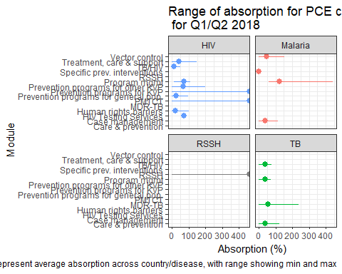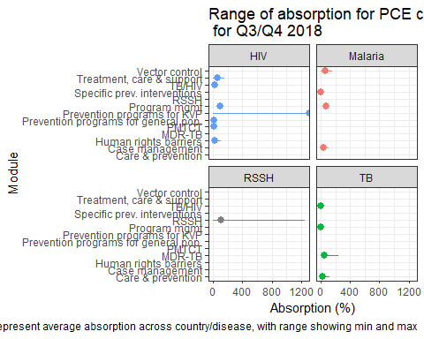

Absorption by module shows that there has been a slight downward trend in absorption between the first and second halves of 2018, although it’s important to note that the PCE is missing several PUDRs for Q3/Q4 2018. These data gaps are also noticeable through the missing error bars in the second graph, for many of these modules, we only have one grant reporting.

# Average absorption by module

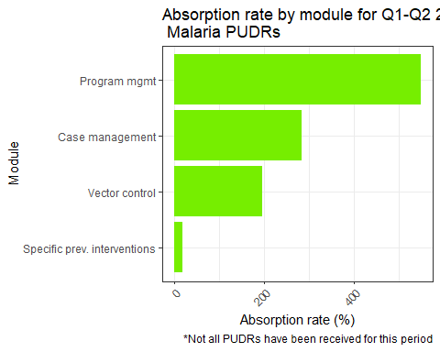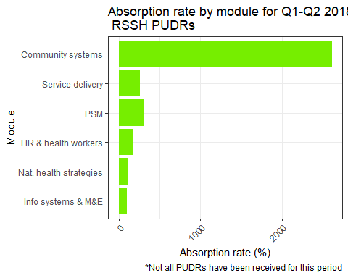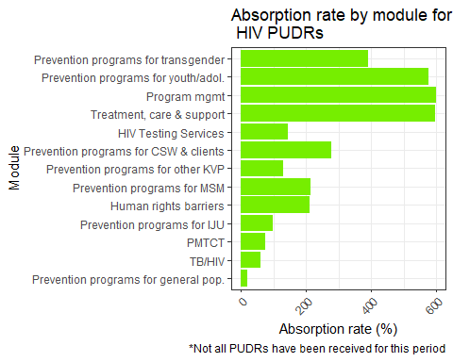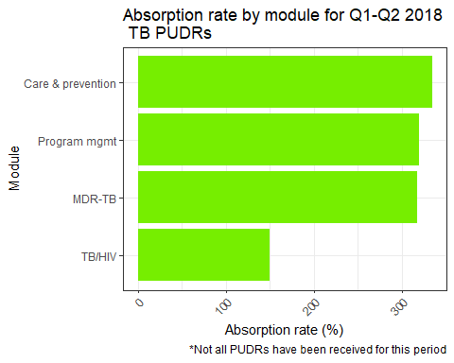

Across all diseases, program management has consistently been an important part of early grant implementation, with average absorption rates by disease shown below.

|  |  |  |
| --- | --- | --- |
| disease | start_date | absorption (%) |
| HIV | 2018-01-01 | 624.7912 |
| HIV | 2018-04-01 | 624.7912 |
| HIV | 2018-07-01 | 284.3591 |
| HIV | 2018-10-01 | 284.3591 |
| Malaria | 2018-01-01 | 986.5519 |
| Malaria | 2018-04-01 | 986.5519 |
| Malaria | 2018-07-01 | 383.7068 |
| Malaria | 2018-10-01 | 383.7068 |
| TB | 2018-01-01 | 198.6757 |
| TB | 2018-04-01 | 198.6757 |
| TB | 2018-07-01 | 0.0000 |
| TB | 2018-10-01 | 0.0000 |

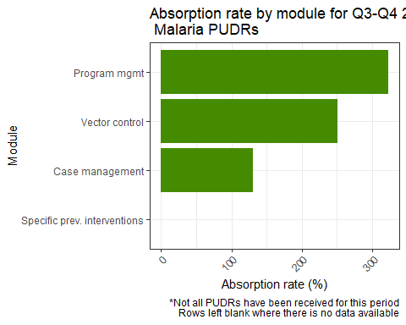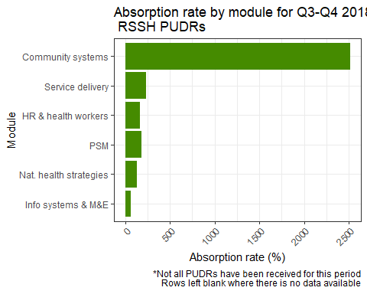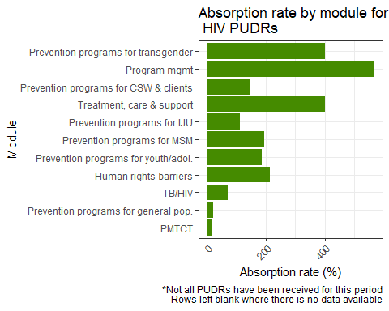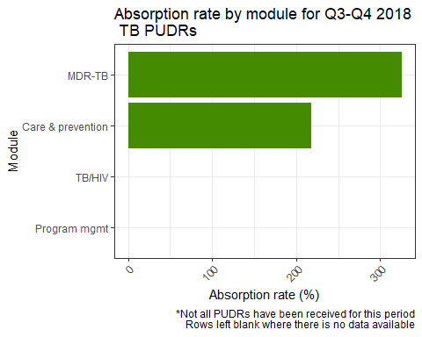

# Rate of change of absorption by module

In the data we have, the rate of change of absorption between reporting periods has been 0. We will continue to monitor this statistic as we receive more PUDRs.