Reliability and Safety Analysis

Year: _2017_ Semester: _Spring_ Team: _12_ Project:____Guitutar________________

Creation Date: ­___March 27, 2017_____ Last Modified: May 1, 2017

Author: __Austin Peterson_____________ Email: ___peter174@purdue.edu_______

Assignment Evaluation:

|  |  |  |  |  |
| --- | --- | --- | --- | --- |
| **Item** | **Score (0-5)** | **Weight** | **Points** | **Notes** |
| **Assignment-Specific Items** | | | | |
| **Reliability Analysis** | 5 | x2 | 10 |  |
| **MTTF Tables** | 5 | x3 | 15 |  |
| **FMECA Analysis** | 5 | x2 | 10 |  |
| **Schematic of Functional Blocks (Appendix A)** | 5 | x2 | 10 |  |
| **FMECA Worksheet (Appendix B)** | 4.5 | x3 | 13.5 | Methods of Detection should be from the user’s perspective |
| **Writing-Specific Items** | | | | |
| **Spelling and Grammar** | 5 | x2 | 10 |  |
| **Formatting and Citations** | 4 | x1 | 4 | Indent in Sources Cited |
| **Figures and Graphs** | 4 | x2 | 8 | Size of schematics |
| **Technical Writing Style** | 5 | x3 | 15 |  |
| **Total Score** | 95.5/100 | | |  |

5: Excellent 4: Good 3: Acceptable 2: Poor 1: Very Poor 0: Not attempted

Comments:

This is really great work. You really nailed down a thorough analysis of your parts’ reliability and weakpoints. The only real improvements I can suggest to the content would be to get more specific with methods of detection.

1. Reliability Analysis

The design of Guitutar has five components that are the most likely to fail: the PIC32MX570F512L microcontroller, the LM1117 Low Drop-out Voltage Regulator, the BM78SPPS5NC2-0002AA Bluetooth transceiver, the MM74HC595PW shift register, and the APT3216LVBC/D Blue LEDs. The PIC32MX570F512L is the brain of the device and will be performing the majority of the functionality. It also has the most I/O pins at 81 pins. The LM1117 Low Drop-out Voltage Regulator is important as it will regulate the 5.2 volt input from the PowerBoost 1000 to 3.3 volts which is the safe voltage rating for the microcontroller. The Bluetooth transceiver is the primary means of connecting the Guitutar device to the controller phone application. The shift register will drive the LED array which is our means of teaching the user how to play the guitar. The LEDs will be turning on and off multiple times and will be supplied around 10 mA of current at 2.65 volts.

For this analysis, the Military Handbook for Reliability Prediction of Electronic Equipment (MIL-HDBK-217F) [1] and the article “Designing for Reliability, Maintainability, and Safety” [7] were used to determine the models for Mean Time to Failure (MTTF) and the failure rate ($λ_{P}$). The models for failure rate are listed before the respective component and varied depending on the type of component. The model for MTTF in years was used for all components that were being analyzed. Some assumptions made for all components were for the Environmental Constant πE, the Learning Factor πL, and the Quality Factor πQ. For the environmental constant, all parts were assumed Ground Fixed since Guitutar is intended to be a mobile device. Therefore, the constant was set as 2.0. For the Learning Factor, each part was at least more than two years in production and was set as 1.0 [7]. For the Quality Factor, each part was assumed to be a commercial part (part fit for commercial use) unless MIL-HDBK-217F stated a different value for the case packaging (i.e. plastic casing is 8.0).

$$MTTF= {10}^{6}/(24*365*λ_{P}) years$$

1.1 PIC32MX570F512L Microcontroller [2]

The PIC32 microcontroller is a 32-bit microprocessor with 100 pins. The die complexity was listed in MIL-HDBK-217F as 0.56 for a 32-bit MOS microprocessor. The temperature coefficient was listed as 0.98 for a 50MHz microcontroller operating at a maximum temperature of +85°C. Due to the high number of pins, the value for C2 is driving the failure rate and MTTF to be lower. The failure rate was calculated to be 6.2974×10-6 failures/hour and the MTTF to be 18.127 years.

$$λ_{P}=\left(C_{1}π_{T}+C_{2}π_{E}\right)π_{Q}π_{L} Failures/{10}^{6} Hours$$

|  |  |  |  |
| --- | --- | --- | --- |
| Parameter name | Description | Value | Comments |
| $$C_{1}$$ | Die Complexity | 0.56 | 32-bit MOS microprocessor |
| $$π_{T}$$ | Temperature Coefficient | 0.98 | Max operating temp of +85°C for 50MHz micro |
| $$C_{2}$$ | Pin Number Constant | 0.04047 | Calculated using equation for SMT packages in MIL-HDBK-217F |
| $$π_{E}$$ | Environmental Constant | 2.0 | Ground Fixed |
| $$π_{L}$$ | Learning Factor | 1.0 | More than 2 years in production |
| $$π_{Q}$$ | Quality Factor | 10 | Commercial part |
| Entire design: |  |  |  |
| $$λ_{P}$$ | | 6.2974×10-6 failures/hour | |
| MTTF (Mean Time to Failure) | | 18.127 years | |

1.2 LM1117 LDO Voltage Regulator [3]

The LM1117 LDO was analyzed as it is going to be taking in 5.2V and regulating it to 3.3V for the microcontroller to use. A base failure rate was listed in MIL-HDBK-217F as 0.0020. Its maximum operating temperature is +125°C and results in a temperature coefficient of 5.1. The quality factor was decided to be based on the plastic case which was listed as 8.0. The LM1117 was also assumed to be metallurgically bonded because of the metal pins used for the packaging. Ground fixed was listed as 6.0 which is a different environmental factor than the other parts. The failure rate was calculated to be 4.896 × 10-7 failures/hour with an MTTF of 233.16 years.

$$λ_{P}=λ_{b}π_{T}π_{S}π_{C}π_{Q}π_{E} Failures/{10}^{6} Hours$$

|  |  |  |  |
| --- | --- | --- | --- |
| Parameter name | Description | Value | Comments |
| $$λ_{b}$$ | Base Failure Rate | 0.0020 | Base Rate for Voltage Regulators |
| $$π_{T}$$ | Temperature Coefficient | 5.1 | Maximum operating temperature +125°C |
| $$π_{S}$$ | Electrical Stress Factor | 1.0 | Given in MIL-HDBK-217F |
| $$π_{C}$$ | Contact Construction Factor | 1.0 | Metallurgically Bonded |
| $$π_{Q}$$ | Quality Factor | 8.0 | Plastic Case |
| $$π_{E}$$ | Environmental Factor | 6.0 | Ground Fixed |
| Entire design: |  |  |  |
| $$λ_{P}$$ | | 4.896 × 10-7 failures/hour | |
| MTTF (Mean Time to Failure) | | 233.160 years | |

1.3 BM78SPPS5NC2-0002AA Bluetooth Transceiver [4]

The BM78SPPS5NC2 Bluetooth Transceiver was assumed to be analyzed in the same manner as a microprocessor as it is operating in a similar manner. This part is a small circuit consisting of multiple parts. The die complexity was assumed to be 0.56 for a 32-bit MOS microprocessor since it has a data transfer rate in the kbps range. This part has 32 pins and the pin number constant was calculated based on the equation given on page 5-14 [1] in MIL-HDBK-217F. The failure rate was calculated to be 3.5964 ×10-6 failures/hour with an MTTF of 31.741 years.

$$λ_{P}=\left(C_{1}π_{T}+C_{2}π_{E}\right)π_{Q}π_{L} Failures/{10}^{6} Hours$$

|  |  |  |  |
| --- | --- | --- | --- |
| Parameter name | Description | Value | Comments |
| $$C_{1}$$ | Die Complexity | 0.56 | Up to 32-bit MOS microprocessor |
| $$π_{T}$$ | Temperature Coefficient | 0.60 | Max operating temp of +85°C for 50MHz micro |
| $$C_{2}$$ | Pin Number Constant | 0.01182 | Calculated using equation for SMT packages in MIL-HDBK-217F |
| $$π_{E}$$ | Environmental Constant | 2.0 | Ground Fixed |
| $$π_{L}$$ | Learning Factor | 1.0 | More than 2 years in production |
| $$π_{Q}$$ | Quality Factor | 10 | Commercial part |
| Entire design: |  |  |  |
| $$λ_{P}$$ | | 3.5964 ×10-6 failures/hour | |
| MTTF (Mean Time to Failure) | | 31.741 years | |

1.4 MM74HC595PW Shift Register [5]

The shift registers were assumed to be similar to a microprocessor since they are a type of integrated circuit. The shift registers are an 8-bit MOS microprocessor with a die complexity value of 0.14. There are 16 pins on the shift register, and the pin number constant was calculated using the equation on page 5-14 [1]. The failure rate was calculated to be 1.4838 ×10-6 failures/hour with an MTTF of 76.934 years.

$$λ_{P}=\left(C_{1}π_{T}+C_{2}π_{E}\right)π_{Q}π_{L} Failures/{10}^{6} Hours$$

|  |  |  |  |
| --- | --- | --- | --- |
| Parameter name | Description | Value | Comments |
| $$C_{1}$$ | Die Complexity | 0.14 | 8-bit MOS microprocessor |
| $$π_{T}$$ | Temperature Coefficient | 0.98 | Max operating temp of +85°C |
| $$C_{2}$$ | Pin Number Constant | 0.00559 | Calculated using equation for SMT packages in MIL-HDBK-217F |
| $$π_{E}$$ | Environmental Constant | 2.0 | Ground Fixed |
| $$π_{L}$$ | Learning Factor | 1.0 | More than 2 years in production |
| $$π_{Q}$$ | Quality Factor | 10 | Commercial part |
| Entire design: |  |  |  |
| $$λ_{P}$$ | | 1.4838 ×10-6 failures/hour | |
| MTTF (Mean Time to Failure) | | 76.934 years | |

1.5 APT3216LVBC/D LEDs [6]

The LEDs had a base rate of 0.00023 which was stated in MIL-HDBK-217F. Assuming that the LEDs had a plastic casing, the quality factor was selected to be 8.0 instead of 10.0 for commercial parts. The maximum operating temperature was +85°C which corresponded to a temperature coefficient of 4.8. The failure rate was calculated to be 1.7664×10-8 failures/hour with a MTTF of 56,612,318.840 years.

$$λ_{P}=λ_{b}π_{T}π_{Q}π_{E}$$

|  |  |  |  |
| --- | --- | --- | --- |
| Parameter name | Description | Value | Comments |
| $$λ_{b}$$ | Base Failure Rate | 0.00023 | Base rate for LEDs |
| $$π_{T}$$ | Temperature coefficient | 4.8 | Maximum operating temperature +85°C |
| $$π_{Q}$$ | Quality Factor | 8.0 | Plastic casing |
| $$π_{E}$$ | Environment Factor | 2.0 | Ground Fixed |
| Entire design: |  |  |  |
| $$λ_{P}$$ | | 1.7664×10-8 failures/hour | |
| MTTF (Mean Time to Failure) | | 56612318.840 years | |

1.6 Reliability Summary

The Mean Time to Failure for all the analyzed components ranged from short (18 years) to long (56 million years). The microcontroller had the shortest MTTF at 18.127 years. The driving factor was due to the package having 100 pins. Microcontrollers with more pins were prone to more failures as seen in MIL-HDBK-217F [1]. This MMTF is acceptable to us since we expect Guitutar to serve as a teacher for the end user on how to play the guitar. Once the end user has a grasp on how to play, they would swap out Guitutar for a normal guitar neck. A possible improvement to the design would be to add a second microcontroller that would control the LED array and switch matrix while the other handled the Bluetooth communication. The LEDs were determined to have the longest MTTF at more than 56 million years. This would mean that if the LEDs are operating within their limits, then the LEDs should never fail.

1. Failure Mode, Effects, and Criticality Analysis (FMECA)

The schematic for Guitutar can be divided into five functional blocks: the LED circuit block, the Power block, the Bluetooth transceiver block, the ESD resistor block, and the microcontroller block. The five blocks are spread out between the five PCBs that make up Guitutar. The LED circuit block is on each PCB and is repeated 23 times (one for each of the 22 frets and one for open strings). The LDO and MCU blocks are on PCB3. The Bluetooth transceiver block is located on PCB1, which is the at the top of the guitar neck. The ESD resistor block spans across each of the five PCBs and are located next to the pads for the fret connections (22 in total).

The LED circuit block includes the LED array, resistor array, and a shift register. These are also the three components that could fail and affect the operation of the device. The LEDs could fail from either being an open or shorted. Moisture could also contribute to LEDs failing. The LEDs operate at a maximum voltage and current of 3V and 30mA. Failure of the shift register would prevent the LEDs from illuminating and prevent the user from knowing what note/chord to press. No LED operation would be noted as a failure of the learning device since the primary goal is to teach users on how to play the guitar. The shift register also needs to output enough current so that the resistor array outputs 2.65V and 10mA to illuminate the LEDs. A failure in the shift register may also cause issues with programming since each shift register will be receiving a bit. The resistor array could either fail open or short in the same way a regular resistor could fail. An open would cause the LED to not illuminate and overall failure of the learning device. A short could potentially send more current or voltage through to the LED and shorting the LED.

The Power block includes the LDO Linear Regulator, the PowerBoost 1000 circuit, power switch, and the battery. The power switch will be a switch to turn the PowerBoost on or off and could fail open or close. A failure of open results in the user being unable to turn on the device, and a failure of close results in the system being unable to turn off. Failure modes for the battery include battery short and battery puncture. A short could be caused by a short between the power rail and ground and would cause the battery to not function or short circuit of the device. A battery puncture would be caused by an external force and would cause a catastrophic failure resulting in loss of device. The linear regulator intakes 5.2V and outputs 3.3V and could fail with a high voltage or fail with a low voltage due to a shorted bypass capacitor. The PowerBoost 1000 is a separate circuit and will be analyzed based on its functionality. The PowerBoost could either fail in that it is not outputting the expected 5.2V (high, low, or no voltage) or the charging circuitry could fail.

The Bluetooth circuit only includes the Bluetooth transceiver. Successful operation requires a copper-free section near the top of the transceiver. Copper in this area would cause the transceiver to either fail in adequate communication to the phone application or it could cause an unintended short in the circuitry of the transceiver. Failure of the bypass capacitor (open or short) could result in either overvoltage or low voltage and ultimately loss of Bluetooth communication.

The ESD protection circuit includes the 330kΩ resistors that are placed after the fret connection pad. These resistors could either fail open or short. An open would prevent the microcontroller from reading the user input from the switch matrix and would not iterate through the song. A short would leave the microcontroller vulnerable to static electricity.

The Microcontroller circuit includes all of the decoupling capacitors, resistors, external oscillator, reset switch, and ICSP programming pins. The external oscillator may be unnecessary for the design, but was included just in case it is needed. Low voltage would be the effect of capacitors and resistors shorting. High voltage would be the effect of capacitors and resistors failing open. The switch could fail either open or close. A fail of open results in loss of reset capability to the MCU, and a fail of short results in the MCU constantly resetting and loss of MCU functionality. Correct operation of the programming pins is necessary to program and debug the MCU. Failure of the pins would result in loss of programming to the MCU and therefore a broken device.

Criticality was divided into four categories: minor, major, hazardous, and catastrophic. Minor is classified as failure conditions that would not significantly reduce the capability of the device. The failure rate of minor criticality is defined to be 10-6 or less. Major is classified as failure conditions that would reduce the functional capability of the device and yet still has some functionality where the user can cope with the failure. The failure rate of major criticality is defined to be 10-7 or less. Hazardous is classified as failure conditions that would reduce the functional capability of the device and could potentially harm the user or others. The failure rate for hazardous criticality is defined to be 10-9 or less. Catastrophic is where failure conditions are expected to cause severe damage to the user and device. The failure rate for catastrophic criticality is defined to be 10-10 or less. For Guitutar, the only catastrophic case that could occur is puncture of the battery and result of fire due to the Lithium-ion battery. However, this is unlikely and therefore the catastrophic category should not occur with the device in any other functional block.

3.0 Sources Cited:

[1] *Military Handbook Reliability Prediction of Electronic Equipment,* Department of Defense, Washingthon, D.C., 1991.

[2] Microchip, “32-bit Microcontrollers (up to 512 KB Flash and 64 KB SRAM) with Audio/Graphics/Touch (HMI), CAN, USB, and Advanced Analog,” PIC32MX570 datasheet, July 2014 [Revised Apr. 2016].

[3] Texas Instruments, “LM1117 800-mA Low-Dropout Linear Regulator,” LM1117 datasheet, Feb. 2000 [Revised Jan. 2016].

[4] Microchip, “Bluetooth 4.2 Dual-Mode Module,” BM78SPPS5NC2 datasheet, Jan. 2016.

[5] ON Semiconductor, “8-Bit Shift Register with Output Latches,” MM74HC595 datasheet, Jun. 2009.

[6] Kingbright, “3.2mmx1.6mm SMD CHIP LED LAMP,” APT3216LVBC/D datasheet, Mar. 2015.

[7] G. Novacek, “Designing for Reliability, Maintainability, and Safety,” Circuit Cellar, iss. 125, Dec. 2000.

Appendix A: Schematic Functional Blocks

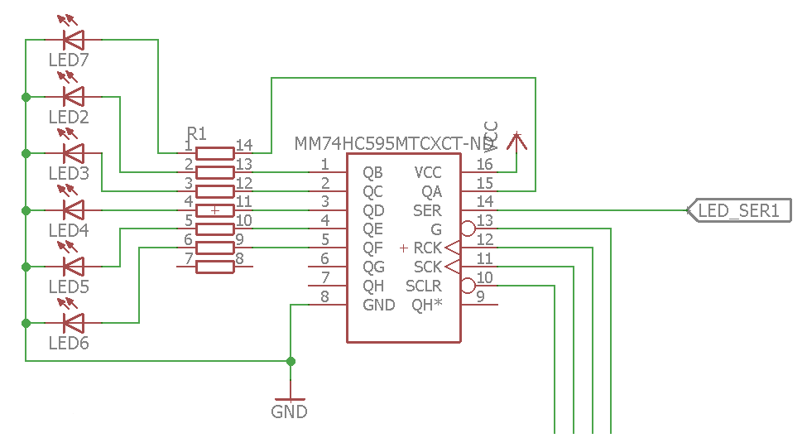

Figure 1 Subsystem A: LED circuit block (23x)

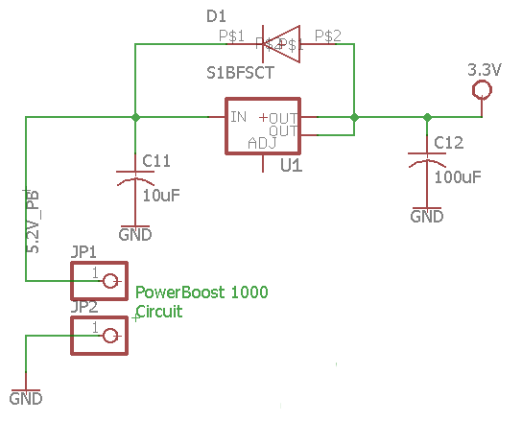

Figure 2 Subsystem B: Power circuit

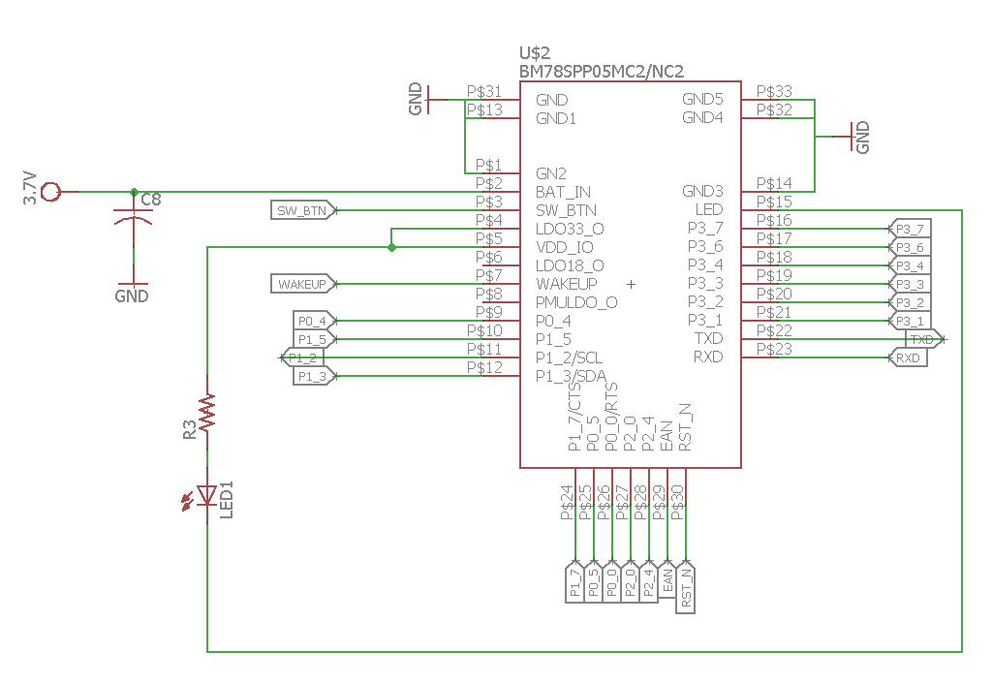

Figure 3 Subsystem C: Bluetooth circuitry

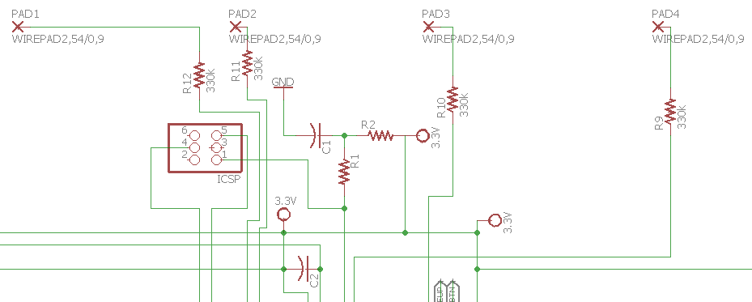

Figure 4 Subsystem D: ESD resistor circuitry and ICSP section for MCU

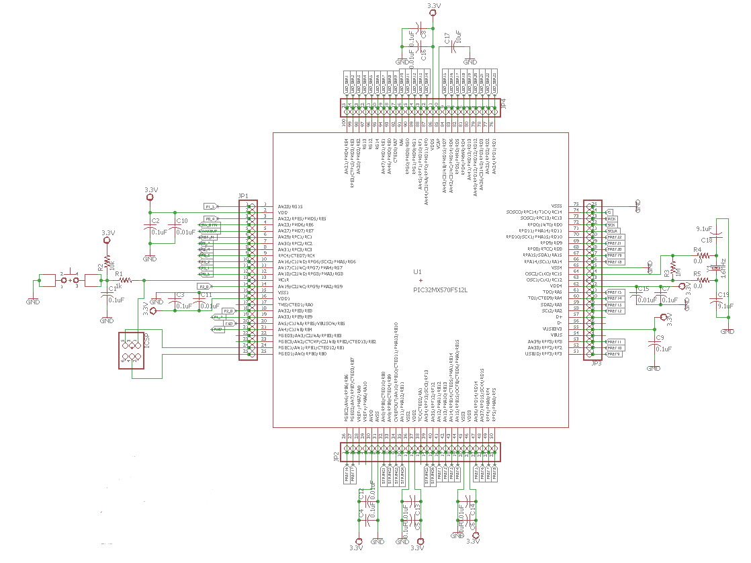

Figure 5 Subsystem E: MCU circuitry

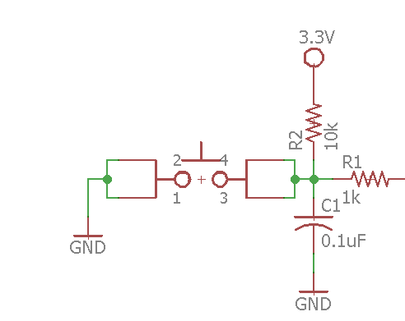

Figure 6 Subsystem E: Reset switch for MCU

Appendix B: FMECA Worksheet

Subsystem A: LED circuit

|  |  |  |  |  |  |  |
| --- | --- | --- | --- | --- | --- | --- |
| **Failure No.** | **Failure Mode** | **Possible Causes** | **Failure Effects** | **Method of Detection** | **Criticality** | **Remarks** |
| A1 | High LED voltage and current | Resistor array short, Shift Register short | Short of LED and loss of light | Observation | Major | Listed as major since loss of shift registers results in no learning functionality and may also result in programming errors |
| A2 | Low LED voltage and current | Resistor array open, Shift Register open, low input voltage from PowerBoost | Dim light or loss of light | Observation | Major | Dim light would allow user to still learn. Loss of light would lose instruction on notes/chords |
| A3 | LED short | High input voltage | Loss of light | Observation | Minor | Listed since the overall device would still work. The user would just not receive instruction on chords/notes |
| A4 | LED open | Low input voltage, moisture | Dim light or Loss of light | Observation | Minor | Listed since the overall device would still work. The user would just not receive instruction on chords/notes |

Subsystem B: Power Circuit

|  |  |  |  |  |  |  |
| --- | --- | --- | --- | --- | --- | --- |
| **Failure No.** | **Failure Mode** | **Possible Causes** | **Failure Effects** | **Method of Detection** | **Criticality** | **Remarks** |
| B1 | Unable to turn on device | Power switch open | Loss of power | Observation | Major | Might need to recharge battery to check if it is just the switch |
| B2 | Unable to turn off device | Power switch closed | Loss of power down | Observation | Minor | Can be mitigated by disconnecting battery from PowerBoost |
| B3 | Loss of power | Battery short | Loss of power or device | Observation of smoke | Hazardous | Battery short could short the entire device. There should be protection on PowerBoost |
| B4 | Device failure | Battery puncture/failure | Loss of device | Observation of fire | Catastrophic | Only likely if constant damage to battery packaging |
| B5 | High 3.3V output | LDO short, decoupling capacitor open, PowerBoost overvoltage | Loss of microcontroller, Loss of device | Observation of smoke | Major | Listed as major since loss of results in no learning functionality |
| B6 | Low 3.3V output | Capacitor short, LDO open, PowerBoost under voltage or no voltage | Insufficient power to MCU | Observation | Minor | Device won’t work |
| B7 | High 5.2V output | Boost converter failure in PowerBoost circuit | LDO overvoltage, Loss of MCU | Observation of smoke | Major | Listed as major since loss of results in no learning functionality |
| B8 | Low 5.2V output | Boost converter short in PowerBoost circuit | Insufficient power to LDO if lower than 3.3V | Observation | Minor | Device should still work if above 3.3V. Battery might need to be recharged. |
| B9 | No 5.2V output | Open in boost converter in PowerBoost circuit | Loss of power | Observation of device not working | Major | Damaged PowerBoost circuit. Charge battery to ensure failure is on PowerBoost |
| B10 | Failure of charging circuitry | MCP73871 failure | Loss of battery charging capability | Observation | Minor | Battery would just have to be charged at an external source instead of plugging a USB to Guitutar |

Subsystem C: Bluetooth Circuit

|  |  |  |  |  |  |  |
| --- | --- | --- | --- | --- | --- | --- |
| **Failure No.** | **Failure Mode** | **Possible Causes** | **Failure Effects** | **Method of Detection** | **Criticality** | **Remarks** |
| C1 | Issues with communicating with phone application | Copper in copper-free section | Inadequate communication or loss of communication to phone app,  Loss of song selection | Observation of pairing between device and phone | Major | Connection to the phone app is important since it is our controller to the device |
| C2 | High 4.2V input | C8 open | Loss of transceiver and communication | Observation of smoke | Major | Connection to the phone app is important since it is our controller to the device |
| C3 | Low 3.3V input | C8 short, Power circuit not outputting 3.3V | Loss of communication | Observation of unlit LED | Minor | Connection to the phone app is important since it is our controller to the device. Less critical than C2 because of no loss to the transceiver |

Subsystem D: ESD Protection Circuit

|  |  |  |  |  |  |  |
| --- | --- | --- | --- | --- | --- | --- |
| **Failure No.** | **Failure Mode** | **Possible Causes** | **Failure Effects** | **Method of Detection** | **Criticality** | **Remarks** |
| D1 | Loss of ESD protection | Resistor array short | Loss of microcontroller | Observation, Static shock and loss of device operation | Hazardous | Possibility of shock to user |
| D2 | Unable to iterate through song chords/notes | Resistor array open | Loss of user input from switch matrix | Observation | Major | Listed as major since loss of results in no learning functionality |

Subsystem E: Microcontroller Circuit

|  |  |  |  |  |  |  |
| --- | --- | --- | --- | --- | --- | --- |
| **Failure No.** | **Failure Mode** | **Possible Causes** | **Failure Effects** | **Method of Detection** | **Criticality** | **Remarks** |
| E1 | Unable to reset microcontroller | Reset switch open | Loss of reset capability | Observation of continuous operation when reset button pressed | Minor | Can be mitigated by powering off PowerBoost circuit |
| E2 | Microcontroller unresponsive | Reset switch close | Loss of microcontroller functionality | Observation of no smoke and no operation | Major | Listed as major since loss of results in no learning functionality |
| E3 | High 3.3V input | Capacitors short,  Resistors short | Loss of microcontroller (short) and functionality | Observation of smoke | Major | Listed as major since loss of results in no learning functionality |
| E4 | Low 3.3V input | Capacitors open, Resistors open, Low input voltage from PowerBoost | Loss of functionality (MCU not on) | Observation | Major | Listed as major since loss of results in no learning functionality |
| E5 | MCU doesn’t program | Programming pin failure (bad connection) | Loss of programming of MCU | Observation | Major | Device is useless if unable to program MCU |