Thales Programming Challenge

Instruções:
- Seu prazo é de 7 dias a partir do recebimento deste, mas por favor nos avise se precisar de mais tempo ou encontrar dificuldades
- Fique a vontade para utilizar 3rd party libraries que possam te ajudar
- Você pode implementar outras funcionalidades que julgar interessante
- O código deve ser disponibilizado em algum sistema de versionamento online, como o
Github ou Gitlab. Precisaremos de acesso ao código. Assim que terminar, envie o link do
projeto para nós através desse e-mail mesmo
- Nós iremos compilar seu código a partir de seu repositório, então tenha certeza que todos
os arquivos para isso se encontram no repositório
- Não esqueça de incluir instruções sobre como compilar e executar o seu programa

Problem
In our system, we would like to transfer files between directories based on the filename. We
want to develop a program capable of doing so.
The program has to be configurable in such a way that we do not have to compile it again if
we would like to change the directories or type of files to be moved. It will operate by only
transferring files from the directory A to B, based on the filename name, matching and
transferring only the matches. These files should be checked and transferred periodically
based on a configurable parameter. All file transfers are unidirectional and will match the
source and destination folders configured on the configuration file. Consider everything is on
the local machine and we are not worried about remote directories.
Also you should create a method to write in a file(log) the following information: file name, origin folder, destination folder and the time that it was moved. You can add other information if you want. The log file can use any format but the most commons are: txt, json, xml, csv.
Make sure that every time a file is moved the log method is called and a new entry is added to the log.

Example of execution
Consider two directories, A and B. We have the files 'coolFile.zip' and 'uglyFile.zip'
on the directory A and nothing on directory B. Our program will check at each 60 seconds for
files on directory A, and will look for files that match a 'cool' prefix. After 60 seconds, it will
transfer 'coolFile.zip' to directory B. After that, it will keep looking for files under
directory A until it is killed.

Graphical Interface
Let’s create a graphic interface to this application!
Use this log file to show in the interface some graphical statics information. You decide what to show.
Also you can create a graphical interface based in this mock:
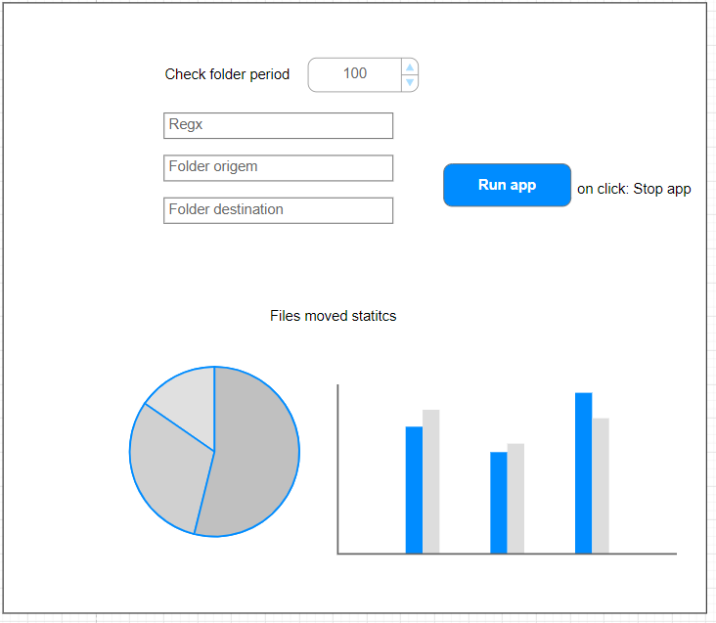

It doesnt need to look like this. It is only an imaginary example, please make it better.

Requirements:
- You can use any language.
- The program must be capable of running on Linux or Windows (please refer the version you have tested)
- Unit tests can be created as part of the development process but is not mandatory
- A configuration file should be used, although no specific format is required. The graphical interface will read and edit this file.
- It must be possible to set any regex for filenames (including extensions matches) on the
configuration file.
- Progress should be tracked with a Git versioning system.

Suggestions:
-You can work with any language that make you comfortable

