**DML_P2_EVIDANCE_OF_TESTING_WITH_OWN_DATA**

--A. Insert a new spectator.

--B. Insert a new event.

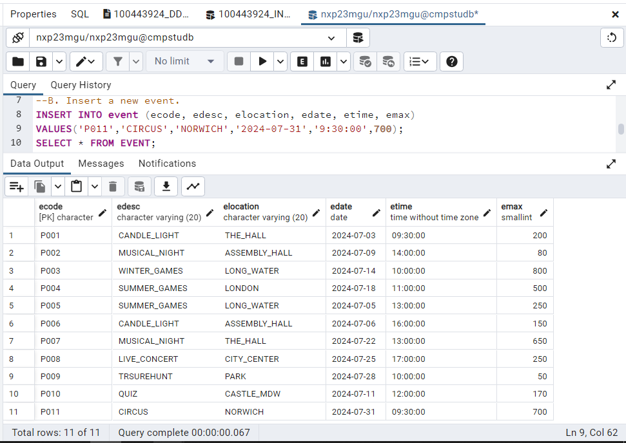

--C. Delete a spectator. The spectator must not have any valid (i.e. not cancelled) tickets before it can be deleted. ASSEUM sno = 11

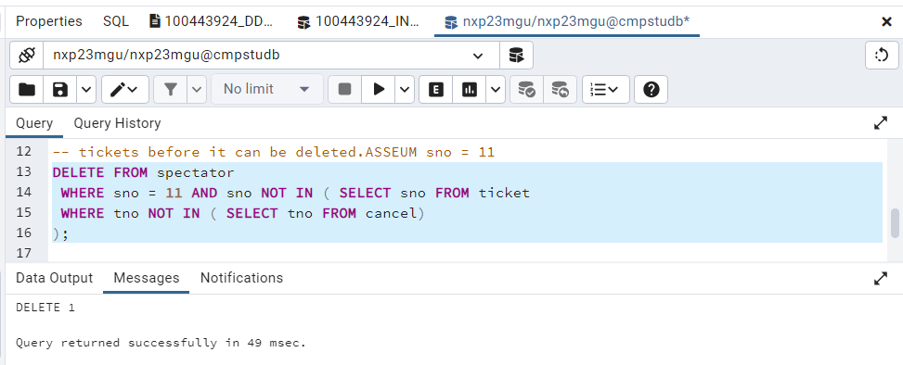

--D Delete an event. All the tickets for the event must be cancelled before an event can be deleted.

--ASSUME EVENT CODE ecode = 'P001'

--Comment : Made Trigger function for cancel ticket record transfer to cancel table before delete event. Below code for delete event and trigger function executed and record of cancel ticket(output) in next task (K2).

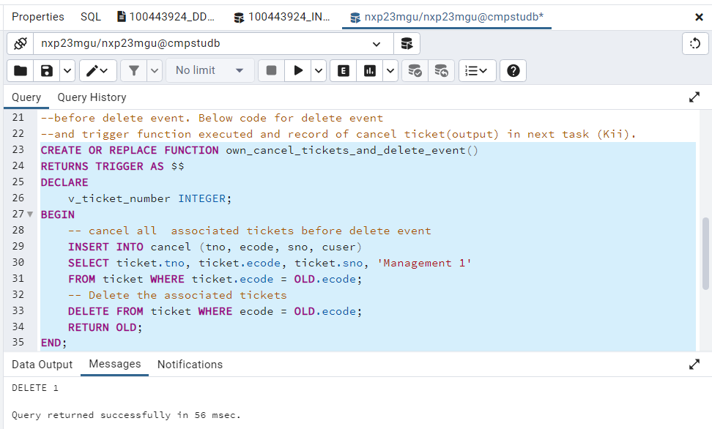

--E. Issue a ticket for an event. A spectator may have only one ticket for a given event.

--F. Produce a report showing the total number of spectators liable to travel to a location. The table should show the total number of spectators that could travel to a location on each date an event is held at a location.

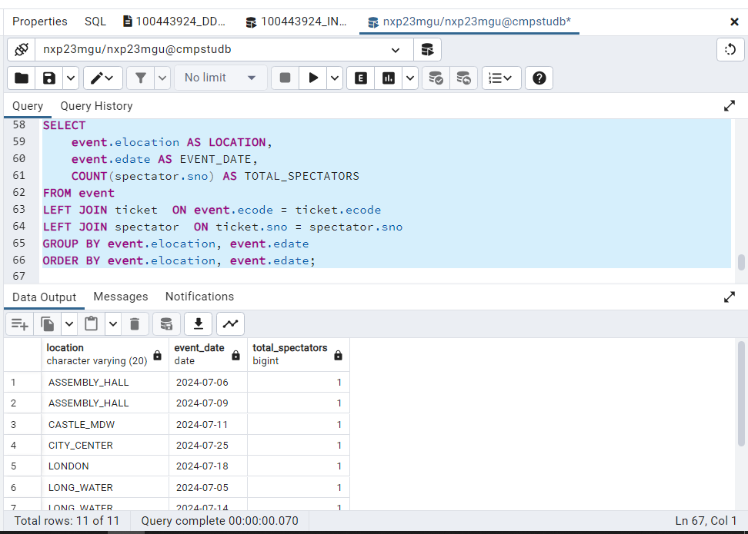

--G. Produce a report showing the total number of tickets issued for each event. Present the data in event description sequence.

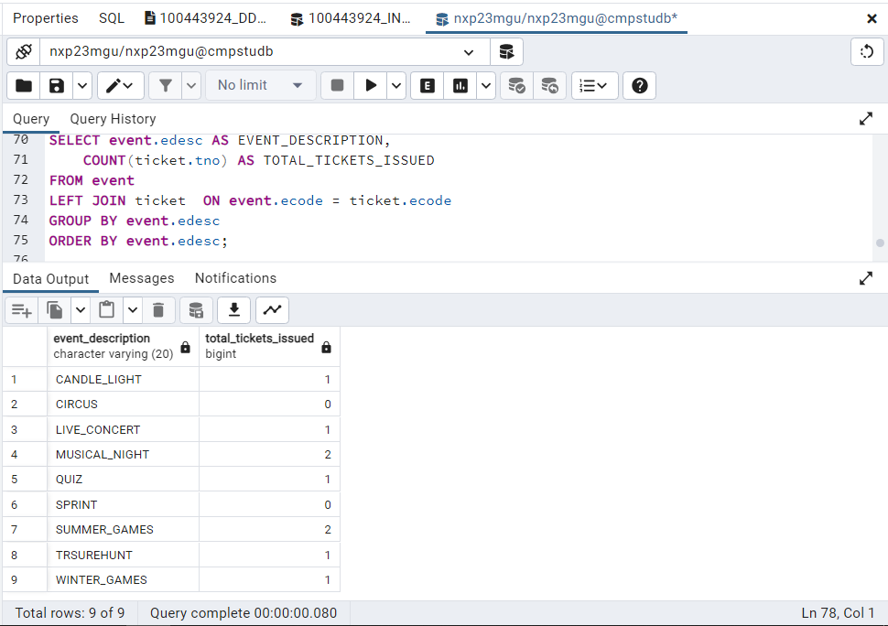

--H. As task G but only for a given event which is specified by the event code.

--I. Produce a report showing the schedule for a given spectator. The spectator is specified by his/her spectator number. The schedule should contain the spectator's name and the date, location, time and event description of each event for which the spectator has been issued a ticket.

Assume sno=2

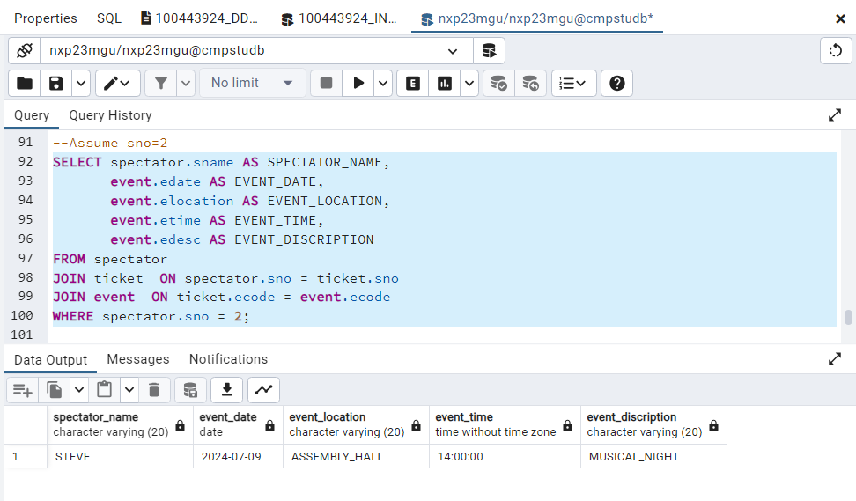

--J. Given a specific ticket reference number, display the name of the spectator and the event code for the ticket and indicate if the ticket is valid or is cancelled.

Assume tno=2

--K. View the details of all cancelled tickets for a specific event.

--Assume ecode ='P001'

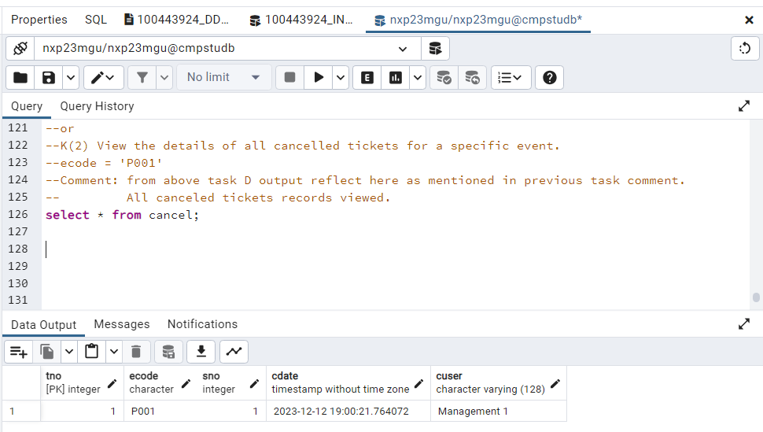

----L. Delete the contents of the database tables.

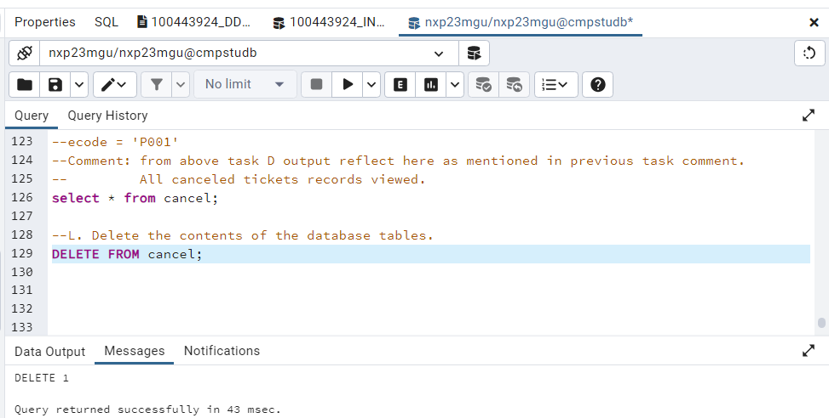--DELETE CANCEL TABLE RECORD

--DELETE TICKET TABLE RECORD

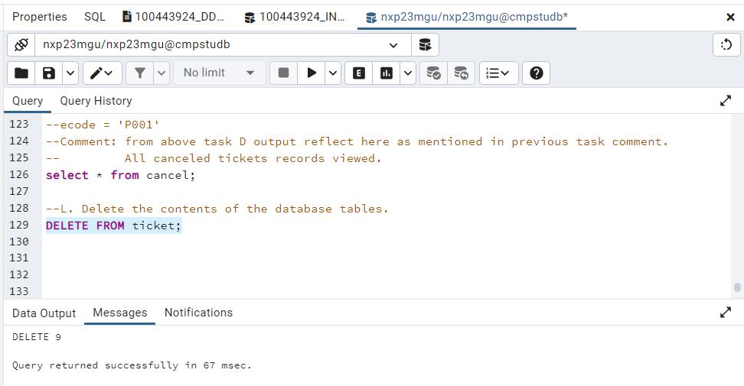

--DELETE SPECTATOR TABLE RECORD

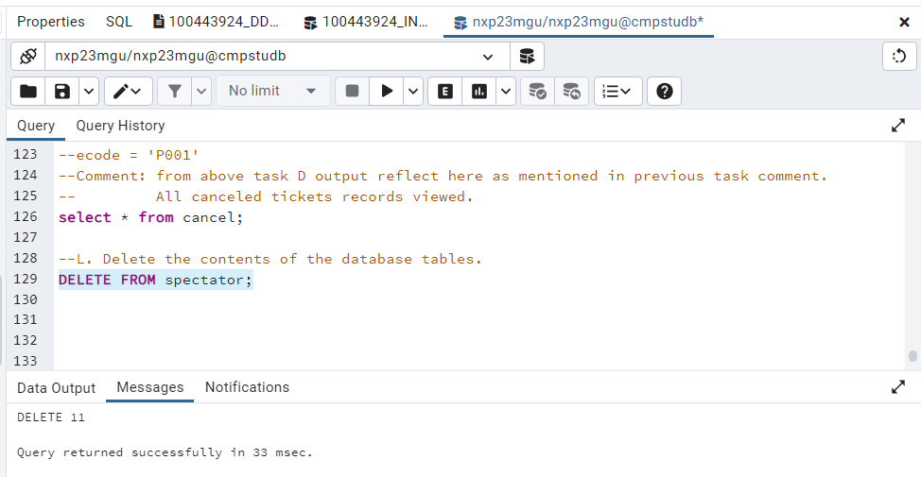

--DELETE EVENT TABLE RECORD

