PROJECT1

Railway Gauges
IMPORT LIBRARIES

We have imported some of the Python Libraries like Numpy, Pandas and Matplotlib.

NumPy is a core library in Python used for numerical computing. It provides fast, efficient tools to work with large amounts of data, especially arrays and mathematical operations.
Some of the Numpy functions are:
- arange() - creates an array of evenly spaced values within a given range.
- diff() - computes the difference between consecutive elements in an array.
- insert() - inserts values at a specified position in an array.
Pandas is a powerful Python library used for data manipulation and analysis. It builds on top of NumPy and provides easy-to-use data structures for working with structured data like tables.
Importing files using pandas is one of the most common tasks in data analysis. Pandas provides simple functions to read different file formats into a DataFrame.
Here we are importing a CSV file into Pandas and Pandas returns a Data Frame object.
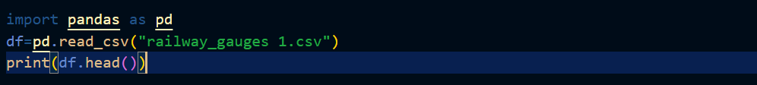
Figure 1:Loading CSV file into Pandas

Using Pandas Data Frame object we can see head(), tail() functions to display top 5, last 5 rows
from imported dataset.

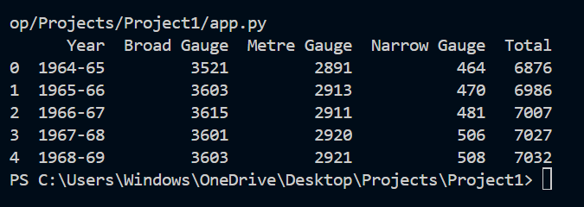
Figure 2: Displaying top 5 rows
Some of the Pandas functions are:
- read_csv()-Loads CSV file into a DataFrame
- fillna()-Replaces missing values with 0
- idxmax()-Returns index of maximum value
I used pandas functions such as read_csv() to load the dataset, head() to preview data, fillna() to handle missing values, and to_numeric() for type conversion. I also used sum() for aggregation and loc[] for filtering. Attributes like columns and dtypes were used to understand the dataset structure. Additionally, I performed column selection, filtering, and feature creation for analysis.
Matplotlib is a popular Python library used for data visualization. It allows you to create charts and graphs to better understand and present data.
It works well with libraries like NumPy and pandas.
Some of the Matplotlib functions are:
- plt.plot() - is used to create a line graph.
- plt.bar() - creates a bar chart.
- plt.show() - Displays the plot.
DATA VISUALIZATION
Matplotlib is used to visualize data in graphical form, helping to analyze trends, compare values, and understand large datasets easily. It is widely used in data science, machine learning, and scientific computing for creating charts like line graphs, bar graphs, and pie charts.
This code is used to visualize the relationship between Year and Total railway tracks using a line graph with Matplotlib.
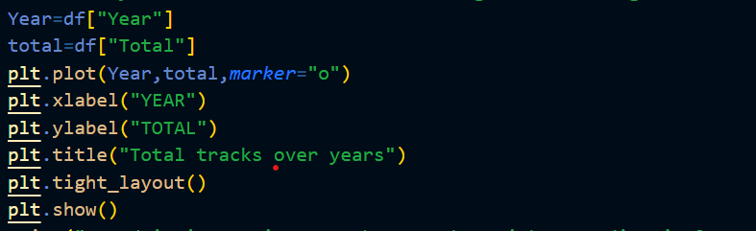
Figure 3: Line plot code using pyplot
The resulting graph shows how the total number of railway tracks changes over different years, helping to identify trends such as increase or decrease over time.
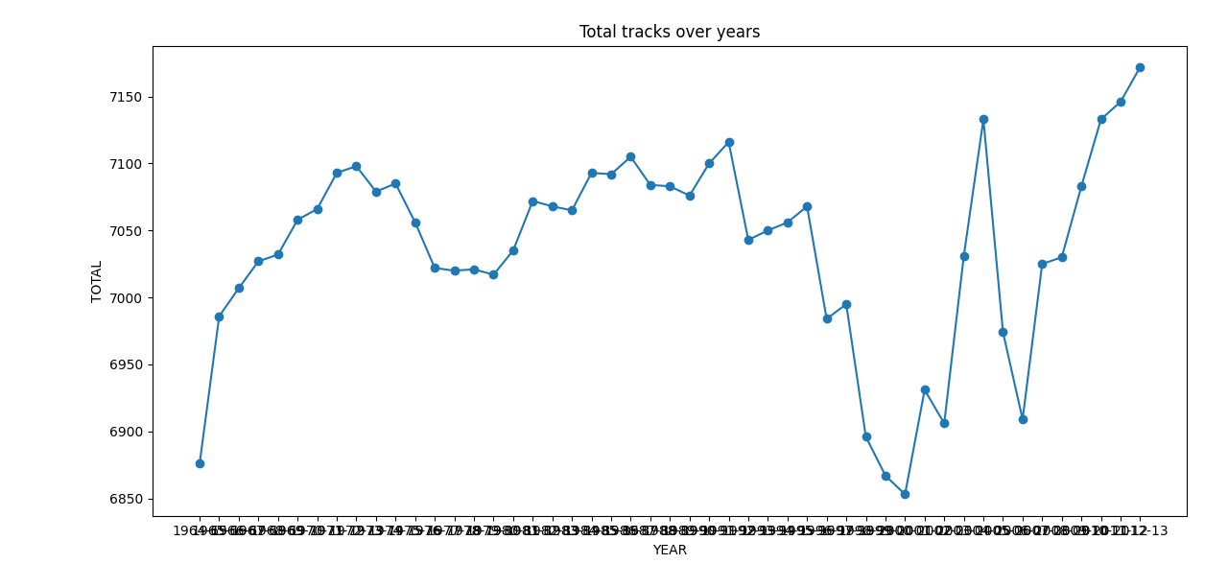
Figure 4: Total track over years Line Plot
RESULTS
The project successfully analyzes railway gauge data using pandas, NumPy, and Matplotlib, and concludes that Broad Gauge dominates the modern railway system with overall increasing track growth.
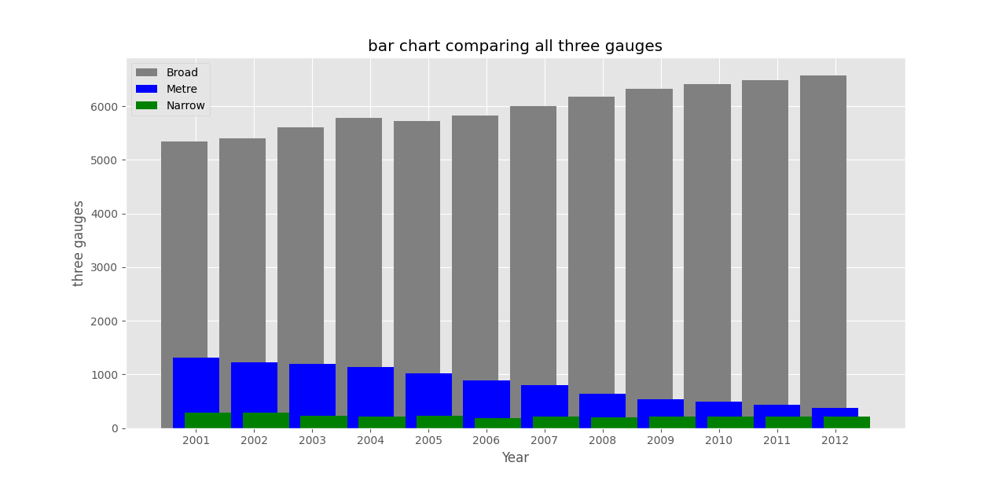
Figure 5: Broad Gauge dominating

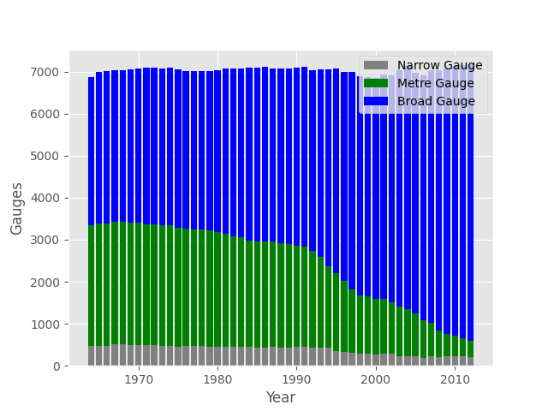
Figure 6: Stacked Bar Graph of all Gauges

