PACIFIC SCHOOL OF ENGINEERING
Kadodara Palsana Road, NH-8, Sanki, Ta. Palsana, Dist. Surat, Gujarat - 394305
Ph: 9904408835 / 9904408838 | Website: www.pacific-soe.ac.in
Student's Weekly Report of Internship
Student Name: | Khorajiya Gulam Ali
Enrollment Number: | 221120107021
Week Duration: | March 12, 2026 - March 18, 2026 (Week 11)
Name Of Organization: | Microsoft Elevate Program (via Edunet Foundation & FICE Education)
External Guide Name: | Adarsh Gupta
External Guide Contact: | 0124-4080107
Internal Faculty Guide: | Prof. Taral Patel

Work done in last Week with description:

1. Week 11-12: Microsoft Elevate Program Completion Session

Description:
Attended final review and wrap-up session on April 7, 2026. Comprehensive review of all modules covered during the 12-week program, best practices discussion, career guidance, and preparation for final project presentations.

Session Components:
- Complete program retrospective: Data Analytics → ML → DL → Azure Cloud
- Industry best practices for AI/ML project deployment
- Discussion on production-grade ML systems and scalability
- Career guidance: Azure certifications roadmap (AZ-104, AI-900, DP-900)
- Resume building tips: highlighting projects and certifications
- Interview preparation guidance for AI/ML roles
- Final project presentation guidelines and rubric
- Q&A session with all trainers

Key Takeaways:
Gained complete understanding of end-to-end AI/ML project lifecycle: from data collection to cloud deployment. Learned importance of monitoring, logging, and continuous improvement in production systems. Received guidance on building portfolio projects for job applications. Understood career paths in Azure cloud engineering and AI/ML development.

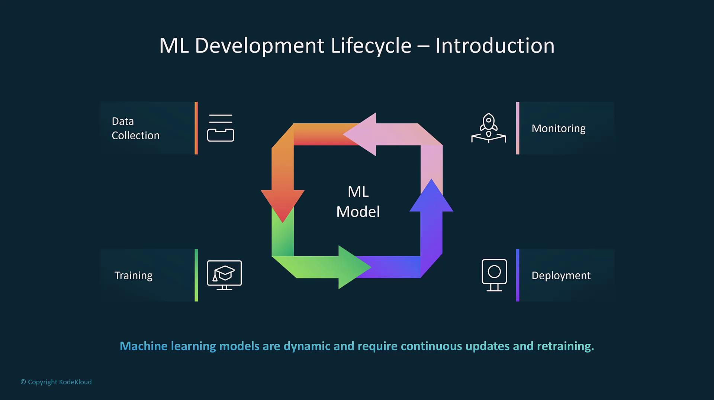
Figure 1: End-to-end AI/ML lifecycle including data collection, model training, deployment, and monitoring.

2. Week 11 Module: Advanced Azure Topics and Optimization

Description:
Attended advanced Azure session on April 8, 2026, covering optimization techniques, cost management, performance tuning, and advanced architectural patterns for production systems.

Key Topics Covered:
- Azure cost optimization strategies and best practices
- Right-sizing resources: choosing appropriate VM sizes and tiers
- Azure Advisor recommendations for cost, security, and performance
- Reserved instances and savings plans
- Autoscaling strategies for Functions and App Services
- Content Delivery Network (CDN) for global distribution
- Azure Front Door for load balancing and acceleration
- Disaster recovery and business continuity planning
- High availability architectures with availability zones
- Performance testing and optimization techniques

Practical Exercises:
Analyzed project Azure costs using Cost Management + Billing. Identified optimization opportunities: lifecycle policies, function timeout reduction, right-sized Cosmos DB throughput. Configured budget alerts to prevent overspending. Reviewed Azure Advisor recommendations and implemented high-priority suggestions. Tested autoscaling configuration for Function App under load.

3. GTU Project - Model Deployment and Azure Integration

Description:
Deployed trained models to Azure infrastructure and integrated all components into working surveillance system. This represents the practical application of 11 weeks of learning.

Deployment Work Completed:
- Packaged YOLOv8 model with dependencies for Azure Functions
- Created Azure Function with Blob trigger for video upload detection
- Implemented frame extraction and preprocessing pipeline
- Integrated YOLOv8 inference in serverless function
- Configured output binding to write detection results to Cosmos DB
- Implemented simple anomaly detection logic (rule-based for demo)
- Setup email notification using SendGrid for high-confidence alerts
- Stored processed frames in Blob Storage 'processed-frames' container
- Retrieved secrets from Key Vault (connection strings, API keys)

Testing Results:
Uploaded 5 test surveillance videos to Blob Storage. Function triggered automatically for each upload. YOLOv8 detected objects (person, vehicle) with 70-85% confidence. Detection data written to Cosmos DB successfully. Email alerts sent for 2 high-confidence detections. Processed frames saved to output container. Average processing time: 15-20 seconds per video. End-to-end pipeline validated successfully.
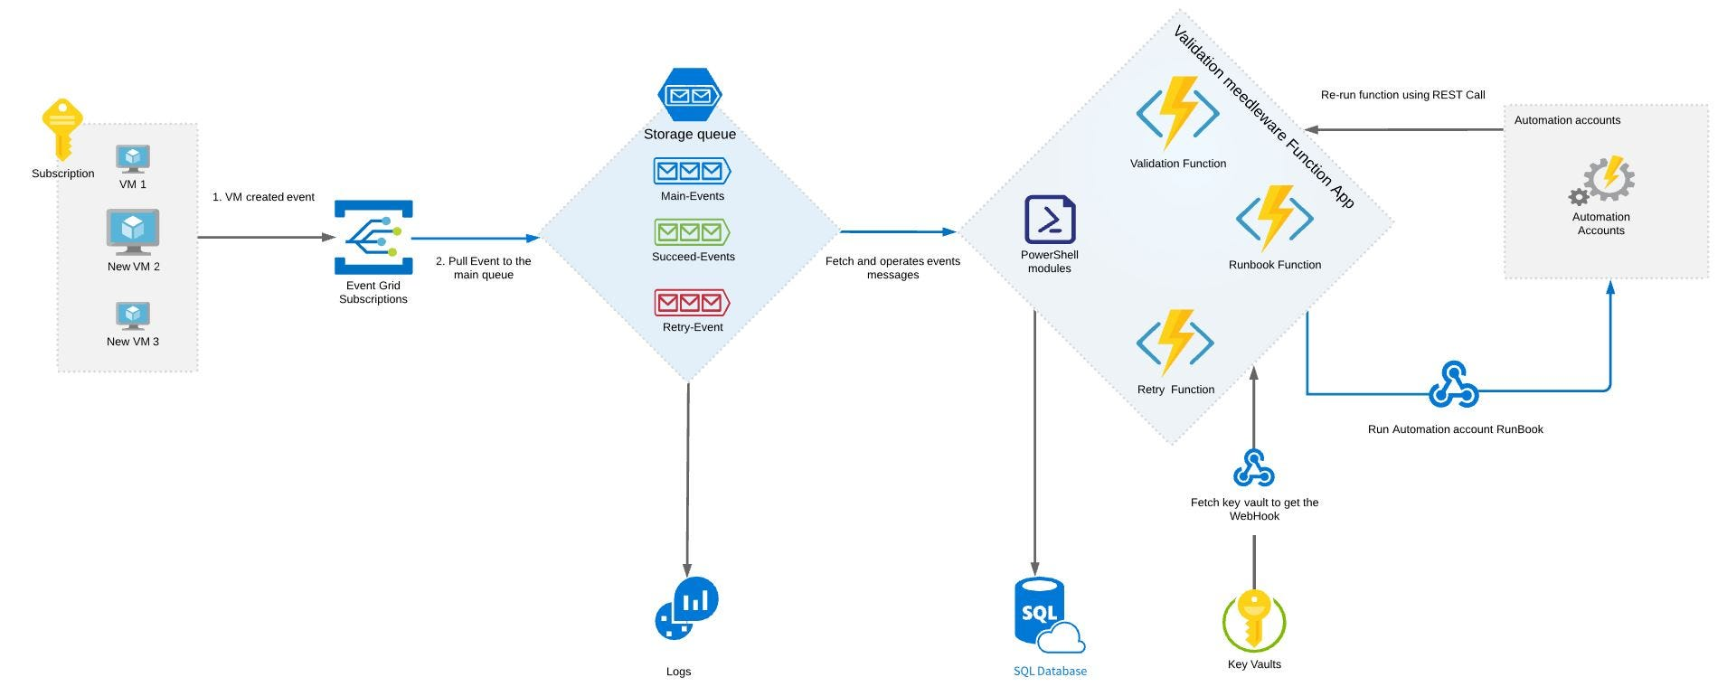
Figure 2: Serverless architecture where video uploads to Blob Storage trigger Azure Functions for AI inference and store results in Cosmos DB.

4. GTU Project - Power BI Dashboard Development

Description:
Built interactive Power BI dashboard to visualize detection metrics, alerts timeline, and system performance. Applied learning from Week 3-4 Power BI modules.

Dashboard Components:
- Connected Power BI Desktop to Azure Cosmos DB using connector
- Imported detection data from 'Alerts' container
- Created Page 1: Overview Dashboard with KPI cards
- Total Detections card, High Confidence Alerts card, Processing Time card
- Bar chart: Detections by Object Class (person, vehicle)
- Line chart: Detections over Time (timeline visualization)
- Created Page 2: Alert Details with table visualization
- Added slicers: Date range, Object class, Confidence threshold
- Applied conditional formatting: high confidence alerts in red
- Published dashboard to Power BI Service

Dashboard Features:
Interactive filtering with slicers. Drill-down capability on charts. Auto-refresh configured for real-time updates. Mobile-friendly layout for tablet/phone viewing. Professional color scheme with consistent theme. Tooltips showing detailed information on hover.

5. GTU Project - End-to-End Testing and Documentation

Description:
Performed comprehensive system testing and created technical documentation for project submission and presentation.

Testing Performed:
- Functional testing: Verified each component works independently
- Integration testing: Tested Blob → Function → Cosmos DB → Power BI flow
- Performance testing: Measured processing time for different video sizes
- Alert testing: Verified email notifications trigger correctly
- Error handling: Tested behavior with invalid inputs
- Monitored Application Insights for errors and warnings
- Documented test results and identified minor issues for fixes

Documentation Created:
- System Architecture Diagram (updated with all components)
- Deployment Guide: step-by-step Azure resource setup
- User Manual: how to upload videos and view dashboard
- Technical Documentation: code structure, API endpoints
- Testing Report: test cases, results, known limitations
- Updated GitHub README with complete project information

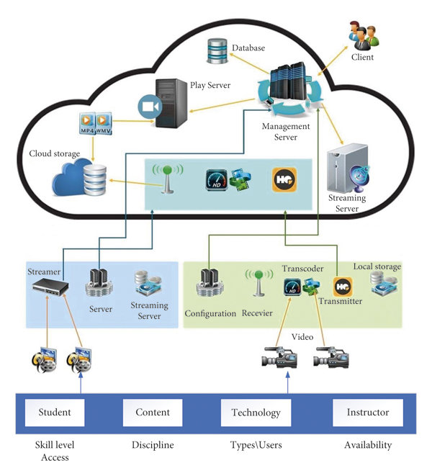
Figure 3: Overall system architecture integrating video ingestion, AI detection, cloud storage, and visualization dashboard.

6. Final Presentation and Demo Preparation

Description:
Prepared comprehensive final presentation covering 12-week internship journey, learning achievements, project implementation, and outcomes.

Presentation Components:
- Updated PowerPoint presentation (30 slides)
- Internship overview and learning journey (Weeks 1-11)
- Skills acquired: Data Analytics, ML, DL, Azure Cloud, DevOps
- Certification achieved: Microsoft Azure Fundamentals (AZ-900)
- Project implementation details and architecture
- Live demo script: video upload → detection → dashboard
- Results and achievements summary
- Future enhancements and learning goals

Demo Preparation:
Recorded demonstration video (5 minutes) showing complete workflow. Prepared 3 sample surveillance videos for live demo. Created backup slides in case of technical issues. Practiced presentation delivery and timing (15-20 minutes total). Prepared answers for anticipated questions. Set up screen sharing and demo environment.
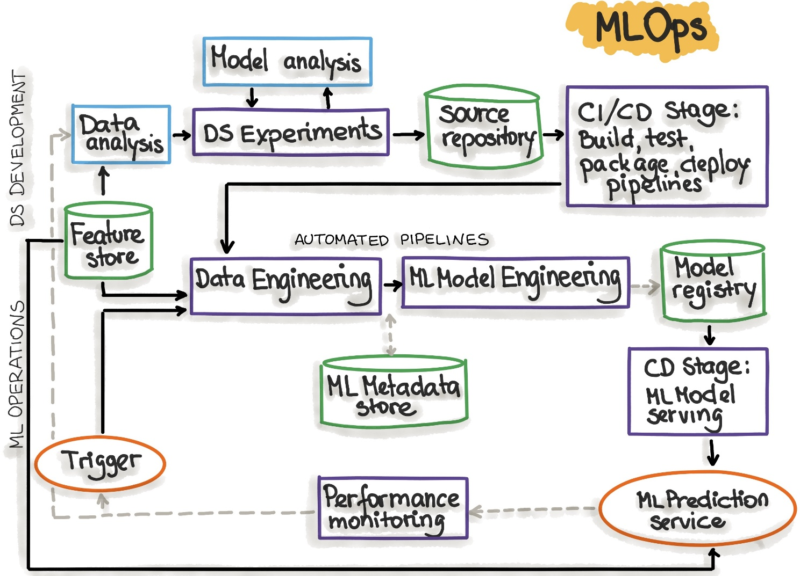
Figure 4: Model deployment workflow demonstrating how trained models are integrated into cloud infrastructure for real-time inference.

Plans for next week:

1. Week 12: Final Presentation and Project Submission
- Deliver final internship presentation to MS Elevate panel
- Conduct live system demonstration
- Answer questions from evaluators
- Submit all project deliverables and documentation

2. GTU Project Final Submission
- Submit final project report to GTU
- Upload project code to GitHub repository
- Submit all weekly reports (Weeks 1-12)
- Complete SAL Institute internship requirements

3. Internship Completion Certificate Collection
- Receive Microsoft Elevate Program completion certificate
- Collect internship recommendation letter
- Add certifications and achievements to resume/LinkedIn

4. Internship Reflection and Future Planning
- Write internship experience reflection
- Document key learnings and skills developed
- Plan next steps: advanced certifications (AZ-104, AI-900)
- Identify areas for continued learning and improvement

Total Working Hours: 40 hours
Signature of Student: _____________________
The above entries are correct, and the grading of work done by Trainee is:
Excellent | Very Good | Good | Fair | Below Average | Poor
☐ | ☐ | ☐ | ☐ | ☐ | ☐

Signature of External Guide with Company Seal:
Date: ___________
Signature of Internal Guide: _____________________
Date: ___________

