# Creating Database and Tables

# Describing tables to show that they have been created.

# Inserting data in the tables.

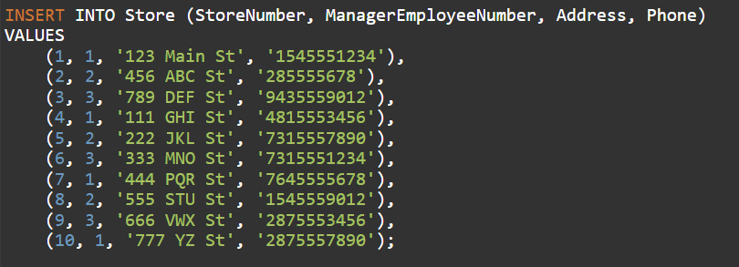

# Displaying the output for the tables.

