# Part 1) Creating a new user.

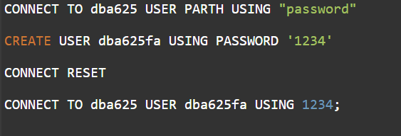

# Part 2) Creating a View.



# Part 3) Granting access.



