# Part 1) Creating a Procedure.

# Part 2) Queries

**Part a)**

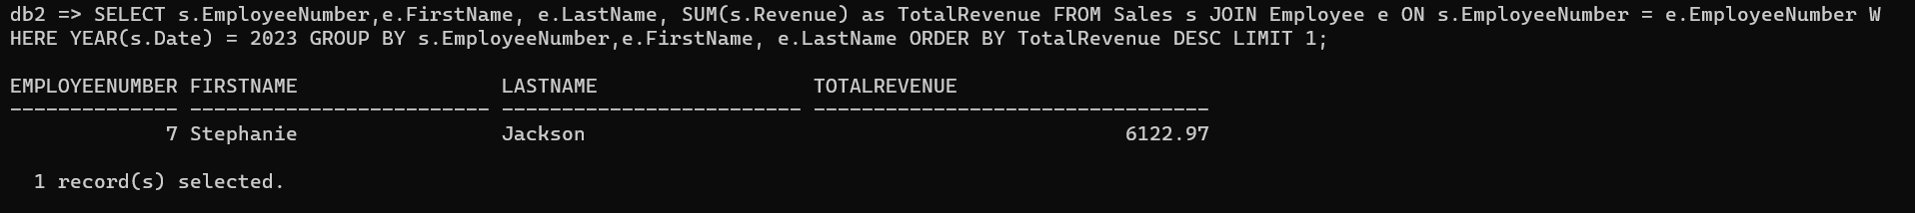

**Part b)**

**Part c)**

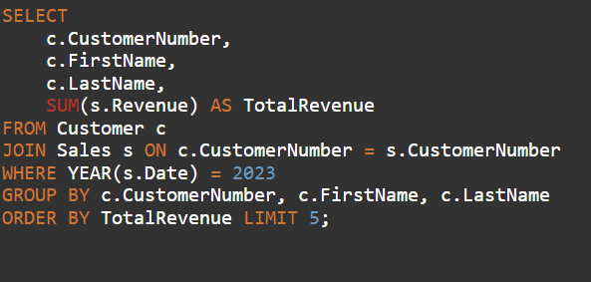

**Part d)**

