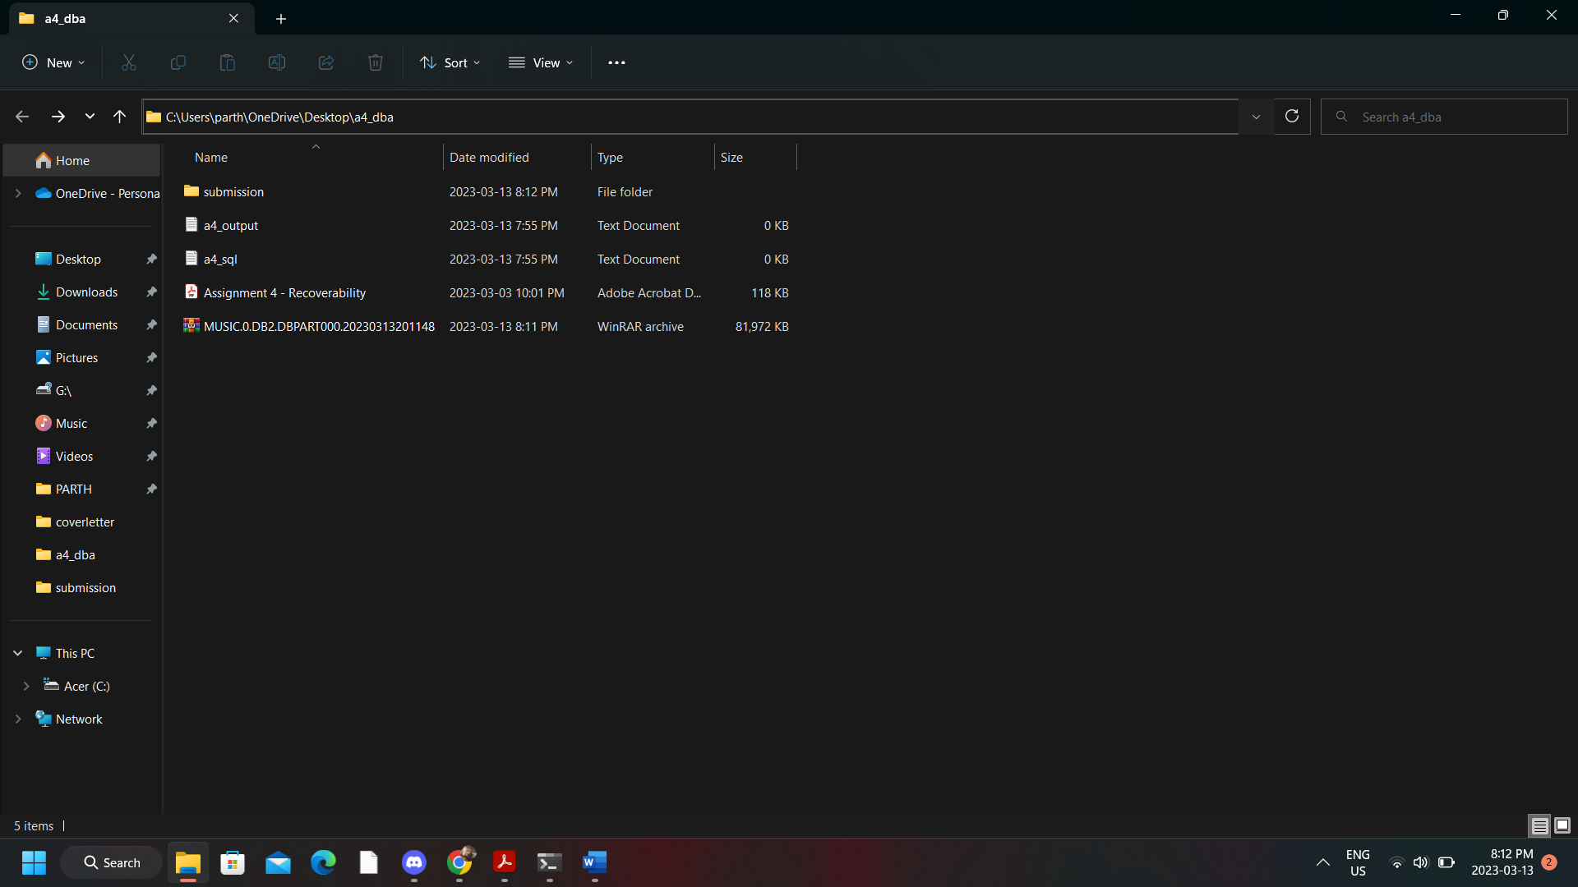

Q) Does your backup image include the required log files ?

Yes

-Q) Is your backup image compressed ?

Yes