**SYD366 – Individual Assignment**

Name: Parth Gulati

**aldoshoes.com**

**Signup process**

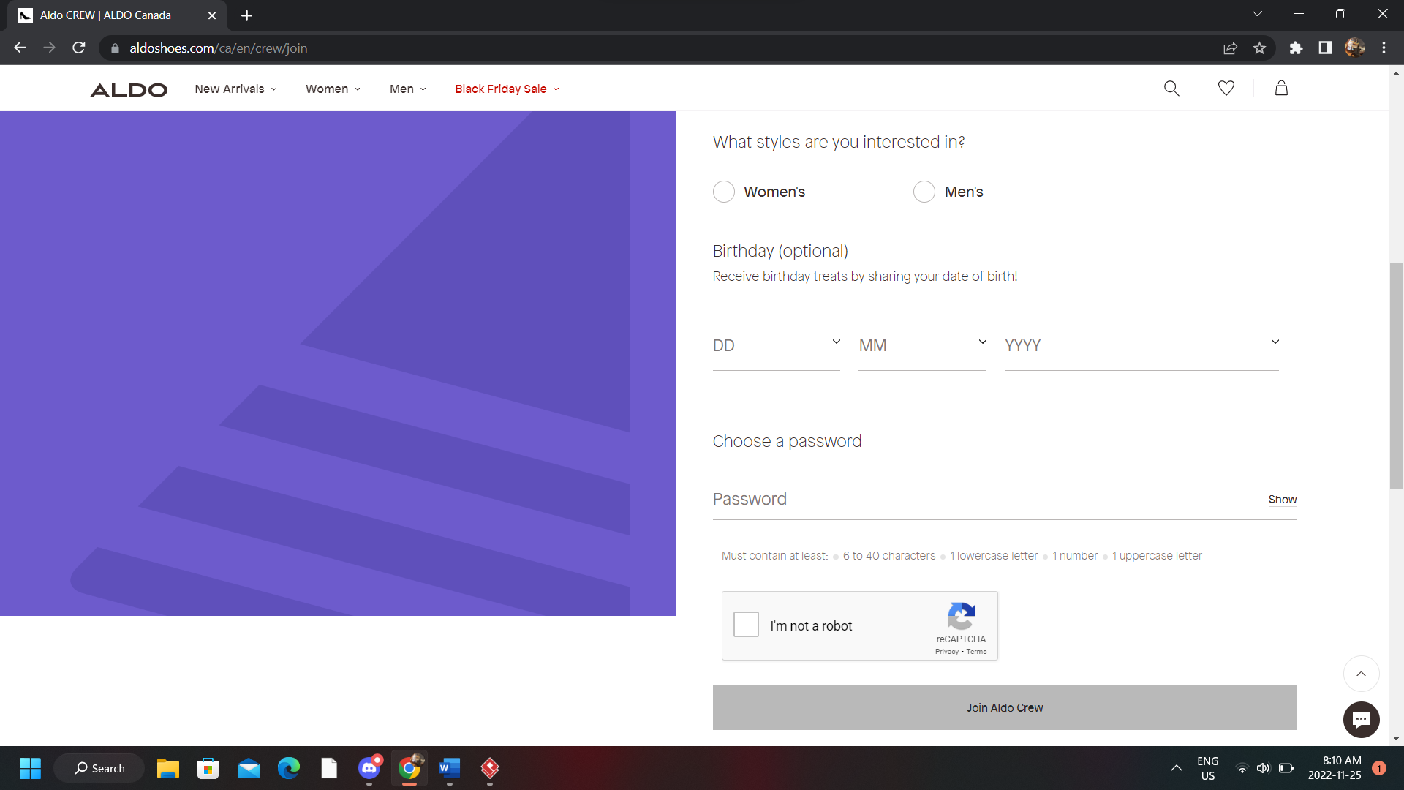

**Creating an order for goods or a service**

**Suggestion**

In the sign up, having shoe size option prompt for only a size like 7 or 7.5 would be better as above we have just asked which style they would prefer as in men’s or women's and based on this selection the shoe size option appears like men’s 7 or women's 7.5. Even though it is an optional field to fill, it is causing us to store our data in string with max size being “Women’s 10.5”, which is 12 characters. Instead of this, we can just save the shoe size in float which would be more efficient for our database as it would require much less space and for any recommendation for the customer, we can just use styles and shoe size field separately and combine them together only if needed.

