Local ipv4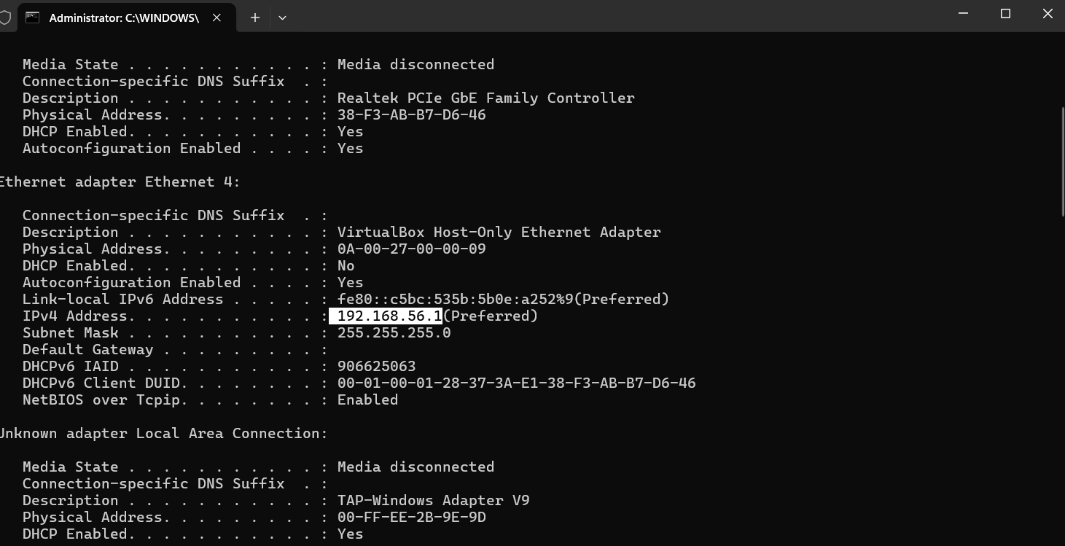

Finding open ports on local ip address : 192.168.56.1 using nmap gui tool

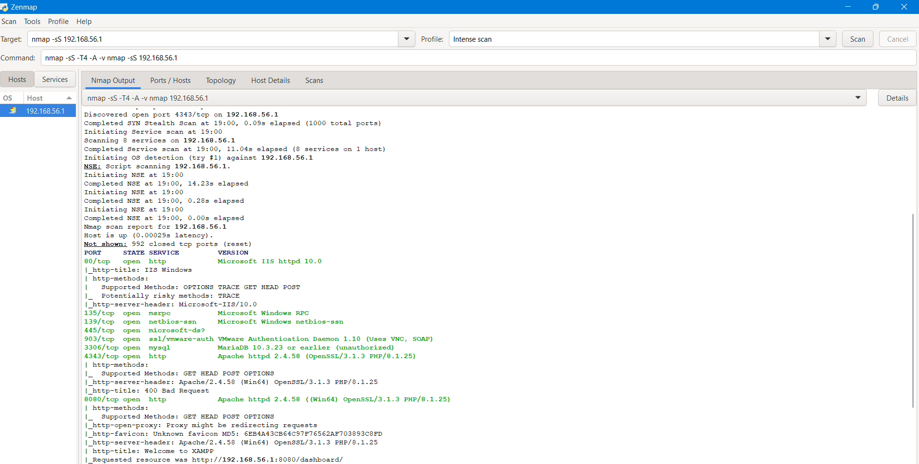

Open ports are written below :

Scanning 192.168.56.1 [1000 ports]

Discovered open port 139/tcp on 192.168.56.1

Discovered open port 80/tcp on 192.168.56.1

Discovered open port 8080/tcp on 192.168.56.1

Discovered open port 445/tcp on 192.168.56.1

Discovered open port 3306/tcp on 192.168.56.1

Discovered open port 135/tcp on 192.168.56.1

Discovered open port 903/tcp on 192.168.56.1

Discovered open port 4343/tcp on 192.168.56.1

Completed SYN Stealth Scan at 19:00, 0.09s elapsed (1000 total ports)

Initiating Service scan at 19:00

Scanning 8 services on 192.168.56.1

Completed Service scan at 19:00, 11.04s elapsed (8 services on 1 host)

SERVICES RUNNING

80/tcp open http Microsoft IIS httpd 10.0

135/tcp open msrpc Microsoft Windows RPC

139/tcp open netbios-ssn Microsoft Windows netbios-ssn

445/tcp open microsoft-ds?

903/tcp open ssl/vmware-auth VMware Authentication Daemon 1.10 (Uses VNC, SOAP)

3306/tcp open mysql MariaDB 10.3.23 or earlier (unauthorized)

4343/tcp open http Apache httpd 2.4.58 (OpenSSL/3.1.3 PHP/8.1.25)

8080/tcp open http Apache httpd 2.4.58 ((Win64) OpenSSL/3.1.3 PHP/8.1.25)