**LEC-03**

1. I created a repository on git hub “Mobile_Computing_Progress” as told. And cloned it and created this document. (another repository was made in lecture 2)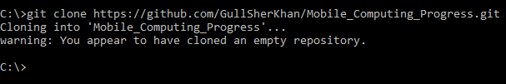
2. I added this document using git add command, then used commit command and pushed it.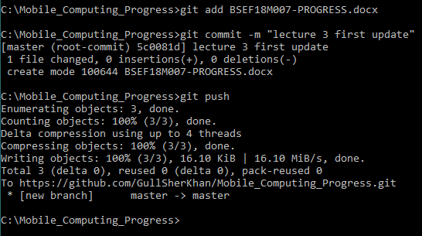
3. I applied git log command.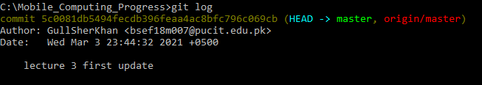
4. I created an empty file to delete it and to test rm command.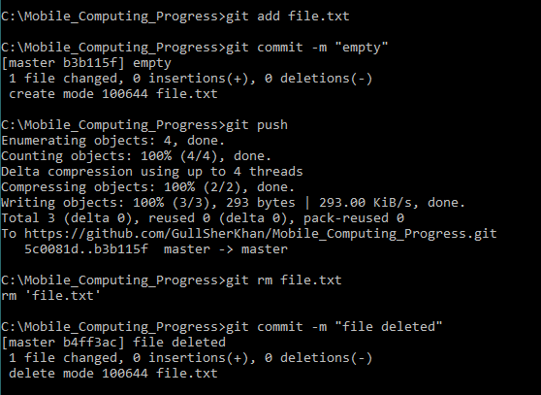

**LEC-04**

1. I created my first project on android studio.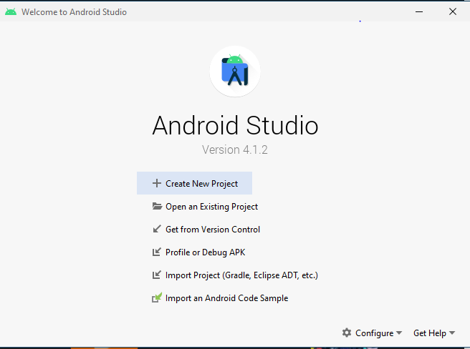
2. I opted empty project.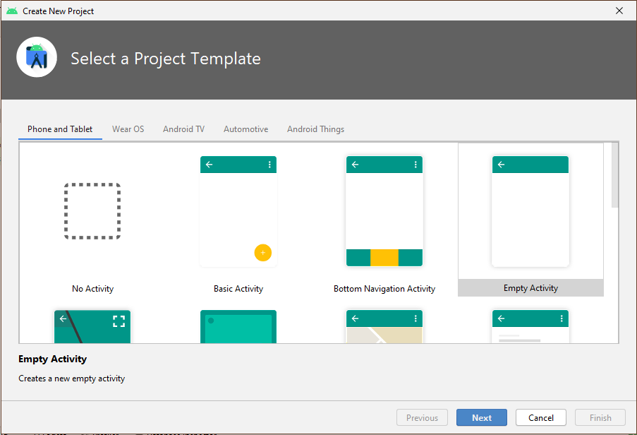
3. Then I created it by applying/choosing some settings.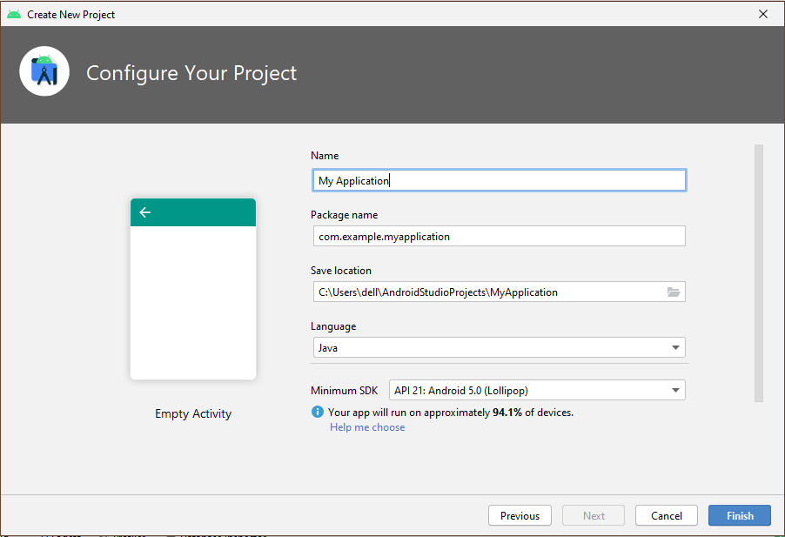
4. The final snip of the create project is below. (the project screen/view I got after creating it is below)5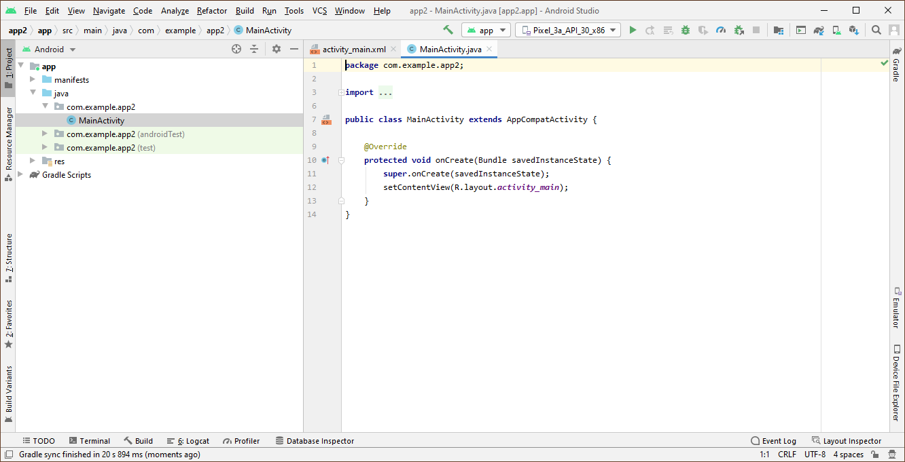
5. 3 Screens added in separate folder

**Lec-05:**

1. I added linear layout to the project as told in the lecture. Go to the xml file of main acitivty.then click on layout and drag a linear layout to the right screen. It added the linear layout in it.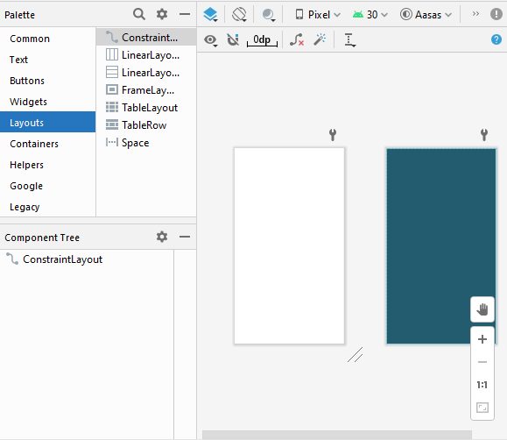
2. I added a button and text view inside it.

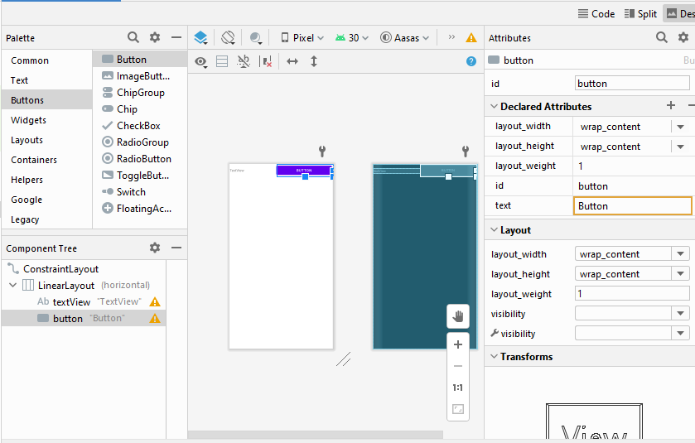

1. I added a constraint layout after removing linear layout. I connected it to the parent constraint layout.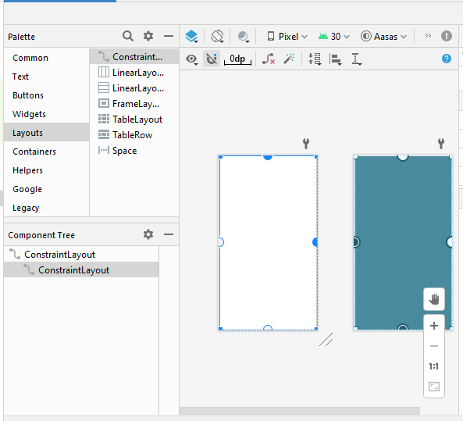
2. I added 3 buttons in it and connected it to the child constraint layout.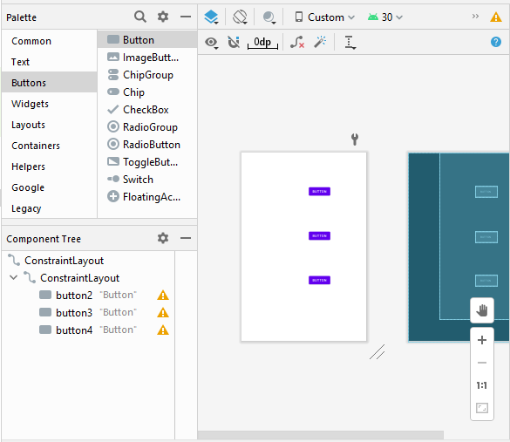
3. I cleared all constraint from the button as told in lecture.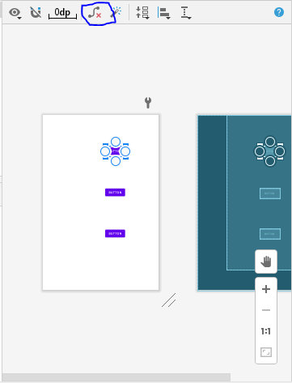
4. I added the constraint using, constraint widget.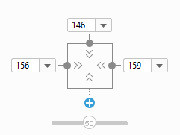
5. I added a text view.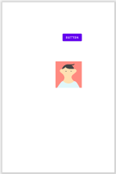
6. I added a onclick function in main activity which sets text in text view by clicking button.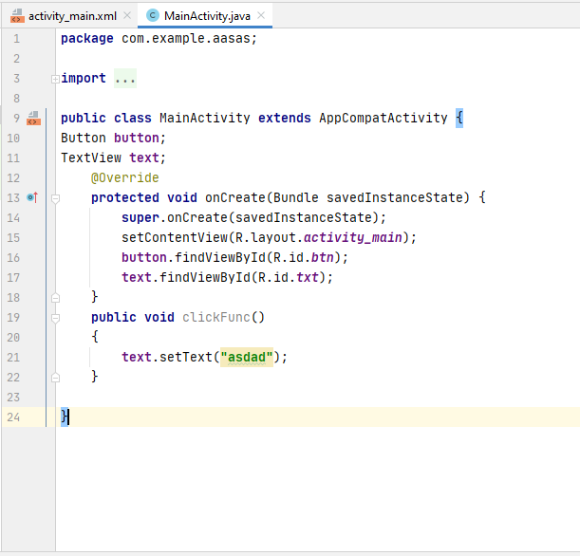
7. Onclick function added and a mistake corrected. (forgot to write View view inside click func)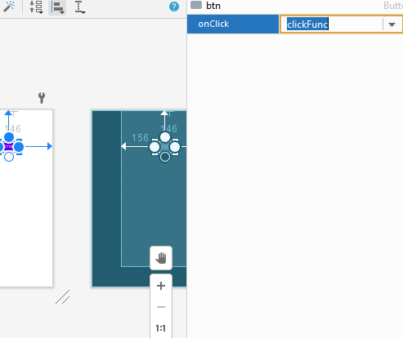

**LEC-06**

1. I added another activity inside project by right clicking on java then new then activity then empty activity.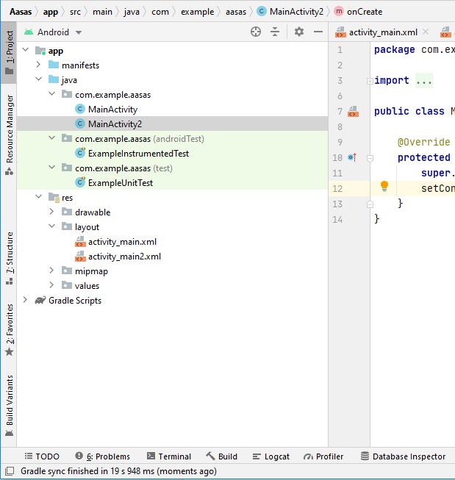
2. I added implicit intent by using code. Code used is Uri for parsing and finding the correct option for system to execute. Then initializing intent to start another activity and then calling it.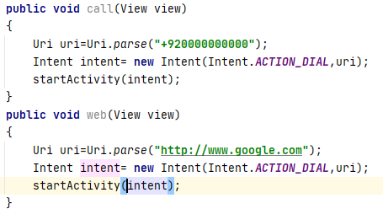
3. I added explicit intent, by using intent for moving to another activity when certain event occurs. 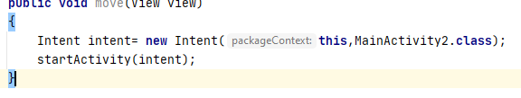

**LEC-08**

1. I made a counter inside android studio by using text view and a button.
2. I added functionality to the counter. By using on click function that when called increases the value of counter.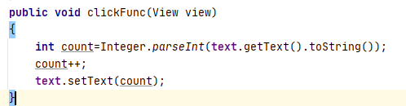
3. I added overrided functions of ALC inside main activity. That will show log inside Logcat about which function was called. i corrected a mistake in previous step I added ***String.valueof(count)*** inside setText.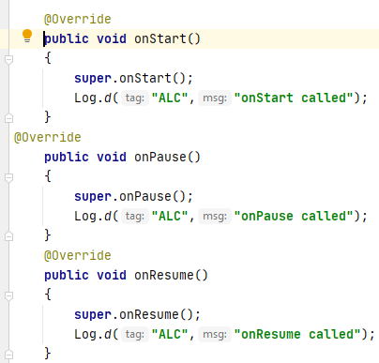
4. I added another button inside activity that moves to another activity.
5. I have added code that saves the value of the counter when screen layout is changed. As mentioned in lecture.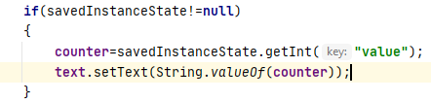

**LEC-09**

1. I created an array list named items in class.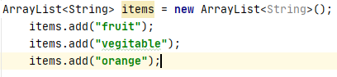
2. I created adapter for the array list above.
3. I created and added a list view to the layout in main activity and attached/set an adapter to it.



1. output was generated on mobile as on pc it takes quite long time and it stops responding.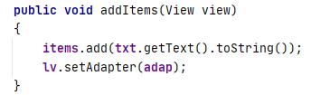
2. I added onclick function to the button and a text which I added in layout.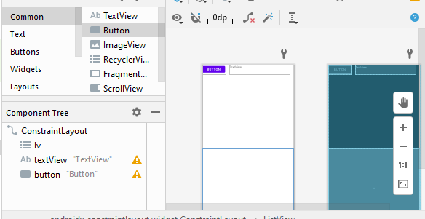
3. I added notify on data set changed and collections sort so that it sorts when a new item enters the list.
4. I added code to send the data to the new activity I created using intent put extra.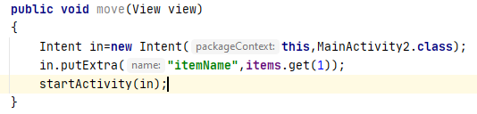
5. I added code in the second activity that accepts the parameter/value coming from the first activity.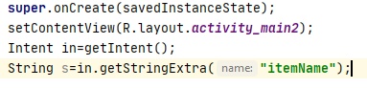

**LEC-10**

1. I created a new activity. By clicking on project then clicking add then blank activity in activity option.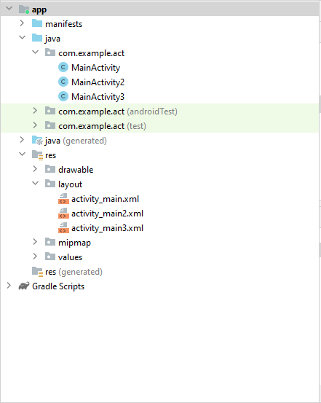
2. I added a seekbar in activity by going to widget then dragging and dropping the seek bar in activity.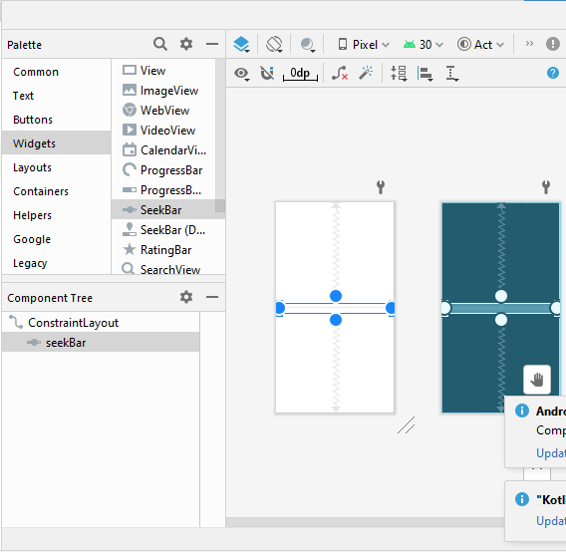
3. I got the seek bar through ID and set max value of it to 40.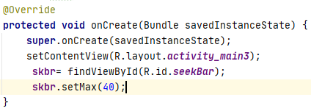
4. I added the seek bar on change listener to the java class. Then added a log function to find out the value of seekbar.

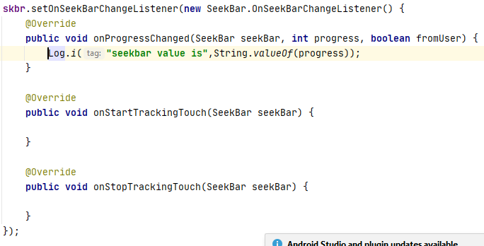

1. I added List view below seek bar in activity according to lecture by going to Legacy>Listview.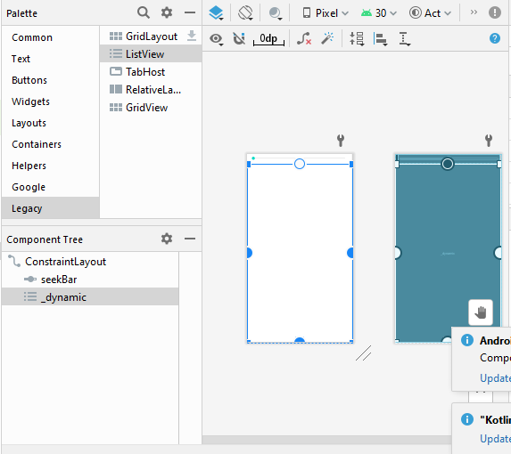
2. I initialized the variable and got listView through its ID.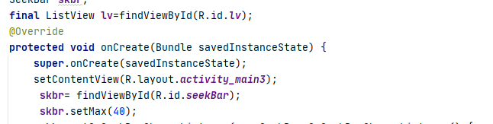
3. I added code that prints the value of progress in list view according to lecture.

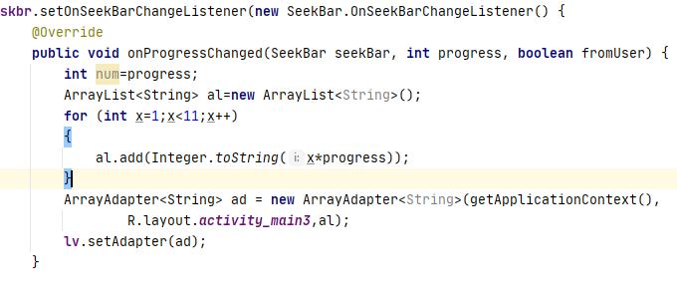

**Lec 10 animation:**

1. I created a new black activity for animation.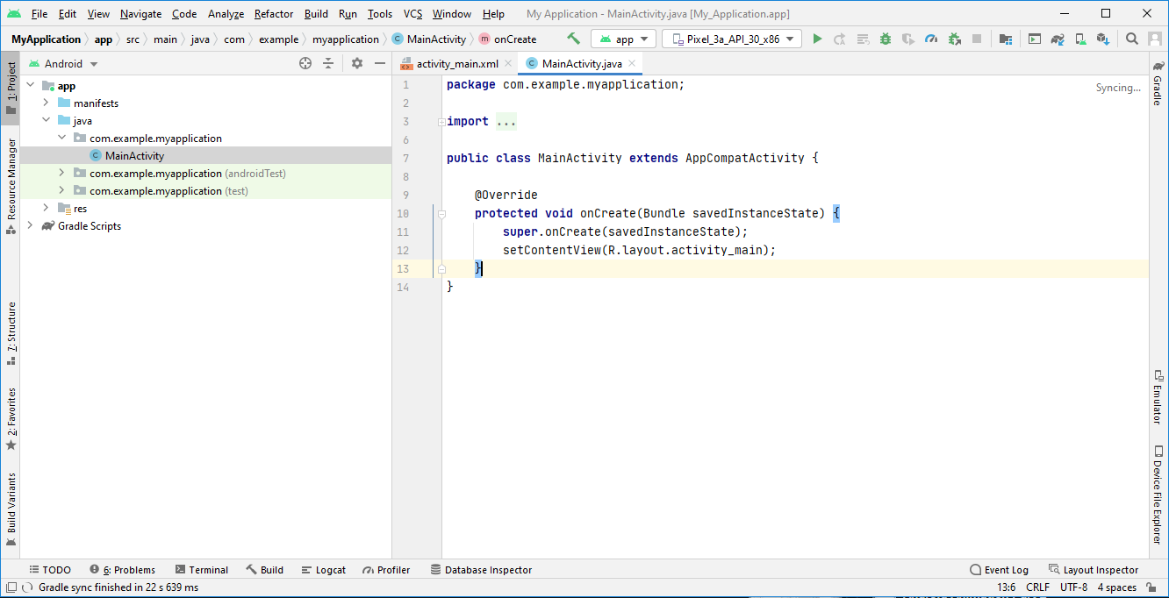
2. I added a png file for animation testing.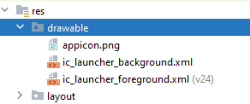
3. I added an image view to the layout.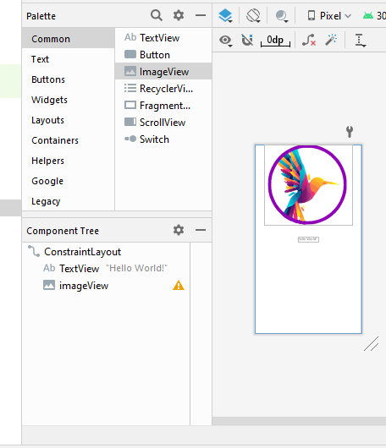
4. I gave it an id and added onclick attribute in it.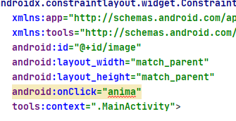
5. I added functionality to onclick function in activity.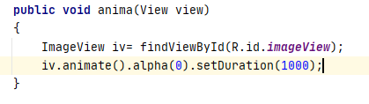
6. I added translation animation to the image view.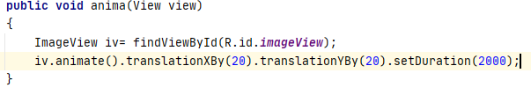
7. I added rotation animation to image view.
8. I added rotation plus fading/alpha animation to the image view.
9. I added scaling animation to the image view.
10. I tried all animations like scaling, rotation, alpha and transformation inside one line.

**Animation part 2**

1. I added video view to activity by going to widget>video view.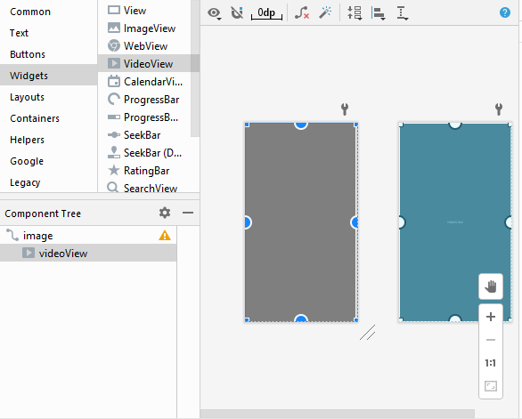
2. I added video in the video path.

**Lec -14:**

1. I created a new project.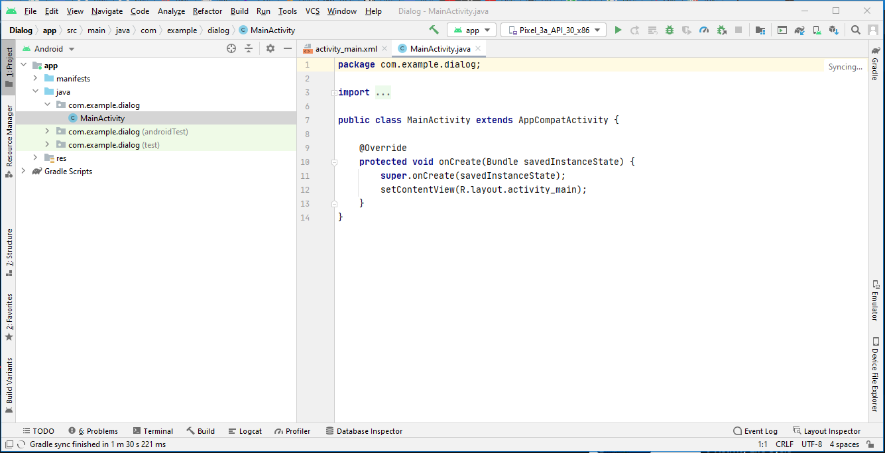
2. I created a new activity.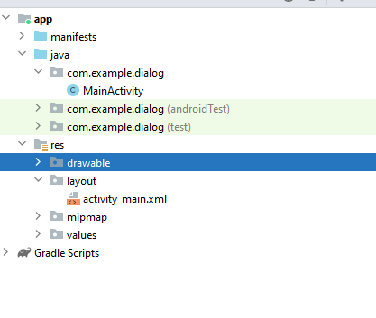
3. I added a button in layout.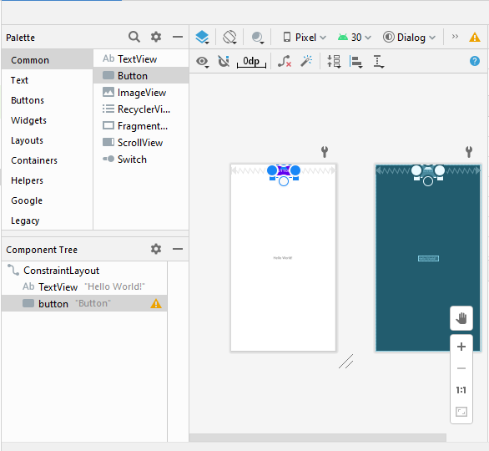
4. I added onclick attribute to the button.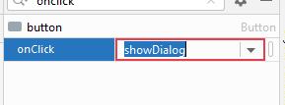
5. I got initialized a Button variable with the id of button I created.
6. I created a simple alert dialog builder without positive and negative buttons.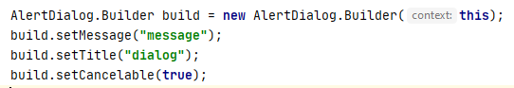
7. I added positive and negative buttons to it.
8. I added toast to the onclick listener in positive and negative button set in alert dialog.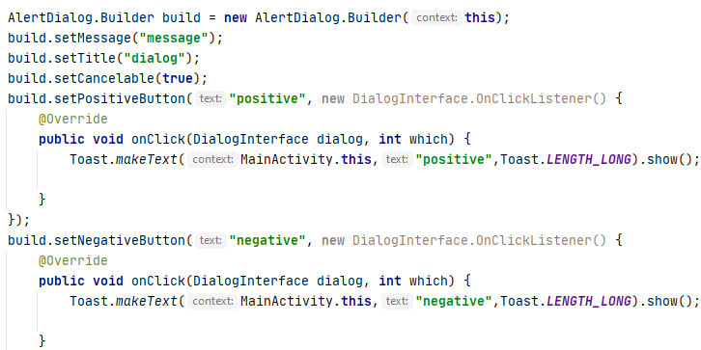
9. I created the alert dialog in the end using builder.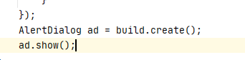

**Notification**

1. I created a new java class that sends the notification if called.
2. I created a constructor inside class that takes context, declared a notification inside class too.