3.1 Login module design
3.1.1 Module description
This module will be displayed as a webpage form. It is the first interface that user will interact with. Only after passing the authentication, the other functions can be used. This module is to verify the identity of users. It will do the strict security verification when the user first login.

3.1.2 Function
IPO chart:
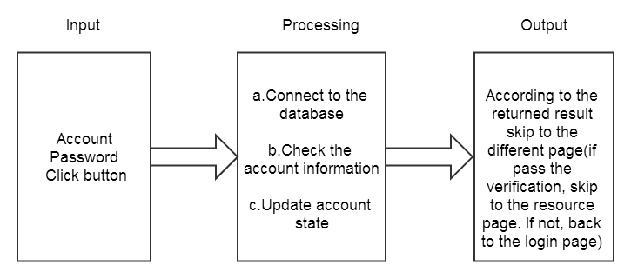
Figure 3.1.1 IPO of the login module
3.1.3 property
After clicking on the sign in button with inputting the user ID and the password, the system will do the verification.

3.1.4 Inputs
Name | Identification | Type and form | Input method
Account | User_ID | Int | Type in
Password | Password | String | Type in
Login | Login | Button | Click the button
Figure 3.1.2 Input list of user login module

3.1.5 Outputs
Name | Identification | Type and form | Output method
Result of verification | Login_result | Enum{success,fail} | By script
FIgure 3.1.3 Output list of user login module
3.1.6 Design approach
When the user click on the sign in button, the script function Login() will be triggered. The data will be posted to the serve and execute the php code below:

<?php
If(CheckStringSafety(form.user_id)
&&CheckStringSafety(form.password))
//check the security of data
{
ConnectionDB Db;
Db.open();
//Connect to the database
If(Db.LoginQuery(form.user_id,form.password))
{
//if find the account
If(SecurityCheck())
//if pass the verification
{
Session("user_id")=form.user_id;
Session("user_type")=getUsertype();
Session("login_state")=true;
Session("time")=time();
//store the login state
$data['result']="Success";
}
else
{
$data['result']="Fail";
}
}
else
{
$data['result']="Fail";
}
Db.close();
//close database connection
}
else
{
$data['result']="Warn";
}
echo json_encode($data);
//return the result of verification
?>
After executing, the result will be send back, the script of the front-end will display the result of verification.
3.1.7 Flow logic
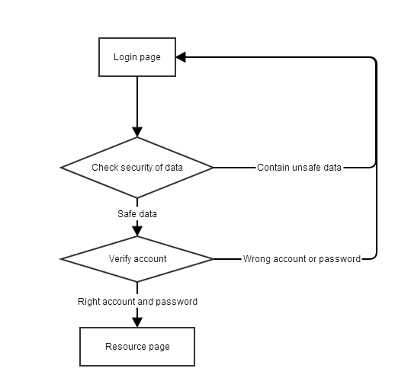
Figure 3.1.4 Flow chart of login module
3.1.8 User interface
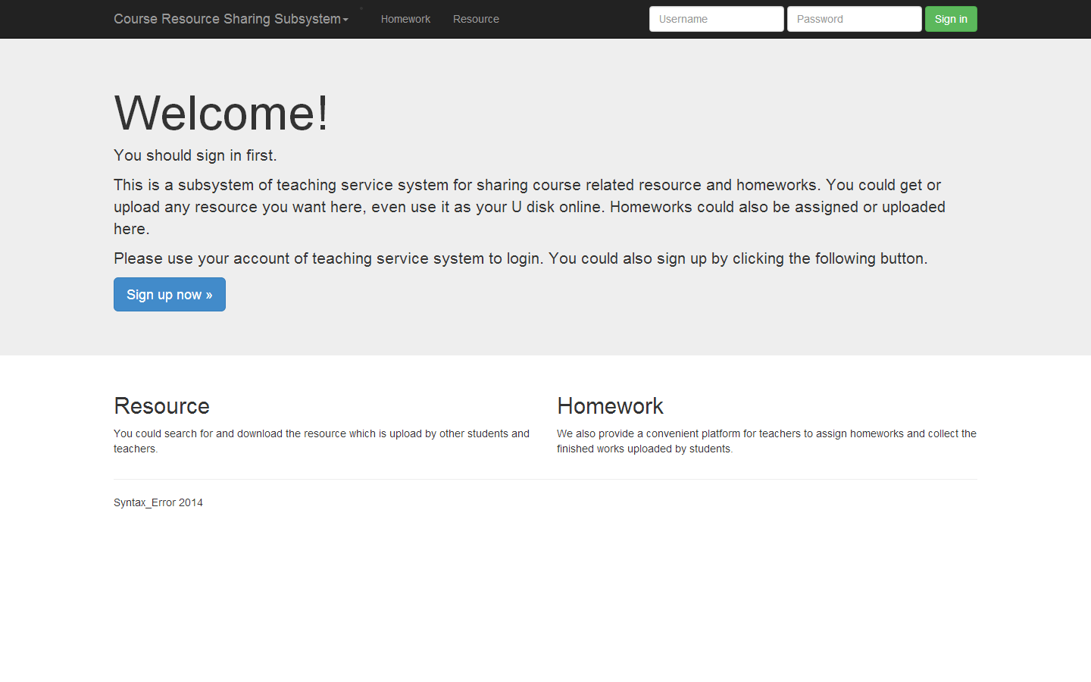
Figure 3.1.5 User interface of the login module

3.1.9 Test plan
The test requires creating corresponding database and test data on the remote server.
Input | Expected result
Existed user ID and password | Gain access of other functions
Existed user ID and wrong password | Return error message
Existed user ID and password but not corresponding | Return error message
User ID or password that contain special characters or sql command | Return warning
Figure 3.1.6 Test plan of login module

3.5 Homework assign module
3.5.1 Module description
This module is for the instructors to assign homework for the courses. Only after logging in as the teacher, they have access to use this function.
3.5.2 Function
IPO chart:
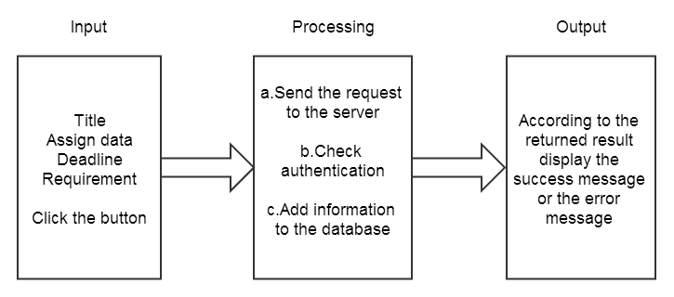
Figure 3.5.1 IPO of the homework assign module

3.5.3 property
This module will show the courses the instructor are teaching on the left. After choosing one course, the assigned homework will be displayed on the right. And there will be a button for the instructor to assign new homework. After clicking on the button, a form will be popped up. The input data will be posted to serve.
3.5.4 Inputs
Name | Identification | Type and form | Input method
Title | Title | String | Type in
Assign data | Assign_data | Date | Type in
Deadline | Deadline | Date | Type in
Requirement | Requirement | String | Type in
Save | Save | Button | Click
Figure 3.5.2 Input list of user login module

3.5.5 Outputs
Name | Identification | Type and form | Output method
Result of submitting | Assign_result | Enum{success,fail,not_teacher} | By script
Figure 3.5.3 Output list of user login module
3.5.6 Design approach
After filling the form and submitting, the php code below will be executed:

<?php
If(CheckStringSafety(form.title)
&&CheckStringSafety(form.requirement))
//check the security of data
{
ConnectionDB Db;
Db.open();
//Connect to the database
If(Session("login_state")==True&&Session("user_type")=="teacher")
//check authentication
{
//if already login
If(AddAssignment(form))
//if add assignment successfully
{
$data['result']="Success";
}
else
{
$data['result']="Fail";
}
}
else
{
$data['result']="Not_teacher";
}
Db.close();
//close database connection
}
else
{
$data['result']="Warn";
}
echo json_encode($data);
//return the result of assignment
?>
After executing, the result will be send back, the script of the front-end will display the result of assignment.
3.5.7 Flow logic
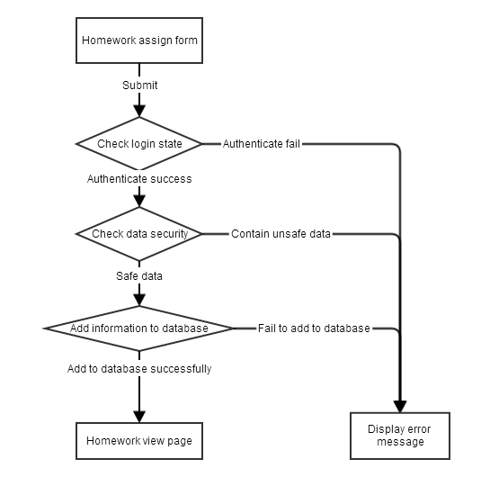
Figure 3.5.4 Flow chart of homework assign module
3.5.8 User interface
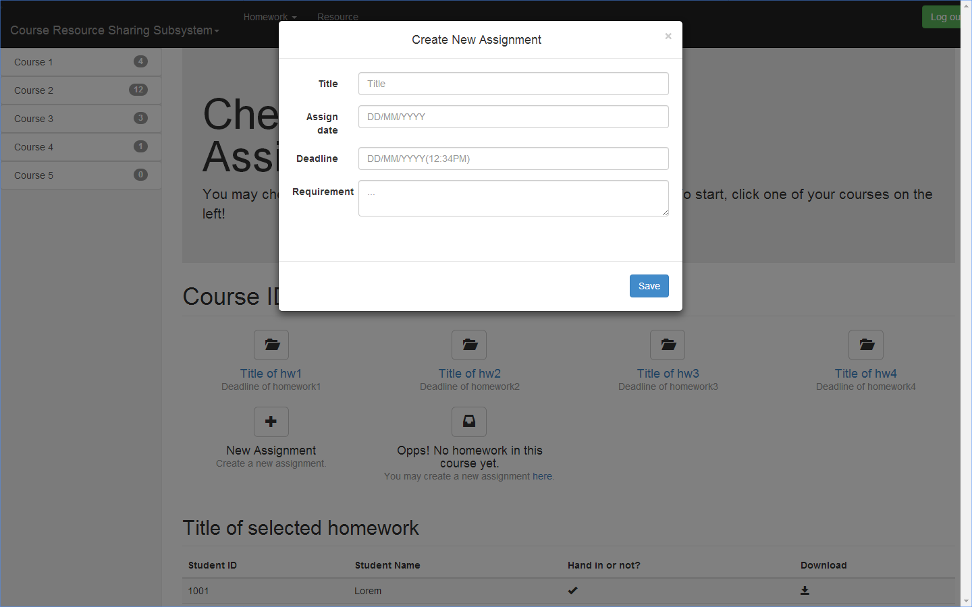
Figure 3.5.5 User interface of the homework assign module

3.5.9 Test plan
The test requires creating corresponding database and test data on the remote server.
Input | Expected result
Correct title, date and requirement | Add assignment successfully
Correct title and requirement with wrong date format | Return error message
Assign date or deadline is illogic | Return error message
Title or requirement that contain special characters or sql command | Return warning
Correct title, date and requirement but log information timeout | Return error message
Figure 3.5.6 Test plan of homework assign module

3.6 Homework upload module
3.6.1 Module description
This module is to upload files to serve from students’ computer. After logged in, students can view their courses and homework and select a homework to upload.
3.6.2 Function
IPO chart:
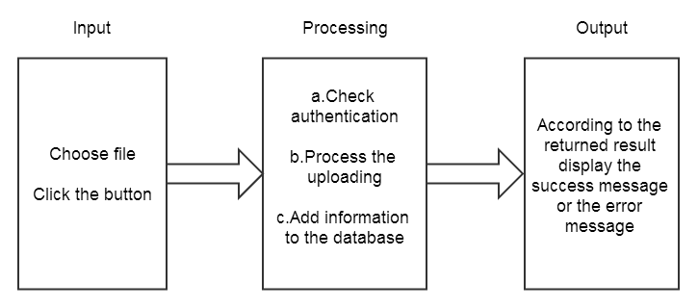
Figure 3.6.1 IPO of the homework upload module

3.6.3 property
After clicking on the submit link, a upload form will be displayed. Students can choose the file to upload and click the save button to submit.

3.6.4 Inputs
Name | Identification | Type and form | Input method
File | File | File | Choose from browser
Save | Save | Button | Click the button
Figure 3.6.2 Input list of user login module

3.6.5 Outputs
Name | Identification | Type and form | Output method
Result of upload | Upload_result | Enum{success,fail,not_student, invalid_file} | By script
FIgure 3.6.3 Output list of user login module
3.6.6 Design approach
When the user click on the save button, the script function Upload() will be triggered. The data will be posted to the serve and execute the php code below:

<?php
ConnectionDB Db;
Db.open();
//Connect to the database
If(Session("login_state"==True&&Session("user_type")=="student")
//check authentication
{
//if already login
if ($_FILES["file"]["size"] < MAXFILESIZE)
//check file size
{
if ($_FILES["file"]["error"] > 0)
//if fail to upload
{
$data['error']=$_FILES["file"]["error"];
}
else
{
//if upload successfully
$data['error']=0;
$tmpname=generateTmpName($_FILES["file"]["name"]);
//generate a new name for the file

while (file_exists("upload/" . $tmpname))
//avoid overwrite the existed file
{
$tmpname=generateTmpName($_FILES["file"]["name"]);
}

if(AddFileInfoToDB($_FILES["file"]["name"],$_FILES["file"]["type"]，$_FILES["file"]["size"], $tmpname, $_POST["course_ID"]))
{
//add information to database
move_uploaded_file($_FILES["file"]["tmp_name"],
"upload/" . $tmpname);
//move the uploaded file to upload folder
}
else
{
$data['error']=-3;
}
}
}
else
{
//if the file is invalid
$data['error']=-1;
}
}
else
{
//not login correctly
$data['error']=-2;
}
Db.close();
//close database connection

echo json_encode($data);
//return the result of uploading
?>
After executing, the result will be send back, the script of the front-end will display the result of uploading.
3.6.7 Flow logic

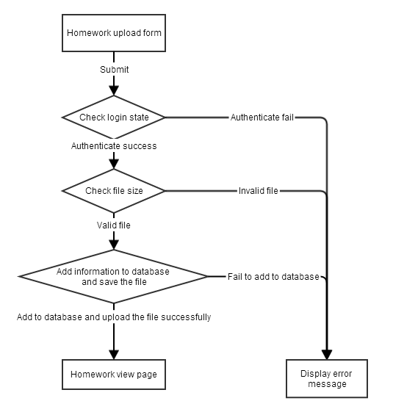
Figure 3.6.4 Flow chart of homework upload module
3.6.8 User interface
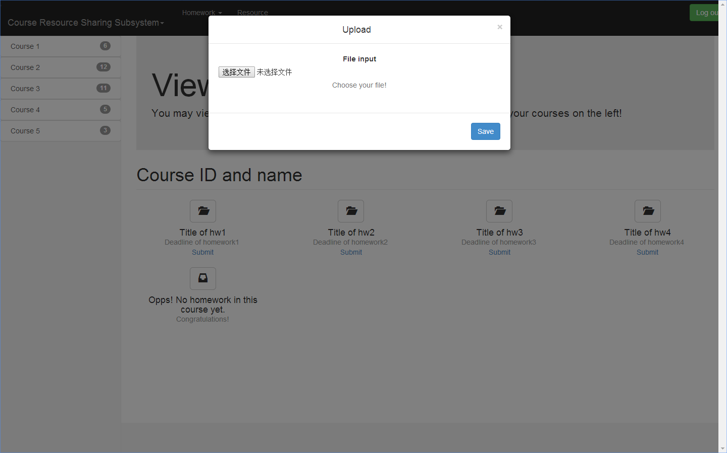
Figure 3.6.5 User interface of the homework upload module

3.6.9 Test plan
The test requires creating corresponding database and test data on the remote server.
Input | Expected result
Valid file | Return success message
Invalid file | Return error message
Valid file but log information timeout | Return error message
Figure 3.6.6 Test plan of homework upload module

3.7 Homework check module
3.7.1 Module description
This module is for the instructors to check their students’ homework. It will display the homework submitting information and provide the download function.
3.7.2 Function
IPO chart:
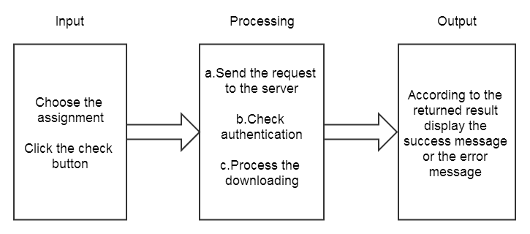
Figure 3.7.1 IPO of the homework check module
3.7.3 property
After choose a specific homework, the page will display the students list and the submit states. For the students who have already submitted, the instructor can click the download button on the right.

3.7.4 Inputs
Name | Identification | Type and form | Input method
Download | Button | Button | Click the button
Figure 3.2 Input list of user login module

3.7.5 Outputs
Name | Identification | Type and form | Output method
Homework | Down_file | file | By script
Message | Down_msg | String | By script
FIgure 3.3 Output list of user login module
3.7.6 Design approach
When the user click on the download button, the script function Download() will be triggered. The data will be posted to the serve and execute the php code below:

<?php
ConnectionDB Db;
Db.open();
//Connect to the database
If(Session("login_state"==True&&Session("user_type")=="teacher")
//check authentication
{
//if already login
$file=getFromDB($_POST["File_ID"],$);
//get file's information from database
$file_path="upload/" . $file.['tempname'];
if(!file_exists($file_path)
//check the file
{
echo "File not existed";
}
else
{
$fp=fopen($file_path,"r");
$file_size=filesize($file_path);
//The header of file
Header("Content-type: application/octet-stream");
Header("Accept-Ranges: bytes");
Header("Accept-Length:".$file_size);
Header("Content-Disposition: attachment; filename=".$file_name);
$buffer=1024;
$file_count=0;
//Send file to browser
while(!feof($fp) && $file_count<$file_size)
{
$file_con=fread($fp,$buffer);
$file_count+=$buffer;
echo $file_con;
}
fclose($fp);
}
}
else
{
//not login correctly
echo "Please login";
}
Db.close();
//close database connection
?>
After executing, the file or the error message will be sent back.
3.7.7 Flow logic
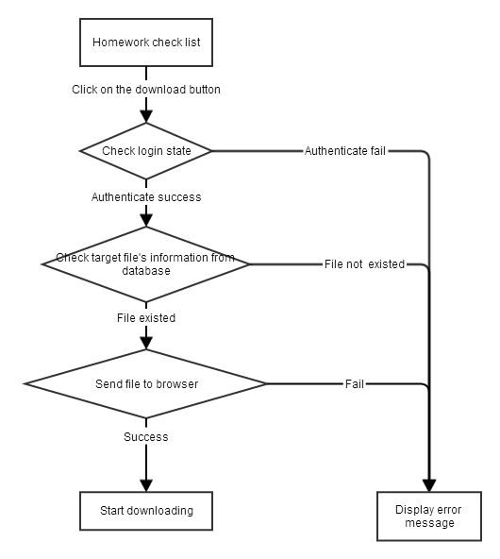
Figure 3.7.4 Flow chart of login module
3.7.8 User interface
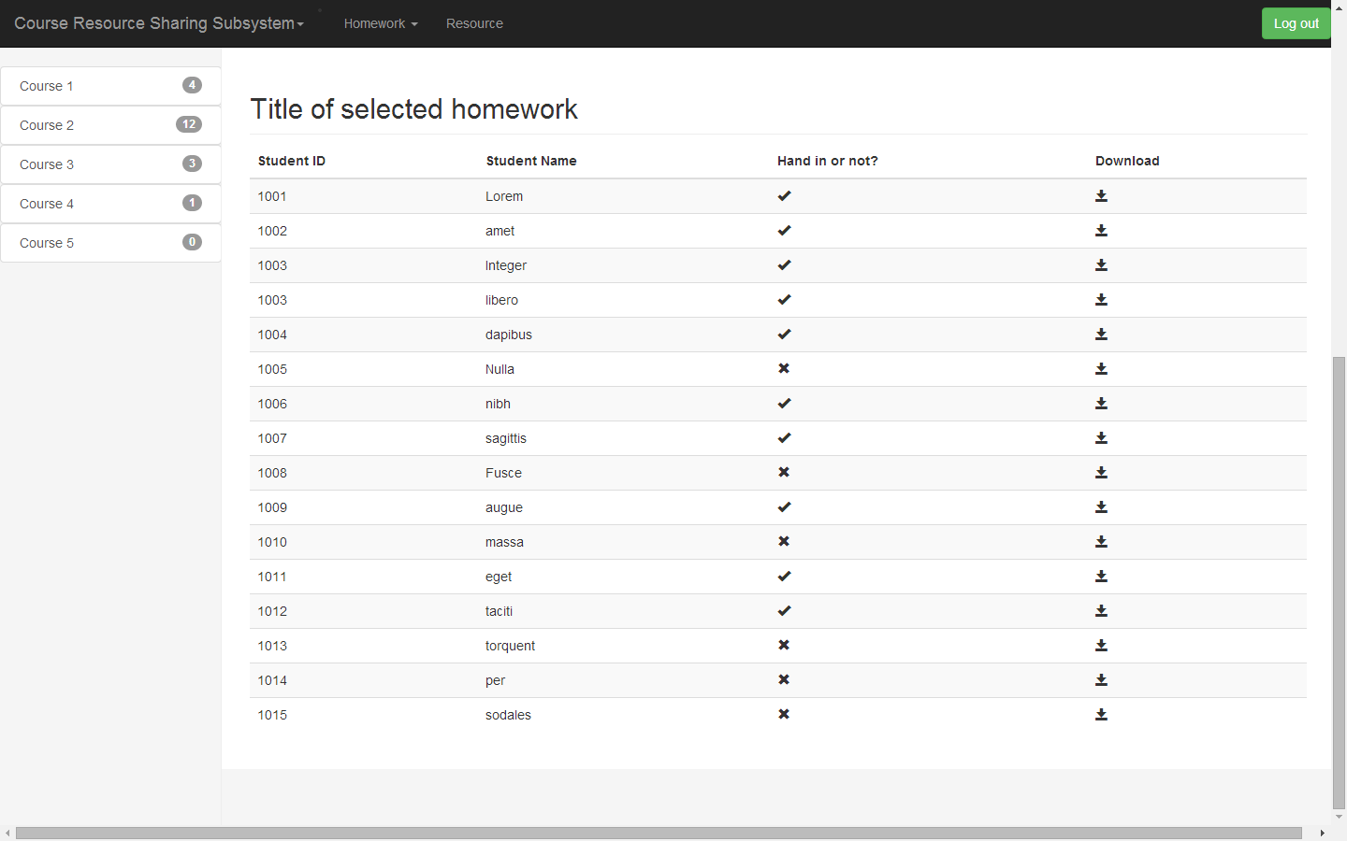
Figure 3.7.5 User interface of the login module

3.7.9 Test plan
The test requires creating corresponding database and test data on the remote server.
Input | Expected result
Click on the download button | Get the file successfully
Click on the download button but login timeout | Return error message
Figure 3.7.6 Test plan of homework check module

