UML Activity Diagram

1. Create a UML activity diagram for the process of making a cup of tea, including the steps of boiling water, steeping tea leaves, adding milk and sugar (optional), and serving.

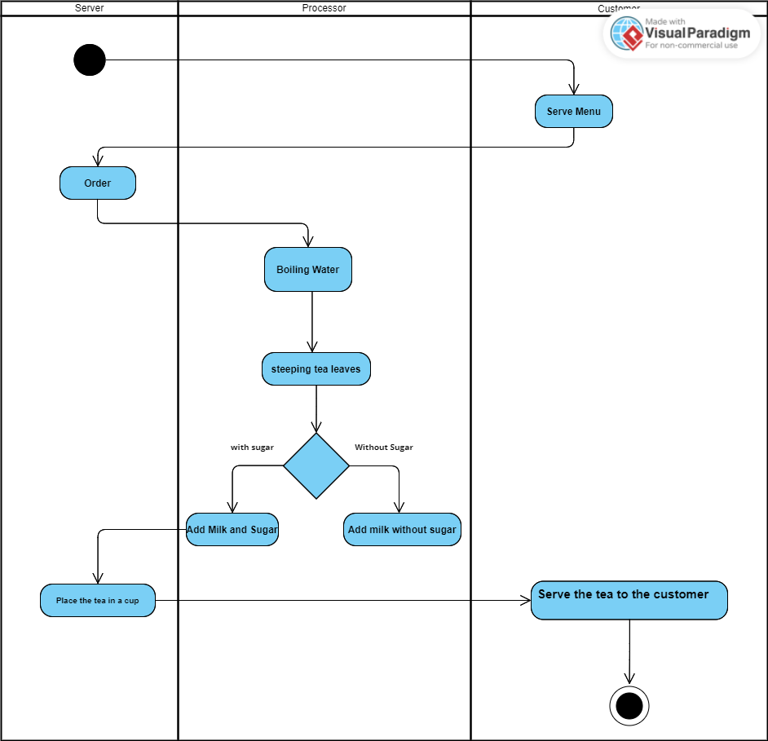

1. Design a UML activity diagram for a banking system, including activities such as checking an account balance, transferring funds between accounts, and printing a bank statement.

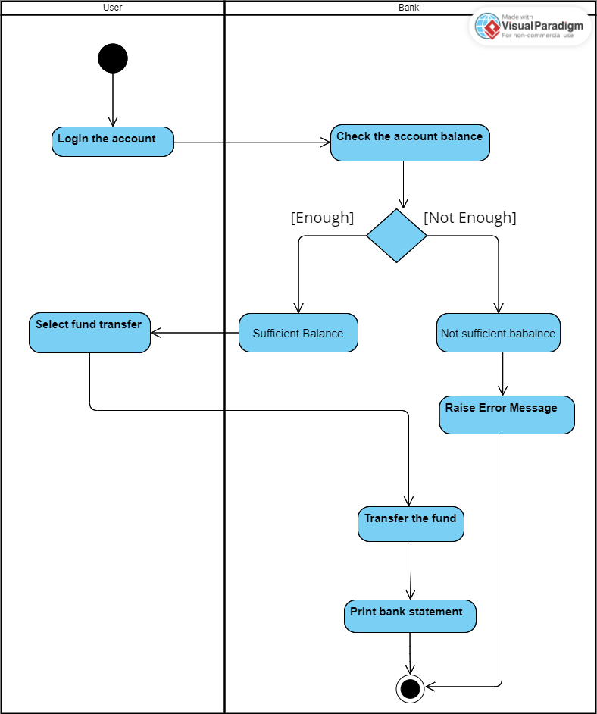

1. Create a UML activity diagram for an online shopping system. Include activities such as browsing products, adding items to the cart, proceeding to checkout, entering shipping and payment details, and completing the purchase. Consider incorporating loops for product selection and decision points for payment methods.

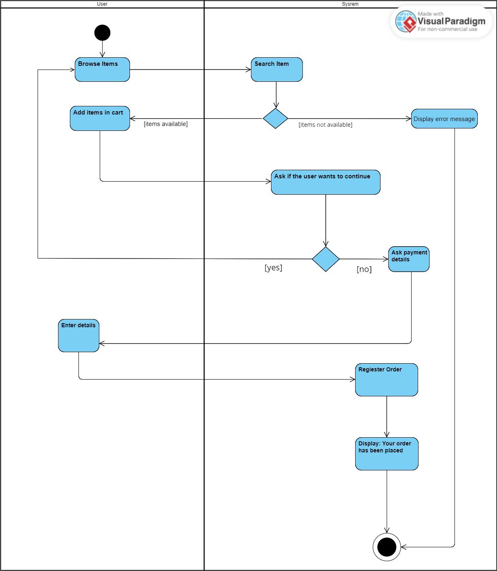

UML Sequence Diagram

1. Create a UML sequence diagram for a simple online shopping process, including interactions between a customer, a shopping cart, and a payment gateway. Include messages for adding items to the cart, updating quantities, processing payment, and receiving order confirmation.

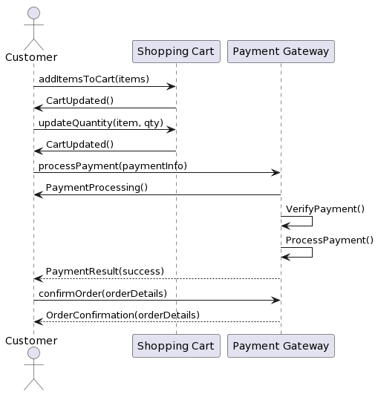

1. Design a UML sequence diagram for a banking system, including interactions between a customer, an ATM machine, and a bank server. Include messages for entering a PIN, requesting a balance, withdrawing funds, and receiving transaction confirmation.

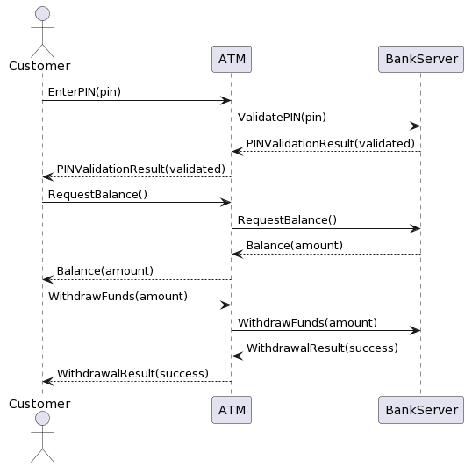

UML Deployment Diagram

1. What is a UML deployment diagram, and what is its purpose?

A UML deployment diagram is a map that shows how software and hardware are arranged in a system. It helps us understand where software runs, how it communicates, and how to improve system performance. It's like a guide for managing and setting up the system effectively.

1. What are the main components or elements in a UML deployment diagram?

There are 4 components in the deployment diagram:

* A node
* A component
* An Artifact
* An interface

1. How do you represent communication between nodes in a UML deployment diagram?

In a UML deployment diagram, communication between nodes is represented by drawing lines or arrows between them. The lines indicate direct connections or specific communication channels/interfaces. We can label the lines with network protocols or technologies used. Additionally, we visually connect artifacts on different nodes to show communication between them.

1. You are working on a UML deployment diagram for an online banking system. The system consists of multiple components, including web servers, application servers, a database server, a security gateway, and user devices. The web servers handle user requests and communicate with the application servers for processing transactions. The database server stores user account information and transaction data. The security gateway ensures secure communication between the components and performs authentication and encryption. User devices include desktop computers, smartphones, and tablets, each running a different banking application. Design a comprehensive UML deployment diagram that showcases the deployment of these components, considering load balancing, high availability, and data privacy.

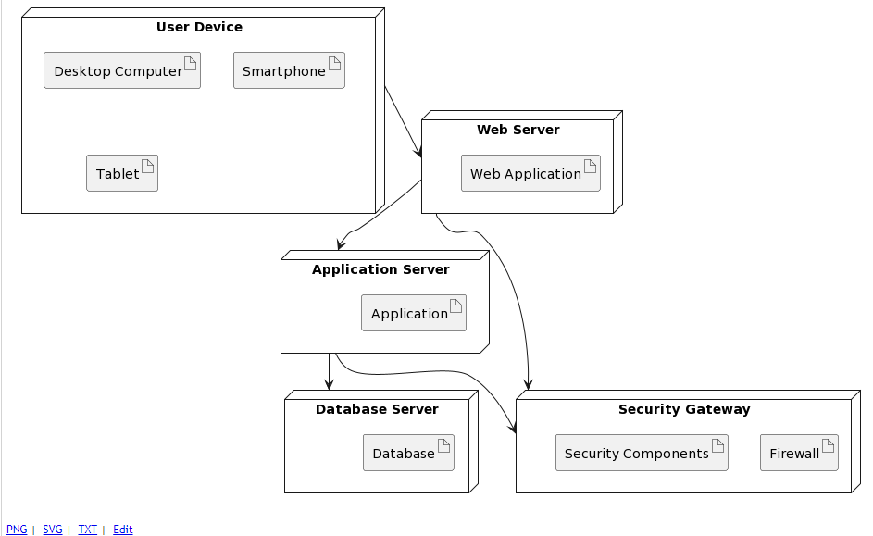

In the UML deployment diagram for the online banking system, user devices like desktop computers, smartphones, and tablets are connected to the system. The Security Gateway ensures secure communication by handling authentication and encryption. A Load Balancer is used to evenly distribute user requests across multiple Web Servers, enhancing system performance. The Web Servers handle user requests and communicate with Application Servers for transaction processing. The Application Servers, in turn, interact with Database Servers to store and retrieve user account information and transaction data. This design incorporates load balancing, high availability, and data privacy measures. Load balancing ensures even distribution of requests, high availability is achieved through redundant servers, and data privacy is maintained through secure communication facilitated by the Security Gateway.