1. Open main folder and **Avito.Meetings.Task.sln** file. I used standart three-tier architecture pattern and Ninject IoC for dependency injection.
2. You need to change connection string for DB or use default (localdb)\MSSQLLocalDB for VisualStudio in Avito.Meetings.Task/Web.Config

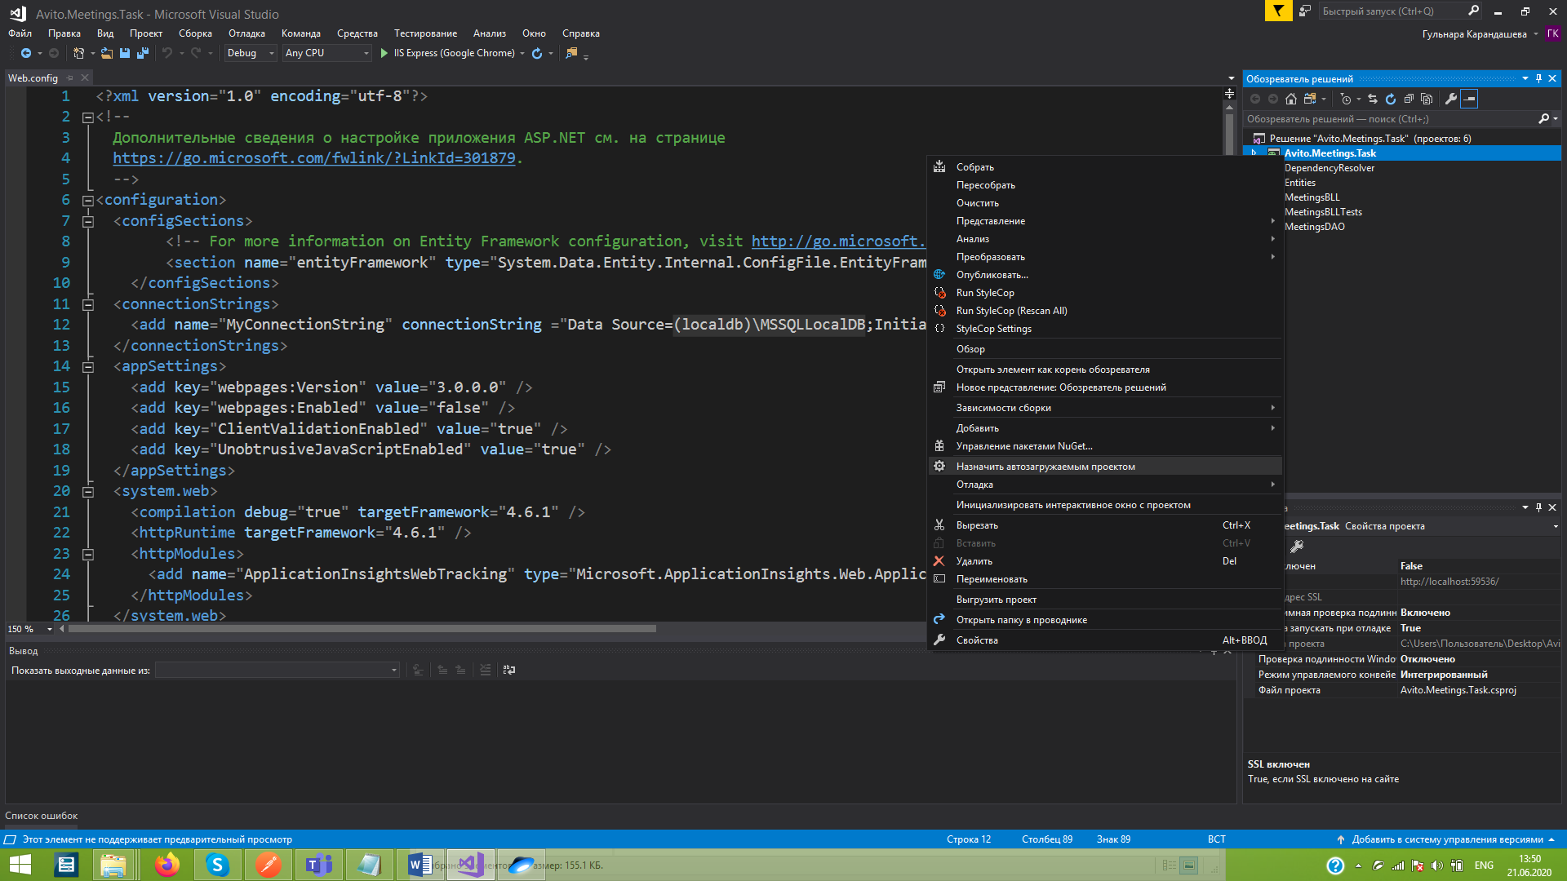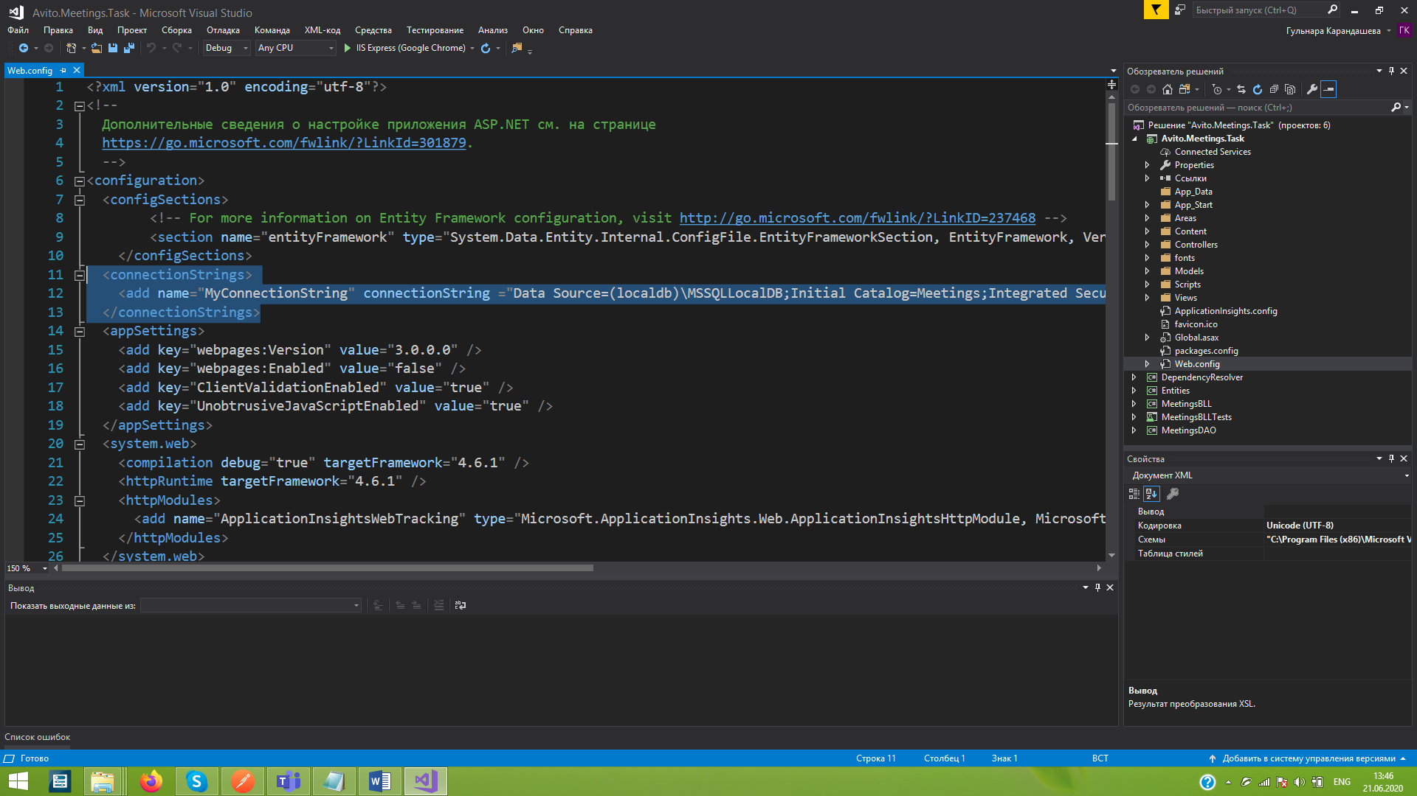

1. Mark Avito.Test.Task as startup project
2. I added DB script in main folder, but you don’t need to use it. It will be created automatically with EntityFramework ORM
3. You can use postman or other tools for API requests

**Request’s description:**

**Delete member from meeting request(POST):**

{...}/api/values/deletemember/{meetingid}/{memberid}

meetingId - Int

memberId - Guid

***Example:***

http://localhost:59536/api/values/DeleteMember/6/6F9619FF-8B86-D011-B42D-00CF4FC964FF

**Add meeting member request(POST):**

{...}/api/values/addmeetingmember/{id}

{id} is a meeting id in which we want to add our member

***Example:***

http://localhost:59536/api/values/AddMeetingMember/5

JSON request(body):

{

"firstname": "sample1",

"email": "sample@gmail.com"

}

*Note:* Email is mandatory field

**Get all meetings request(GET):**

{...}/api/values/getallmeetings

***Example:***

http://localhost:59536/api/values/getallmeetings

**Add meeting request(POST):**

{...}/api/values/addmeeting

***Example:***

http://localhost:59536/api/values/addmeeting

***JSON request (Body):***

{

"starttime": "2020-06-20T15:20:26.6134276+03:00",

"endtime": "2020-06-20T15:40:26.6134276+03:00",

"members": [

{

"firstname": "sample1",

"lastname": "sample2",

"email": "sample@gmail.com"

},

{

"firstname": "sample1",

"lastname": "sample2",

"email": "sample@gmail.com"

}

]

}

**Cancel meeting request(POST):**

{...}/api/values/deletemeeting/{id}

***Example:***

http://localhost:59536/api/values/deletemeeting/5