* **Create an ER diagram for the given airlines database.**

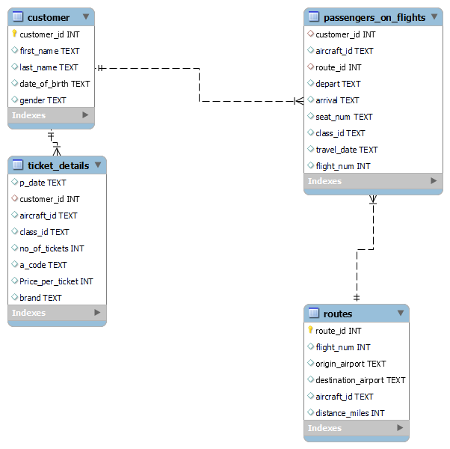

* **Write a query to create route_details table using suitable data types for the fields, such as route_id, flight_num, origin_airport, destination_airport, aircraft_id, and distance_miles. Implement the check constraint for the flight number and unique constraint for the route_id fields. Also, make sure that the distance miles field is greater than 0.**

alter table routes

modify column flight_num int check (flight_num between 1000 and 2000),

modify column distance_miles int check(distance_miles >0);

alter table routes

modify column route_id int unique;

* **Write a query to display all the passengers (customers) who have travelled in routes 01 to 25. Take data  from the passengers_on_flights table.**

select * from passengers_on_flights where route_id between 1 and 25;

* **Write a query to identify the number of passengers and total revenue in business class from the ticket_details table.**

select count(no_of_tickets) as no_of_passengers , sum(price_per_ticket) as total_revenue from ticket_details

where class_id="bussiness";

* **Write a query to display the full name of the customer by extracting the first name and last name from the customer table.**

select concat(first_name," " ,last_name) as full_name from customer;

* **Write a query to extract the customers who have registered and booked a ticket. Use data from the customer and ticket_details tables.**

Select

customer.customer_id, customer.first_name,customer.last_name,customer.date_of_birth

from customer

inner join ticket_details on customer.customer_id=ticket_details.customer_id;

* **Write a query to identify the customer’s first name and last name based on their customer ID and brand (Emirates) from the ticket_details table.**

select customer.first_name, customer.last_name from customer

inner join ticket_details on customer.customer_id=ticket_details.customer_id;

select * from ticket_details;

* **Write a query to identify the customers who have travelled by *Economy Plus* class using**

**Group By and Having clause on the passengers_on_flights table.**

select customer_id, class_id, count(flight_num) as no_of_flight

from passengers_on_flights where class_id="economy plus" group by

customer_id, class_id;

* **Write a query to identify whether the revenue has crossed 10000 using the IF clause on the ticket_details table.**

select

if (sum(no_of_tickets*price_per_ticket)>10000,"True","False")

from ticket_details;

* **Write a query to find the maximum ticket price for each class using window functions on the ticket_details table.**

select t.*,

max(price_per_ticket) over(partition by class_id) as max_ticket_price

from ticket_details t;

* **Write a query to extract the passengers whose route ID is 4 by improving the speed and performance of the passengers_on_flights table.**

create index route_id1

on passengers_on_flights(route_id);

select * from where route_id=4;

* **For the route ID 4, write a query to view the execution plan of the**

**passengers_on_flights table.**

select * from passengers_on_flights where route_id=4;

* **Write a query to calculate the total price of all tickets booked by a customer across different aircraft IDs using rollup function.**

select aircraft_id ,sum(price_per_ticket*no_of_tickets) as

total_price_of_all_tickets from ticket_details

group by aircraft_id with rollup;

* **Write a query to create a view with only business class customers along**

**with the brand of airlines.**

create view business_class_view as

select brand, class_id from ticket_details

where class_id="bussiness";

* **Write a query to create a stored procedure that extracts all the details from the routes table where the travelled distance is more than 2000 miles.**

CREATE DEFINER=`root`@`localhost` PROCEDURE `distance`(dis int)

BEGIN

select * from routes where distance_miles>dis;

END;

call distance(2000);

* **Write a query to create a stored procedure that groups the distance travelled**

**by each flight into three categories. The categories are, short distance travel**

**(SDT) for >=0 AND <= 2000 miles, intermediate distance travel (IDT) for >2000**

**AND <=6500, and long-distance travel (LDT) for >6500.**

CREATE DEFINER=`root`@`localhost` PROCEDURE `groups`()

BEGIN

select flight_num, aircraft_id, distance_miles,

case

when distance_miles>=0 and distance_miles<=2000 then "short distance

travel(SDT)"

when distance_miles>=2000 and distance_miles<=6500 then "intermediate

distance travel(IDT)"

when distance_miles>=6500 then "long distance travel(LDT)"

else "Not Correct"

end as distance_group

from routes order by distance_group desc;

call groups;

* **Write a query to extract ticket purchase date, customer ID, class ID and**

**specify if the complimentary services are provided for the specific class**

**using a stored function in stored procedure on the ticket_details table.**

**Condition:**

**If the class is *Business* and *Economy Plus,* then complimentary services are given**

**as *Yes,*else it is *No.***

CREATE DEFINER=`root`@`localhost` PROCEDURE

`complimentary_services`()

BEGIN

select p_date, customer_id, class_id ,

case

when class_id="bussiness" then "Yes"

When class_id="economy plus" then "Yes "

else "No"

End As Complimentary_Services

from ticket_details;

END;

call complimentary_services;