**LAB # *10***

***Apply Web Development Client Side Scripting HTML, Login form, CSS and Java Scripting***

### *Exercise 10.1:*

***Code:***

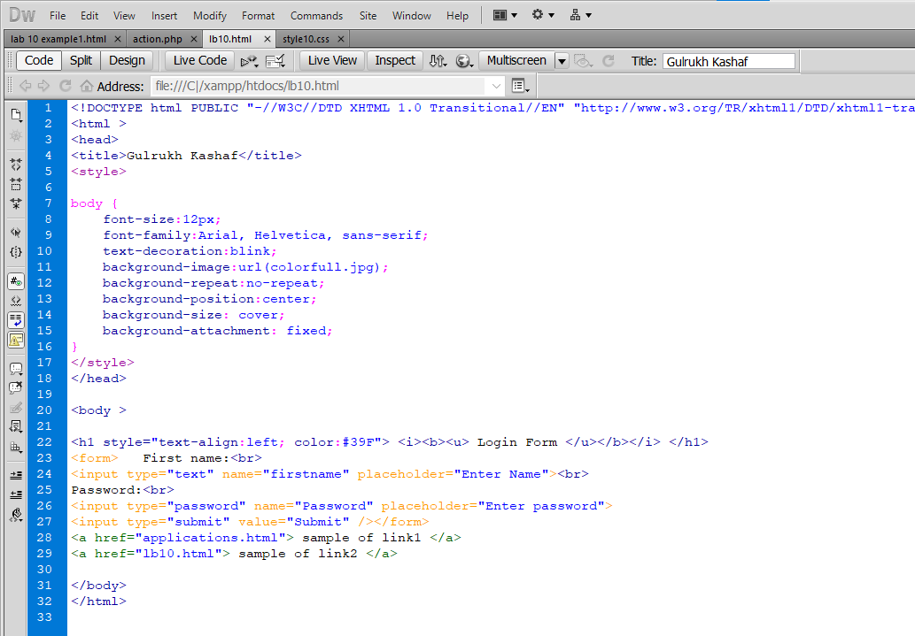

***Output:***

