**LAB # *12***

***Implement Server Site Scripting on MYSQL***

*The following illustrates the BikeStores database diagram:*

*The BikeStores sample database has two schemas sales and production, and these schemas have nine tables.*

*Create the given tables with the mentioned fields using XAMPP Server*.

***Create 9 database :***

***Database # 01 “Customer”:***

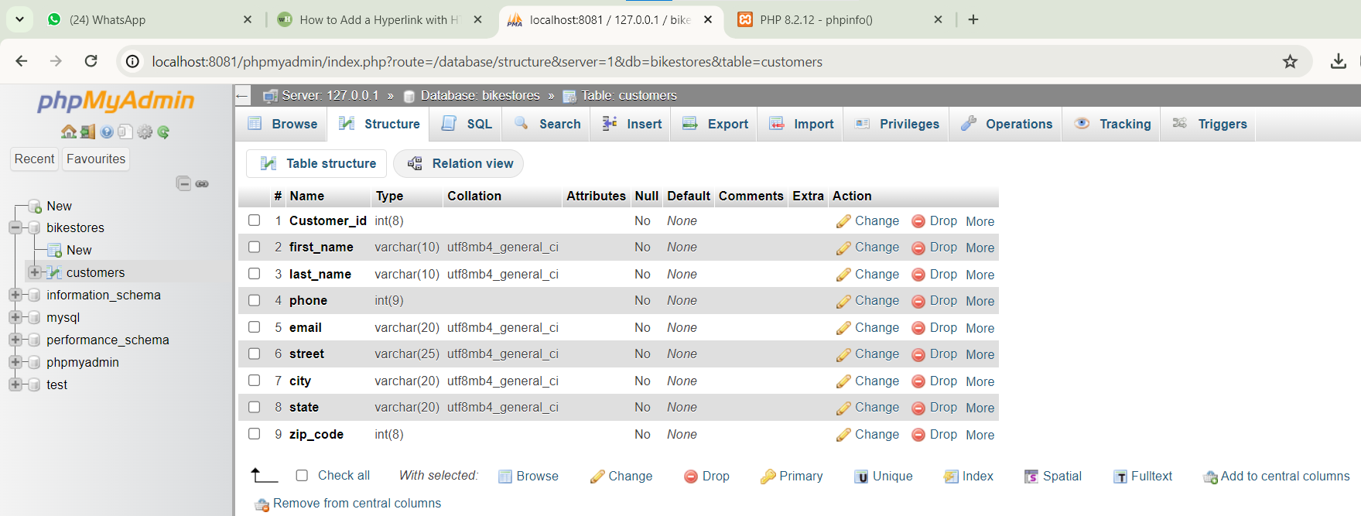

***Database # 02 “Staff”:***

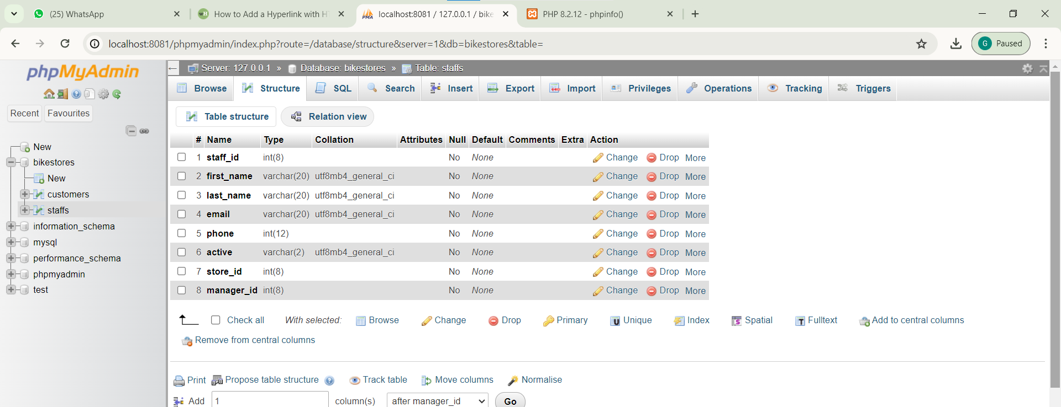

***Database # 03 “orders”:***

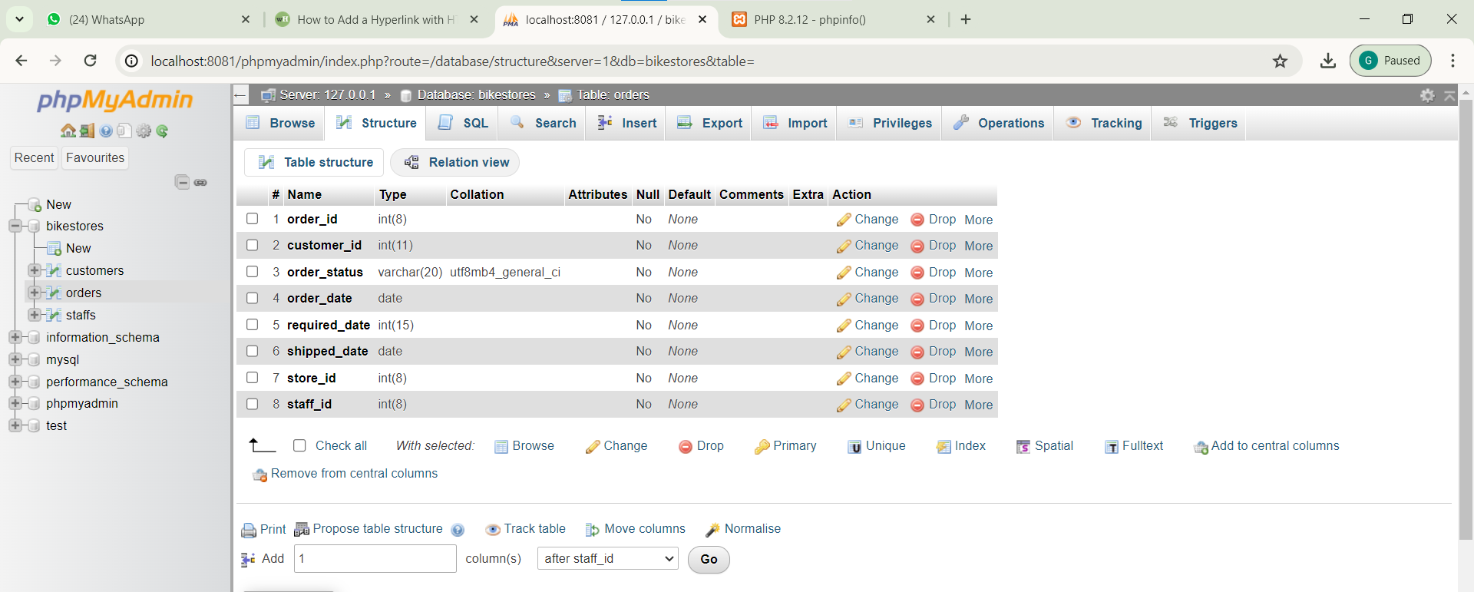

***Database # 04 “Stores”:***

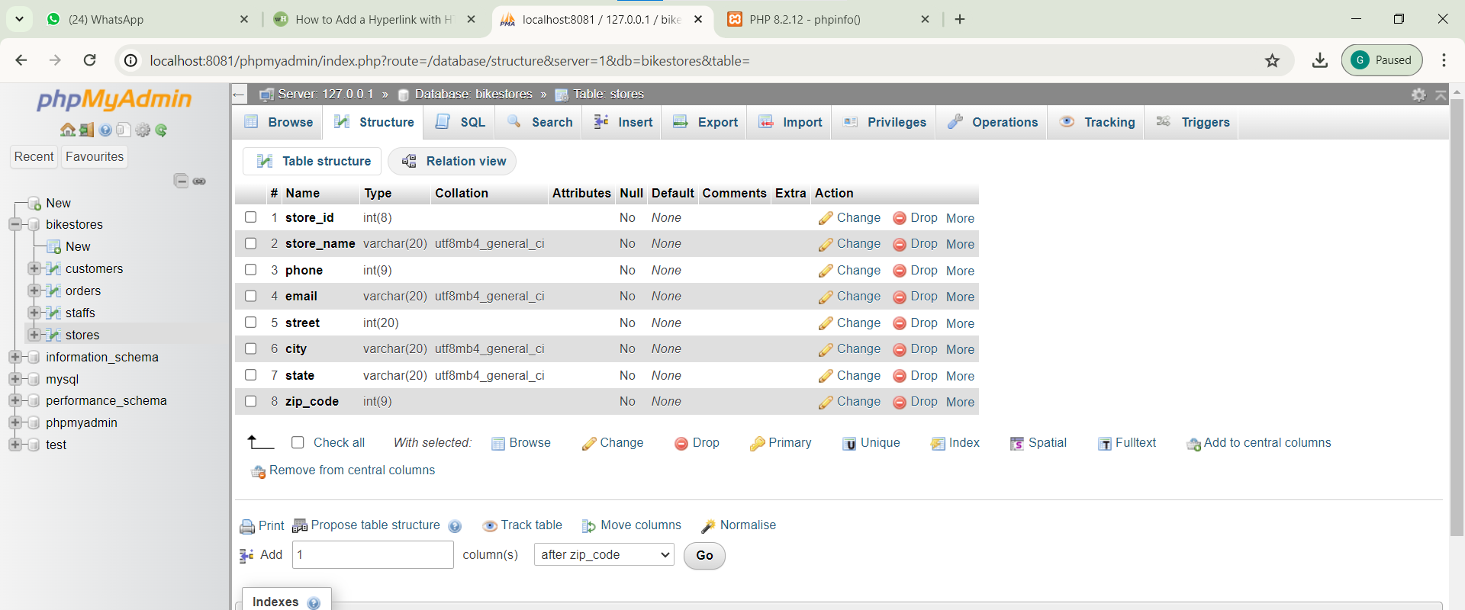

***Database # 05 “Order_items”:***

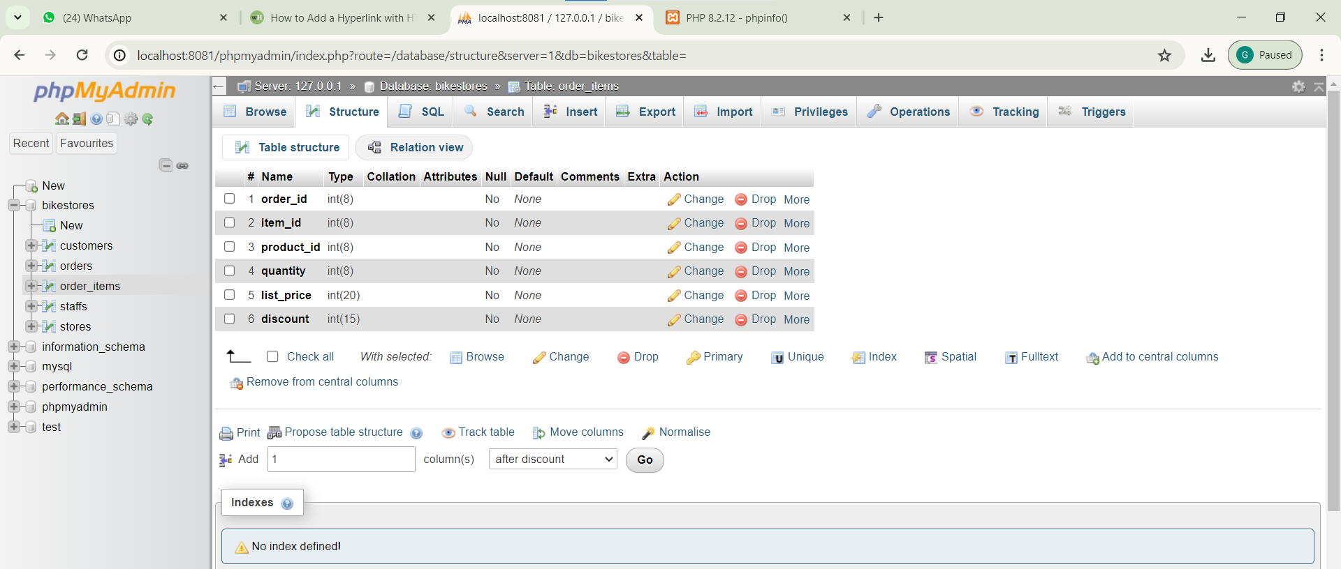

***Database # 06 “Categories”:***

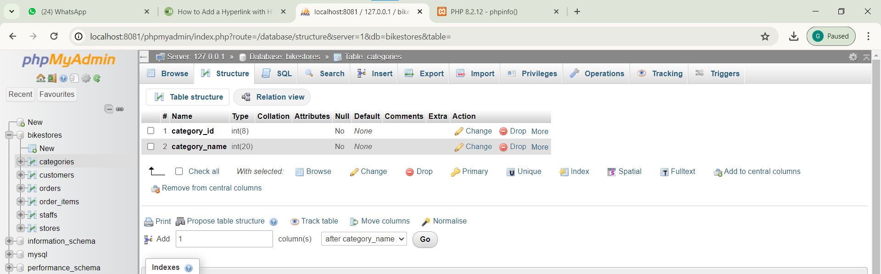

***Database # 07 “Products”:***

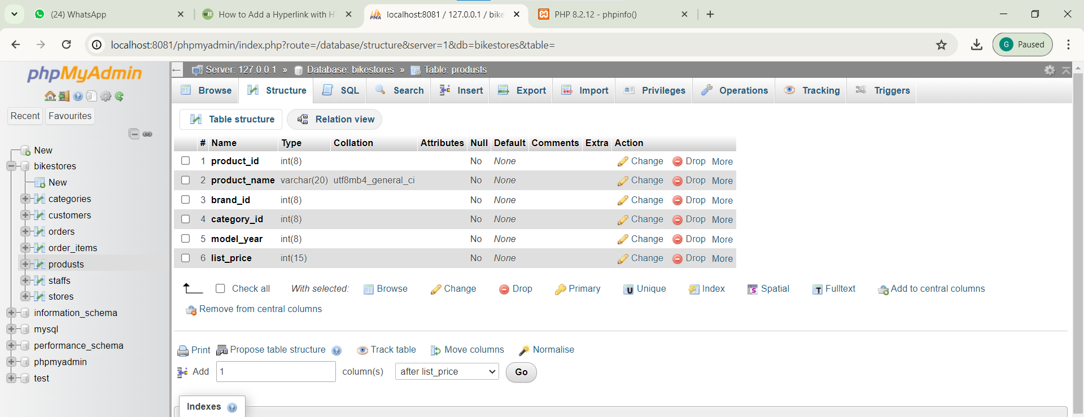

***Database # 08 “stocks”:***

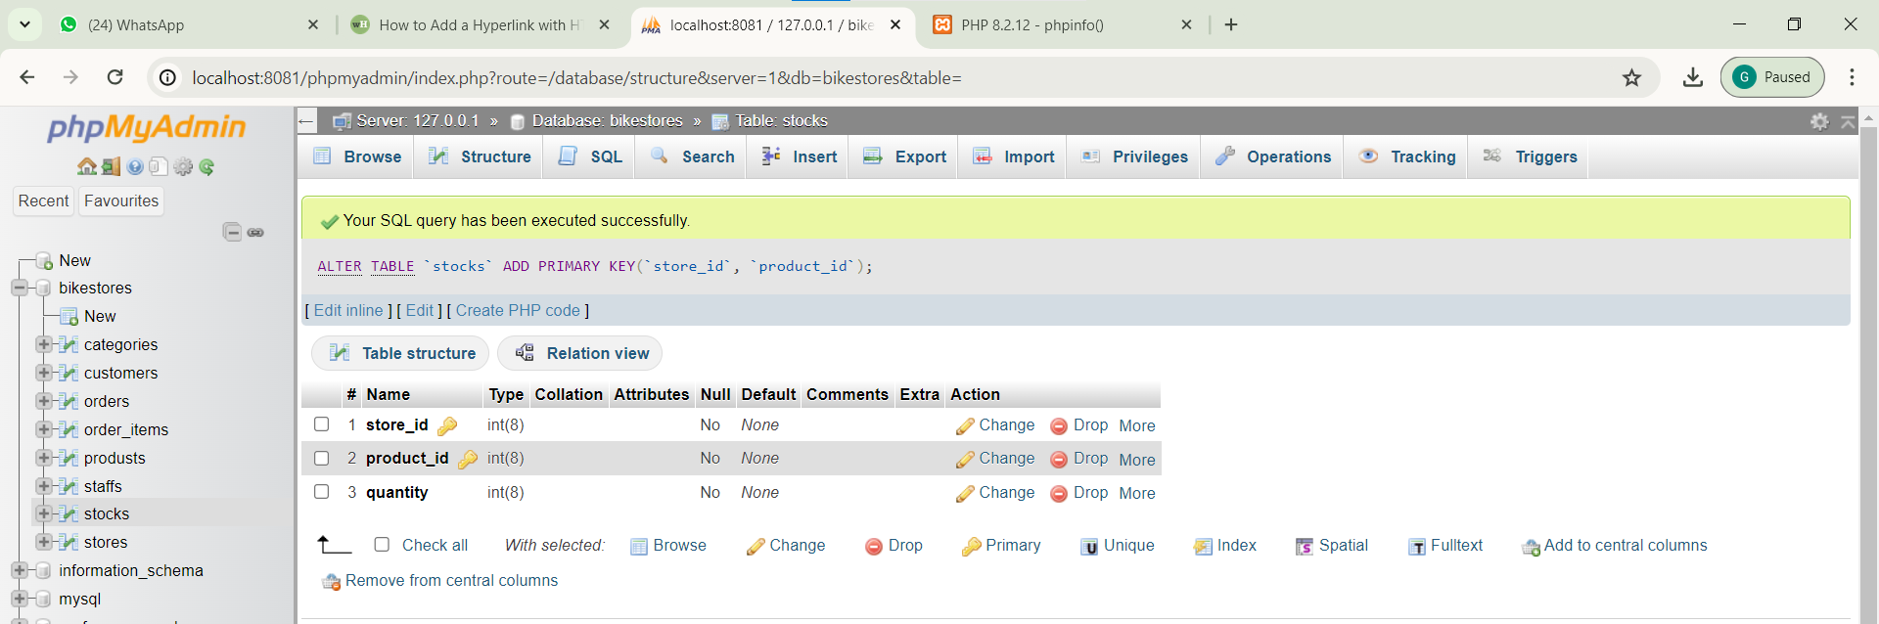

***Database # 09 “brands”:***

