**LAB # *03***

## *Creating Gantt Chart and PERT Chart using MS Project*

### *Exercise*

*Create Gantt Chart and Network Diagram in Microsoft Project with above mention projects.*

### Exercise # 01

1. *Social website like (Facebook, Twitteretc.)*

***GANTT CHART:***

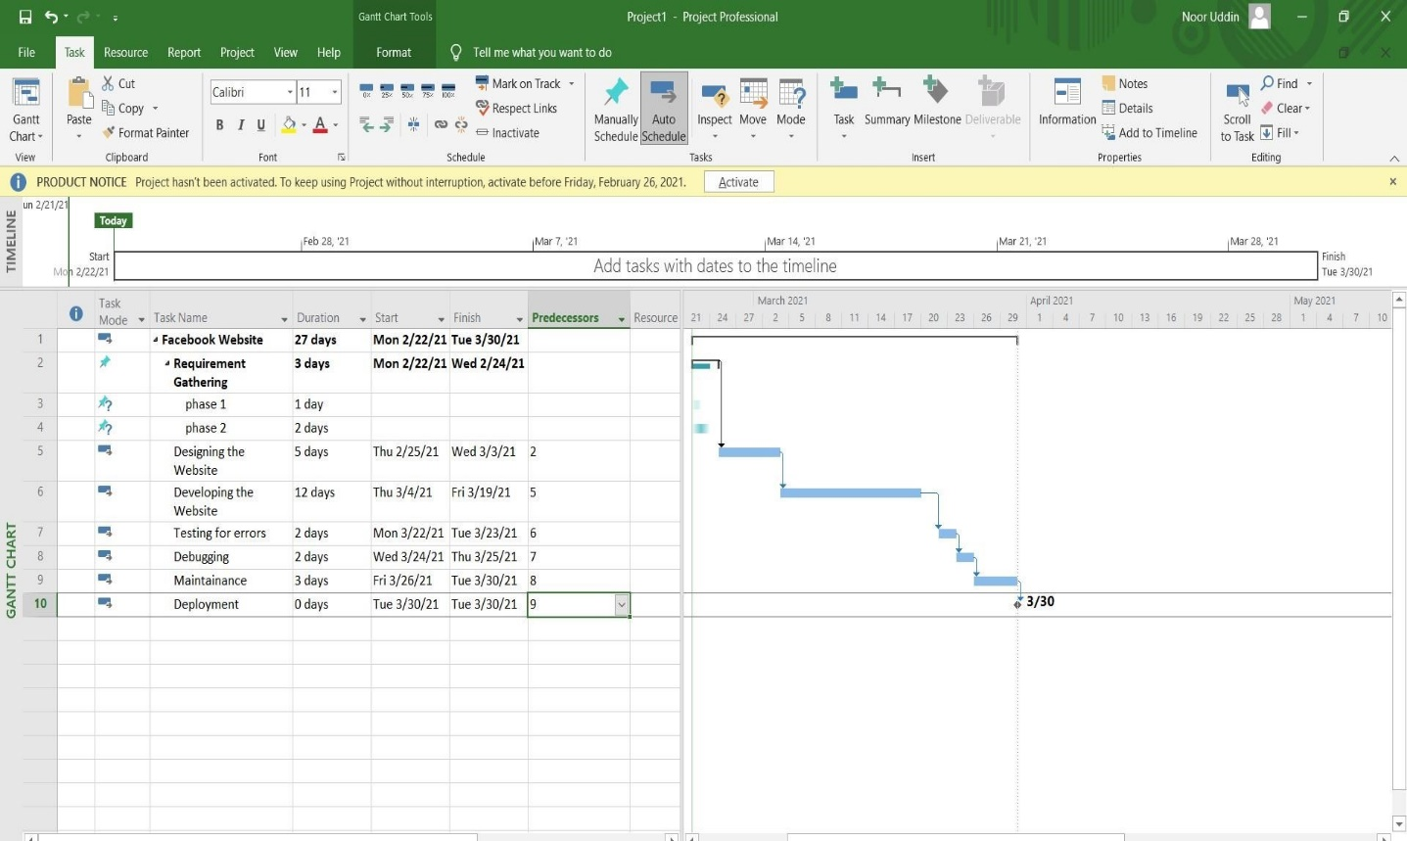

***NETWORK DIAGRAM:***

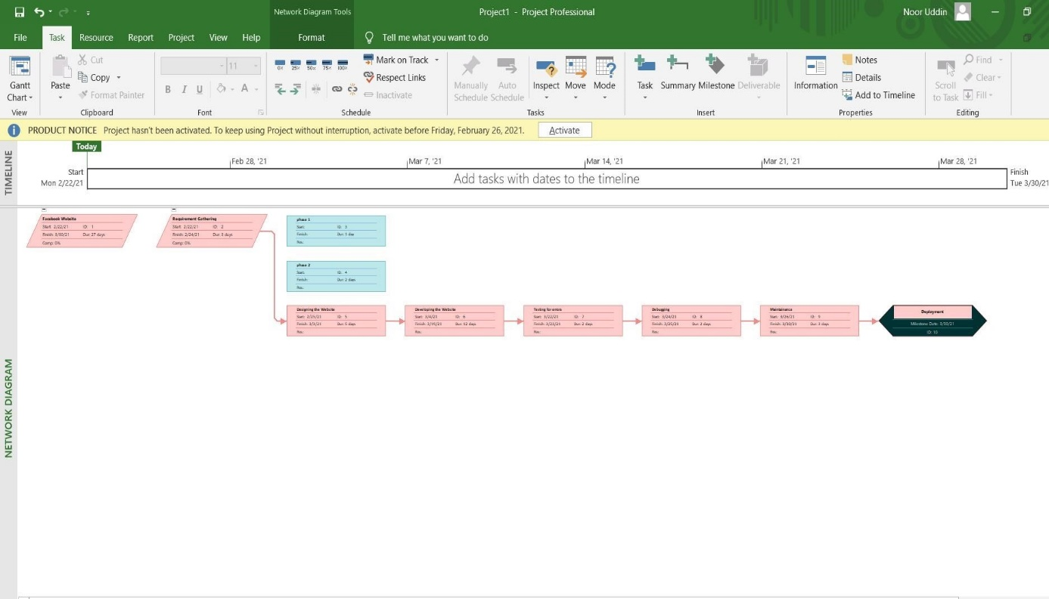

### Exercise # 02

1. Hospital Management System

***GANTT CHART:***

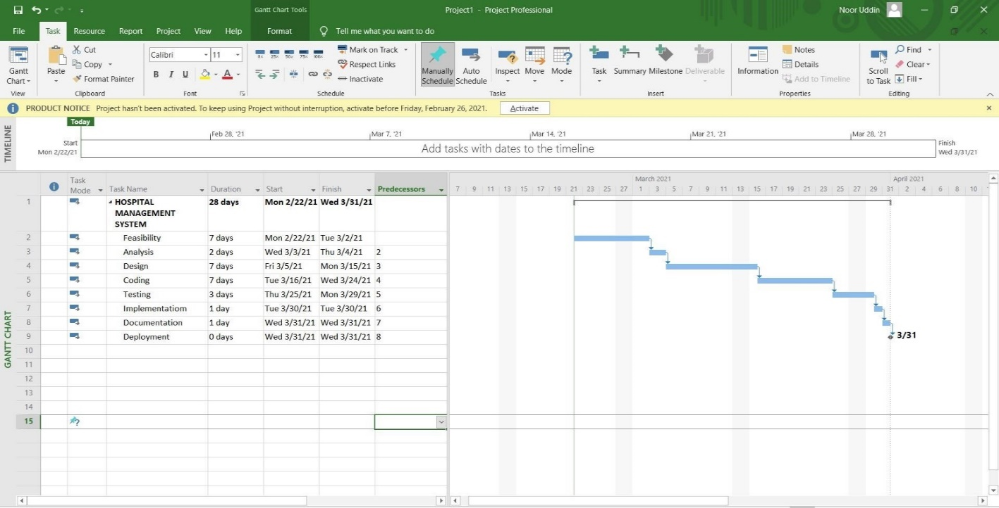

***NETWORK DIAGRAM:***

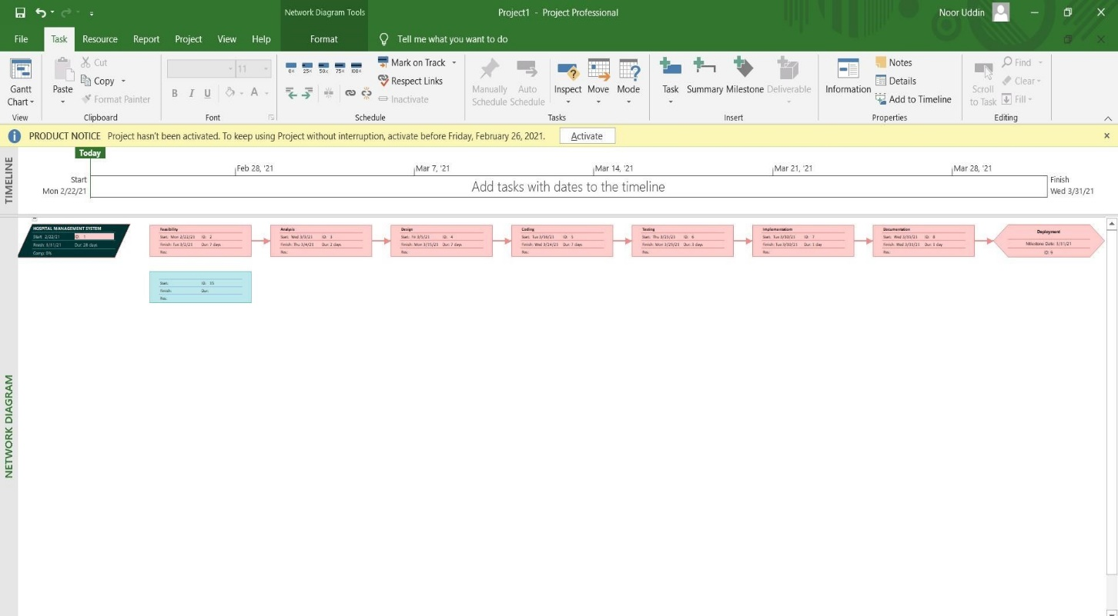

### Exercise # 03

1. Faculty Management System

***GANTT CHART:***

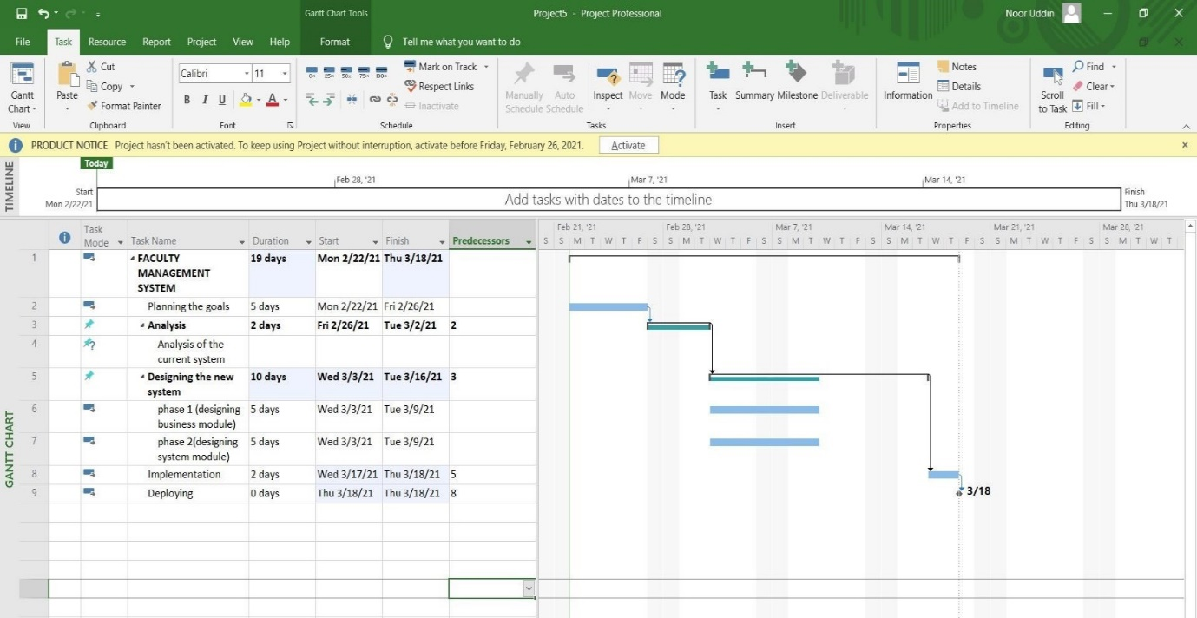

***NETWORK DIAGRAM:***

