**LAB # *05***

***Illustrate Use Case Diagram Using “Rational Rose”***

### *Exercise 5.1:*

*Draw a use case diagram of the stated scenario: A user has all the rights of login to a catalog management website browse the catalog and view products. Similarly, the administrator of that website has all the rights that a user has but in addition to that administrator has other rights too that include Logout, create product, edit product and to delete product. Find out the actors and relation of actor or actors to the use cases. Note: Show the relevant association of actors with the use cases.*

*State the Actors and Use Cases of the above stated scenario and describe briefly the dependencies between them*

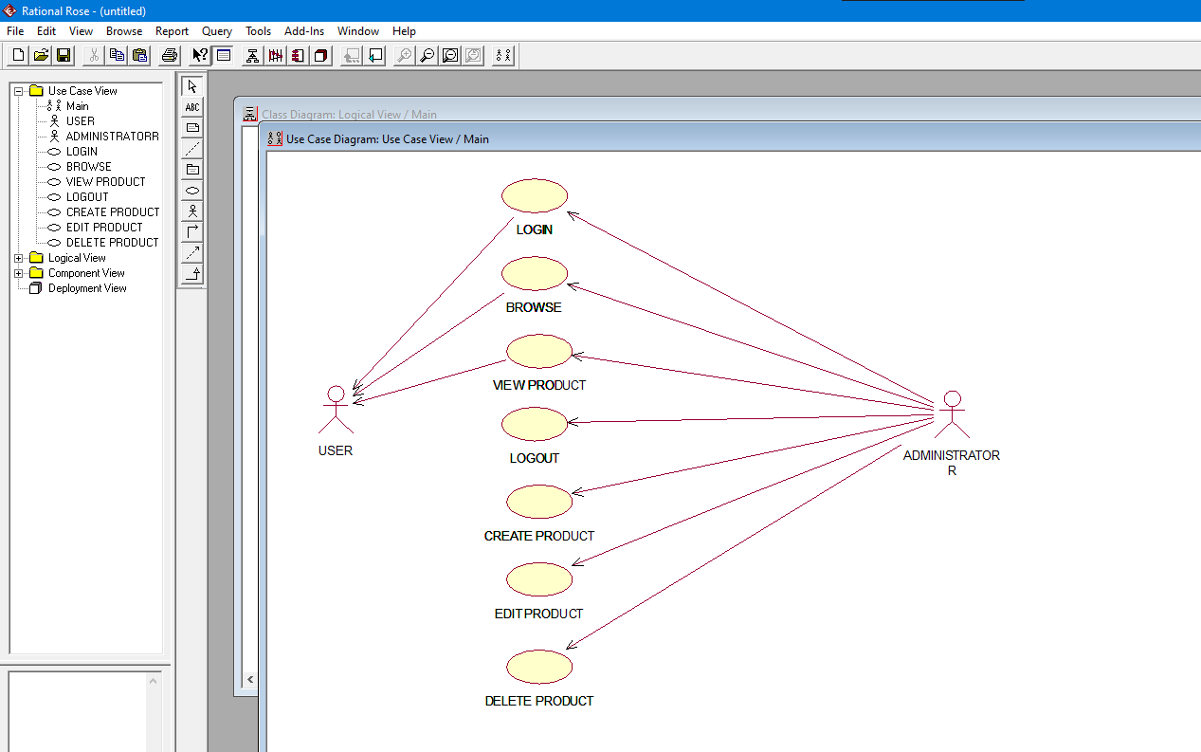

### *Exercise 5.2:*

*At the start of each semester a student can request a prospectus containing a course list. Information about a course is provided, such as the tutor, department and pre-requisites. The new system will allow students to create a schedule, then select four courses. Each student chooses two others in case their first choices become full or are cancelled. No course can have more than 10 students. No course can have less than 3 students or it will be cancelled. This will be the same functionality as available to other internal users of the system. When registration is complete, the registration system sends a message to the billing system to send out a bill to the student. Tutors use the system to find which classes they are teaching and who the students are. The registrar will administer the system. For a period at the beginning of the semester the student can change their schedule. Students must be allowed to access the system during this time to add or delete courses. Identify the Actors, Use Cases and Association of the given scenario.*

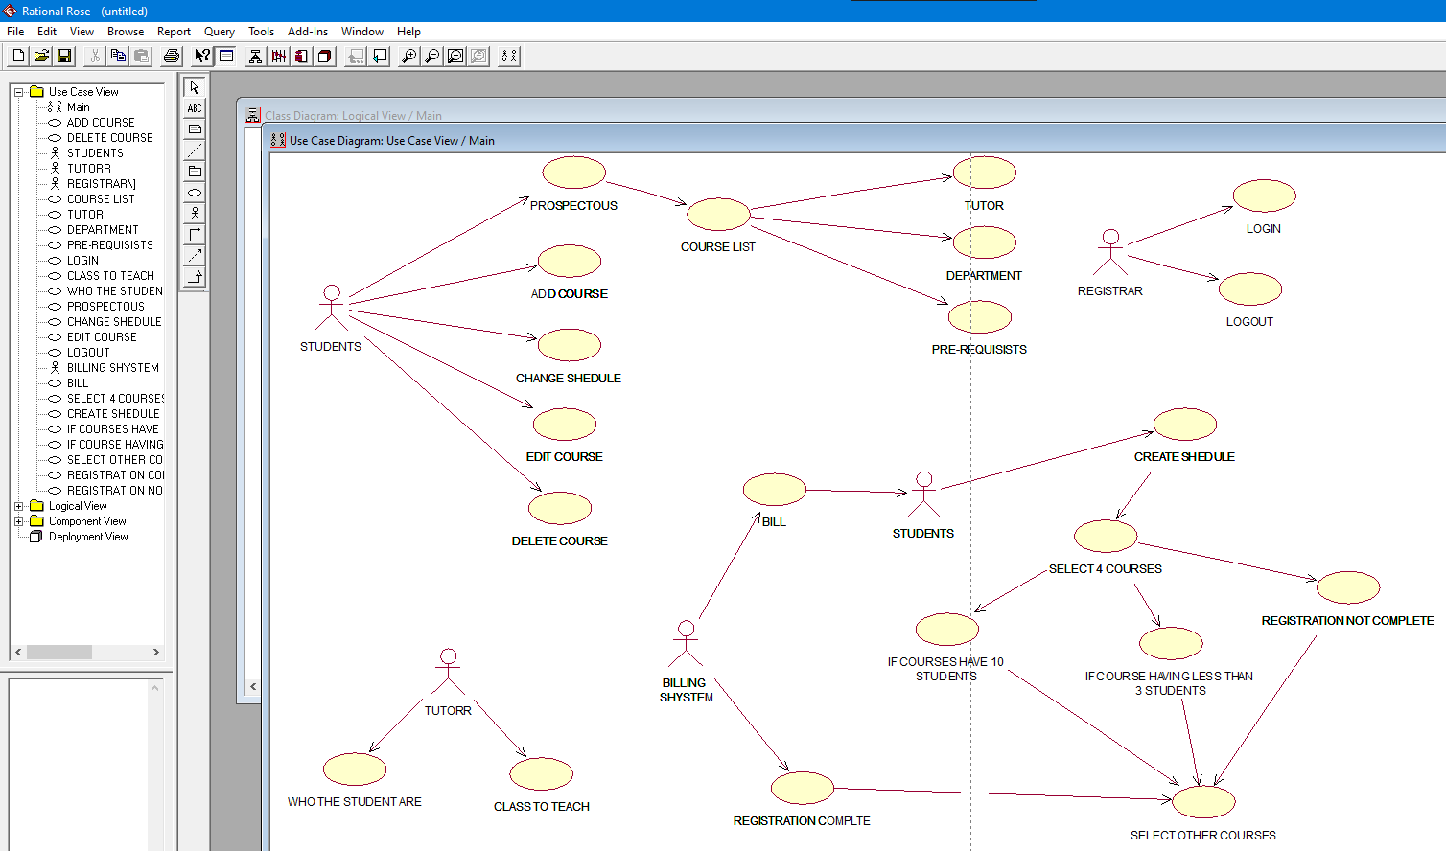

### *Exercise 5.3:*

***For the hospital Management System, a general example is shown below.***

*The Actors and their use cases are identified as: -*

***Task 1****: Receptionist--Interact with Visitors; Give appointments to Medical Representatives, Revert to Phone Queries, Handles Patient Registration.*

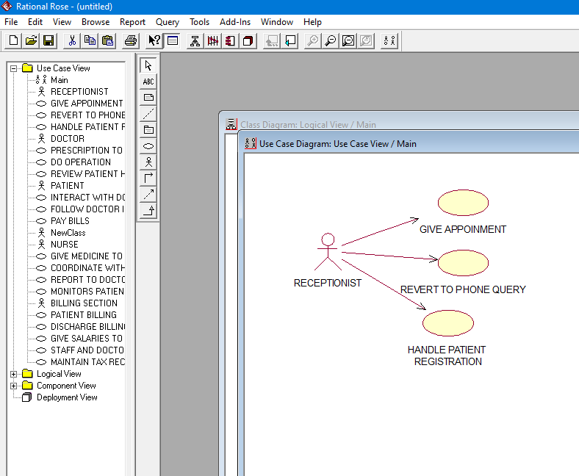

***Task 2****: Doctors--Give prescription to Patient, Do Operation, and Review Patients health.*

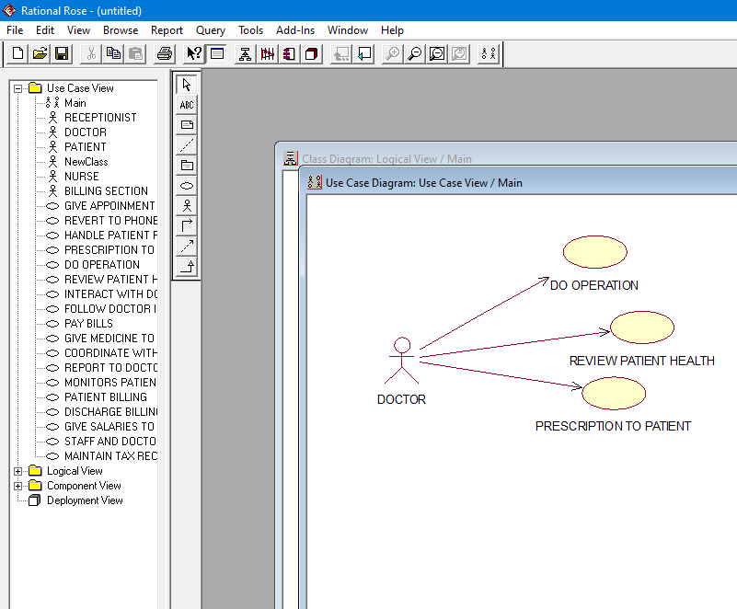

***Task 3:*** *Nurse--Give Medicine to Patient, Coordinate with Doctors in Operation, Report to doctors, Monitors Patients health.*

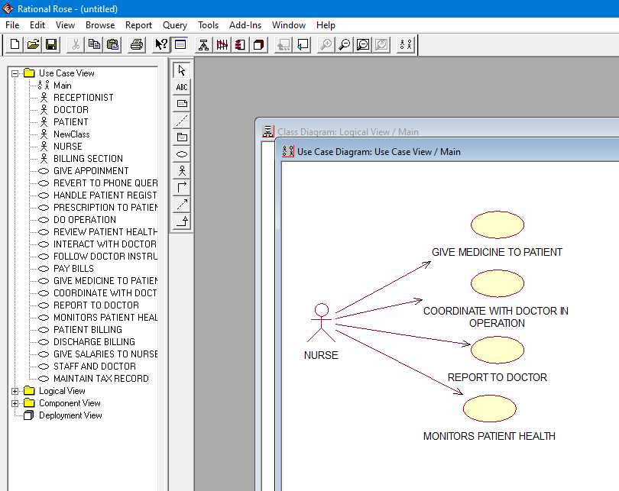

***Task 4:*** *Patient--Interact with Doctor, Follow Doctor Instructions, Pay Bills.*

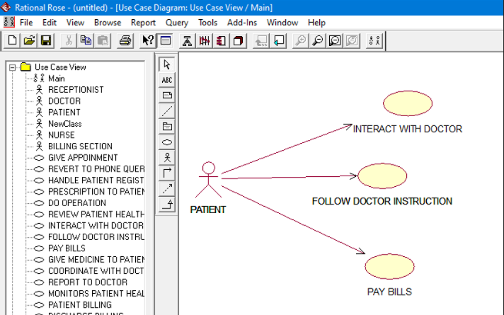

***Task 5:*** *Billing Section--Patient Billing, Discharge Billing, give salaries to Nurse, Staff and Doctors, Maintain Tax Records.*

*Here for the Billing Section we have considered Patient Billing and Discharge billing as separate, as the Patient might not be admitted and is charged for only counseling. Draw the Use Case Diagram for the above scenario.*

