**LAB # *06***

***Working with class Diagram of UML***

### *Exercise 6.1:*

***Develop a Class Diagram using the specifications given below:***

*• Add the PeopleInformation, UniversityArtifacts, and Interfaces packages to the Main class diagram.*

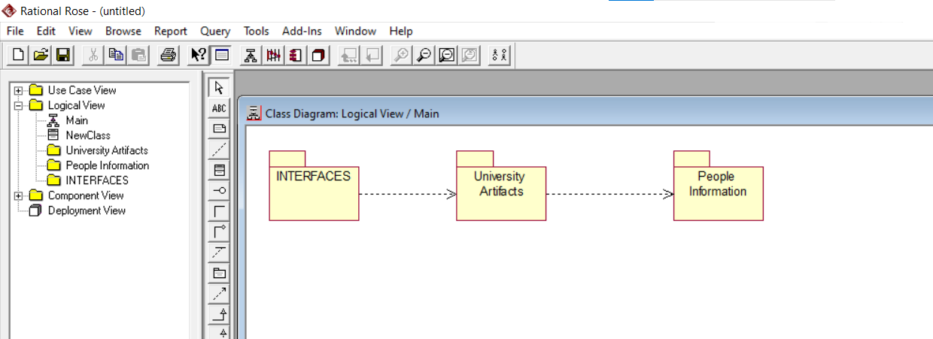

**Create the Main class diagram for each package**

*. • Add the StudentInformation and ProfessorInformation classes to the PeopleInformation package Main class diagram.*

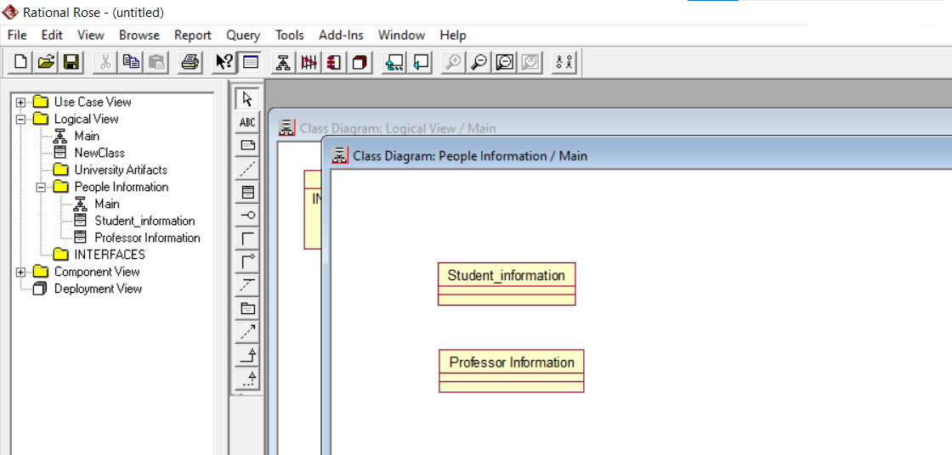

*• Add the Course and CourseOffering classes to the UniversityArtifacts package Main class diagram*

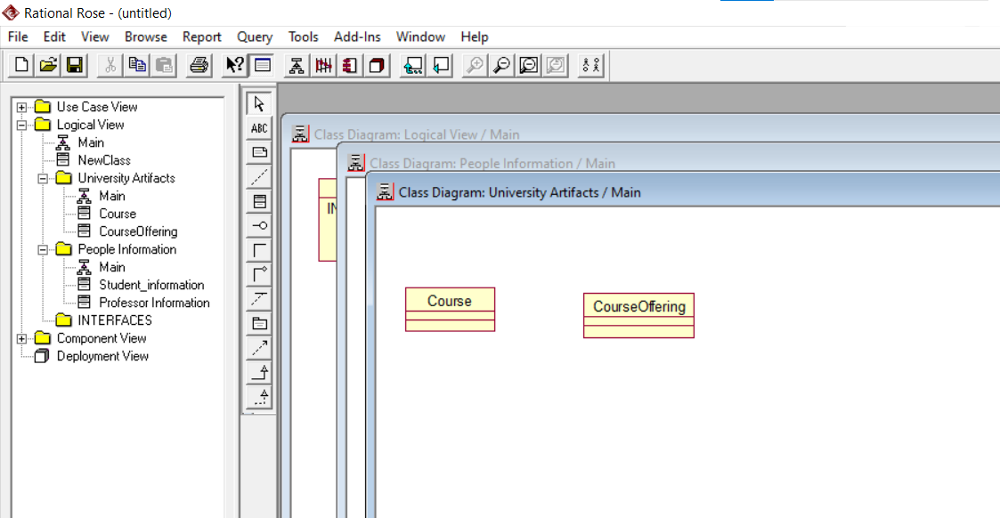

*. • Add the CourseOptionsForm and CourseForm classes to the Interfaces package Main class diagram.*

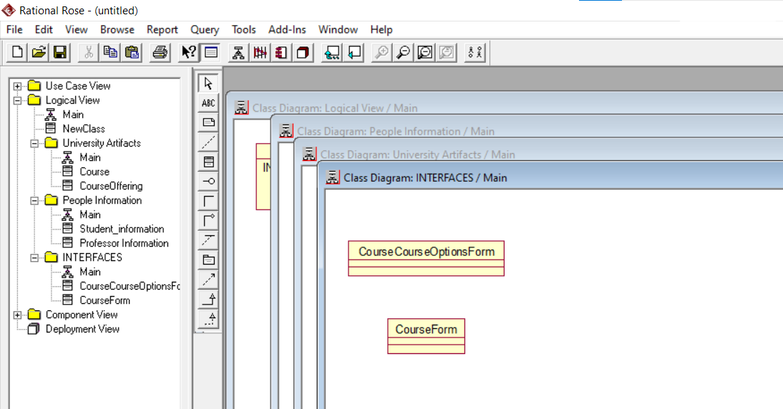

*• Create a new class called Catalog using the toolbar and place it on the UniversityArtifacts package Main class diagram. Don‘t forget to document the new class.Create a new class diagram called Course Information for the UniversityArtifactspackage. Add the Course class to the Course Information class diagram*

