*LAB # 01*

INTRODUCTION to oop

# *OBJECTIVE:*

*To understand OOP (Java Environment), Data Types and Mixed Athematic Expression*

LAB Exercise

**Exercise # 01:**

**Code:**

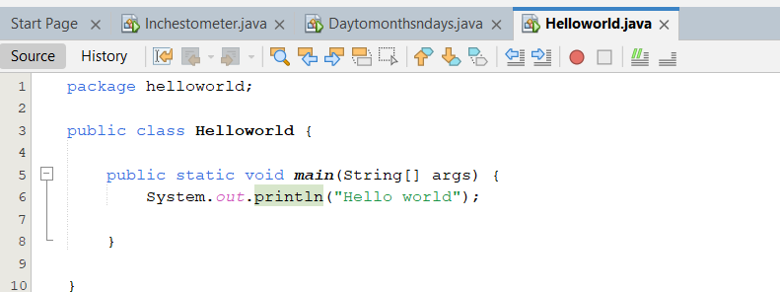

**Output:**

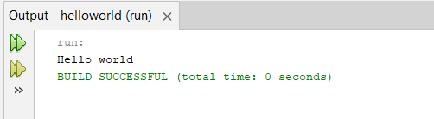

**Exercise # 02:**

**Code:**

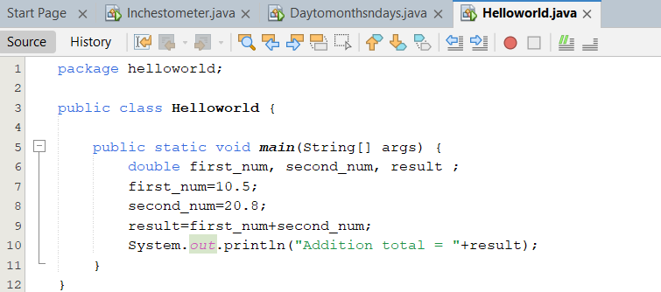

**Output:**

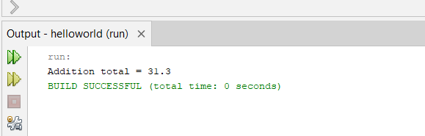

**Exercise # 03:**

**Code:**

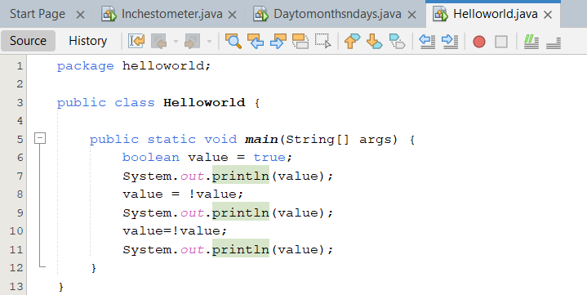

**Output:**

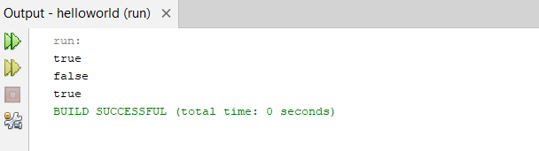

**Exercise # 04:**

**Code:**

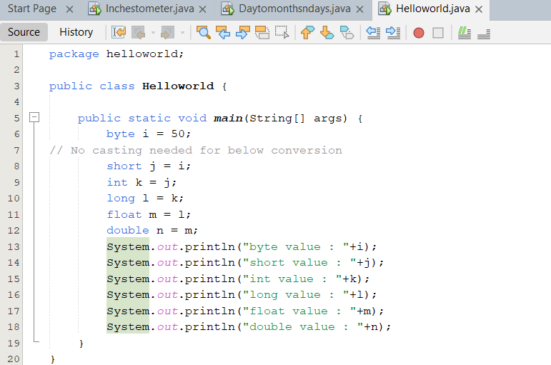

**Output:**

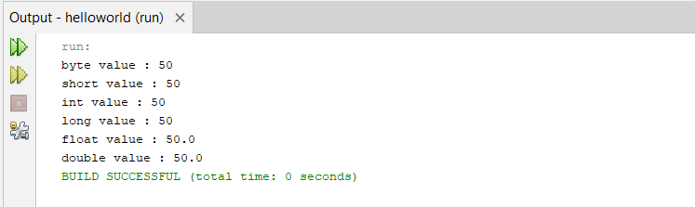

**Exercise # 05:**

**Code:**

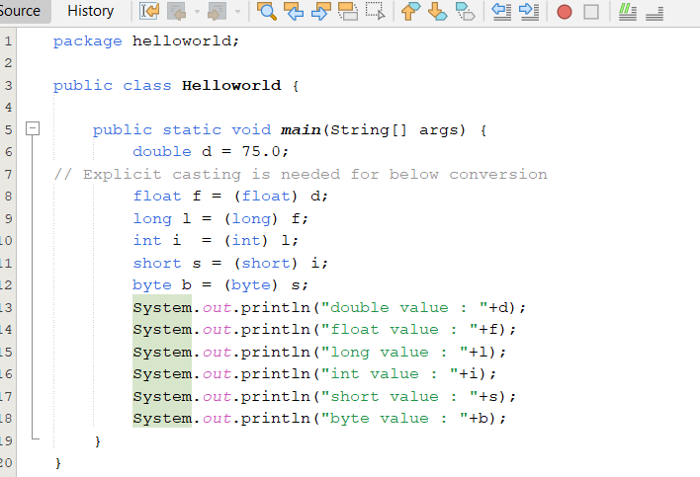

**Output:**

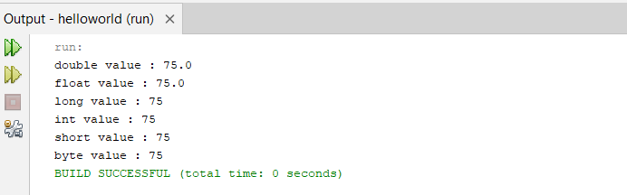

LAB task

**Task # 01:**

*1. Write a Java program that reads a number in inches, converts it to meters. Note: One inch is 0.0254 meter.*

*Example: Test Data Input a value for inch: 1000.*

*Expected Output: 1000.0 inch is 25.4 meters.*

**Code:**

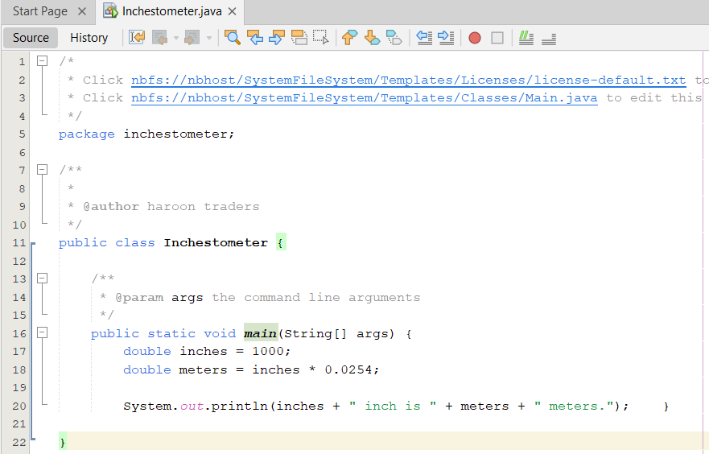

**Output:**

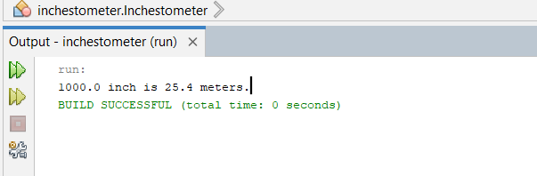

**Task # 02:**

*Write a Java program to convert days into number of months and days.*

*Example: Test Data Input the number of days: 69.*

*Expected Output: 69 days are 2 months and 9 days.*

**Code:**

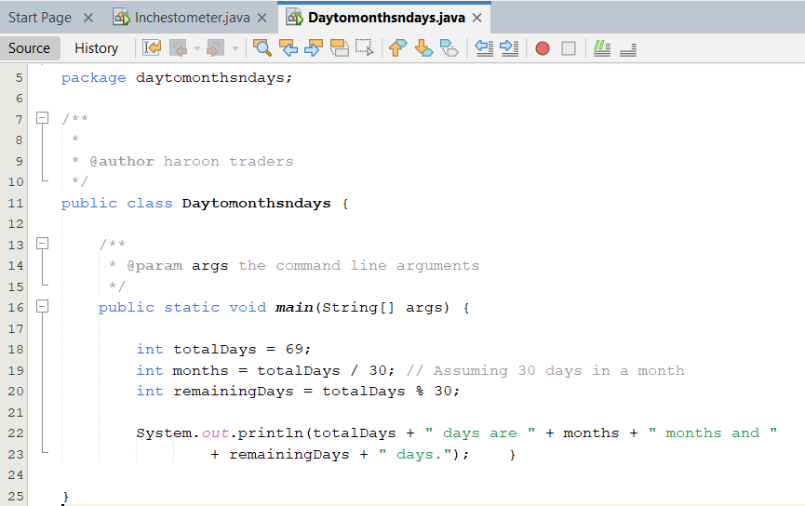

**Output:**

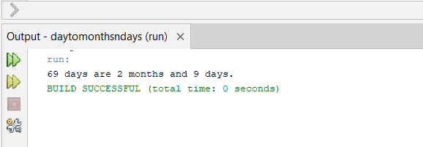

**Task # 03:**

*Write a Java program to compute body mass index (BMI).*

*Note: weigh in kilogram = weight * 0.45359237.*

*height in feet= inches * 0.0254.*

*BMI= weight in kilogram/(height in fee)^2.*

**Code:**

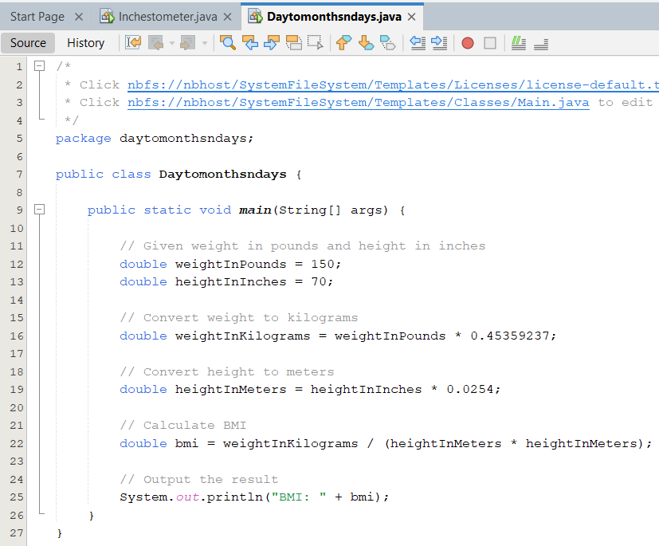

**Output:**

