*LAB # 10*

abstract classes, interface and final keyword

# *OBJECTIVE:*

*To Study abstract classes, interface and final keyword*

LAB TASK

**Task # 01:**

*Create an Interface Shape with three child classes Circle, Square and Rectangle. Create a method Draw in each class. Create an Object of each class that can call the method Draw and it will call automatically the Draw method of each class. The text of Draw method e.g. Circle is "This is a Circle".*

**Code:**

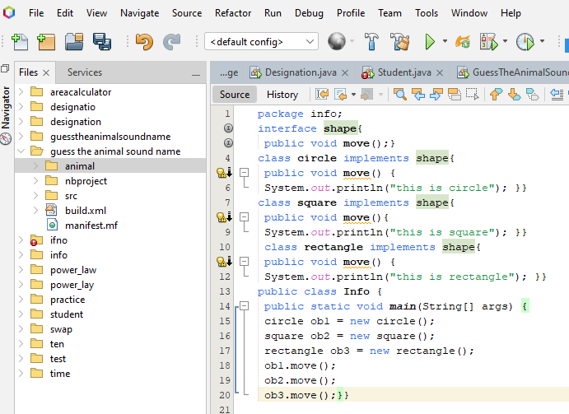

**Output:**

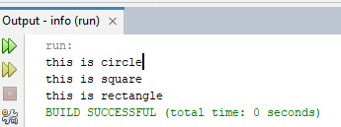

**Task # 02:**

*Define an abstract base class Shape that includes protected data members for the (x, y) position of a shape, a public method to move a shape, and a public abstract method show() to output a shape. Derive subclasses for lines, circles, and rectangles. Also, define the class PolyLine as its base class. You can represent a line as two points, a circle as a center and a radius, and a rectangle as two points on diagonally opposite corners. Implement the toString() method for each class. Test the classes by selecting ten random objects of the derived classes, and then invoking the show() method for each. Use the toString() methods in the derived classes*

**Code:**

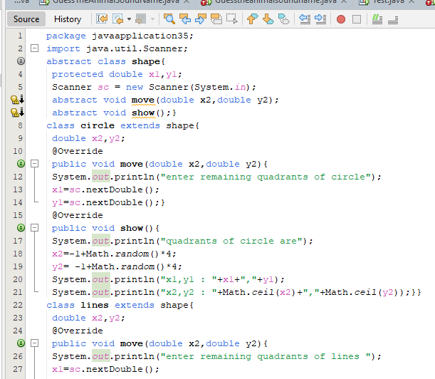

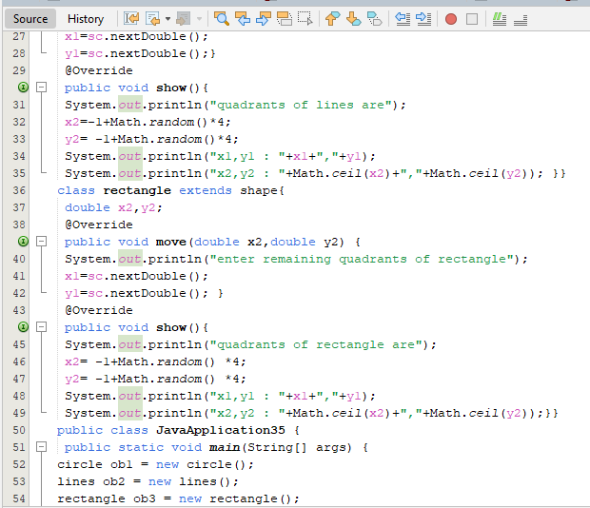

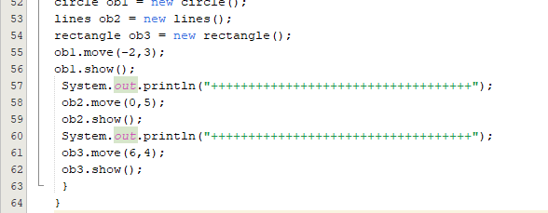

**Output:**

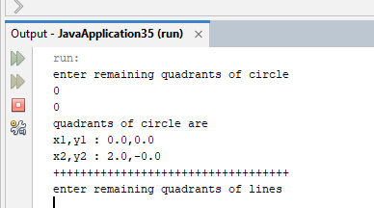

**Task # 03:**

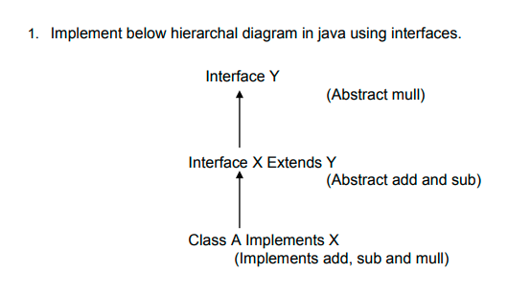

**Code:**

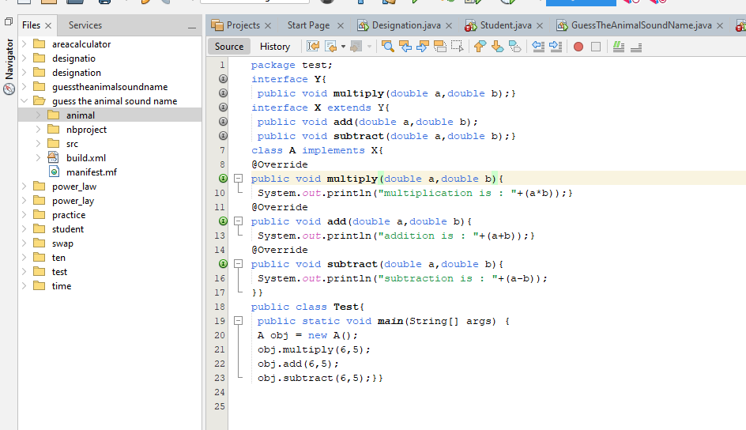

**Output:**

