*LAB # 13*

creating your own - exception

# *OBJECTIVE:*

*To study to create your own exception*

**Task # 01:**

*Add an exception class that calls a method to throw an exception to invigilate customer’s age in the cinema hall. When the user enters age less than 18 so an exception should be created displaying not eligibility message in the output.*

**Code:**

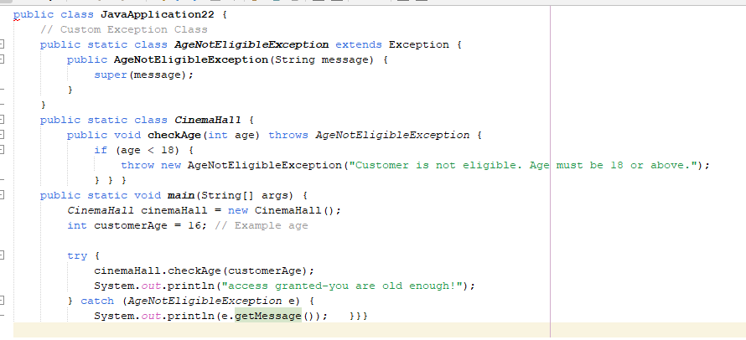

**Output**

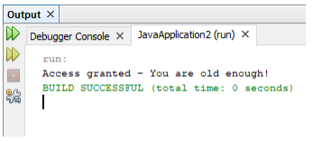

**Task # 02:**

*Drive two Classes. One is of exception class and another is of using the exception class, prompt to deposit the money ranging from 1000 to 50,000 and display “money has been deposit.” else generate an “error.” by calling the exception in both the cases. (Hint: try-catch*

**Code:**

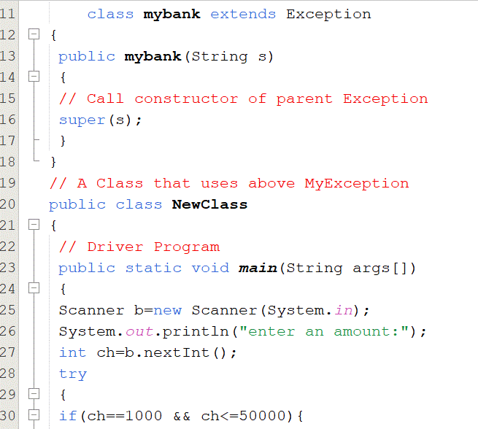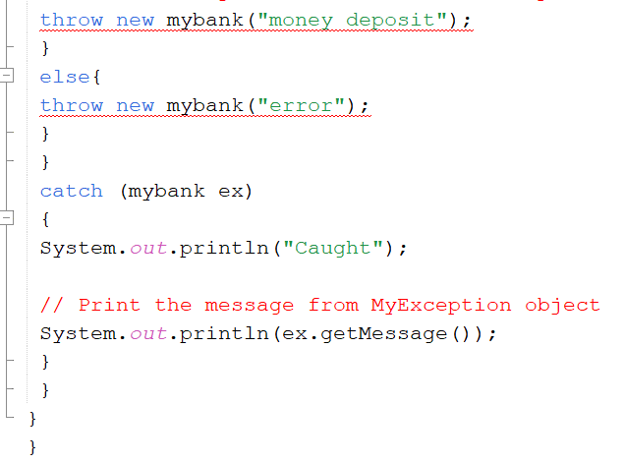

**Output**

