*LAB # 14*

wrapper classes, scanner class and array class

# *OBJECTIVE:*

*To det familiar with wrapper classes, scanner classes and array classes*

LAB TASK

**Task # 01:**

*Write a program to take the integer value from the user and convert an integer into binary, hexadecimal, and octal with the help of methods defined in wrapper class of Integer and Long.*

**Code:**

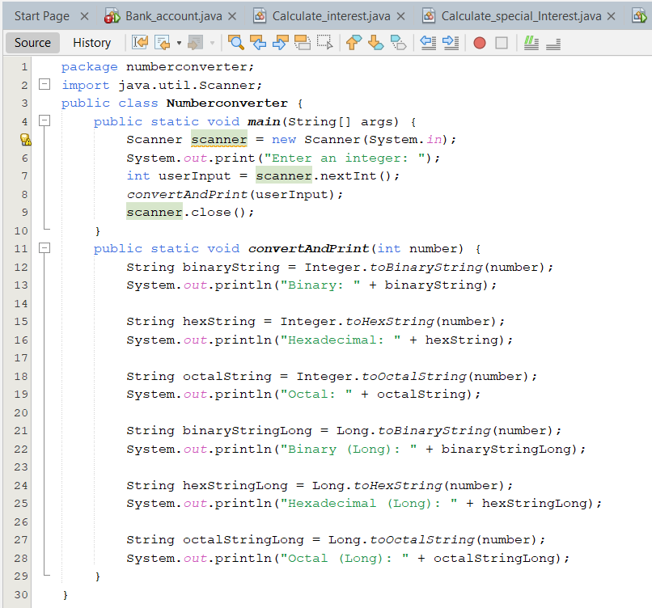

**Output**

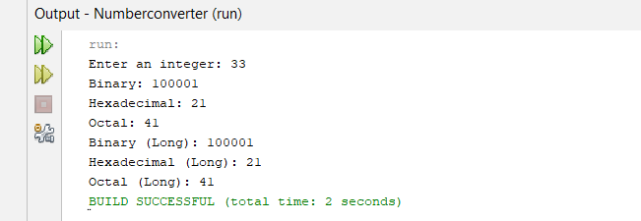

**Task # 02:**

*Write a program to display the sign of the Zodiac corresponding to a birth date entered through the keyboard.*

**Code:**

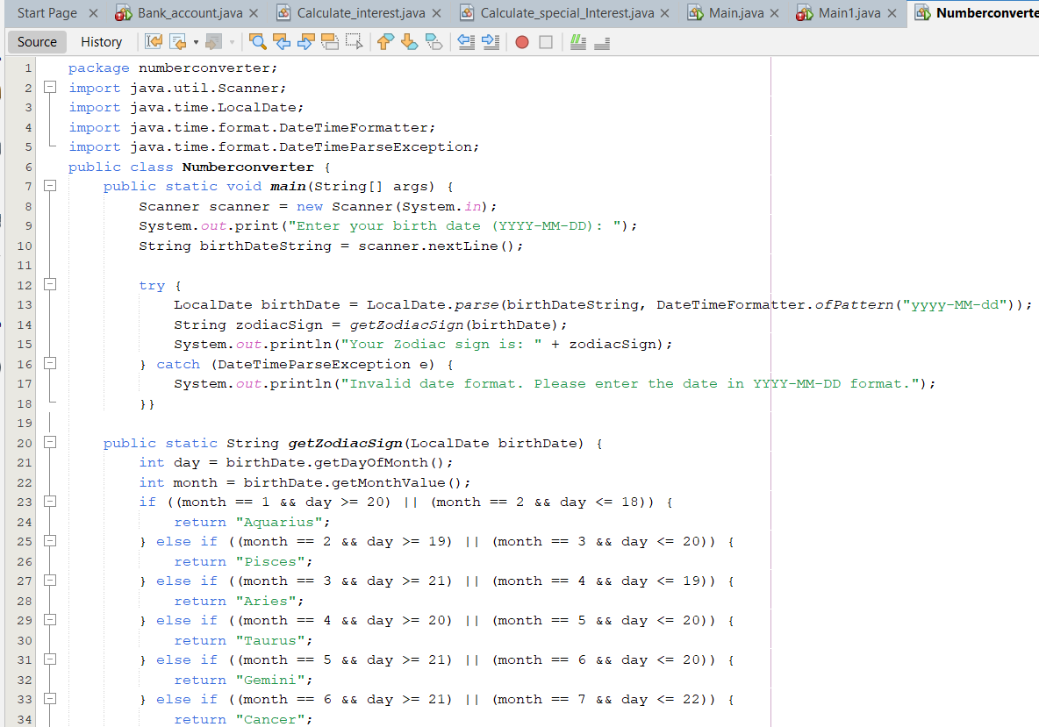

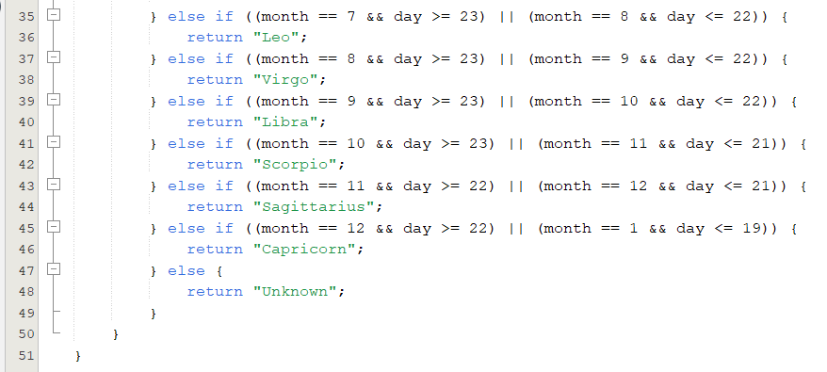

**Output:**

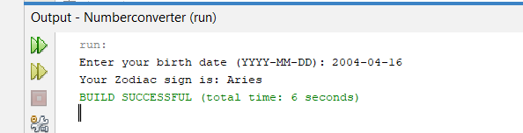

**Task # 03:**

*Write a program to take 10 integer values from the user and display the odd values with their indexes and copy of the original array by using the search and copy method respectively, define in array class. Example: Array= {11,22,33,44,55,66,77,88,99,111}*

*Sample Output: 11 found at index= 1 33 found at index= 3 55 found at index= 5 77 found at index= 7 111 found at index= 9 Array= {11,22,33,44,55,66,77,88,99,111*

**Code:**

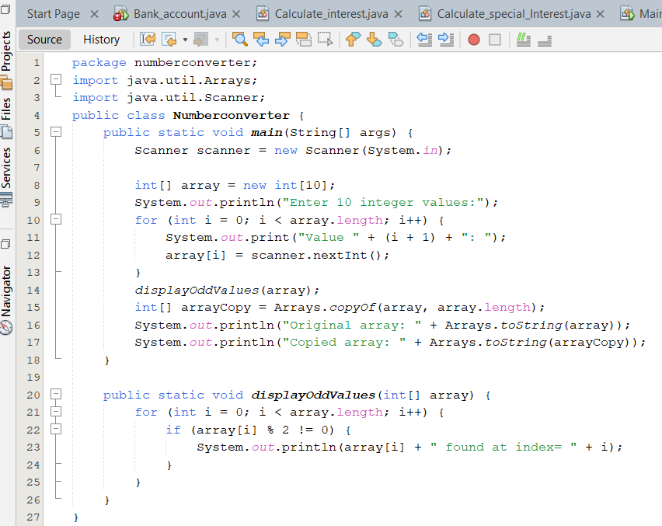

**Output:**

