*LAB # 05*

INTRODUCTION CLASSES. METHODS AMD CONSTRUCTOR

# *OBJECTIVE:*

*To Study classes, methods and constructor*

**Task # 01:**

*Write a program that create two classes one is Power_law another is the main method class. Power_law class contains current, voltage and power fields in integer datatype, and a method to calculate power and display the output.*

**Code:**

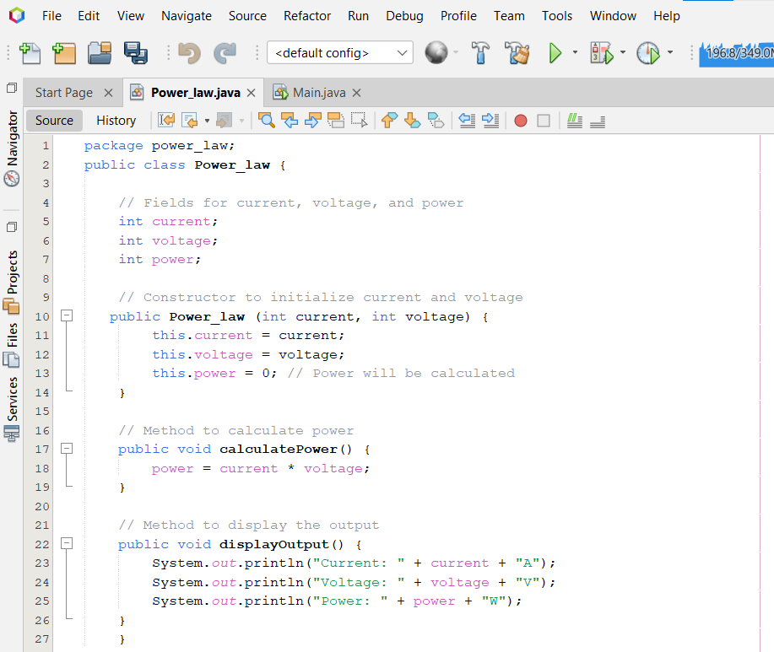

**Main class:**

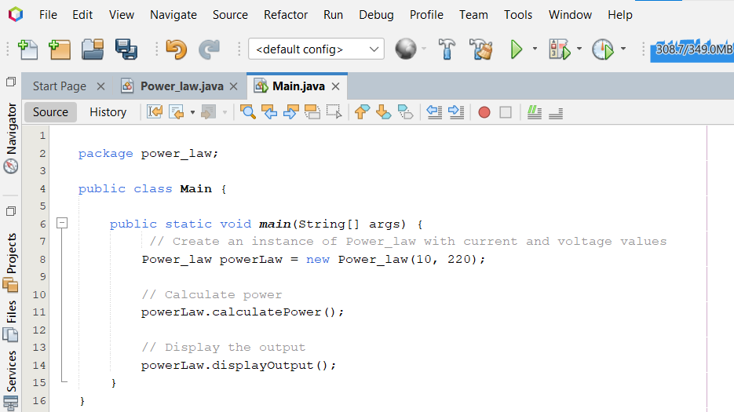

**Output**

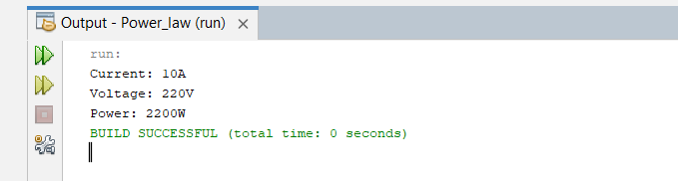

**Task # 02:**

*Write a program that creates two classes one is Student another is the main method class. student contains private fields of roll-no, semester, GPA, and use a constructor and a method to get and show the above information of three students using get and show method in java..*

**Output**

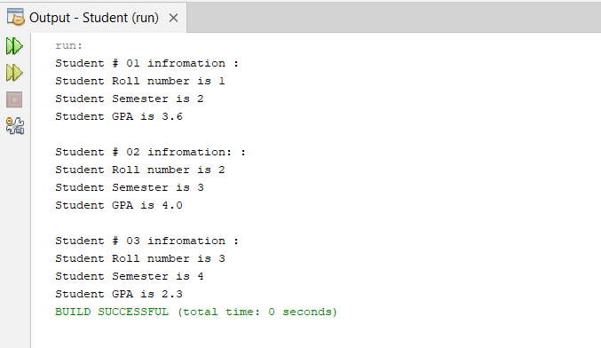

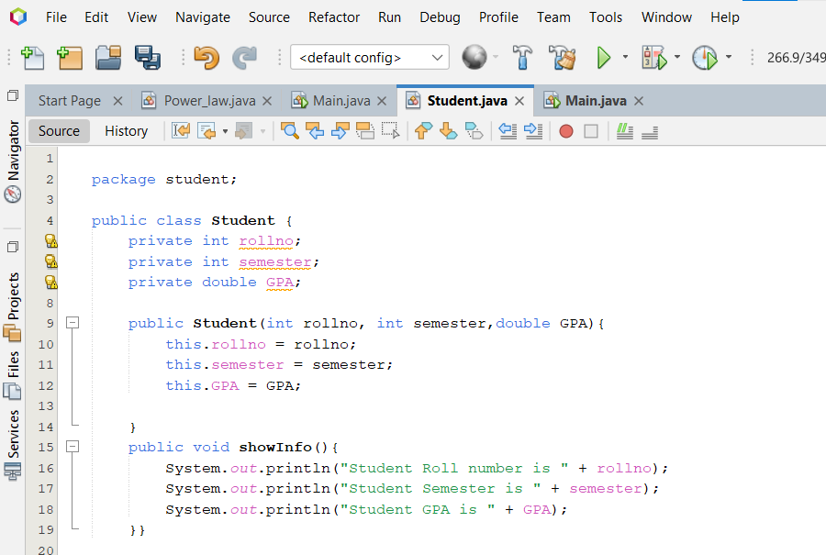

**Main class:**



