*LAB # 06*

INTRODUCing Method and constructor overloading

# *OBJECTIVE:*

*To Study methods overloading and constructor overloading*

**Task # 01:**

*Write a program that creates two classes one is Employee and another is the main method class. Employee class contains emp_code, name, designation and salary fields, and three constructors; one is a default constructor, the second constructor contains three field emp-code, name, and designation and if the designation is clerk set salary of Rs. 5000 if the designation is peon set salary of Rs. 2000 and if manager set salary of Rs. 10000 for others set the salary of Rs. 1000 and third constructor contain four fields emp_code, name, designation, and salary. Display information of employee using display method In Java..*

**Code:**

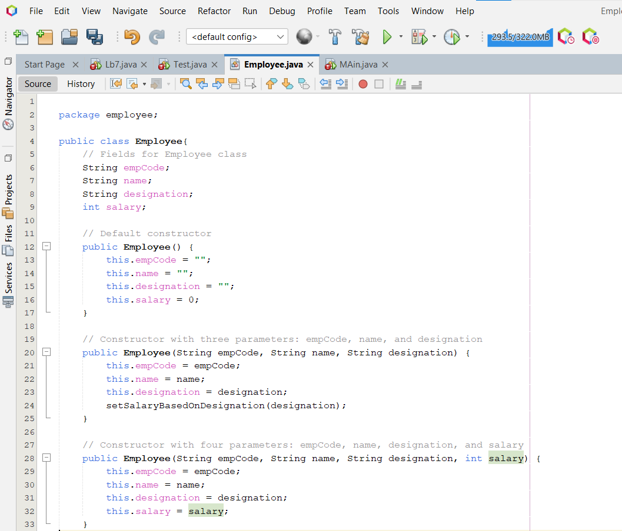

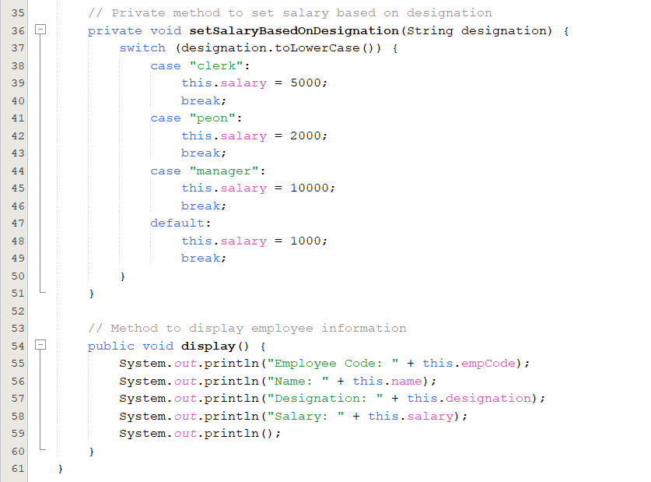

**Main class:**

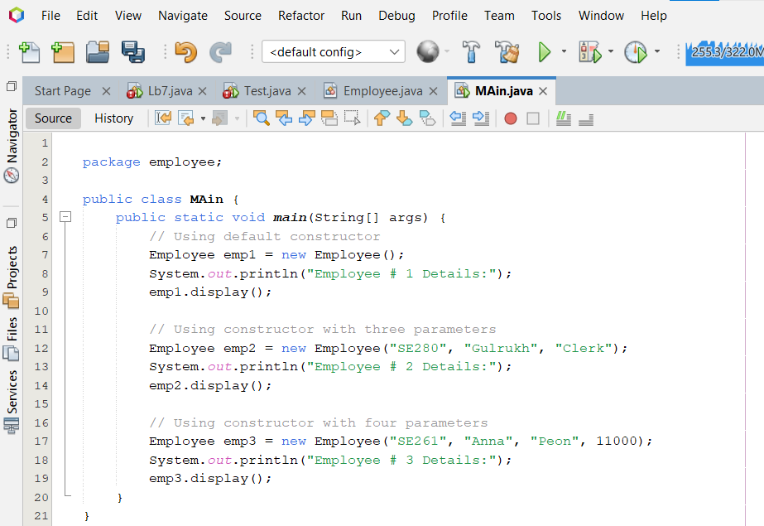

**Output**

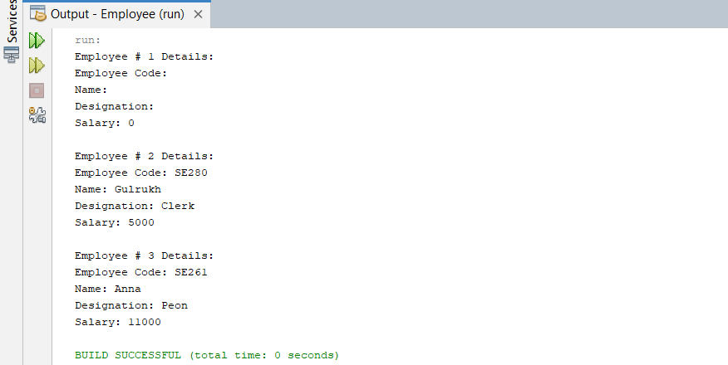

**Task # 02:**

*Write a program that creates two classes one is Measurement, and another is the main method class. Measurement class contain km, meter, millimeter in decimal and a constructor and three methods; first method will return the round off kilometer, the second method will return the round off meter and third will return the round off millimeter. Takes the values and display them.*

**Code:**

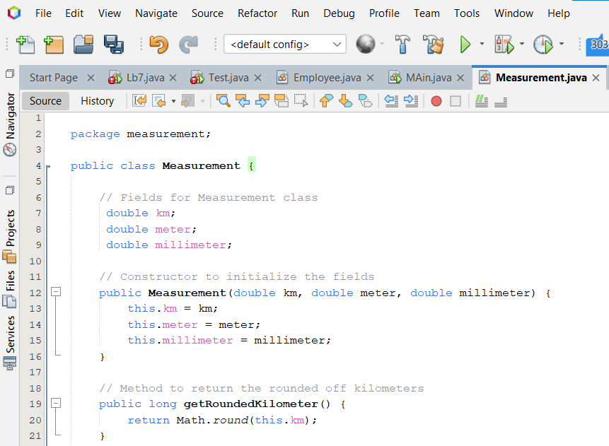

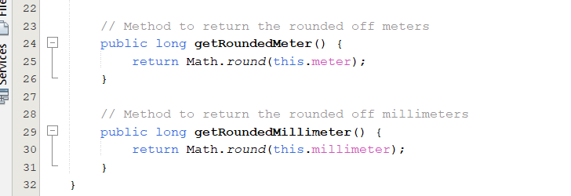

**Main class:**

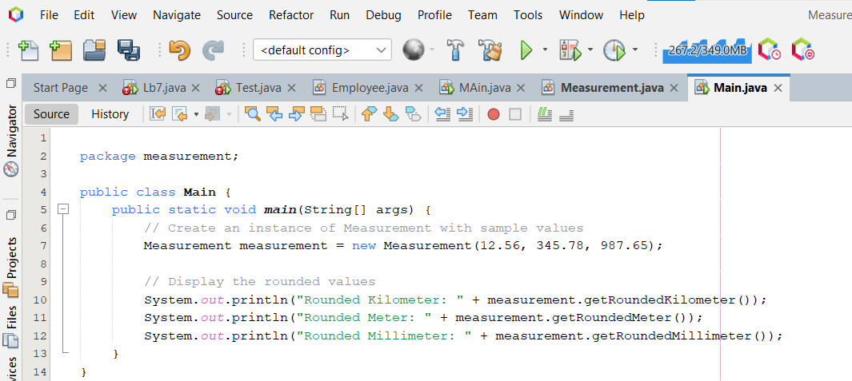

**Output**

