*LAB # 07*

pass object as parameter

# *OBJECTIVE:*

*To Study pass object as parameter to methods*

**Task # 01:**

*Write a program to take two values from the user and swap those values by using the concept of arguments passing by reference.*

*Sample Output: Before swapping: First value: 15 Second value: 20 After Swapping: First value: 20 Second value: 15*

**Code:**

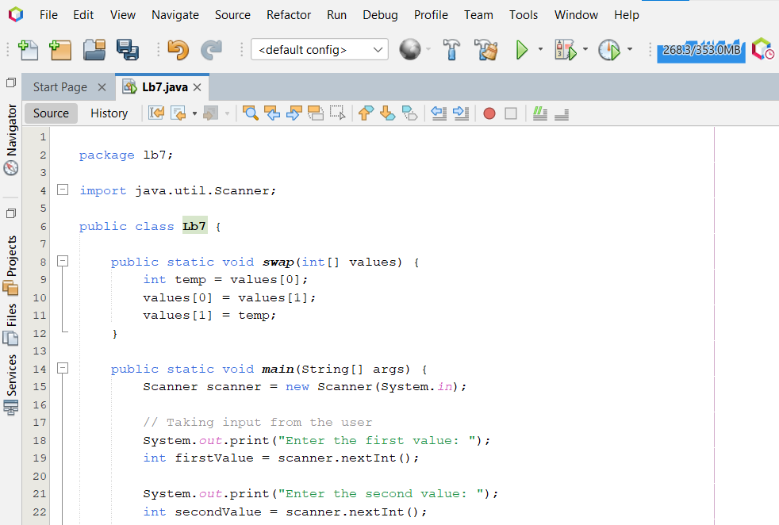

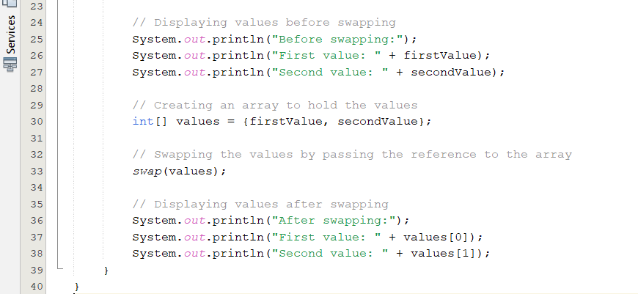

**Output**

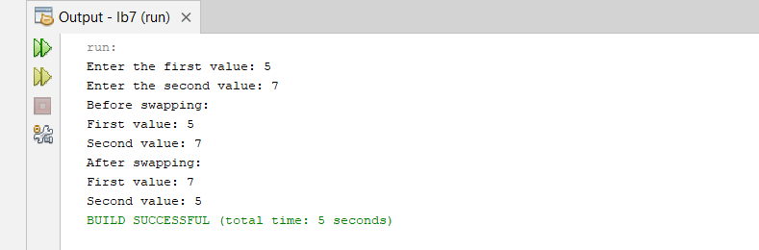

**Task # 02:**

*Write a program to take a value from the user and print next 5 values that should be the increment of 10 from the previous value using the concept of returning object*

*Sample Output: 5 15 25 35 45*

**Code:**

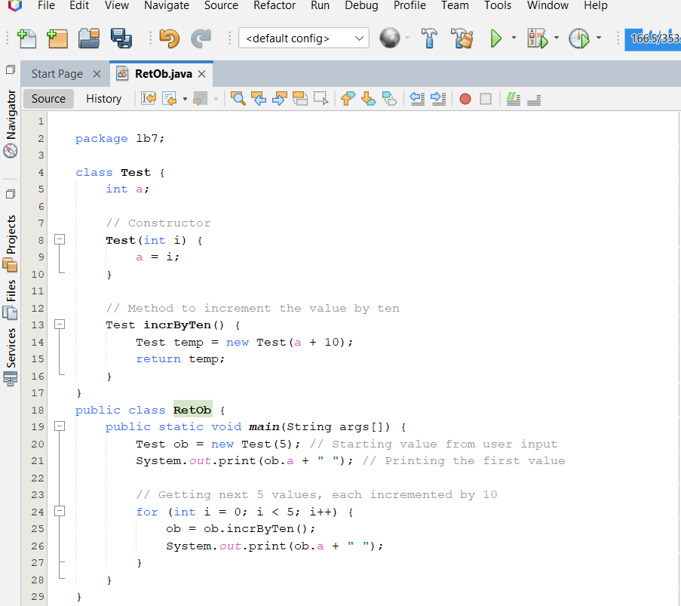

**Output**

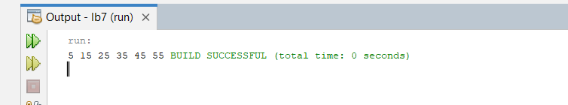

**Task # 03:**

Write a program to calculate time for 2 different locations by using the concept of arguments passing by value.

Sample Output:

Time: hour: mins: sec

Time1: 3:30: 5

Time2: 4:45:15

**Code:**

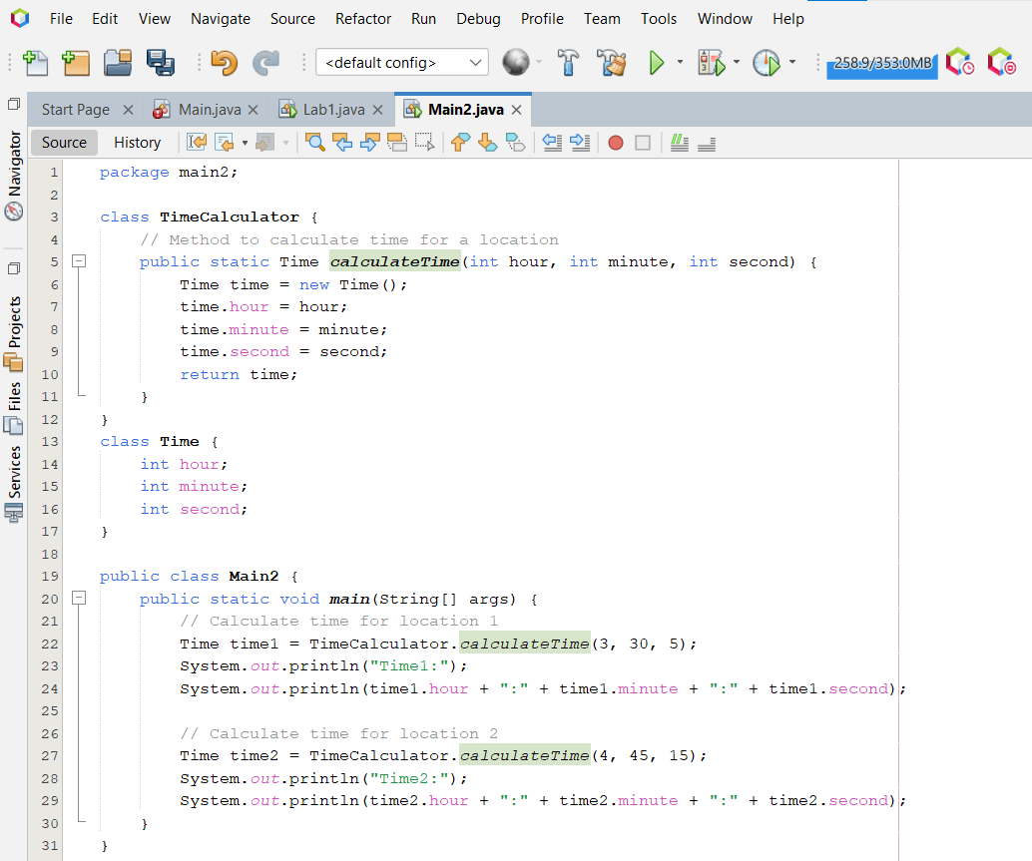

**Output**

