*LAB # 11*

shell scripting

# ***OBJECTIVE:***

*To do programming with Shell Scripts.*

*LAB task*

*Write a script which displays Good Morning if hour is less than 12.00, Good Afternoon if hour is less than 5.00p.m, and Good Evening if hour is greater than 5.00p.m.*

***SOURCE CODE:***

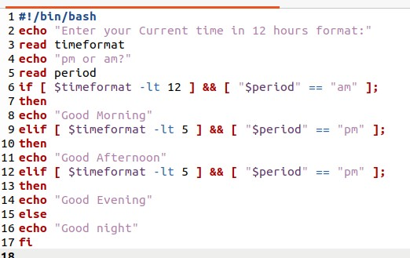

***OUTPUT:***

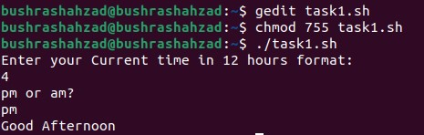

*Write a script that determines whether number is odd or even.*

***SOURCE CODE:***

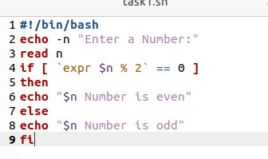

***OUTPUT:***

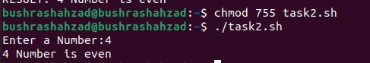

*Write a script which takes two numbers as input and asks user choice for multiplication, division, addition, and subtraction. Like* ***(calculator)****, and then calculate the output. Apply suitable checks; if user enters wrong input the program again ask for correct input.*

***SOURCE CODE:***

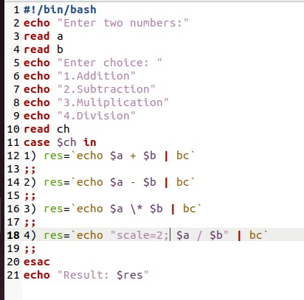

***OUTPUT:***

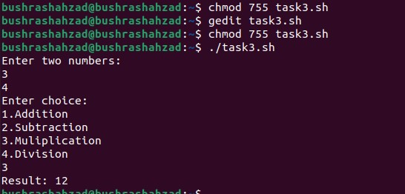

*Write a script to print no’s as 5, 4, 3, 2, 1 using while loop.*

***SOURCE CODE:***

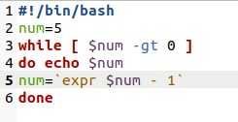

***OUTPUT:***

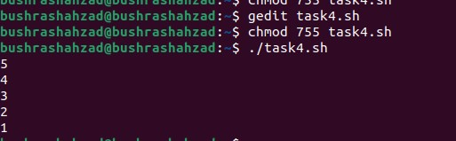

*Write script to print given number in reverse order, for e.g. If no is 123 it must print as 321.*

***SOURCE CODE:***

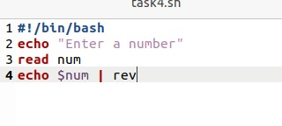

***OUTPUT:***

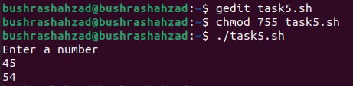

*Write script to print given numbers sum of all digits, for e.g. If no is 123 it's sum of all digit will be 1+2+3 = 6.*

***SOURCE CODE:***

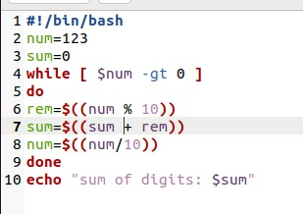

***OUTPUT:***

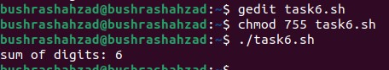

*Write Script to find out biggest number from given three no’s. No’s are supplies as command line argument. Print error if sufficient arguments are not supplied*

***SOURCE CODE:***

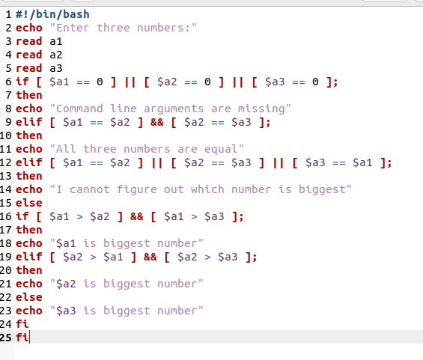

***OUTPUT:***

