*LAB # 12*

perl scripting

# ***OBJECTIVE:***

*Introduction to Perl Scripting in Linux Operating System.*

*LAB task*

1. *Construct an array @family holds a list of family member names. The first hash %shoe_color contains favorite shoe color per person. The second hash %shoe_size contains shoe size per person name. Evaluate and print the favorite shoe color and shoe size per each family member. For shoe sizes 10 and above, add the word ‘Large’ to the output line.*

*Output line should be in the format: “John wears large brown shoes size 12”*

***SOURCE CODE:***

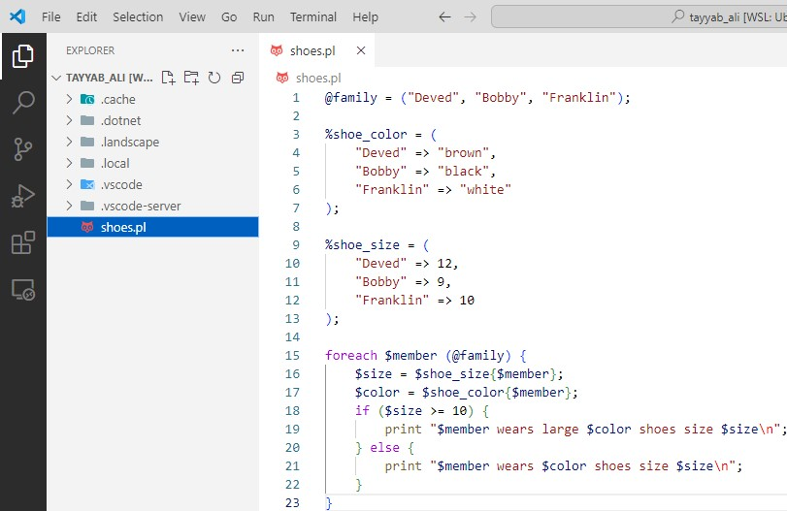

***OUTPUT:***

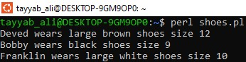

1. *Loop through and print out all even numbers from the @NUMBERS array in the same order they are received. Don't print any numbers that come after 237 in the array*

***SOURCE CODE:***

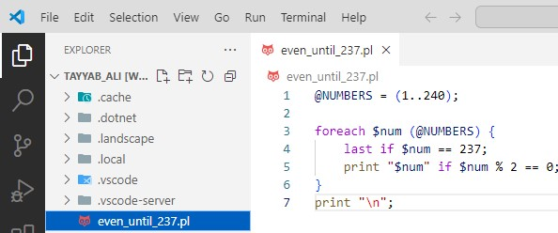

***OUTPUT:***



1. *Follow these instructions and print the result after each step.*
2. *Assign scalar $a to a starting value of 5. Print value of $a .*
3. *Add 6 to the previous result. Print the new result.*
4. *Multiply the previous result by 2. Print the new result.*
5. *Auto increment the previous result. Print the new result.*
6. *Subtract 9 from the previous result. Print the new result.*
7. *Divide the previous result by 7. Print the new result.*

***SOURCE CODE:***

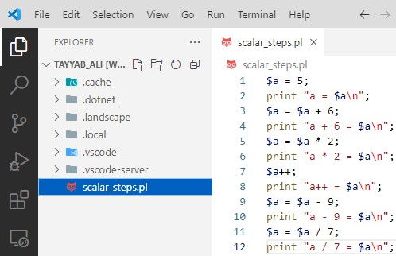

***OUTPUT:***

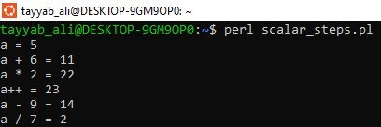

1. *Declare two scalar variables and assign numeric values to them. Then perform mathematical operations on those variables and print the results. (Addition, Subtraction, Multiplication and division)*

***SOURCE CODE:***

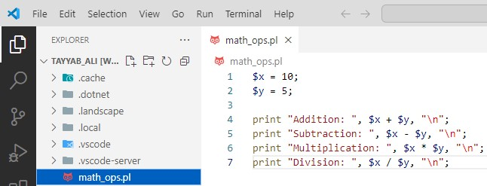

***OUTPUT:***

