*LAB # 13*

open ended

*task # 01:*

*You are developing a smart greeting system for a hotel lobby display screen. The system should welcome guests with an appropriate greeting based on the current time of day:*

* ***"Good Morning"*** *for hours before 12:00 PM*
* ***"Good Afternoon"*** *for hours between 12:00 PM and 5:00 PM*
* ***"Good Evening"*** *for hours after 5:00 PM*

*Extend the system so it:*

* *Automatically fetches the current time*
* *Displays the greeting along with a custom message (e.g., breakfast availability in the morning, spa discount in the evening)*
* *Can be reused by other departments (like a receptionist dashboard)*

***Write a Python script*** *that implements this logic as a function, and make it modular enough for future upgrades like multilingual greetings or weather-based tips.*

***SOURCE CODE:***

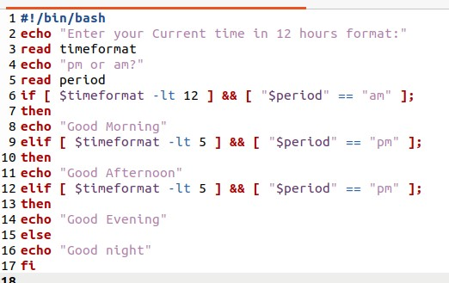

***OUTPUT:***

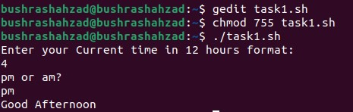

Top of Form

Bottom of Form

*task # 02:*

*You are developing a* ***basic billing module for a small shop's Point of Sale (POS) system****. The shopkeeper often needs to do quick calculations during billing—for example, combining prices, applying discounts, or splitting bills among customers.*

*Your task is to write a* ***simple calculator script*** *that:*

* *Takes two numerical inputs (e.g., total price and discount, or bill amount and number of people)*
* *Asks the user to choose an operation:*
  + ***Addition*** *(e.g., adding price of two items)*
  + ***Subtraction*** *(e.g., applying a discount)*
  + ***Multiplication*** *(e.g., total for multiple quantities)*
  + ***Division*** *(e.g., splitting a bill)*
* *Validates user input:*
  + *Only accepts valid numbers and choices*
  + *Asks again if the user enters an invalid number or wrong option (e.g., division by zero)*

*Make sure your script is* ***user-friendly*** *with clear instructions, and structure it in a* ***reusable function*** *for future expansion (like adding tax or loyalty points).*

***SOURCE CODE:***

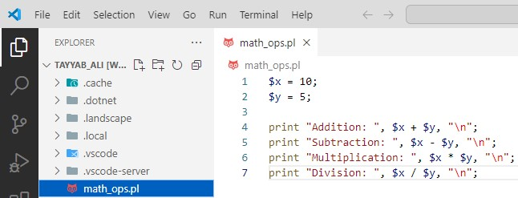

***OUTPUT:***

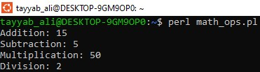

*task # 03:*

*You are developing a* ***billing system for a small restaurant****. A waiter needs to calculate the total bill for two food items quickly. Each item has a price, and the system must compute:*

* *The* ***total cost*** *(addition)*
* *The* ***price difference*** *(subtraction)*
* *The* ***total cost if buying multiple sets*** *(multiplication)*
* *The* ***cost per person*** *when dividing the total bill among two people (division)*

*Write a Perl script that:*

* *Declares two scalar variables to represent the item prices*
* *Performs* ***addition****,* ***subtraction****,* ***multiplication****, and* ***division***
* *Prints the result of each operation in a clear, formatted message*

*This system helps waiters make quick calculations without manual error.*

***SOURCE CODE:***

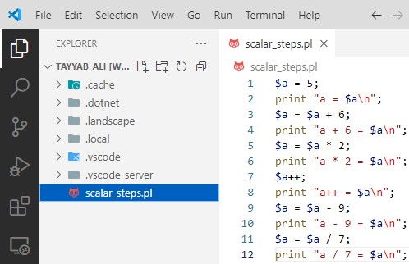

***OUTPUT:***

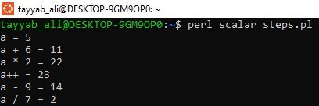

*task # 04:*

*You are developing a* ***salary adjustment tool*** *for an HR department to simulate salary changes for a new employee during the probation period. The salary is adjusted in multiple steps based on performance, bonuses, and deductions.*

*Write a Perl script that follows these steps:*

* ***Initial salary*** *is set to $5/hour*
* ***Add a $6 performance bonus***
* ***Double the salary*** *for an outstanding review*
* ***Apply one-time annual increment*** *(auto-increment by 1)*
* ***Subtract $9*** *as a tax deduction*
* ***Divide the result by 7*** *to calculate the daily equivalent for a 7-day payroll breakdown*

*Print the updated salary after each adjustment step to track the change transparently.*

***SOURCE CODE:***

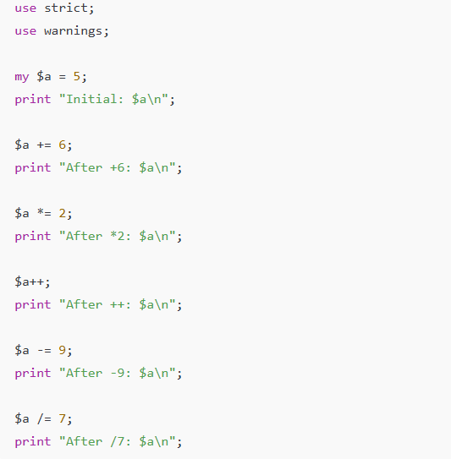

***OUTPUT:***

