*LAB # 06*

cpu scheduling algorithms-2

# *OBJECTIVE:*

*To simulate CPU Scheduling Algorithms. (priority, round robbin).*

*LAB task*

*1. Write a program which takes as an argument the arrival time, burst time, priority and no. of processes. Calculate average waiting time and turnaround time using Priority Scheduling (Non preemptive and preemptive both). Display a text-based Gantt chat on the screen*

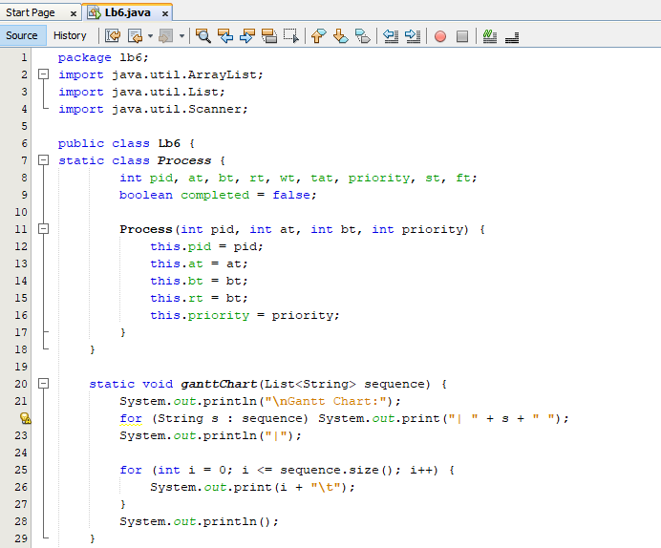

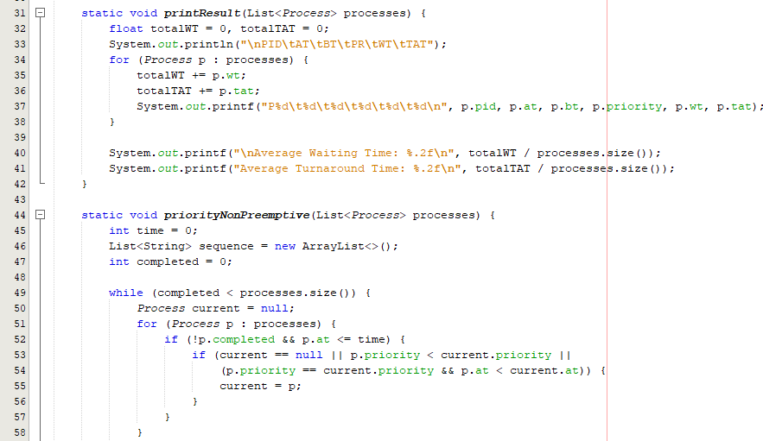

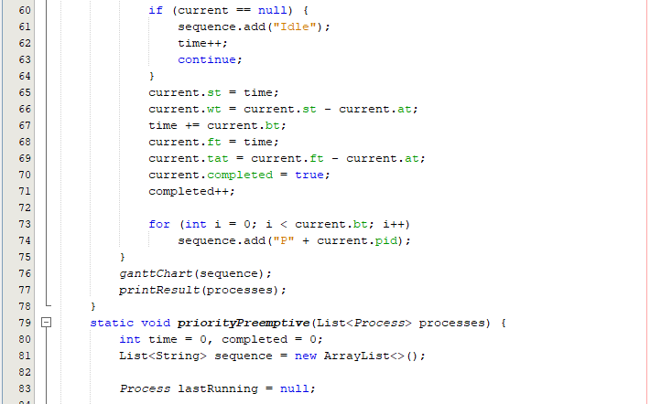

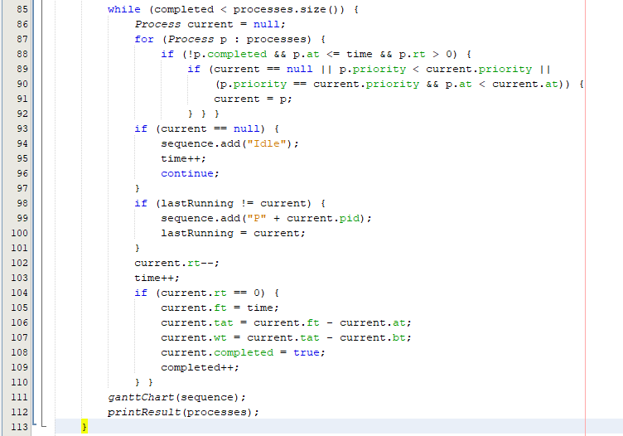

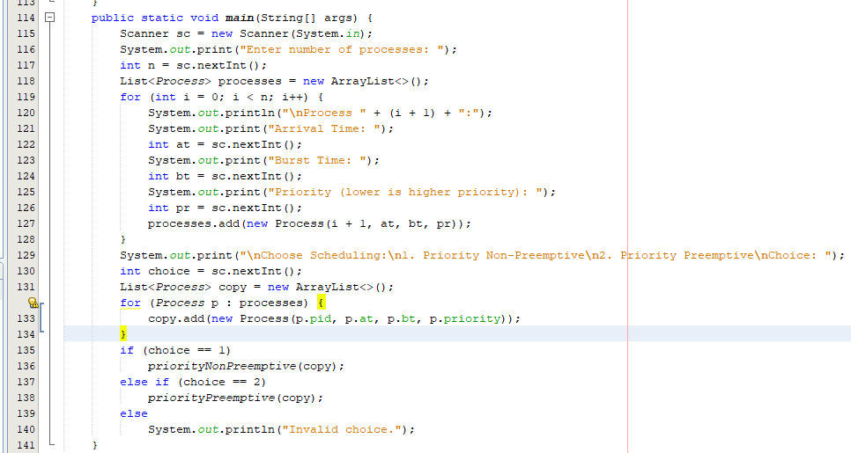

***OUTPUT FOR PREEMPTIVE:***

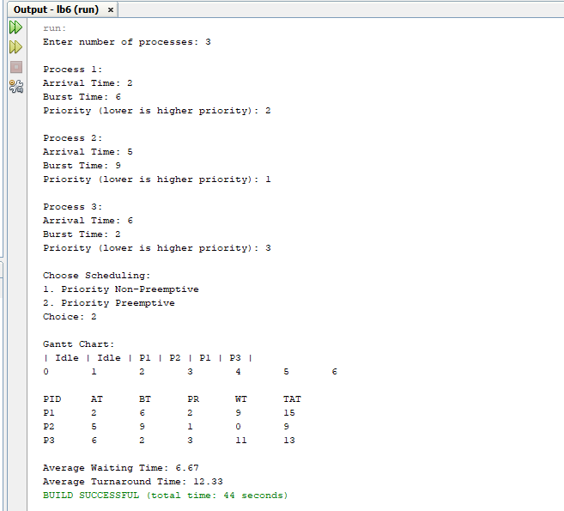

***OUTPUT FOR NON-PREEMPTIVE:***

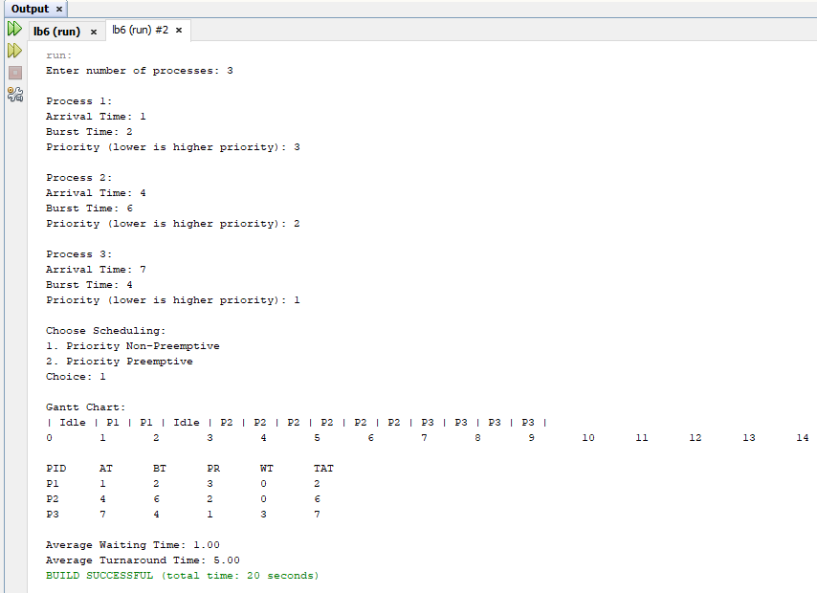

*2. Write a program which takes as an argument the arrival time, burst time and no. of processes. Calculate average waiting time and turnaround time using Round Robin Scheduling with a fixed time quantum of 4. Display a text-based Gantt chat on the screen.*

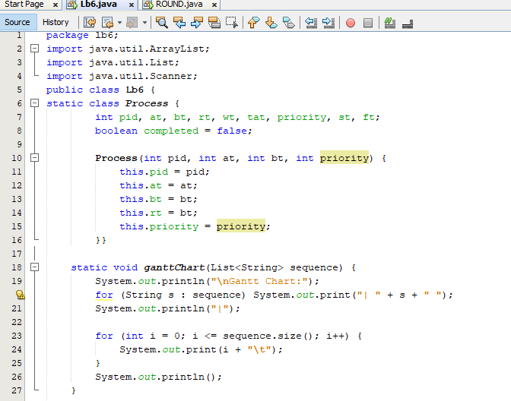

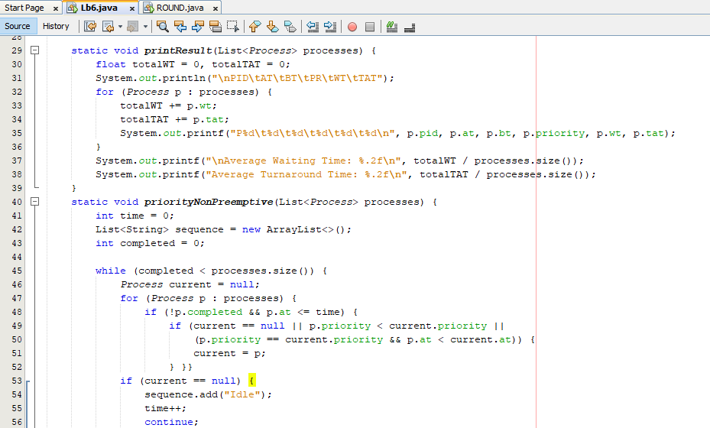

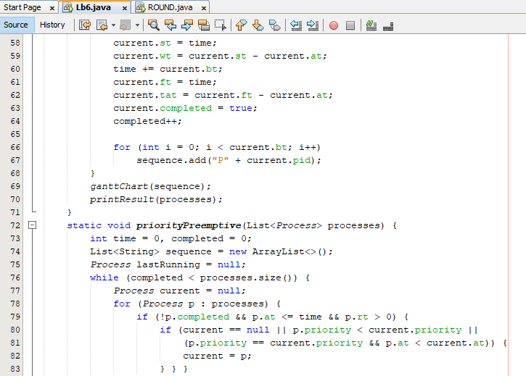

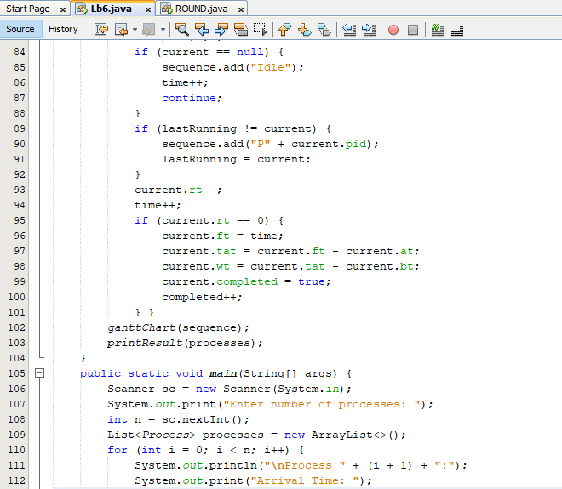

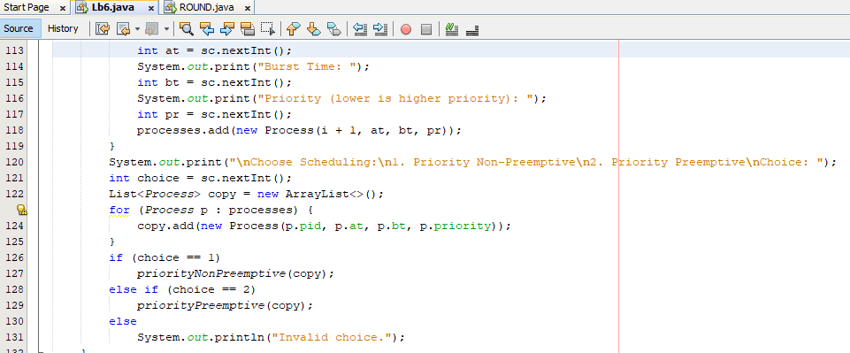

***OUTPUT:***

