*LAB # 09*

semaphores

# ***OBJECTIVE:***

*Study the features of semaphores.*

*LAB task*

1. *What was the mistake in the Program 1, and how it is rectified in Program 2?*

***PROGRAM #01:***

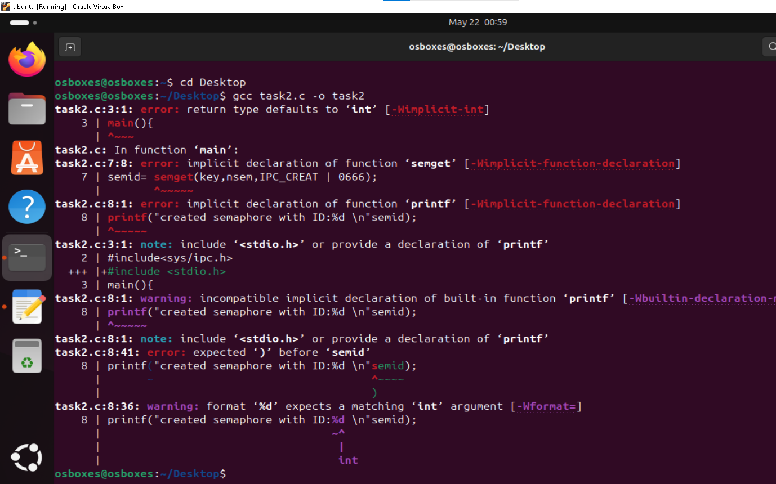

***PROGRAM #02:***

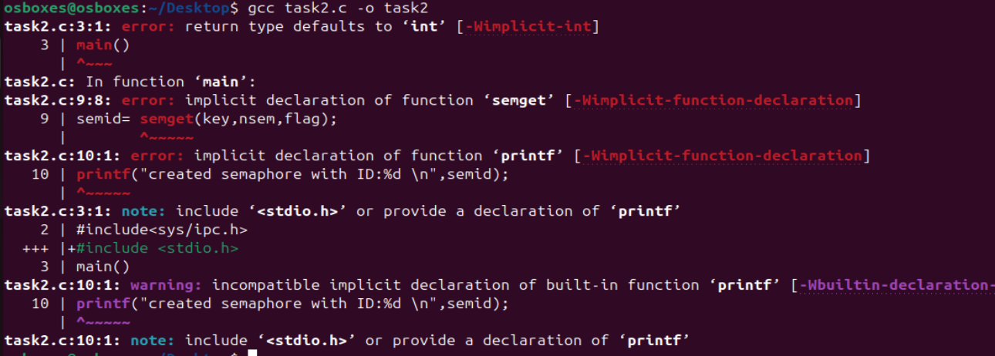

*In Program 1, the value of the identifier of the semaphore is -1 it means it’s an error. This problem occurs because we do not specify that how many semaphores we want. We have assigned a 0 to the variable nsem which is the minimum requirement. As a result, an error is returned. So, to rectify this error, we set the value of nsem as 1 in Program#2 so that the semaphore can be created without an error.*

1. *Do ipcs –s at the prompt to see a listing of the semaphores and an entry for the semaphore will be displayed.*

***Yes, the ipcs –s at the prompt will show the listing and entry of semaphore.***

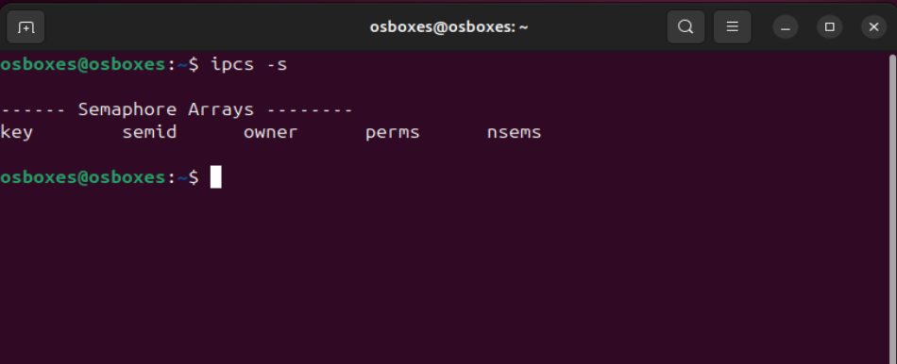

1. *Run the Programs 3 and 4, and find out what is the problem in 3 and how it is rectified in*

***PROGRAM #03:***

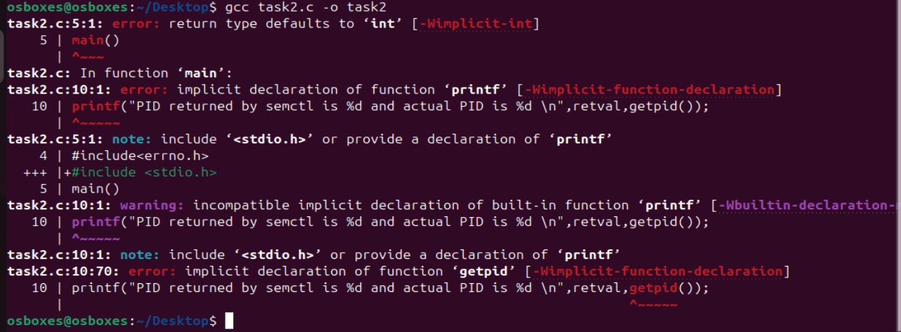

***PROGRAM #04:***



*In these programs, semctl() function is used to find out which process has set the value of semaphore. A value of GETPID passed to the semctl() will result in it passing the Pid of the process that has set the value of semaphore. In program 4, the setval is used so that the value can set and print in the output as compared to program#3.*