*LAB # 09*

behavioral patterns: mediator pattern & observer pattern

# *OBJECTIVE:*

*Understand behavioral design patterns: Mediator Pattern and Observer Pattern*

***MEDIATOR PATTERN:***

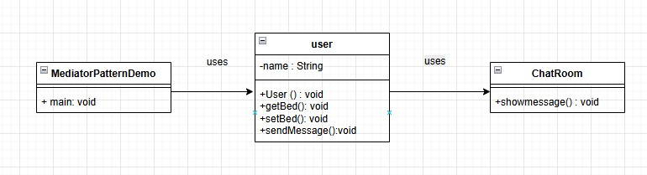

***CODE:***

*Class Diagram Summary:*

* *MediatorPatternDemo uses User*
* *User has methods: getBed(), setBed(), sendMessage()*
* *User uses ChatRoom*
* *ChatRoom has method: showMessage()*

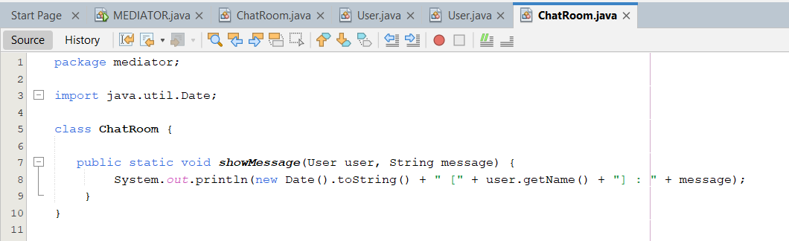

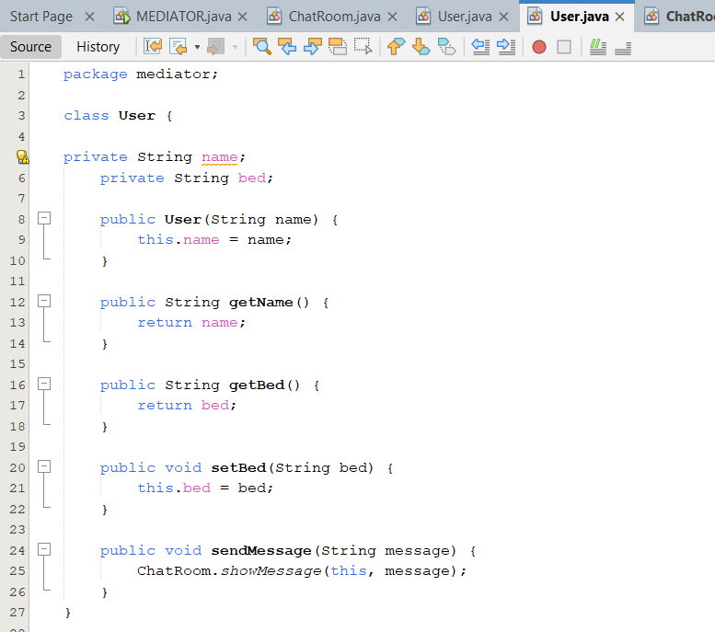

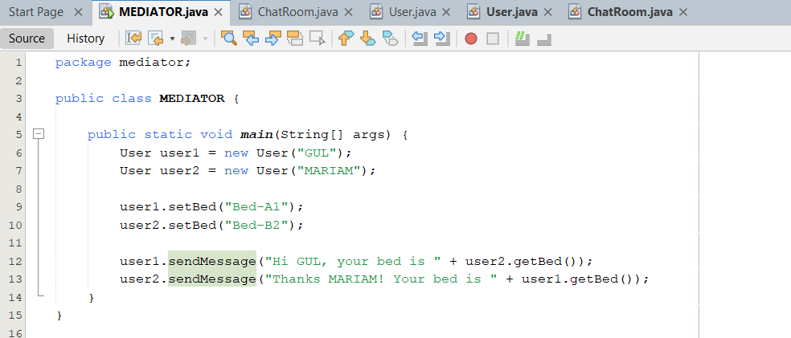

***OUTPUT:***

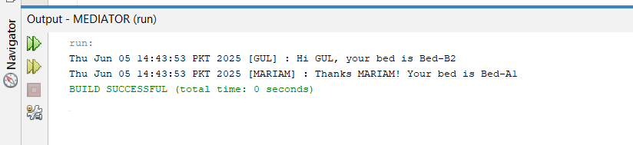

***OBSERVER PATTERN:***

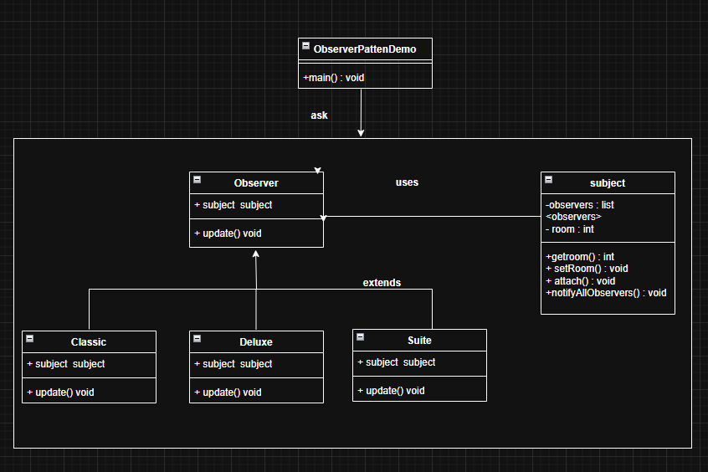

***CODE:***

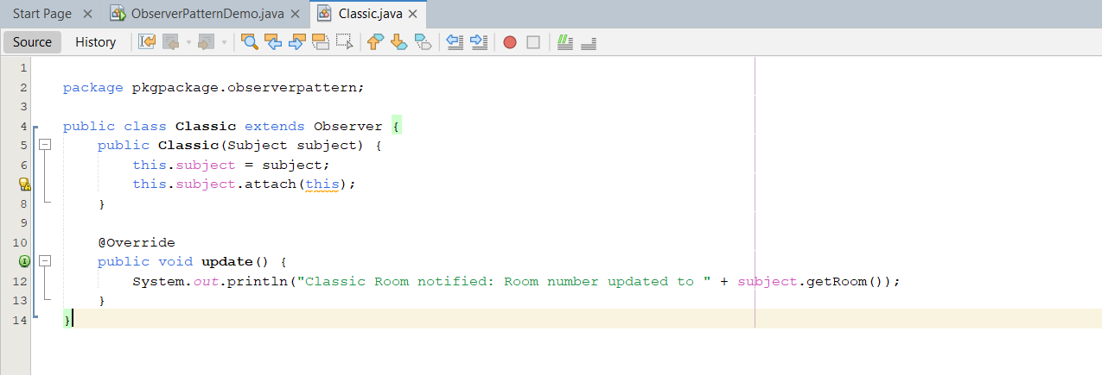

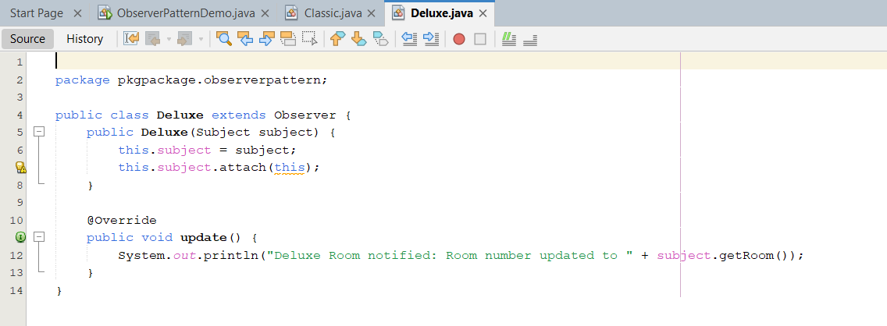

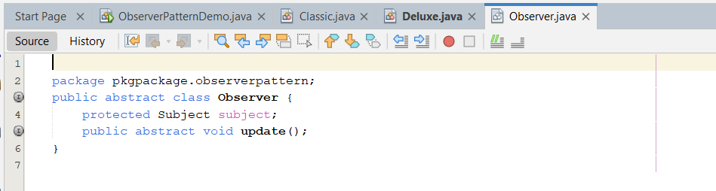

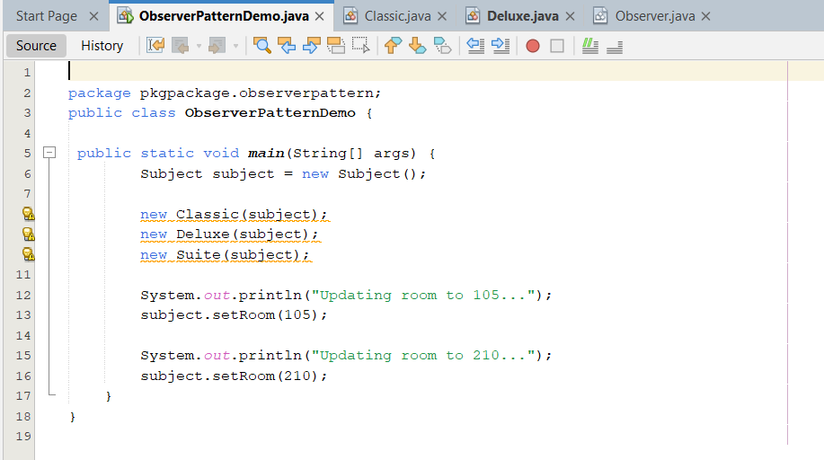

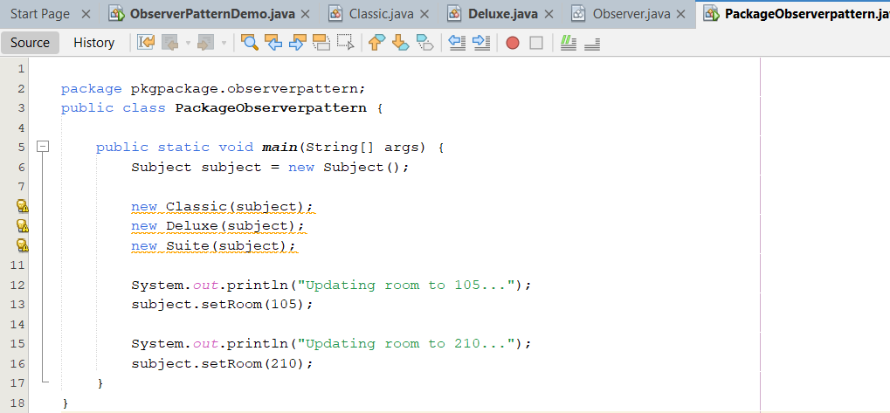

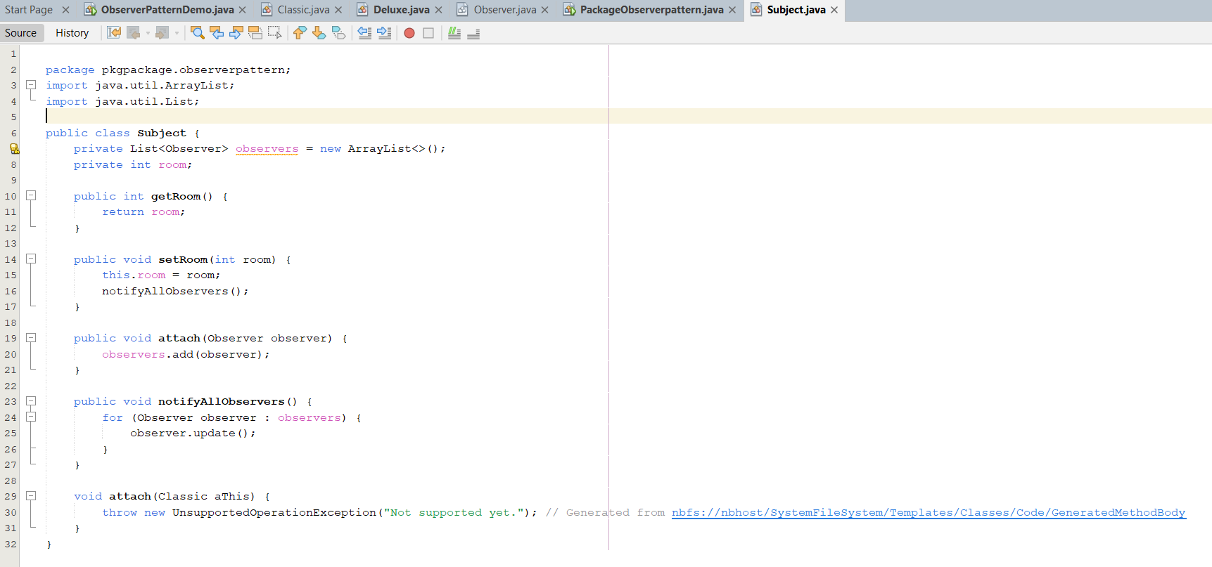

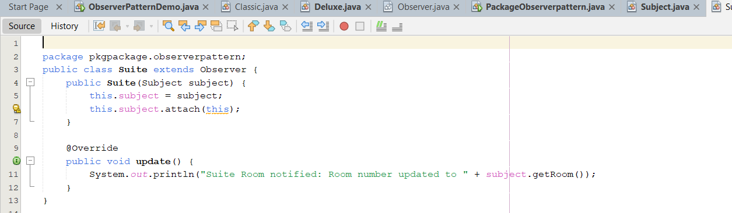

***OUTPUT:***

