**LAB # 11**

modules and packages

# *OBJECTIVE:*

*Getting familiar with the environment for using modules and packages*

HOME tasks

***EXERCISE***

1. ***Point out the errors, if any, and paste the output also in the following Python programs.***

**Code 1**

* **Code(incorrect)**

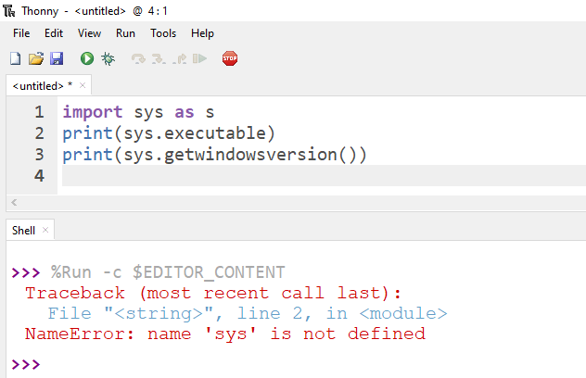

* **Code(correct):**

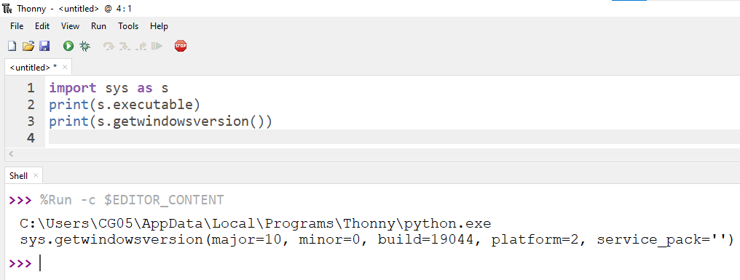

**Code 2**

* **Code(incorrect)**

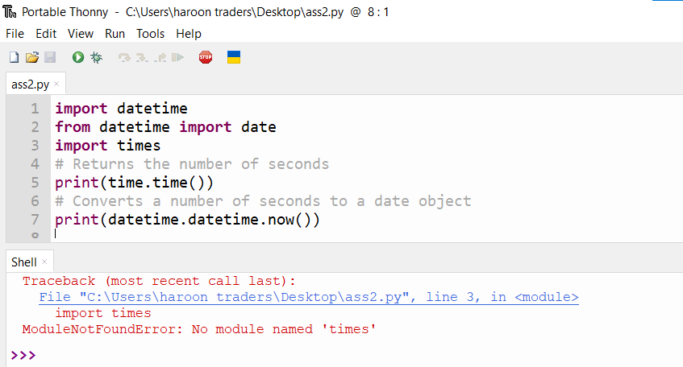

* **Code(correct):**

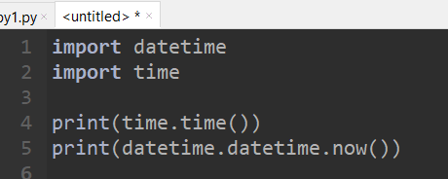

* **Output:**

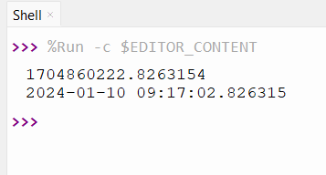

**Code 3**

* **Code(incorrect)**

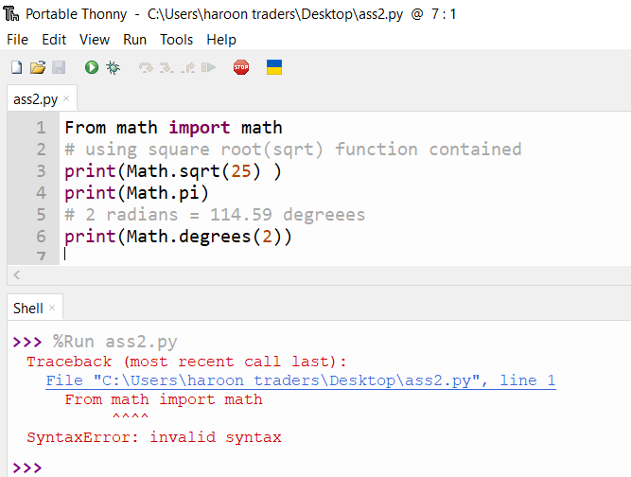

* **Code(correct):**

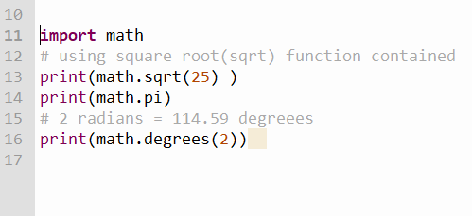

* **Output:**

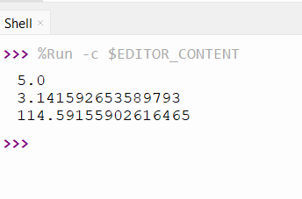

1. ***What would be the output of the following programs***

**Code 1**

* **Code:**

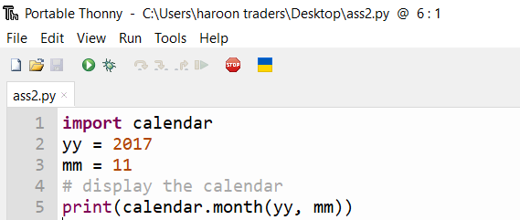

* **Output:**

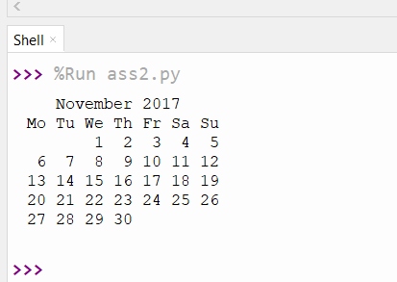

**Code 2**

* **Code:**

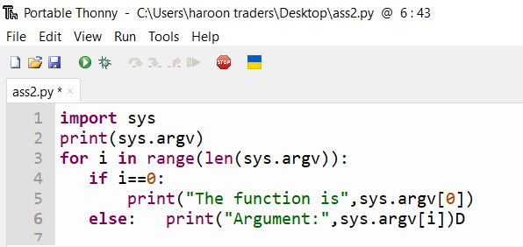

* **Output:**

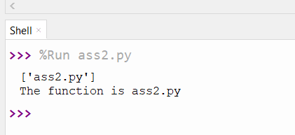

* **Code:**

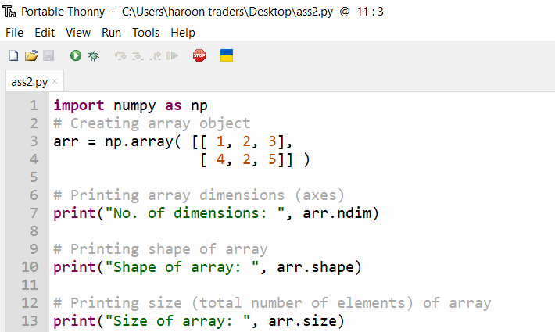**\**

* **Output:**

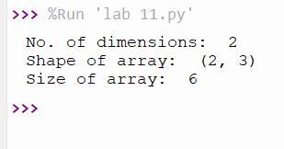

***3. Write Python programs for the following****:*

*1. Write a NumPy program to create an 1D array of 10 zeros, 10 ones, 10 fives*

* **Code:**

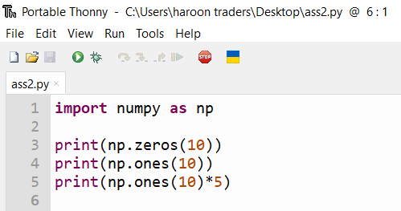

* **Output:**

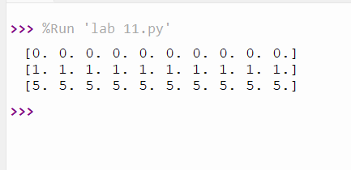

*2. Write a NumPy program to create a 3x3 matrix with values ranging from 2 to 10.*

* **Code:**

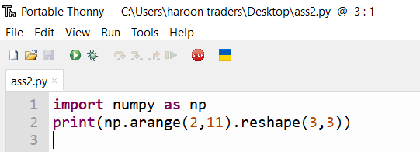

* **Output:**

