**LAB # 12**

Strings

# *OBJECTIVE:*

*Working on the string formatting*

HOME tasks

***EXERCISE***

***Point out the errors, if any, and paste the output also in the following Python programs.***

**Code 1**

* **Code(incorrect)**

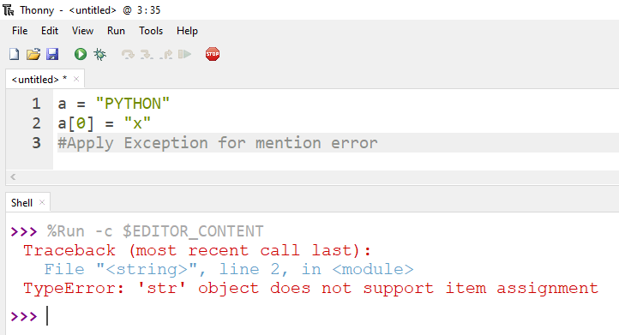

* **Code(correct)**

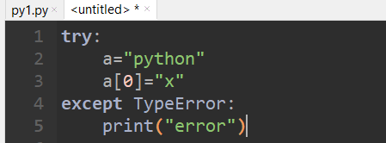

**Code 2**

* **Code(incorrect)**

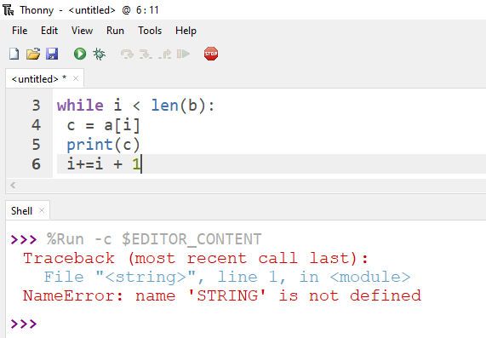

* **Code(correct)**

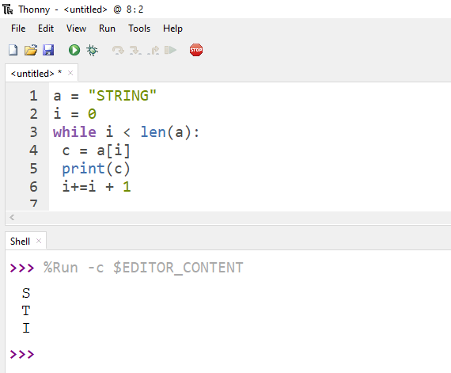

**Code 3**

* **Code(incorrect)**

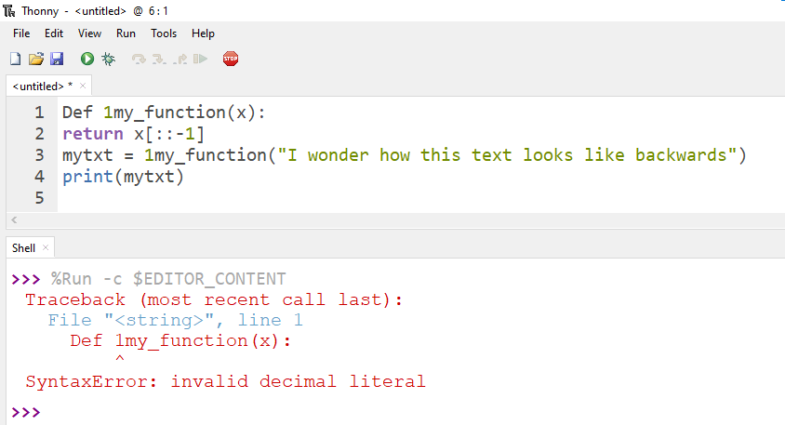

* **Code(correct)**

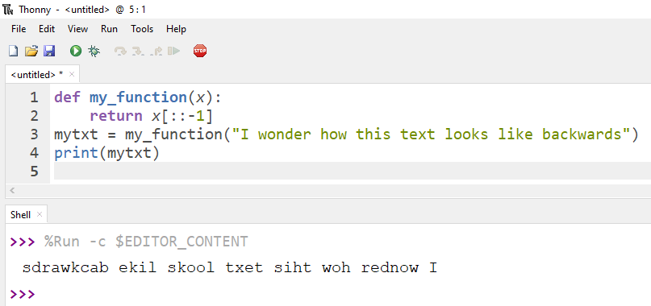

1. ***What would be the output of the following programs***

**Code 1**

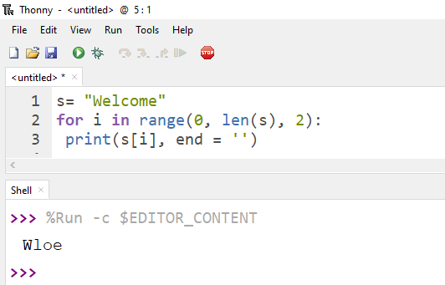

**Code 2**

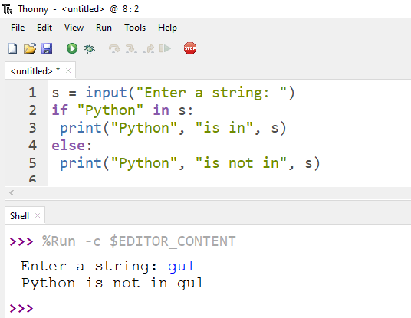

**Code 3**

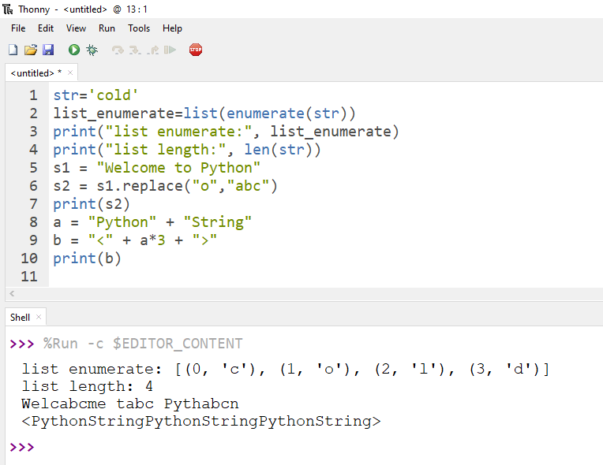

***3. Write Python programs for the following****:*

**Code 1**

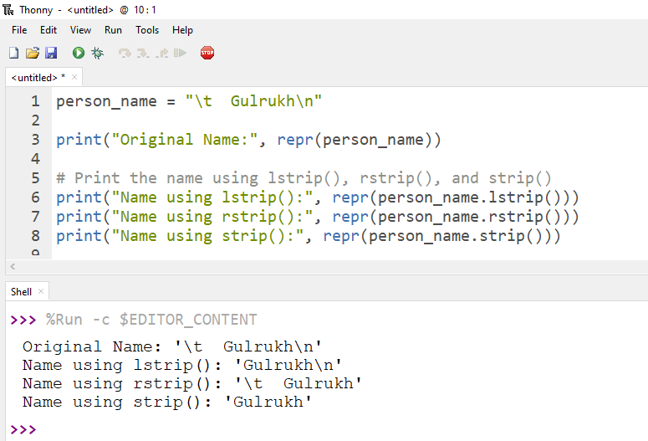

**Code 2**

