**LAB # 13**

exception handling

# *OBJECTIVE:*

*Constructing a fault tolerant program by implementing exception handling techniques.*

HOME tasks

***EXERCISE***

1. ***Point out the errors, if any, and paste the output also in the following Python programs.***

**Code 1**

* **Code(incorrect):**

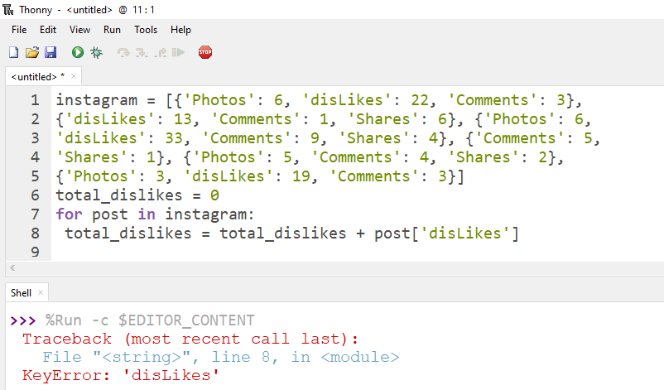

* **Code(correct):**

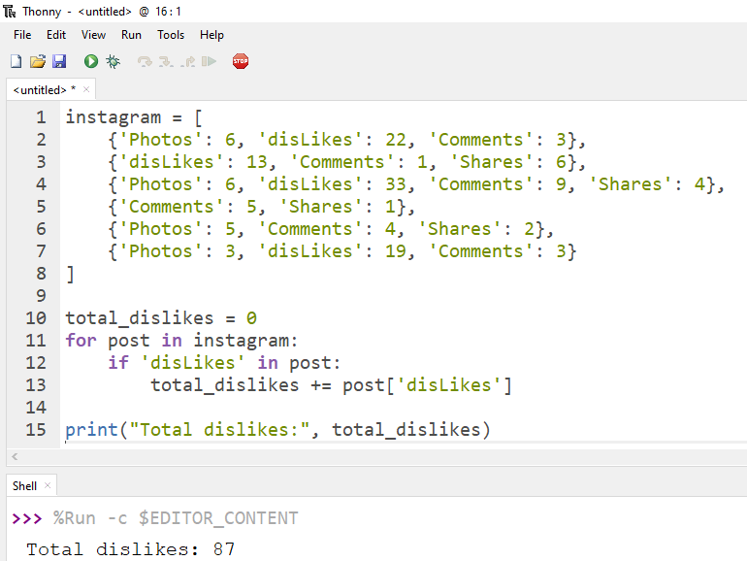

**Code 2**

* **Code(incorrect):**

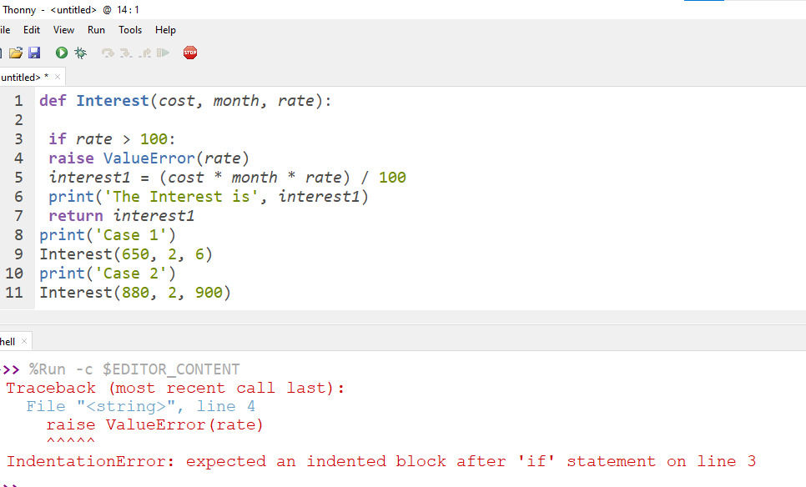

* **Code(correct):**

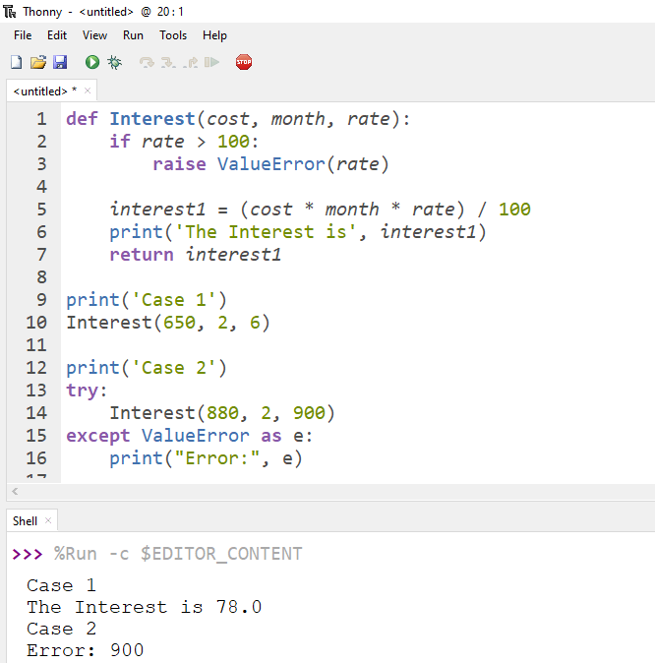

**Code 3**

* **Code(incorrect):**

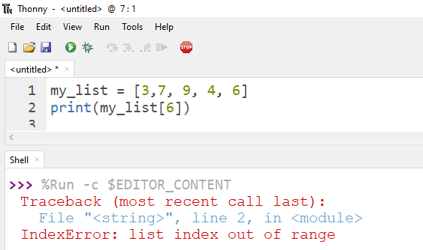

* **Code(correct):**

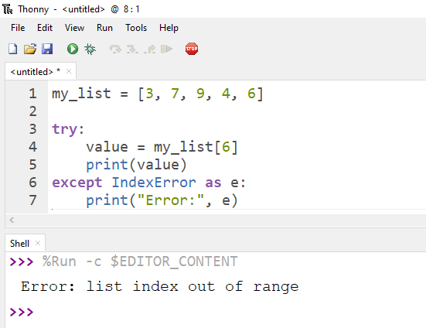

1. ***What would be the output of the following programs***

**Code 1**

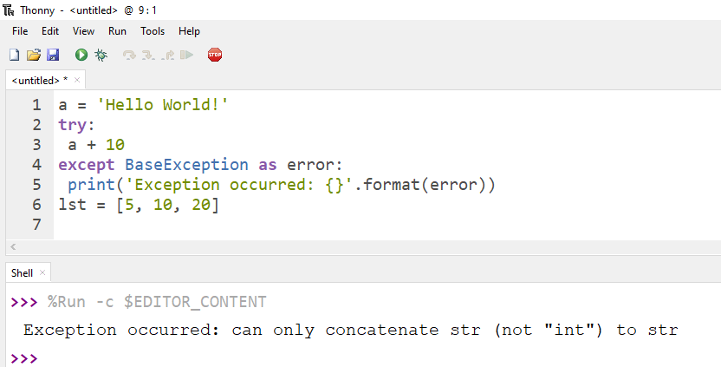

**Code 2**

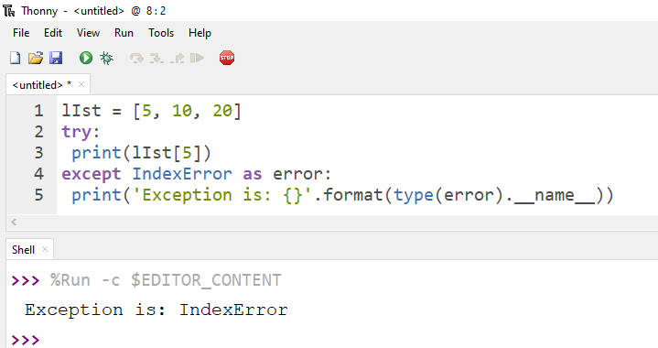

**Code 3**

r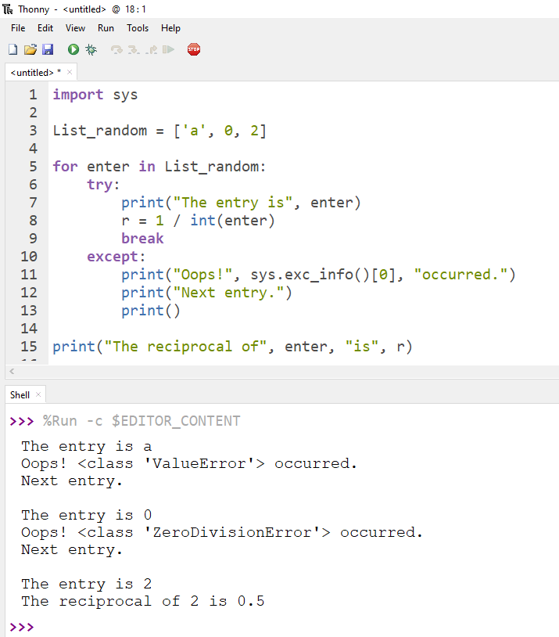

***3. Write Python programs for the following****:*

*Write a program to make a basic calculator for kids in super market so that they may verify their calculation using Exceptional Handling. This program must have all four arithmetic operations.*

* **Code:**

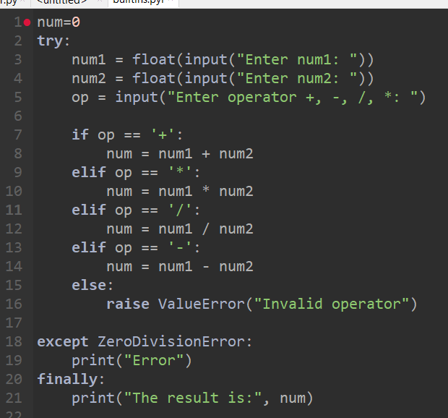

* **Output:**

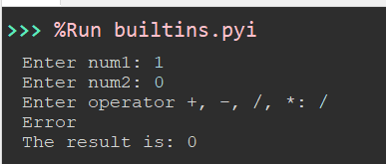

*Write a program to store 5 types of coffee with a number (e.g. Espresso=1, Cappuccino=2, Macchiato=3 etc.), Now ask the user “which coffee you would like to have, please enter your desire number”. Use try block to print the coffee name, except block to display if any invalid number or character has been entered by the user and final block to greet the customer at last.*

* **Code:**

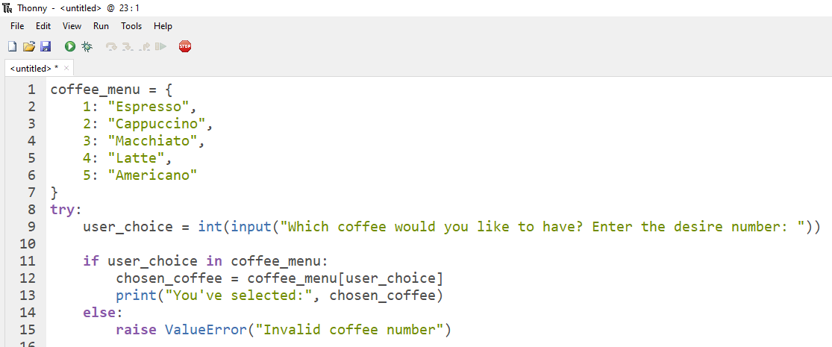

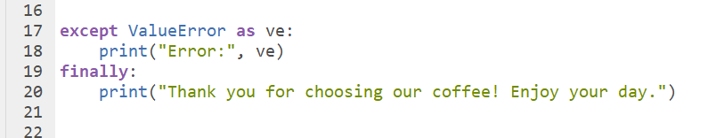

* **Output:**

