*LAB # 04*

DECISIONS

# *OBJECTIVE:*

*To get familiar with the concept of conditional statement for simple decision making.*

HOME tasks

***EXERCISE***

1. ***Point out the errors, if any, and paste the output also in the following Python programs.***

**Tasks #01A**

* **Code(incorrect):**

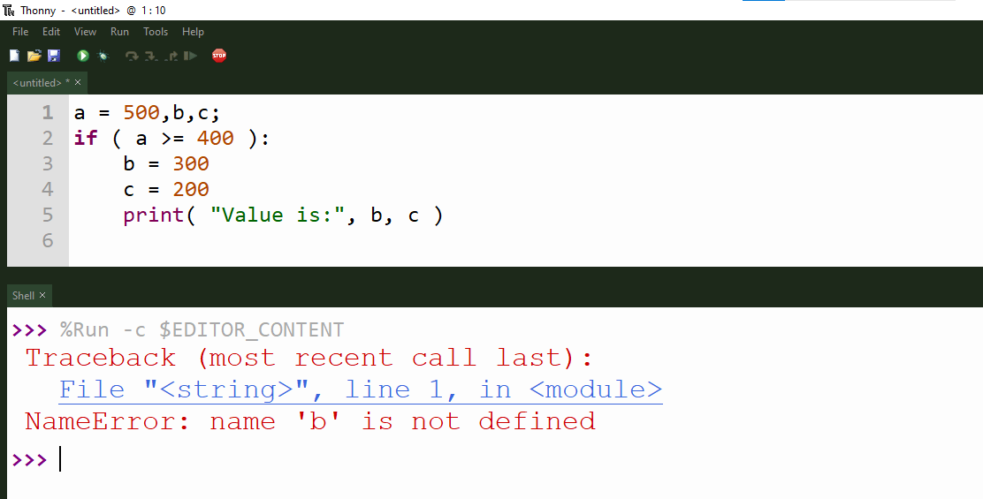

* **Code(correct one):**

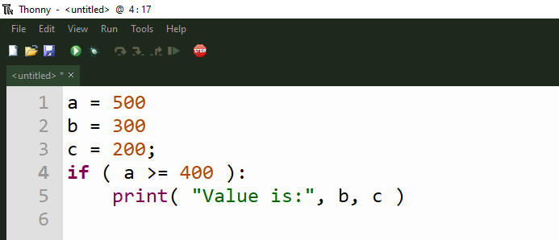

* **Output:**

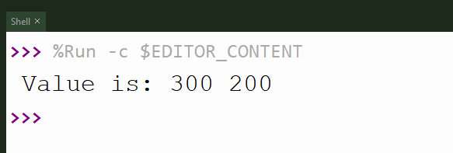

**Tasks #01B**

* **Code(incorrect):**

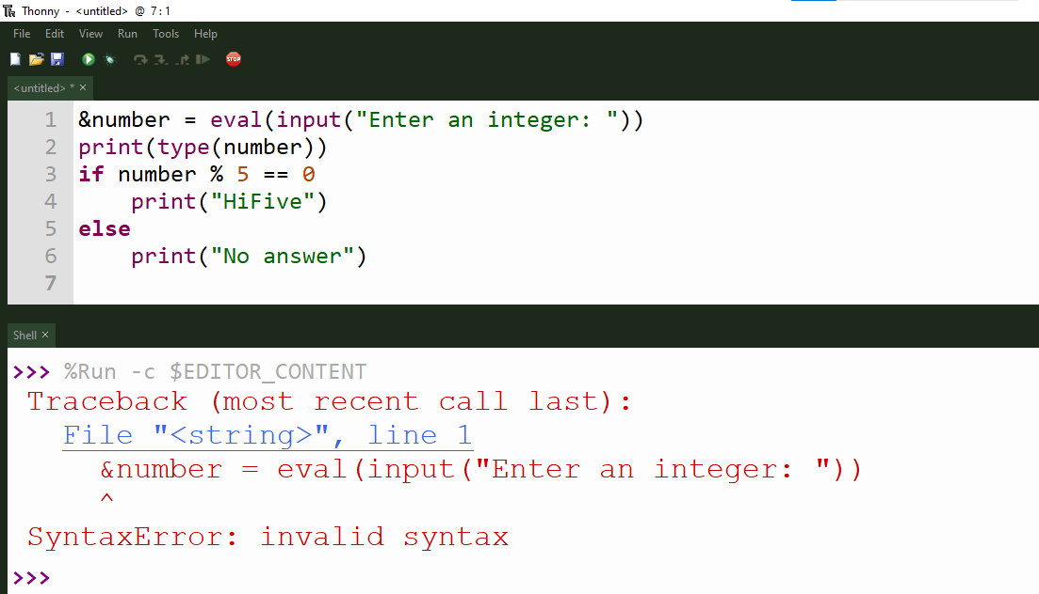

* **Code(correct one):**

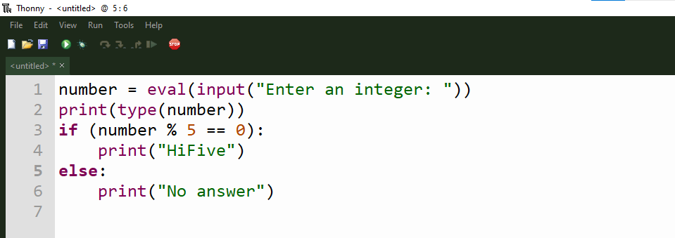

* **Output:**

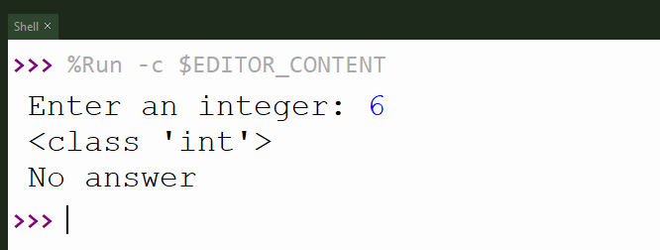

**Tasks #01C**

* **Code(incorrect):**

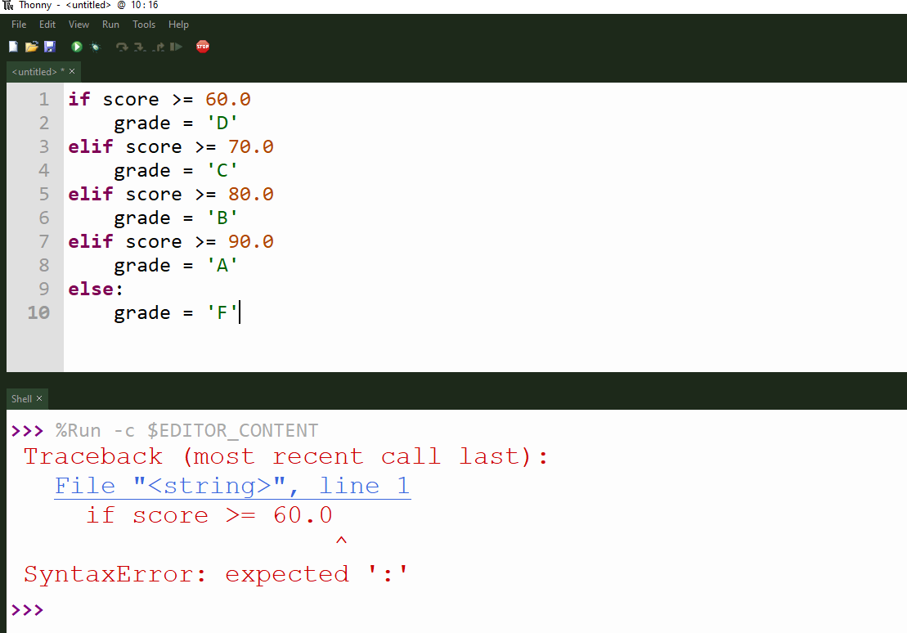

* **Code(correct one):**

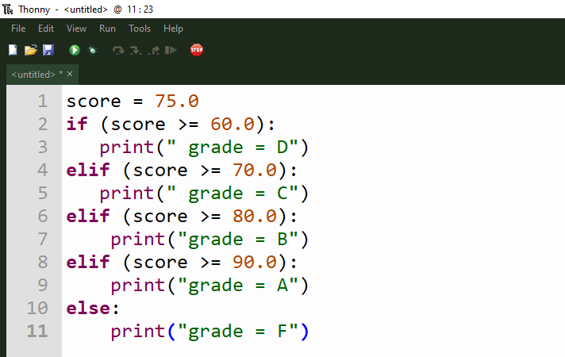

* **Output:**

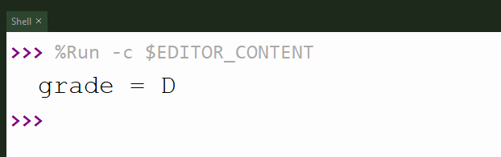

1. ***What would be the output of the following programs:***

**Tasks #02A**

* **Code:**

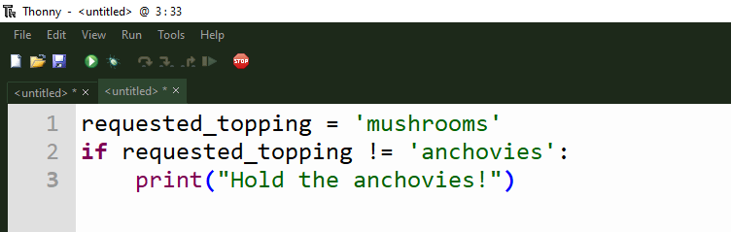

* **Output:**

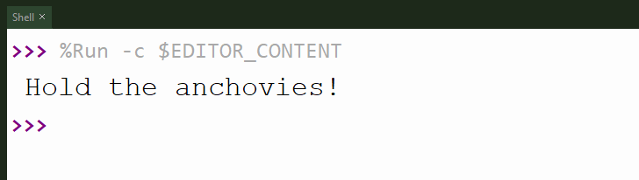

**Tasks #02B**

* **Code:**

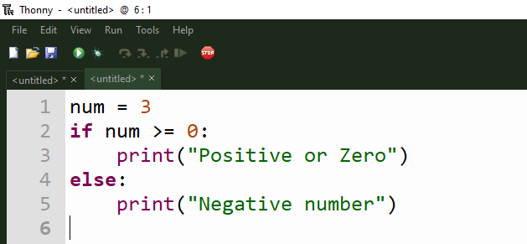

* **Output:**

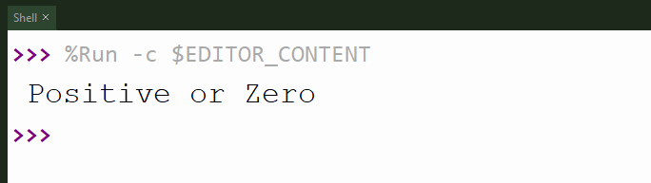

**Tasks #02C**

* **Code:**

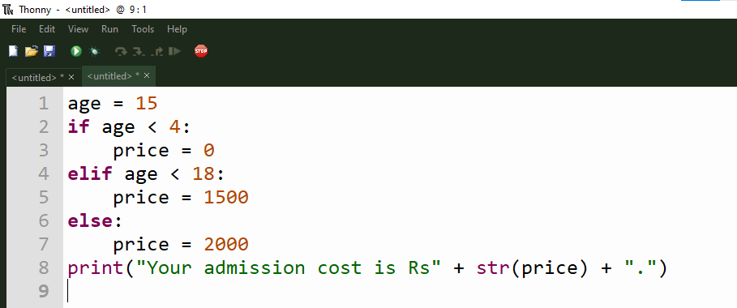

* **Output:**

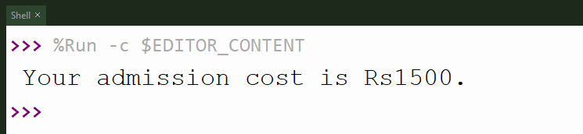

1. ***Write Python programs for the following****:*
2. *Any integer is input through the keyboard. Write a program to find out whether it is an odd number or even number.*

* **Code:**

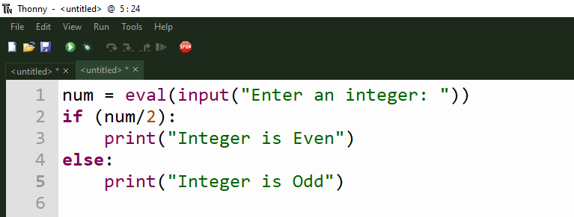

* **Output:**

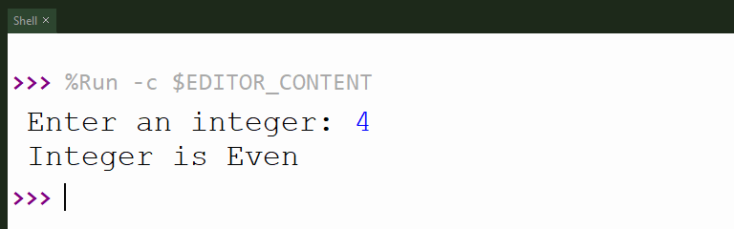

1. *Write a program that asks for years of service and qualification from the user and calculates the salary as per the following table:*

|  |  |  |
| --- | --- | --- |
| *Years of Service* | *Qualifications* | *Salary* |
| *>= 10* | *Masters* | *150,000* |
| *>= 10* | *Bachelors* | *100,000* |
| *< 10* | *Masters* | *100,000* |
| *< 10* | *Bachelors* | *70,000* |

* **Code:**

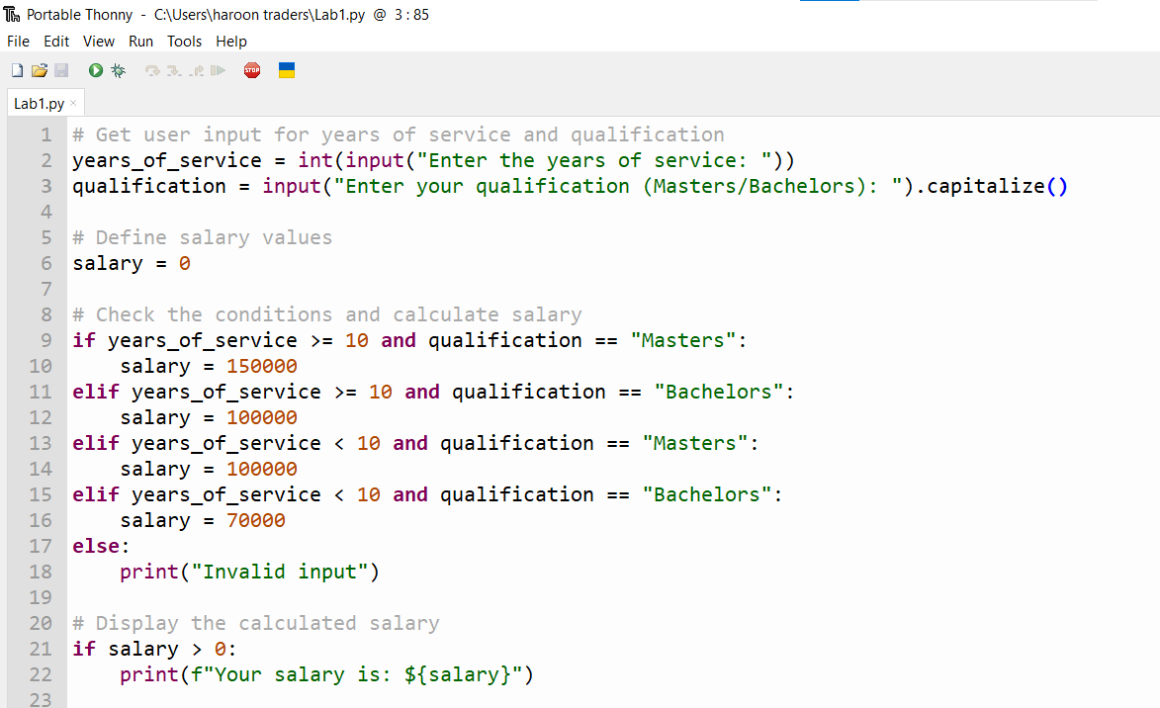

* **Output:**

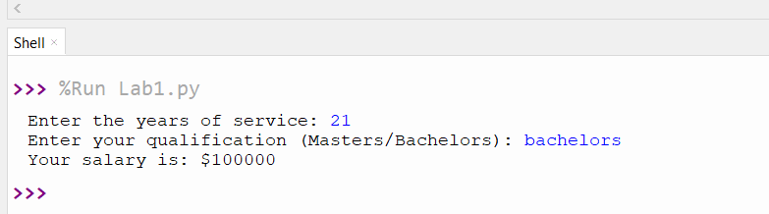

*3) Write an if-elif-else chain that determines a person’s stage of life, take input value for the variable age, and then apply these conditions:*

*• If the person is less than 2 years old, print a message that the person is a baby.*

*• If the person is at least 2 years old but less than 4, print a message that the person is a toddler.*

*• If the person is at least 4 years old but less than 13, print a message that the person is a kid.*

*• If the person is at least 13 years old but less than 20, print a message that the person is a teenager.*

*• If the person is at least 20 years old but less than 65, print a message that the person is an adult.*

*• If the person is age 65 or older, print a message that the person is an elder.*

* **Code:**

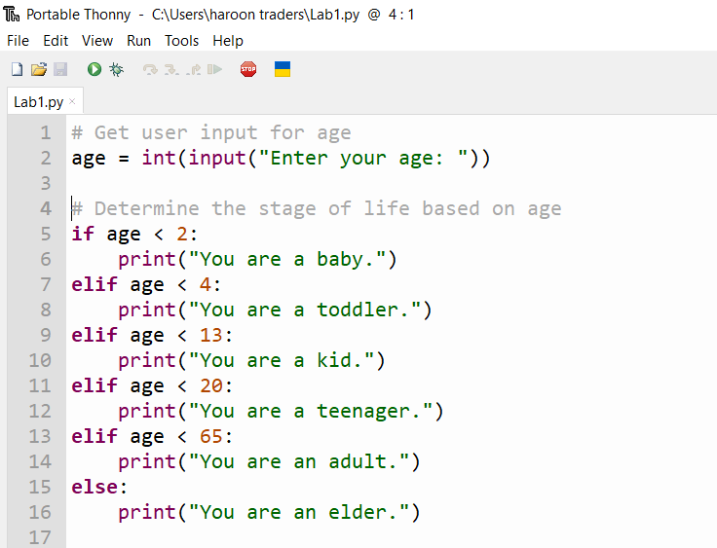

* **Output:**

