*LAB # 05*

ITERATION WITH LOOPS

# *OBJECTIVE:*

*To get familiar with different types of loops*

HOME tasks

***EXERCISE***

1. ***Point out the errors, if any, and paste the output also in the following Python programs.***

**Tasks #01A**

* **Code(incorrect):**

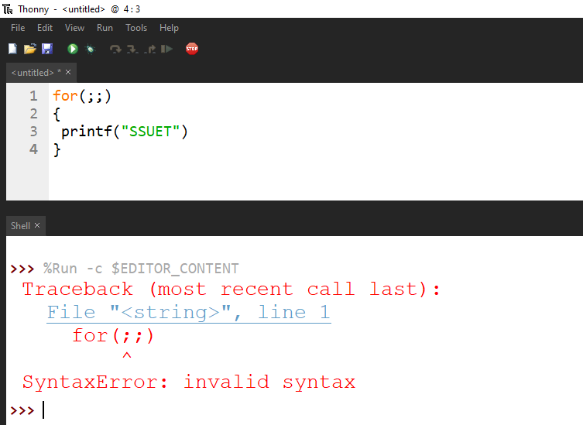

* **Code(correct one):**

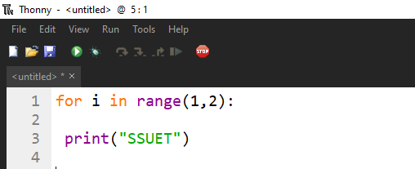

* **Output:**

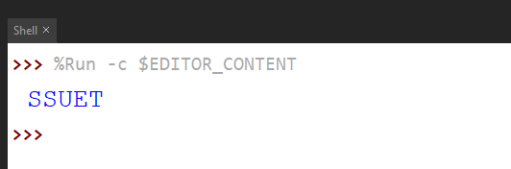

**Tasks #01B**

* **Code(incorrect):**

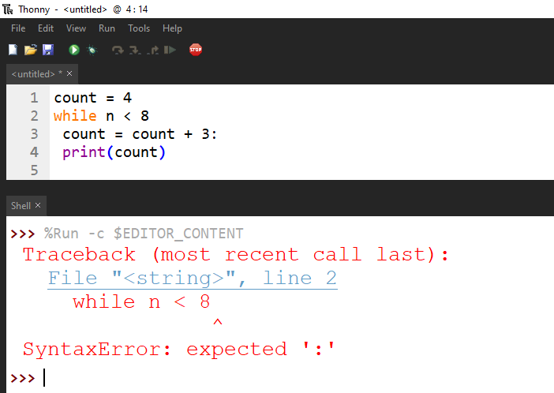

* **Code(correct one):**

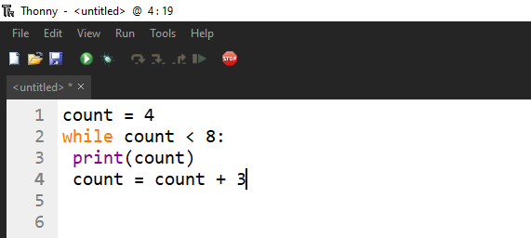

* **Output:**

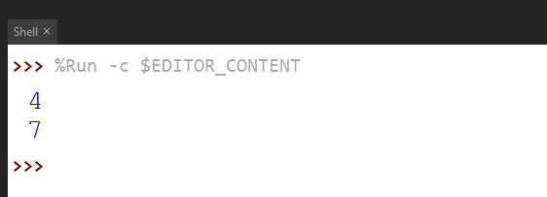

**Tasks #01C**

* **Code(incorrect):**

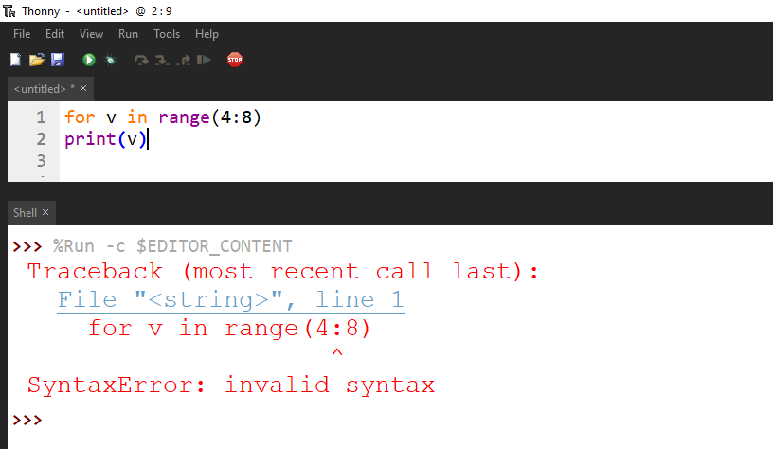

* **Code(correct one):**

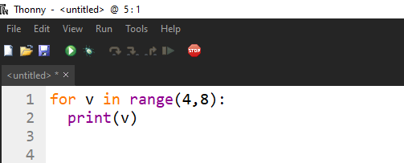

* **Output:**

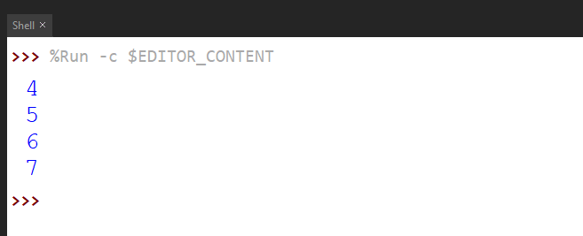

1. ***What would be the output of the following programs:***

**Tasks #02A**

* **Code:**

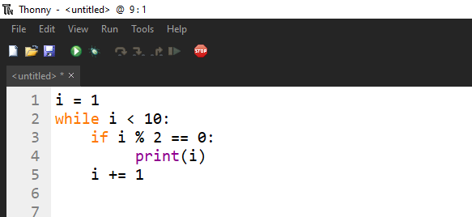

* **Output:**

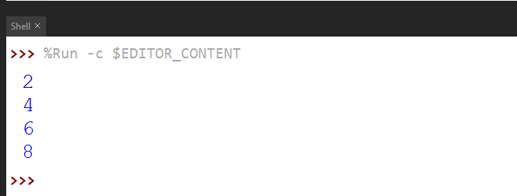

**Tasks #02B**

* **Code:**

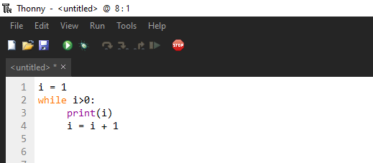

* **Output:**

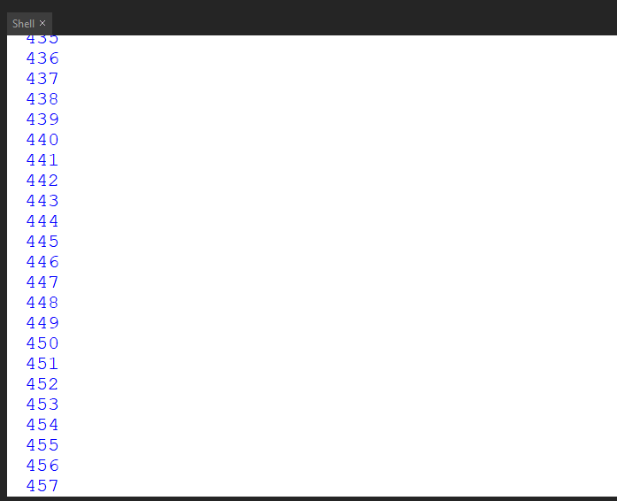

**Tasks #02C**

* **Code:**

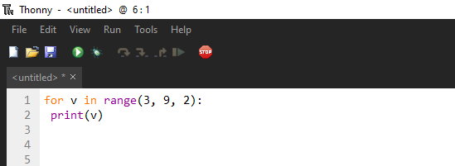

* **Output:**

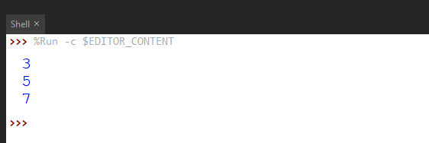

1. ***Write Python programs for the following****:*

*Write a program that prints the first 10 natural numbers and their sum using ‘for loop’. Sample output: The first 10 natural number are : 1 2 3 4 5 6 7 8 9 10 The Sum is : 55*

* **Code:**

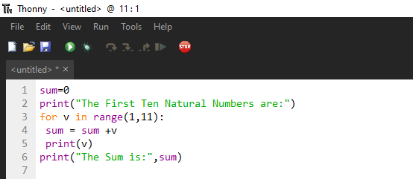

* **Output:**

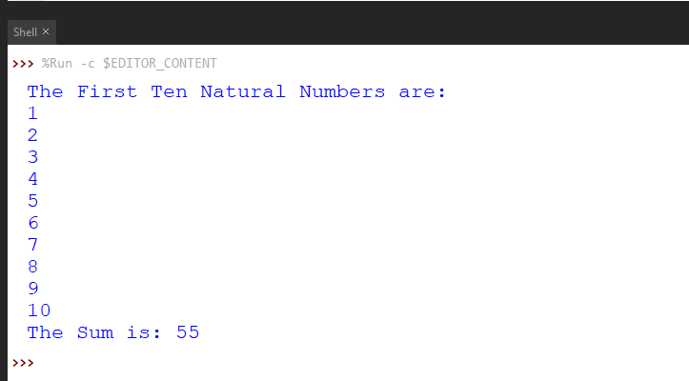

1. *Write a program to print the multiplication table of the number entered by the user. The table should get displayed in the following form. 29 x 1 = 29 29 x 2 = 58 … 29 x 10 = 290*

* **Code:**

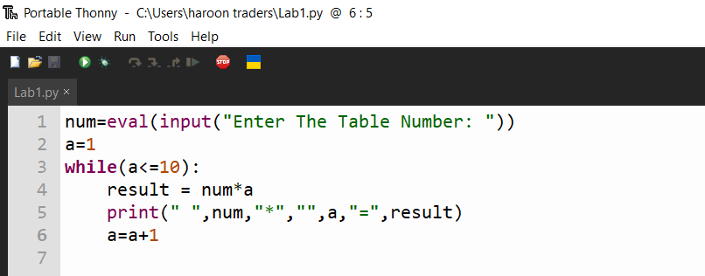

* **Output:**

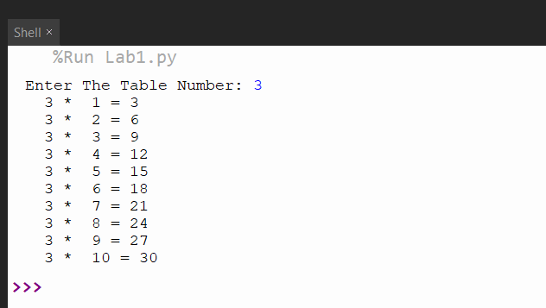

1. *Write a program that take vowels character in a variable named “vowels” then print each vowels characters in newline using ‘for loop’*

* **Code:**

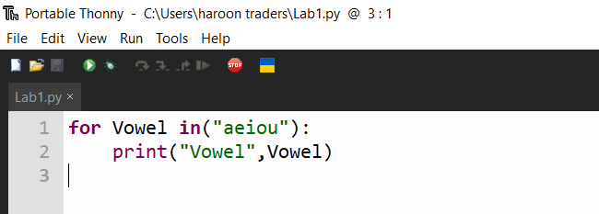

* **Output:**

