**LAB # 06**

NESTED STATEMENTS, BREAK AND CONTINUE STATEMENTS

# *OBJECTIVE:*

*Working on nested statements and control loop iteration using break and continue*

HOME tasks

***EXERCISE***

1. ***Point out the errors, if any, and paste the output also in the following Python programs.***

**Code 1**

* **Code(incorrect)**

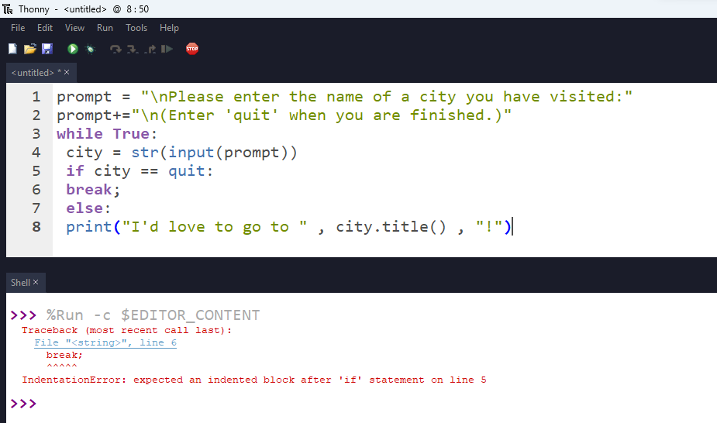

* **Code(correct one):**

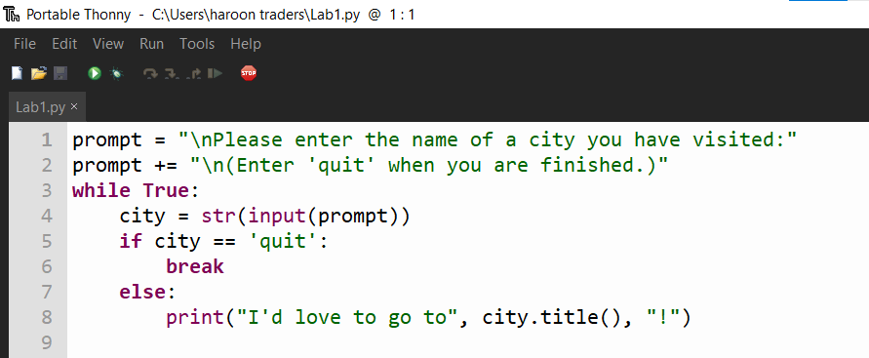

* **Output:**

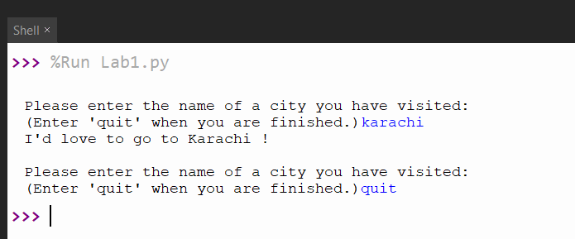

**Code 2**

* **Code(incorrect)**

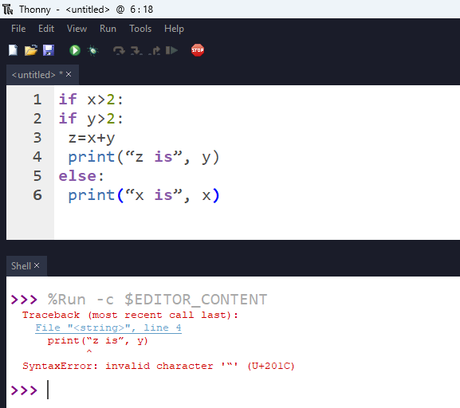

* **Code(correct one):**

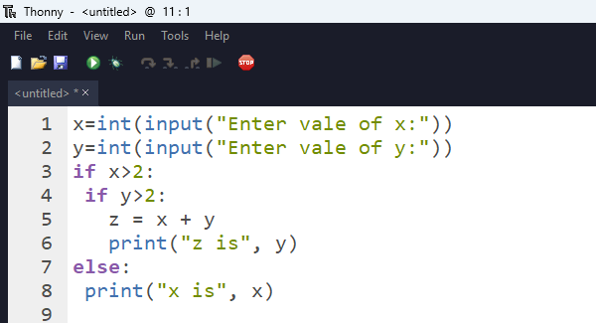

* **Output:**

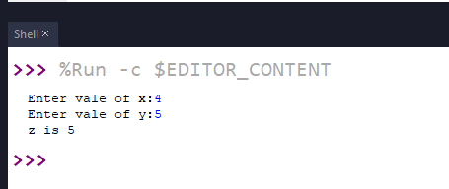

**Code 3**

* **Code(incorrect)**

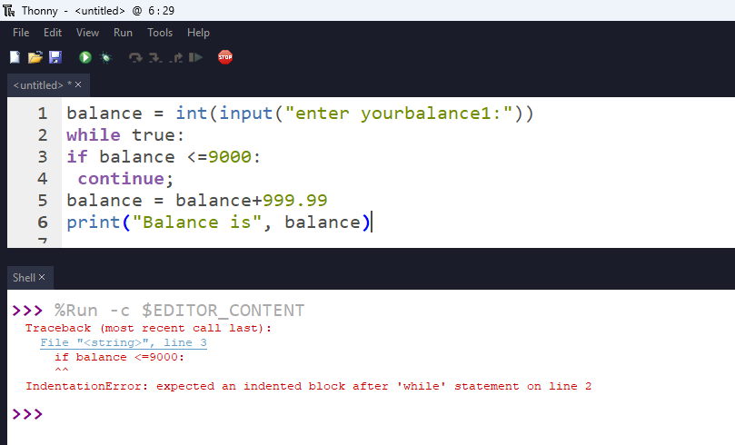

* **Code(correct one):**

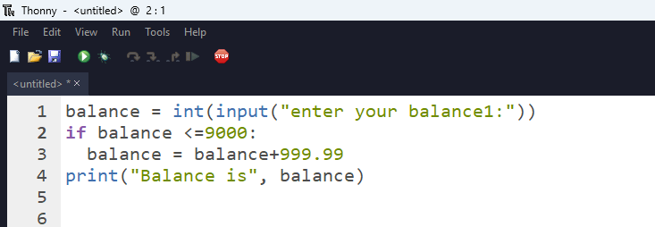

* **Output:**

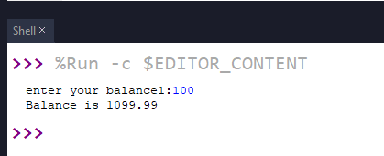

1. ***What would be the output of the following programs:***

**Code 1**

* **Code:**

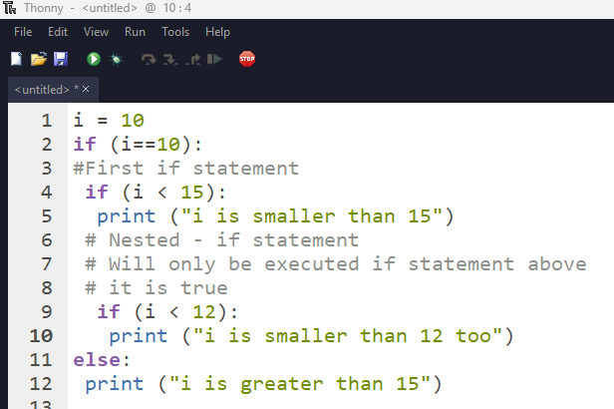

* **Output:**

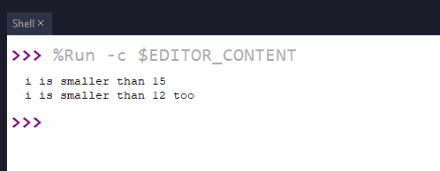

**Code 2**

* **Code:**

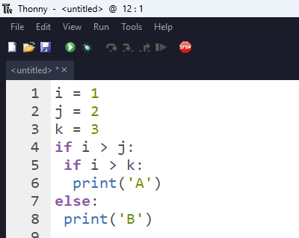

* **Output:**

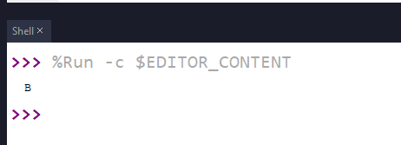

**Code 3**

* **Code:**

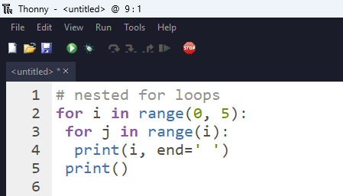

* **Output:**

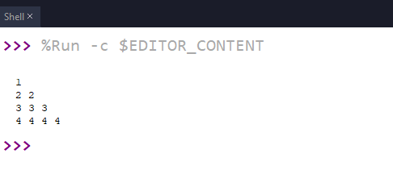

1. ***Write Python programs for the following****:*

**Code 1**

*Write a program to print all prime numbers from 900 to 1000. [Hint: Use nested loops, break and continue]*

* **Code:**

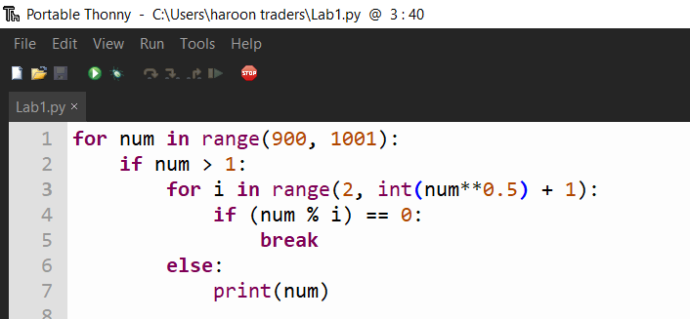

* **Output:**

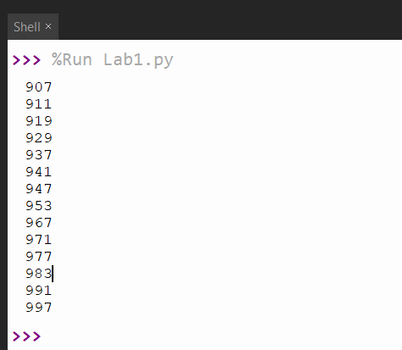

**Code 2**

*Write a program to display multiplication table (1-5) using nested looping Sampled output: [hint: '{ } ' .format(value)] 02 X 01 = 02*

* **Code:**

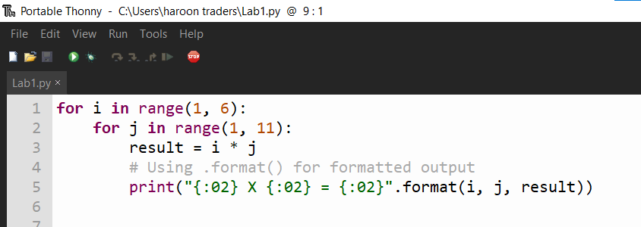

* **Output:**

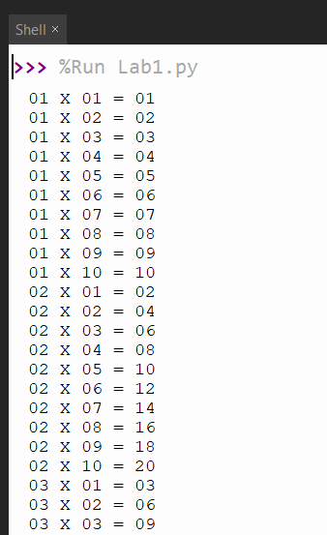 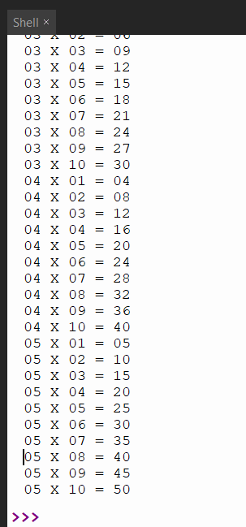

**Code 3**

*Write a program to add first seven terms twice of the following series:*

* ****Code:**

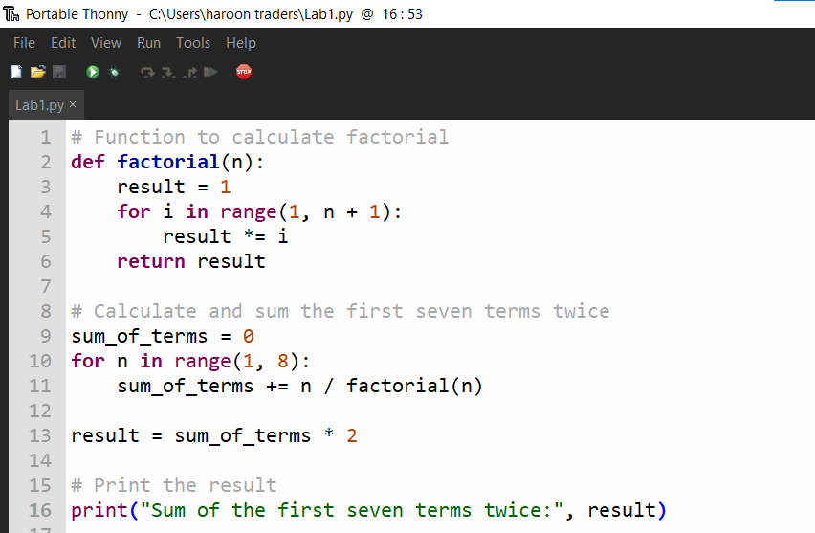

* **Output:**

